**Task 2: Instruction – Write a recipe** Date: ____________________

Name and Surname: ________________________________

Write a recipe that is only known in South- Africa for example: Melktert, Malva pudding, Vetkoek, Bobotie, Bunny Chow, Koeksister.

**Remember:**

1. Your recipe’s name.
2. The ingredients and the amount of each ingredient listed underneath each other.
3. The method of how to prepare and make your dish.

For example:

1. Switch the stove to 180˚
2. Butter your pan.
3. Remember that each step needs to be clear and the reader needs to understand what to do.

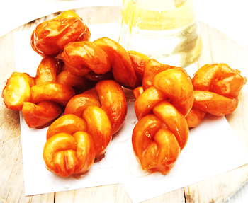**Rubric:**

|  |  |
| --- | --- |
| 1. Recipe known in South-Africa. | /2 |
| 1. Heading and sub-headings. | /3 |
| 1. Ingredients and the amount listed. | /5 |
| 1. The method is easy to read and to understand. | /5 |
| 1. Spelling. | /5 |
| 1. Neat work. | /5 |
| 1. Sentence structure. | /5 |
| **Total marks:** | **/30** |































































