









Bea Terblanche
Grade 3
Natural Sciences and Technology
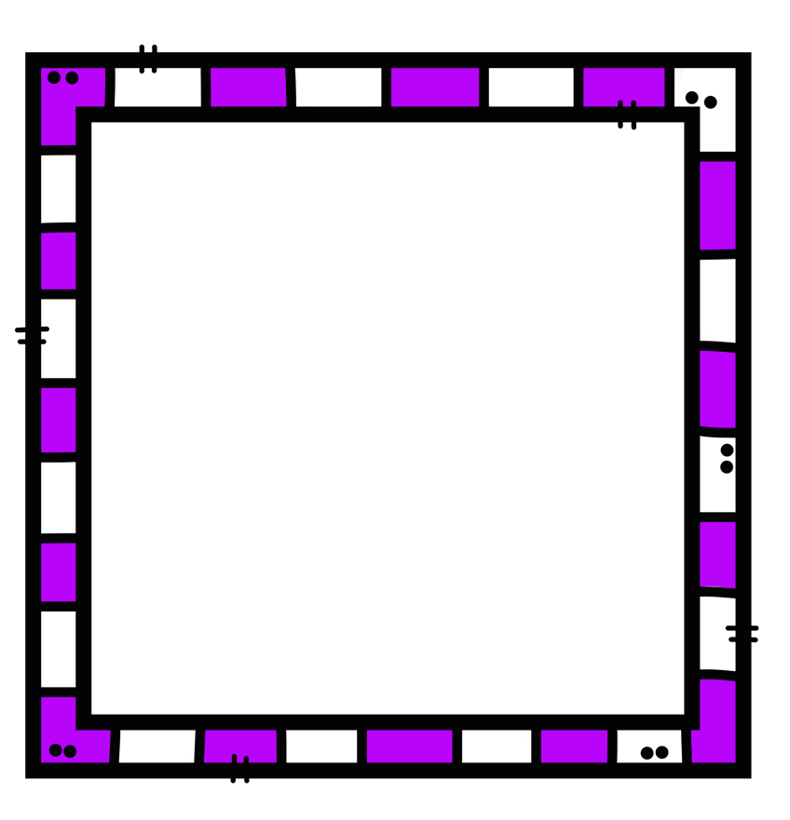

Bea Terblanche
Grade 3
Mathematics


Bea Terblanche
Grade 3
Social Sciences

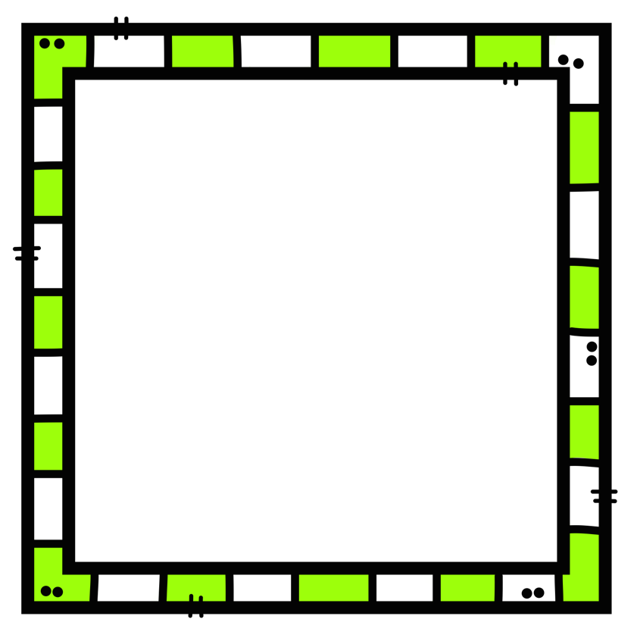

Bea Terblanche
Grade 3
English Home Language


Bea Terblanche
Grade 3
Afrikaans first additional language

Bea Terblanche
Grade 3
Daily Planning


Bea Terblanche
Grade 3
General

Bea Terblanche
Grade 3
Resources

Bea Terblanche
Grade 3
Lesson Planning

Bea Terblanche
Grade 3
Personal file

Bea Terblanche
Grade 3
Marks

