**Life Skills**

**Assessment Terms 3**

**Grade 2**

**Name and Surname: ____________________________**

**Date: _________________________________**

|  |  |  |
| --- | --- | --- |
| **Assessment Marks** |  |  |
| 1. Beginning knowledge and Personal and Social Well-being | **45** |  |
| 1. Creative Arts | **35** |  |
| 1. Physical Education | **20** |  |
| **Total** | **100** |  |

**Activity 1**

**Beginning knowledge and Personal and Social Well-being**

**Marks: 45**

1. **Ground**
   1. Give one reason why ground is important to us. (1)

____________________________________________________________________________________________

* 1. How many types of ground is there? __________ (1)
  2. Write down the 3 types of ground. (3)

_______________

_______________

_______________

* 1. Connect the type of ground with their correct description. (2)

|  |  |  |
| --- | --- | --- |
| Clay |  | This type of ground is the best to plant seeds and young plants. |
| Loam | The soil particles of this ground stick together and become very wet. |

1. **Transport**
   1. Write down 4 types of transport? (4)

_______________

_______________

_______________

_______________

* 1. Look at the pictures and connect them with the correct word. (4)

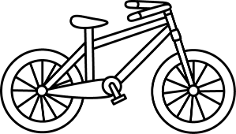

|  |
| --- |
| donkey car |
| bicycle |
| car |
| truck |
| motorcycle |

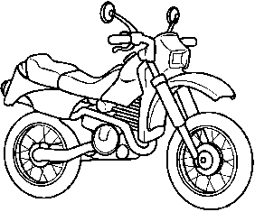

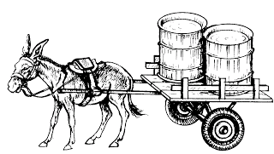

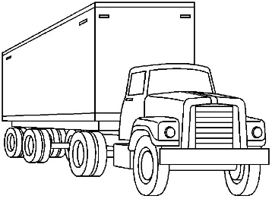

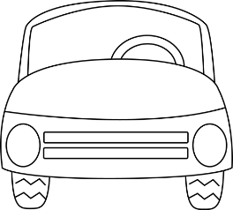

* 1. What type of transport do we use to do the following, for example rail transport. (4)
     1. To travel from South Africa to Australia.

_________________________

* + 1. To get from your house to school.

________________________

* + 1. To go fishing on the deep sea.

________________________

* + 1. To travel from your home to your friends house.

________________________

* 1. What is rail transport?

_______________________________________________________________________________________(2)

1. **Road safety**
   1. Look at the picture and write down 4 road rules. (4)

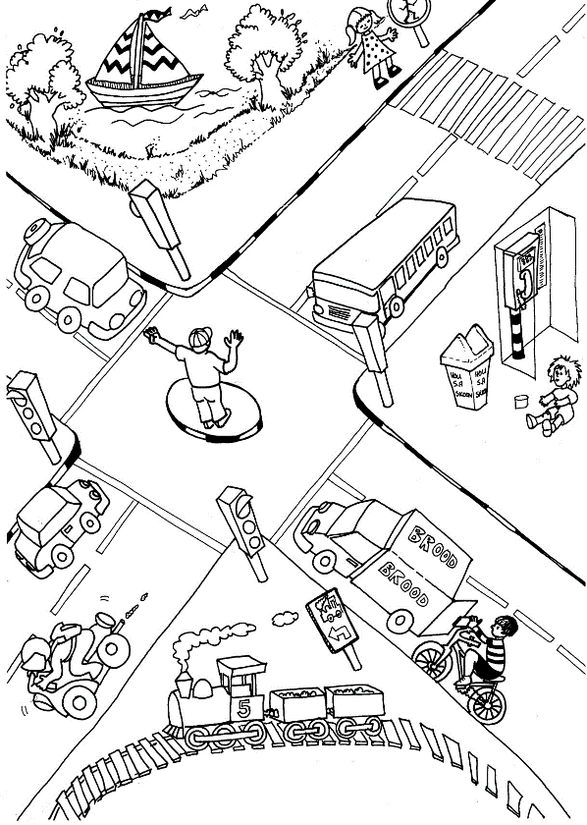

1. __________________________________________________________________
2. __________________________________________________________________
3. __________________________________________________________________
4. __________________________________________________________________
   1. 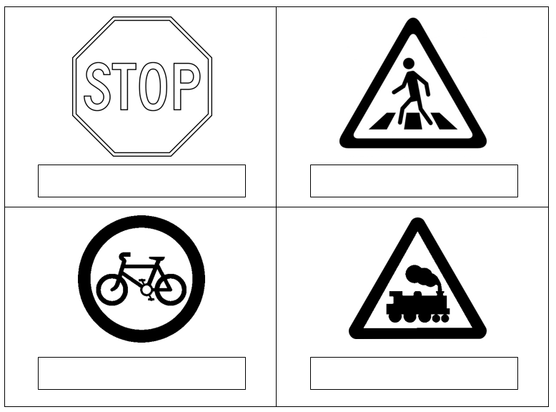What does the traffic signs stand for? (4)
   2. Is the following statements true or false? (5)
      1. When you ride on your bicycle with friends you should drive behind each other. __________
      2. You don’t have to stop at an orange traffic light. __________
      3. At a stop sign you must first stop to look if it is save and then drive. _____________
      4. Children may play in the road. ___________
      5. You should always put on your safety belt in the car.

_____________

1. **People who help us**
   1. Match the descriptions with their picture by drawing a line. (5)

|  |  |  |
| --- | --- | --- |
| I help animals who are sick or got hurt. |  | Image result for doctor clipart black and white |
| I help people who are sick to get better. | Image result for firemen clipart black and white |
| I help you to keep your teeth healthy and clean. | Image result for policeman with gun clipart black and white  Related image |
| I extinguish fires at buildings and homes. |  |
| I protect you against criminals and keep the neighborhood save. | Related image |

* 1. Write down the names of the places and buildings. (3)

|  |  |  |
| --- | --- | --- |
|  |  |  |
|  |  |  |

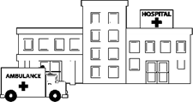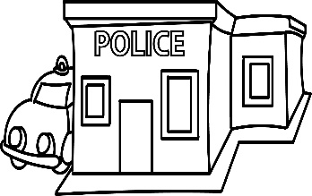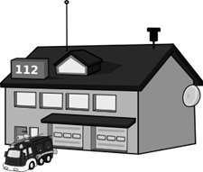

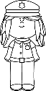

* 1. Choose the correct word in the box and write it with its description. (4)

|  |  |  |  |
| --- | --- | --- | --- |
| library | post office | hairdresser | teacher |

* + 1. A person can post letters here and buy stamps. ____________
    2. They teach me every day to make me smart. ____________
    3. She cuts my hair so that I look neat. ___________
    4. I take out books here. ___________

|  |  |  |
| --- | --- | --- |
| **Marks – Beginning knowledge and Personal and Social Well-being** |  |  |
| 1. Ground | **7** |  |
| 1. Transport | **14** |  |
| 1. Road safety | **13** |  |
| 1. People who help us | **11** |  |
| **Total** | **45** |  |

**Activity 2**

**Creative arts**

**Marks: Performing arts and Visual arts = 35**

**2.1. Performing arts – Improvise and Interpret**

Roleplay

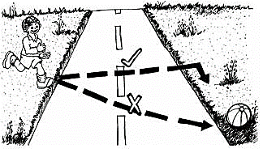Work in groups of 5 and create a roleplay about one of the following topics:

* Road rules for cars.
* Road rules for pedestrians
* Road rules for cyclists.

Tour group will be assessed according to the following rubric:

|  |  |  |  |  |  |
| --- | --- | --- | --- | --- | --- |
| **Rubric – Performing arts** | **5** | **4** | **3** | **2** | **1** |
| 1. Participation: Learner actively participates and makes a contribution to the planning of the roleplay. | 5 | 4 | 3 | 2 | 1 |
| 1. Enjoyment: The learner enjoys participating in the creative activity and gives his cooperation. | 5 | 4 | 3 | 2 | 1 |
| 1. Content: The roleplay is applicable to one of the given topics. | 5 | 4 | 3 | 2 | 1 |
| 1. Creative: Was the learners creative with their roleplay. | 5 | 4 | 3 | 2 | 1 |
| **Total** | **___/20** | | | | |

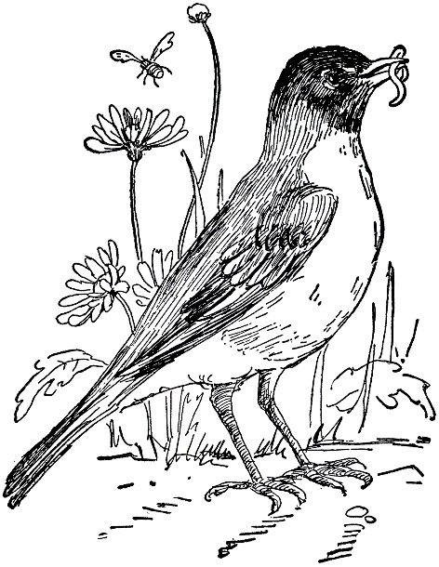**2.2. Visual arts – Create in 2D**

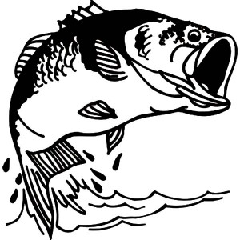**Assignment:**

Choose one of the following topics:

1. Birds
2. Fish
3. Insects

Draw an artwork in warm colors using oil pastels. Your artwork must only be in warm colors.

Remember warm colors are: Red, orange and yellow.

You will be assessed according to the following rubric:

|  |  |  |
| --- | --- | --- |
| **Rubric – Visual arts** |  |  |
| 1. The learner kept to the topic: Birds, fish or insects. | **5** |  |
| 1. The learner was creative. | **5** |  |
| 1. The learner only used warm colors in his artwork. | **5** |  |
| **Total** | **15** |  |

**Activity 3**

**Physical Education**

**Marks: 20**

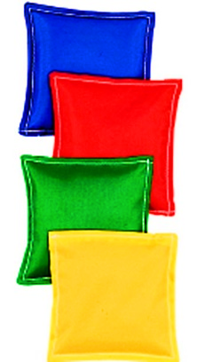**Purpose of activity – Coordination and Balance**

**Resources needed:**

* Tambourine / drum
* Beanbags

Instructions

Activity 1

* Learners walks in a circle with their arms stretched out, while holding a beanbag and the teacher is playing the tambourine / drum.
* When the tambourine / drum stops playing, they stop, throws the bag in the air and catches it.
* Next, learners put the bean bag on their head. The teacher plays the tambourine / drum while the children are walking in the circle. If the teacher stops playing, they can remove the bean bag from their head. If their beanbag falls off their head, they must move out of the circle and they are out.
* Play the balancing game until there is only one learner left.

Activity 2

* The pupils stand two-two across each other.
* They throw and catch the beanbags.
* The pupils who caught the beanbag five times in a row can go sit.
* If the beanbag falls they have to start over.

|  |  |  |
| --- | --- | --- |
| **Rubric – Physical Education Activity 1** |  |  |
| 1. The learner was capable to catch the beanbag. | **4** |  |
| 1. The learner listened when the tambourine/drum starts and stops to play. | **2** |  |
| 1. The learner was able to balance the beanbag on his head. | **4** |  |
| **Total** | **10** |  |

|  |  |  |
| --- | --- | --- |
| **Rubric – Physical Education Activity 1** |  |  |
| 1. Group work: The learner worked as a team with his partner. | **2** |  |
| 1. The learner was able to catch and throw the beanbag. | **4** |  |
| 1. The learner was able to catch the beanbag 5 times in a row. | **4** |  |
| **Total** | **10** |  |