**Life skills**

**Grade 1 Assessment task**

**Term 3**

**Name and Surname: ____________________________**

**Date: _________________________________**

**MEMORANDUM**

|  |  |  |
| --- | --- | --- |
| **Rubric Assessment task** |  |  |
| 1. Beginning Knowledge | **10** |  |
| 1. Personal and Social Well-being | **35** |  |
| 1. Creative Arts | **35** |  |
| 1. Physical Education | **20** |  |
| **Total** | **100** |  |

**Activity 1**

**Beginning Knowledge**

**Marks: 10**

* 1. Manners

Look at the pictures below and write down the manners you see in each picture.

**Total: ______ / 5**

|  |  |
| --- | --- |
| Image result for share coloring pages | I share with my friend. |
| Related image  I did not take the blocks! | It is wrong to tell a lie. Always tell the truth. |
| Image result for good manners clipart black and white  I will wait my turn. | Wait for your turn. |
| Image result for greet each other clipart  Hello!! | Greet people. |
| Image result for wrong mark clipart black and whiteBlack and White Angry Face BoyRelated imageBlack and White Happy Face Boy | Be friendly. |

* 1. **Responsibilities**

Match the pictures with their correct responsibility by drawing a line with a ruler.

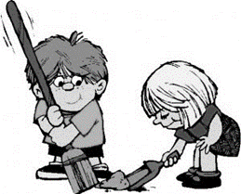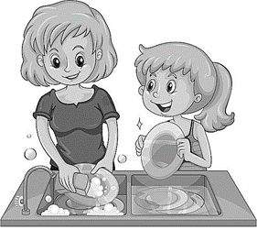

**Total: ______ / 10**

**Total: ______ / 5**

|  |
| --- |
| I show my family that I love them. |
| I help setting the table. |
| I play nicely with my friends and I respect their toys. |
| I help to clean the house. |
| I help my mother to wash the dishes. |

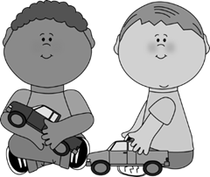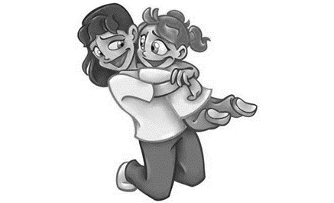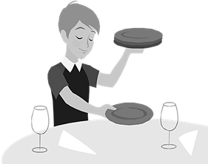

**Activity 2**

**Personal and Social Well-being**

**Marks: 20**

**2.1. a) Food – Healthy and unhealthy food**

Color in the if the food is healthy OR color in the if the food is unhealthy.

|  |  |
| --- | --- |
|  |  |
|  |  |
|  |  |

**Total: ______ / 5**

**2.2. My community**

a) Write the names in the box at the correct picture.

|  |  |  |  |  |  |
| --- | --- | --- | --- | --- | --- |
| Doctor | Fireman | Policeman | Nurse | Farmer | Florist |

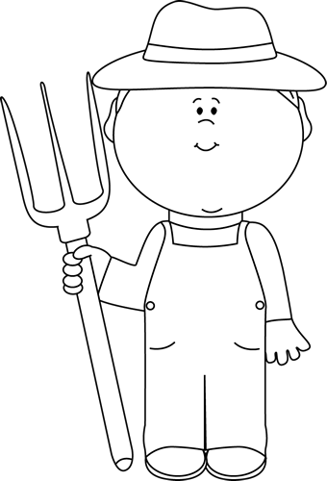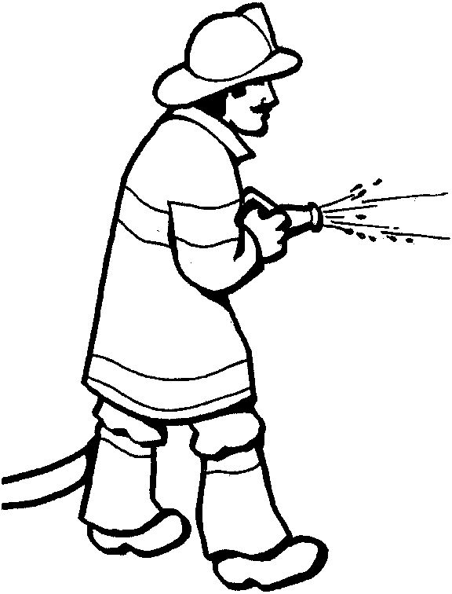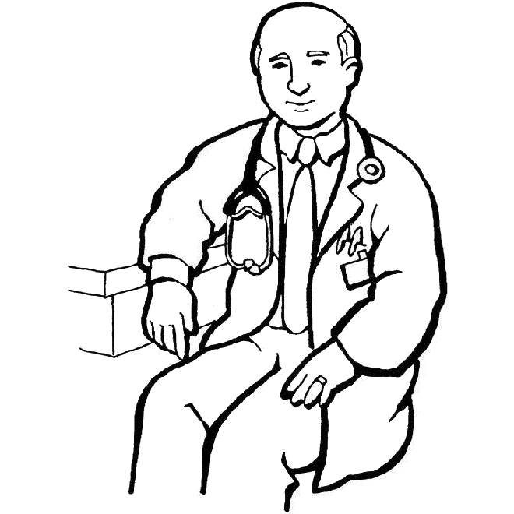

Doctor

Fireman

Farmer

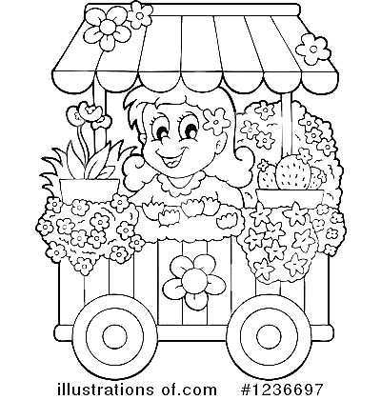

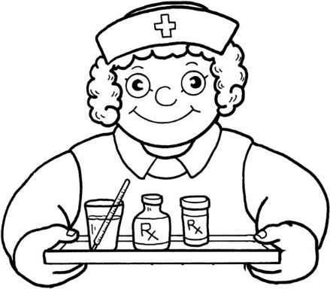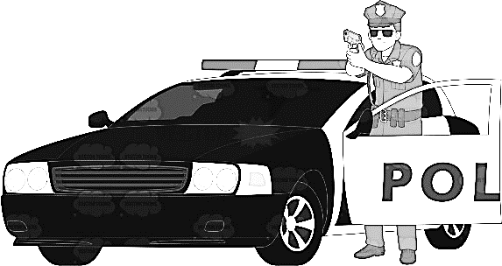

Nurse

Policeman

Florist

**Total: ______ / 6**

**b) Write the names of the places in my community.**

|  |  |  |  |
| --- | --- | --- | --- |
|  |  |  |  |
|  |  |  |  |

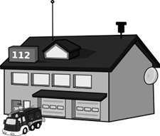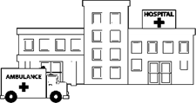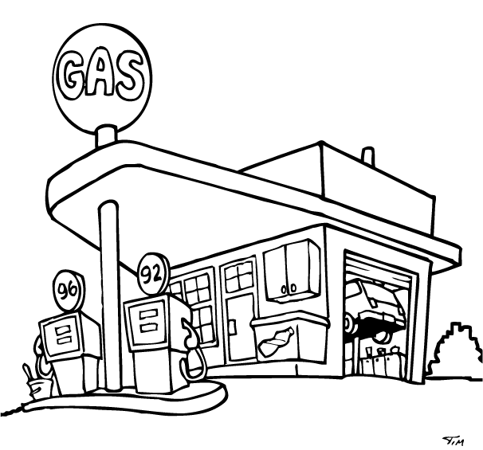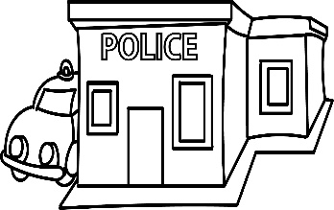

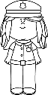

Fire station

Gas station

Police station

Hospital

**Total: ______ / 4**

**2.3. Pets**

a) Match the pets with their shelters

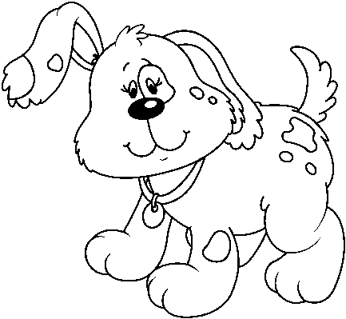

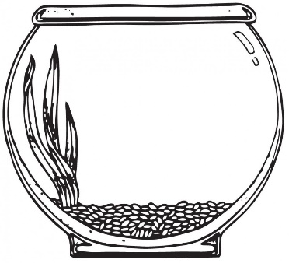

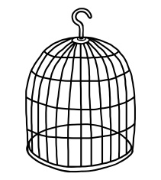

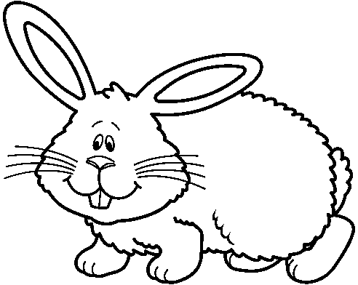

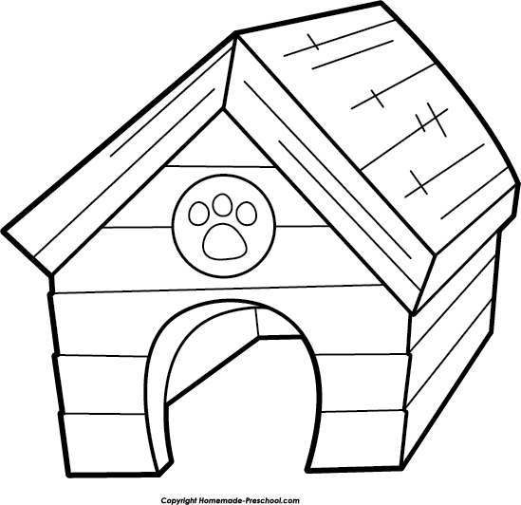

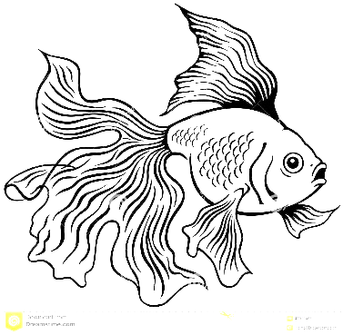

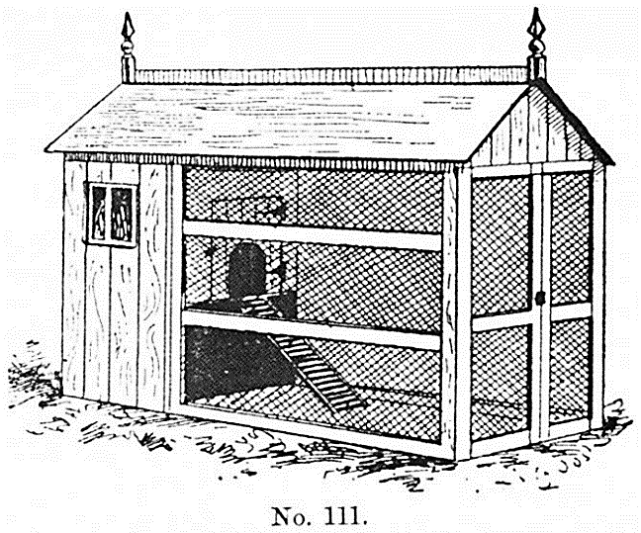

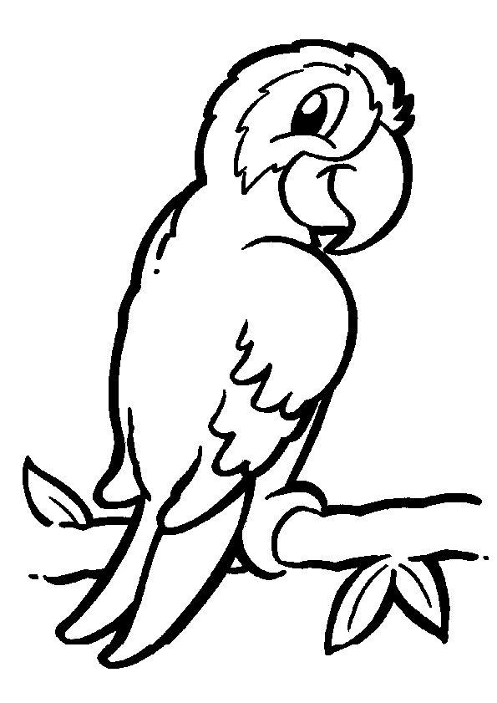

**Total: ______ / 4**

**b) Is the following statements true or false?**

True

1. It is not good manners to tease an animal. ____________

False

1. A cat lives in a doghouse. __________

True

1. A parrot lives in a bird cage. ____________

False

1. A fish can live on dry land. _________

True

1. A pet is a man’s best friend. ________
2. You do not have to take care of your pet and give the food, water and love. __________

False

**Total: ______ / 6**

**2.4. Plants**

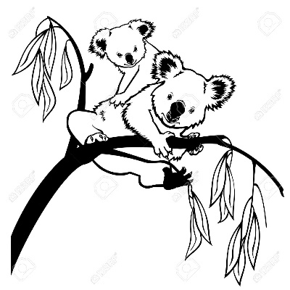a) Look at the pictures and write 3 reasons why we need

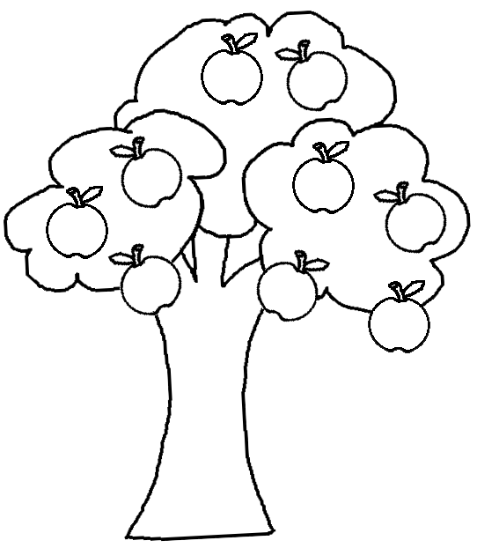 plants.

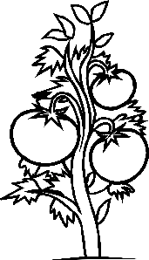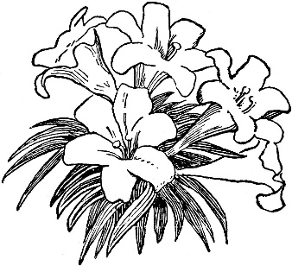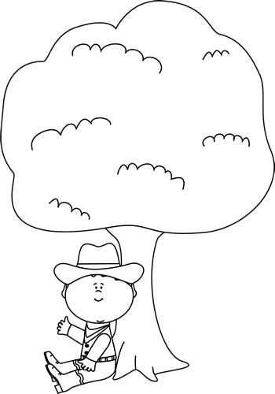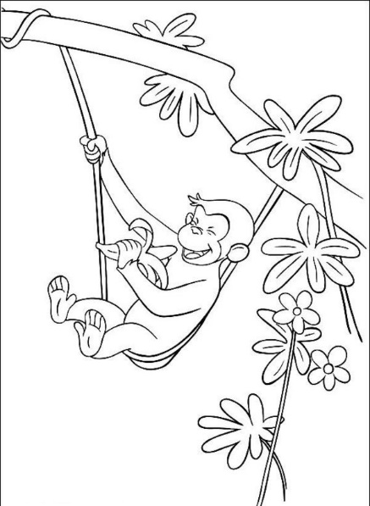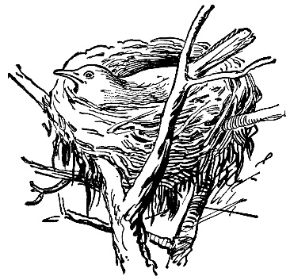

Animals lives in trees.

We get beautiful flowers from plants.

Food – Fruit and vegetables grow on plants and trees

Shading from the sun.

**Total: ______ / 3**

1. ____________________________________
2. ____________________________________
3. ____________________________________

|  |  |  |  |
| --- | --- | --- | --- |
| roots | f lower | leaf | stem |

**b) Use the words in the box and name the parts of the f lower.**

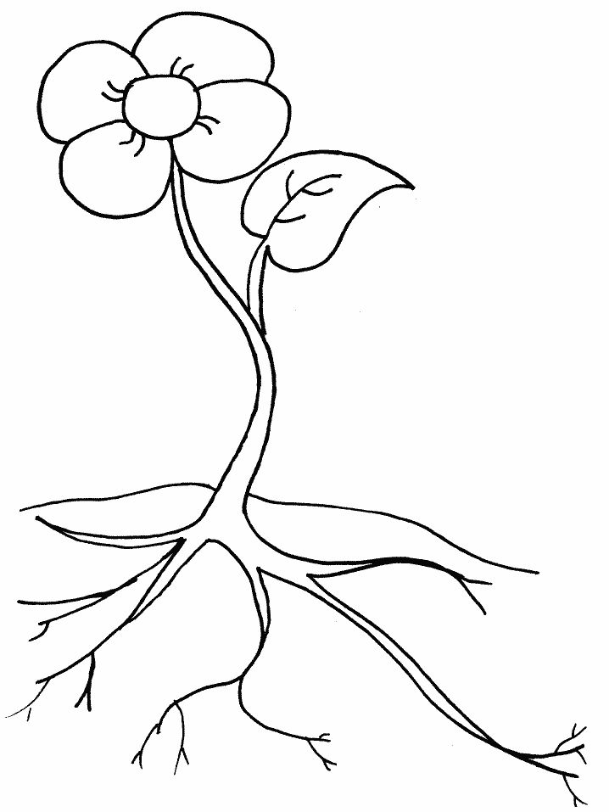

f lower

leaf

stem

roots

**Total: ______ / 4**

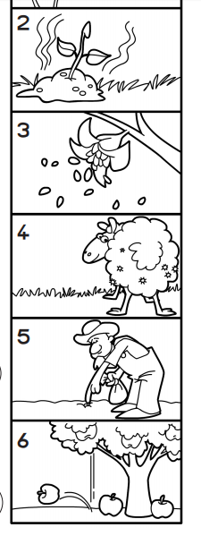**c) Number the pictures in the correct order.**



3

2

1

**Total: ______ / 3**

|  |  |  |
| --- | --- | --- |
| **Rubric Personal and Social Well-being** |  |  |
| 1. Food | **5** |  |
| 1. My Community | **10** |  |
| 1. Pets | **10** |  |
| 1. Plants | **10** |  |
| **Total** | **35** |  |

**Activity 3**

**Creative arts**

**Marks: Performing arts and Visual arts = 35**

**3.1. Performing arts – Improvise and Interpret**

Roleplay

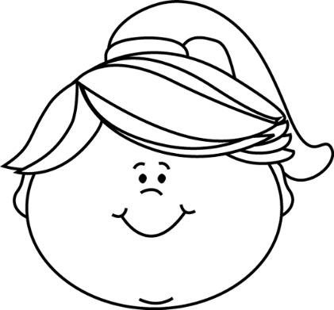Learners have to word in pairs of 2. They must create a story to explain what **good manners** is.

**Example:**

John: Come play with me David. I have brought my

new ball to school.

David: That sounds fun. Let’s see who can kick the ball

the furthest.

John: Look! Brian is sitting alone. Let’s ask him to come

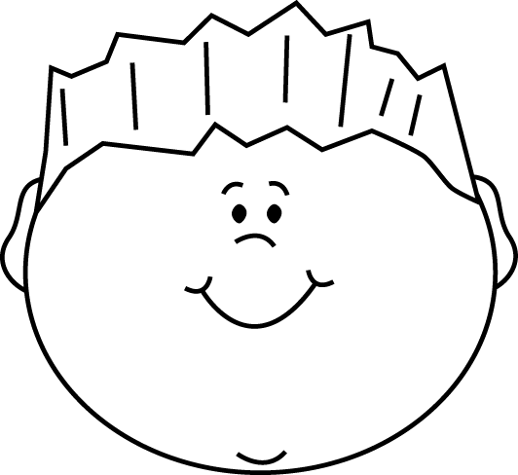 play with us.

David: Yes, let’s ask him!

|  |  |  |  |  |  |
| --- | --- | --- | --- | --- | --- |
| **Rubric – Performing arts** | **5** | **4** | **3** | **2** | **1** |
| 1. Participation: Learner actively participates and makes a contribution to the planning of the roleplay. | 5 | 4 | 3 | 2 | 1 |
| 1. Enjoyment: The learner enjoys participating in the creative activity and gives his cooperation. | 5 | 4 | 3 | 2 | 1 |
| 1. Content: The roleplay is applicable to the topic "good manners" | 5 | 4 | 3 | 2 | 1 |
| **Total** | **___/15** | | | | |

* 1. 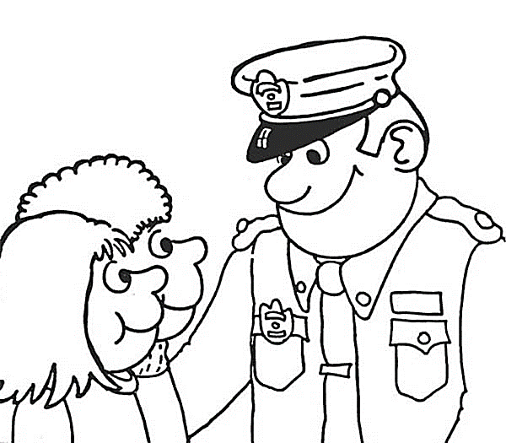**Visual arts – Create in 2D**

**Assignment:**

Draw and paint: "People who help me"

• Use A3 paper and acrylic paint.

• Learners draw and paint the theme: "People who help me".

• Learners must also paint the background and draw detail.

• Explain that objects that are far away should be smaller and

the color duller.

* Explain that objects which are near are bigger and clearer.

• Encourage learners to fill the entire picture.

|  |  |  |
| --- | --- | --- |
| **Rubric – Visual arts** |  |  |
| 1. The learner kept to the topic: "People who help me." | **5** |  |
| 1. The learner was creative. | **5** |  |
| 1. Did the learner make the objects which is far away smaller and objects which are near larger? | **5** |  |
| 1. Did the learner make the objects which is far away duller and objects which are near more clearly? | **5** |  |
| **Total** | **20** |  |

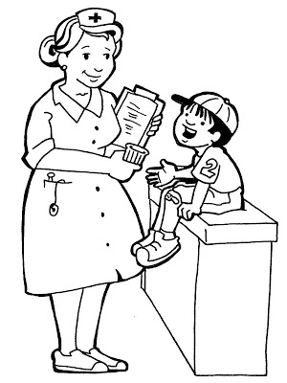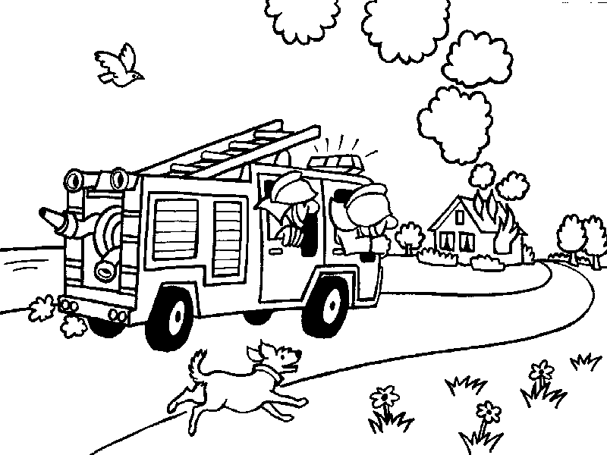

**Activity 4**

**Physical Education**

**Marks: 10**

**Purpose of activity – Coordination and Perceptual Motor**

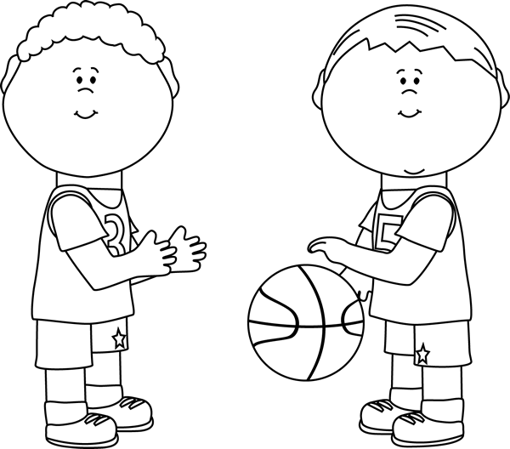

**Resources needed:**

* Empty container or trash can.
* A tennis ball
* A bean bag
* A rugby ball
* A netball ball

**Instructions**

* Divide into teams. Each team is in a row.
* Place a trash can or empty container about five steps away from the team.
* The first assignment is that the learners should try to throw the different balls with ONE HAND.
* The learner in front of the line throws the item into the container, runs to get the ball and hands it to the next learner in the line.
* If you miss, try again and try again. Each learner must throw the tennis ball, bean bag, rugby ball and netball ball.
* The second assignment is: The learners must now throw the items with TWO HANDS in the container. Each learner must throw tennis ball, bean bag, rugby ball and netball ball with two hands.
* Everybody in the team gets a turn. The first team who finish is the winning team.

|  |  |  |
| --- | --- | --- |
| **Rubric – Physical Education** |  |  |
| 1. The learner was capable to throw the tennis ball in the container with ONE HAND. | **2** |  |
| 1. The learner was capable to throw the netball ball in the container with ONE HAND. | **2** |  |
| 1. The learner was capable to throw the rugby ball in the container with ONE HAND. | **2** |  |
| 1. The learner was capable to throw the bean bag in the container with ONE HAND. | **2** |  |
| 1. The learner was capable to throw the tennis ball in the container with TWO HAND. | **2** |  |
| 1. The learner was capable to throw the netball ball in the container with TWO HAND. | **2** |  |
| 1. The learner was capable to throw the rugby ball in the container with TWO HAND. | **2** |  |
| 1. The learner was capable to throw the bean bag in the container with TWO HAND. | **2** |  |
| 1. The learner waited his turn and followed the instructions. | **2** |  |
| 1. The learner was enthusiastic about the activity and gave his best. | **2** |  |
| **Total** | **20** |  |