**Name and Surname: _________________________________ Date: ___________________**

**English First Additional Language - Grade 4** Total: Section A: 30

Section B: 20

**Question 1: Read the stories A - D and answer the question.**

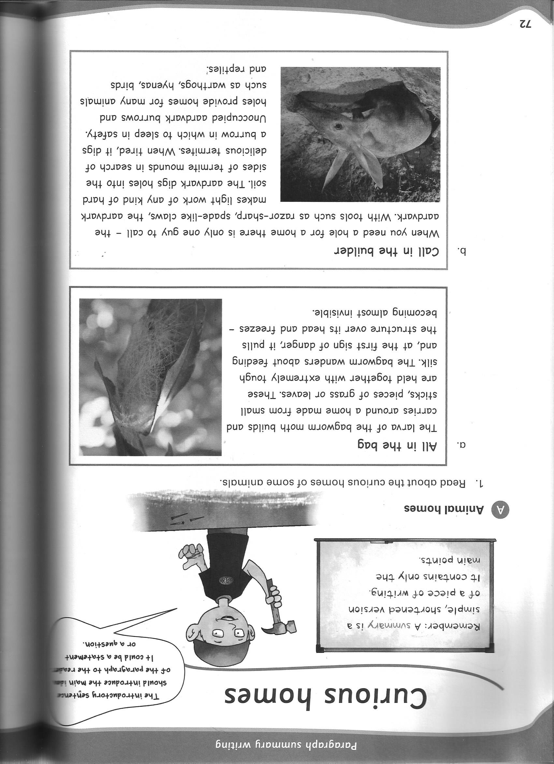

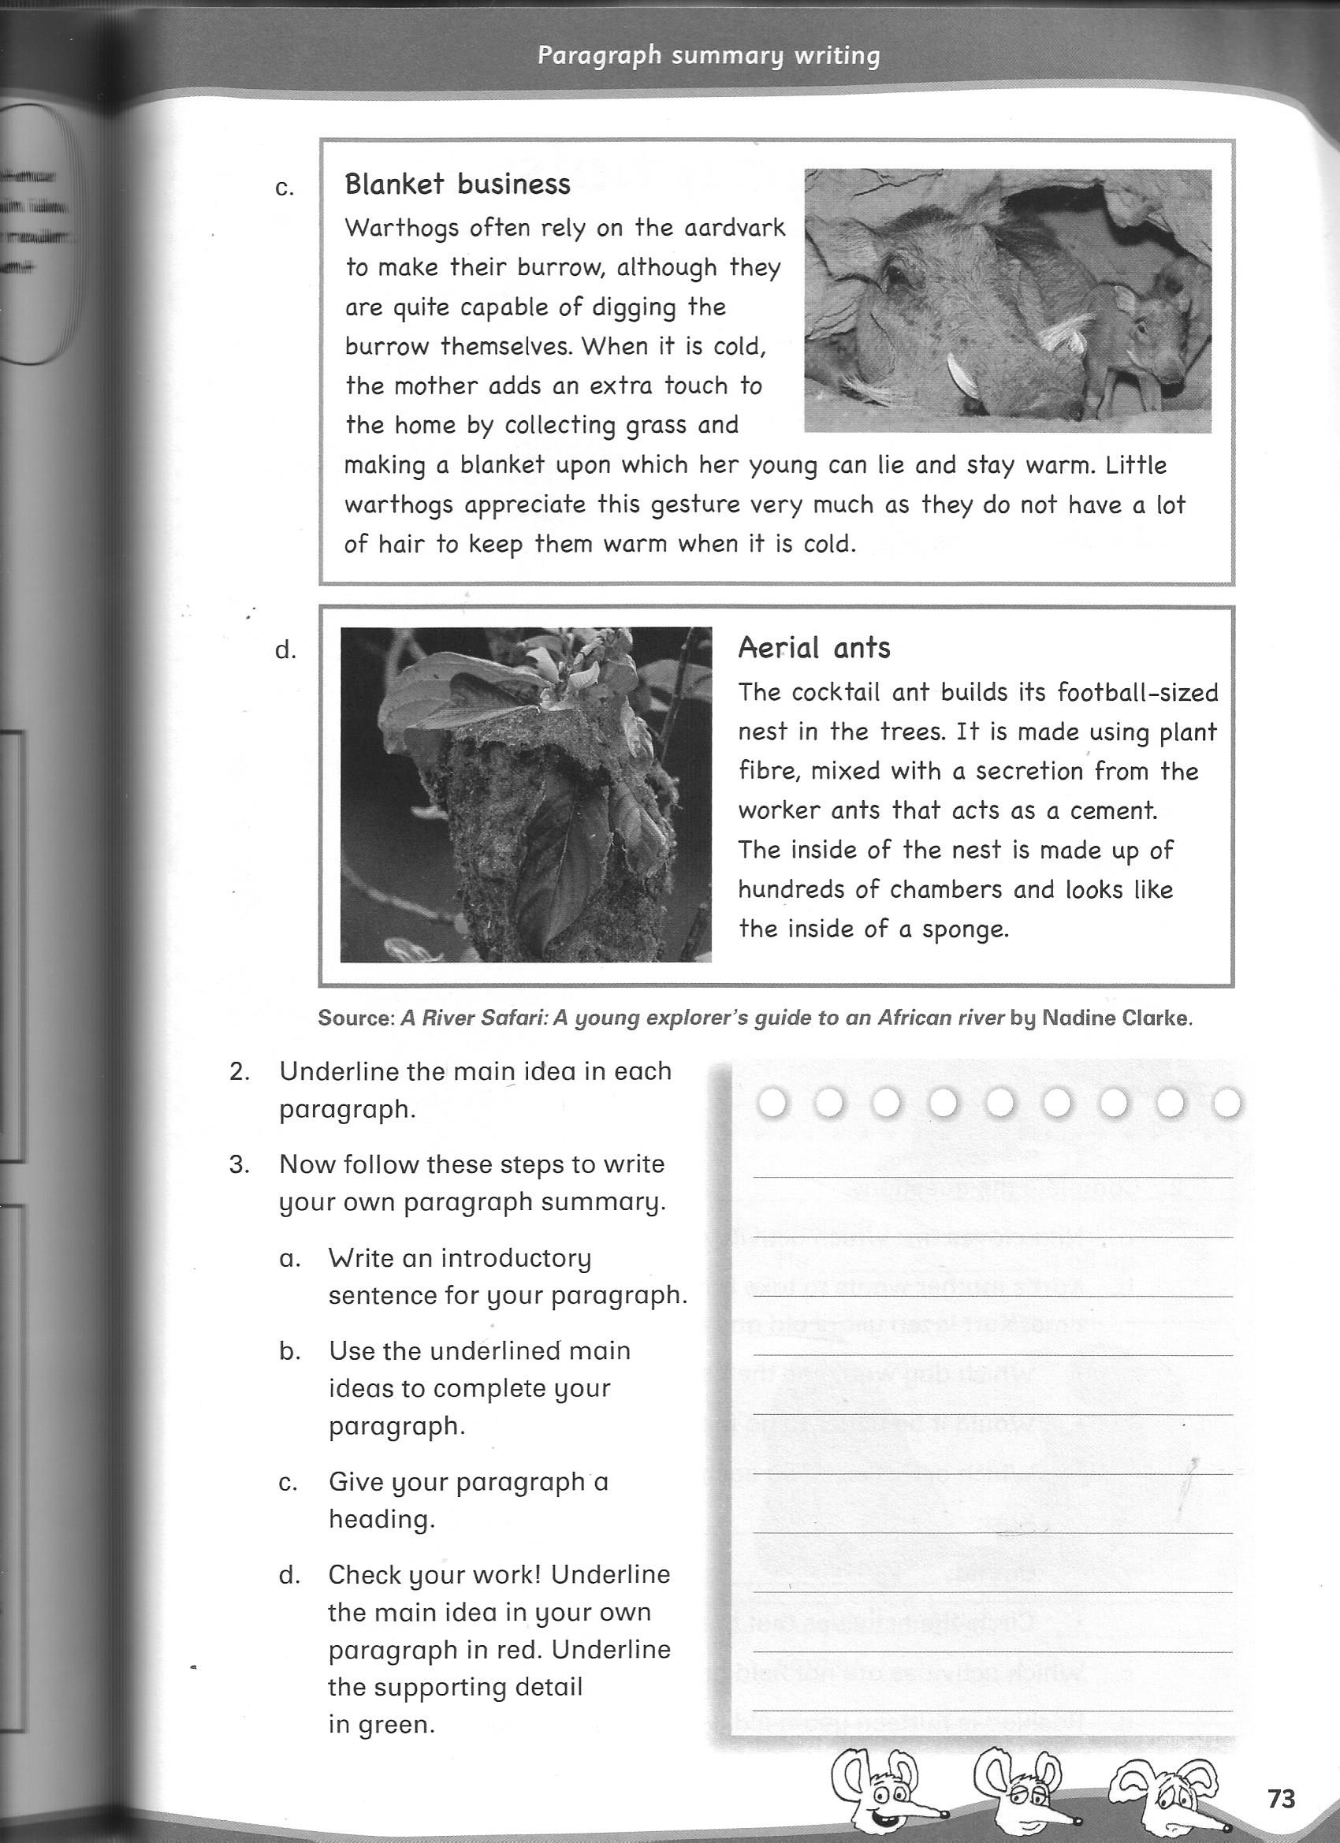

1. What is the bagworm’s home made of? (3)

__________________________ _________________________ ________________________

1. What does the bagworm do when he sees danger? (2)

________________________________________________________________________________

________________________________________________________________________________

1. Who do you call when you need a hole for a home? (1)

________________________________________________________________________________

1. How does the claws of an aardvark look like? (2)

________________________________________________________________________________

1. What does the aardvark eat? (1)

________________________________________________________________________________

1. How does it get hold of the food? (1)

________________________________________________________________________________

1. Who else uses the aardvark’s home? (4)

________________________________________________________________________________

________________________________________________________________________________

1. How do the warthogs make their home warm when it is cold? (2)

________________________________________________________________________________

________________________________________________________________________________

1. How big is the aerial ant’s nest? (1)

________________________________________________________________________________

1. Where do they build their nests? (1)

________________________________________________________________________________

1. What does the inside of the nest look like? (2)

________________________________________________________________________________

________________________________________________________________________________

________________________________________________________________________________

**Total: 20**

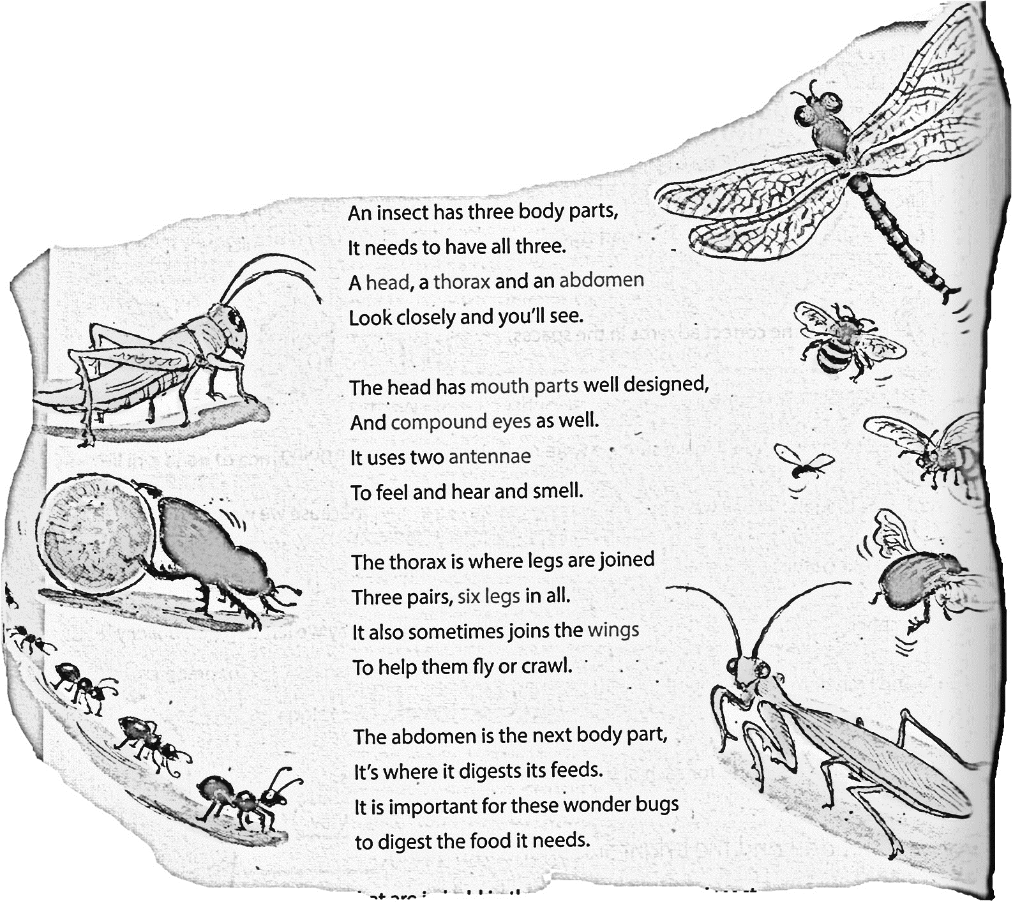**Question 2: Read the poem and answer the questions.**

**Insects**





1. How many body parts does an insect have? (1)

_______________________________________

1. Name the body parts. (3)

___________________________ __________________________ _______________________

1. List two things that is on an insect’s head? (2)

________________________________________ ___________________________________

1. How many legs does an insect have? (1)

________________________________________

1. What word in the poem RHYMES with THREE? (1)

________________________________________

1. What word in the poem RHYMES with WELL? (1)

________________________________________

1. What word in the poem RHYMES with FEEDS (1)

________________________________________ **Total: 10**

**Total Marks: 30**

**Section B:**

**Question 1: Give the OPPOSITES of the following words.**

**Remember spelling counts! (5 x $1/2$ = 2,5)**

1. small: _____________________
2. empty: ____________________
3. cry: ______________________
4. sharp: ____________________
5. old (man): _________________

**Question 2: Fill in the table (5 x $1/2$ = 2,5)**

**Remember spelling Counts!**

|  |  |
| --- | --- |
| **Animal** | **Where the animal lives.** |
| bird | 1. |
| 2. | hive |
| 3. | stable |
| pig | 4. |
| frog | 5. |

**Question 3: Rewrite the sentence and fill in the correct CAPITAL LETTERS, FULL STOP,**

**EXCLAMATION MARK AND QUESTION MARK. (10x $1/2$ = 5)**

1. frank and bill went to loftus versveld on saturday to watch rugby (6)

______________________________________________________________________________

______________________________________________________________________________

1. eben etzebeth was the man of the match at saturday’s game (4)

______________________________________________________________________________

______________________________________________________________________________

**Question 4: Read the sentence and fill in the correct ARTICLE- AN, A or THE. (4 x $1/2$ = 2)**

1. There was __________ lot of frost that winter.
2. ___________ snake handler came to take ___________ snake away.
3. She phoned ______________ emergency service.
4. That is ____________ helpful book about animals.

**Question 5: Read the sentence and shorten the words in brackets by using an**

**APHOSTROPHE. (3)**

1. He (does not) ___________________ like to read.
2. (They are) _______________________ good in maths.
3. (We have) _______________________ been waiting for you.

**Question 6: Change into the PRESENT INDEFINITE TENSE. (5)**

1. Rico and and Marnus (to play) soccer during each break.

___________________________________________________________________________

1. The boy (to walk) home every day after school.

____________________________________________________________________________

1. She always (to sing) in the car.

____________________________________________________________________________

1. The dogs (to bark) at the postman.

____________________________________________________________________________

1. The two girls (to do) their homework.

____________________________________________________________________________

Total marks: 20