**Name and Surname:_________________________________ Date:___________________**

**English First Additional Language-Grade 4** Total: Section A: 30

Section B: 20

**Question 1: Read the stories A - D and answer the question.**

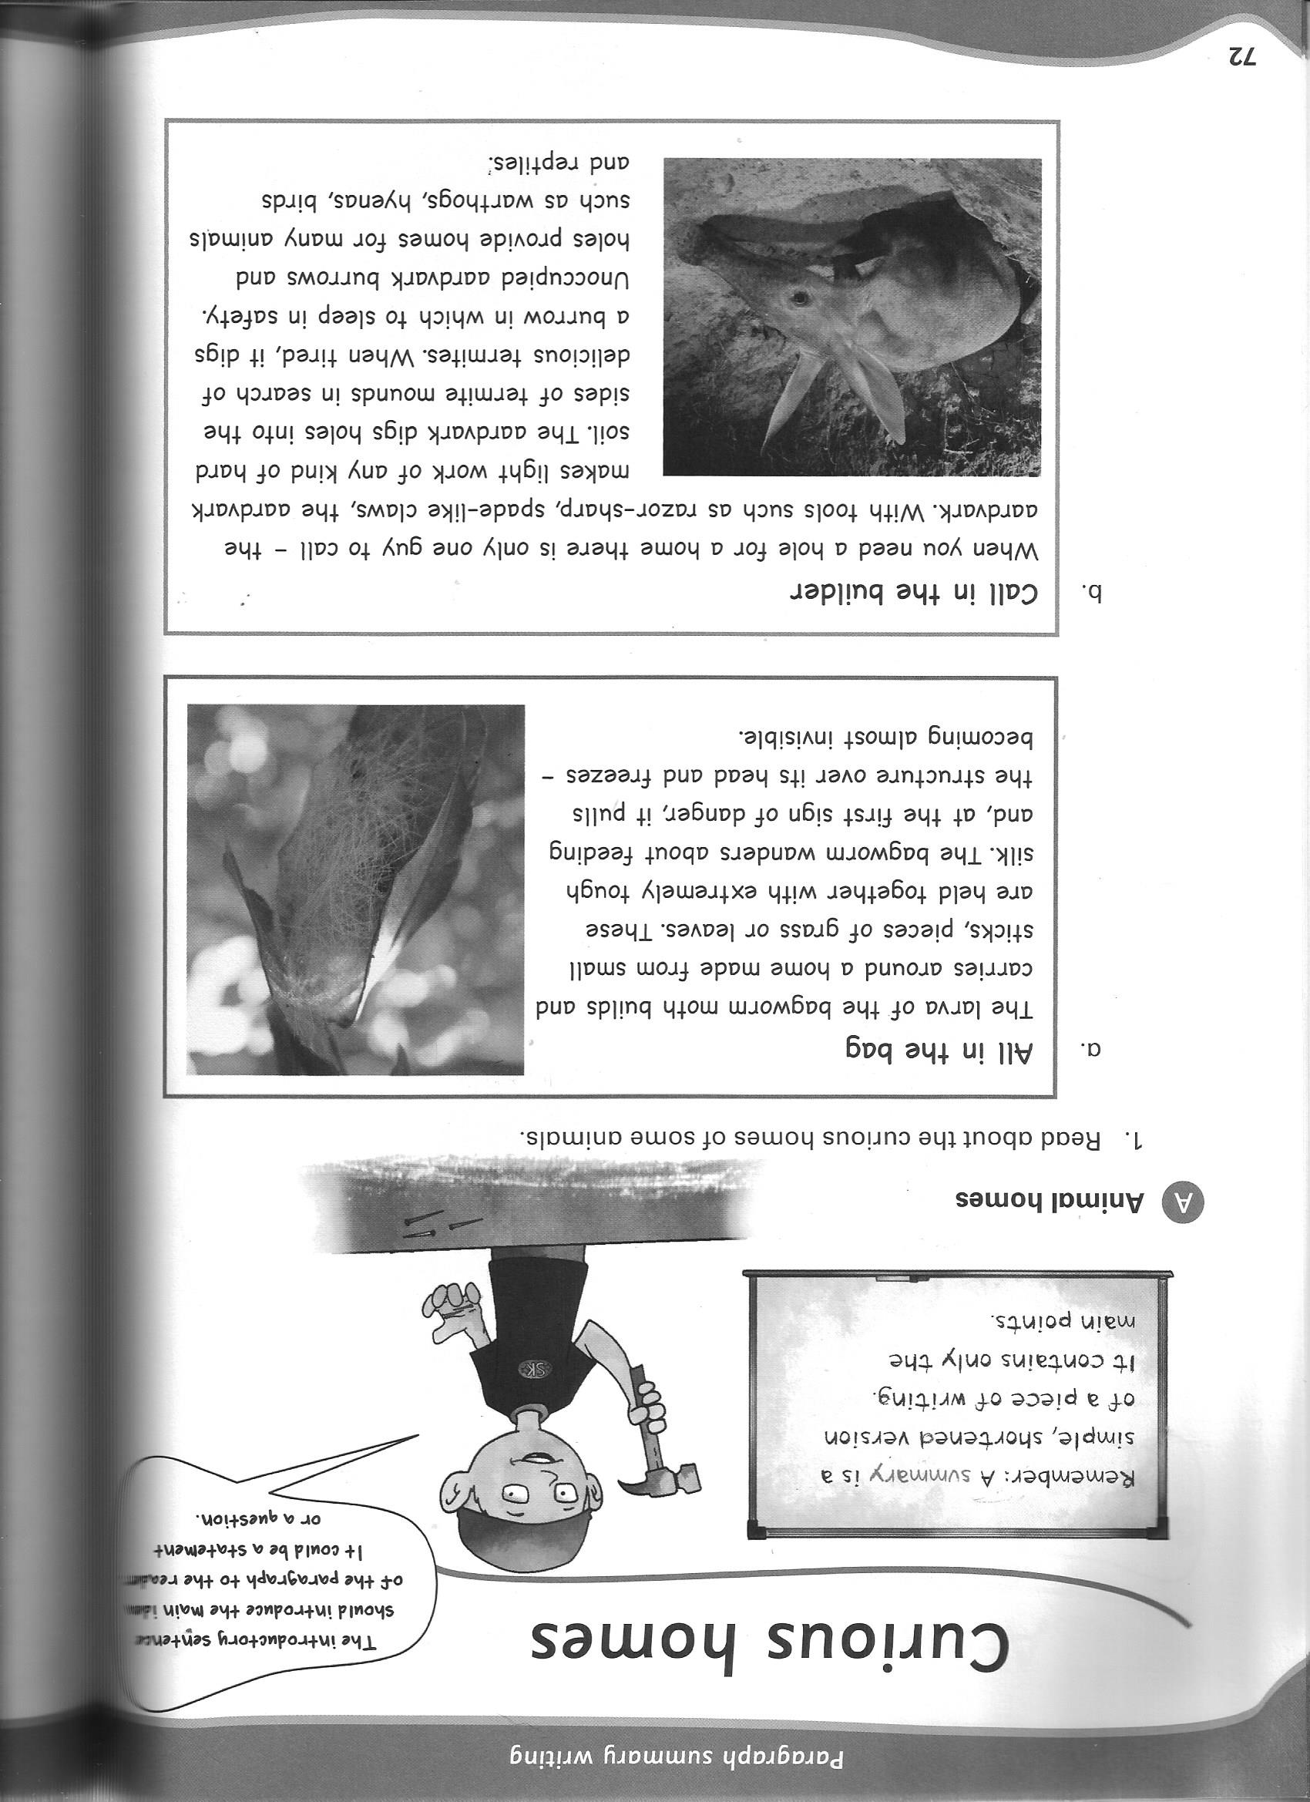

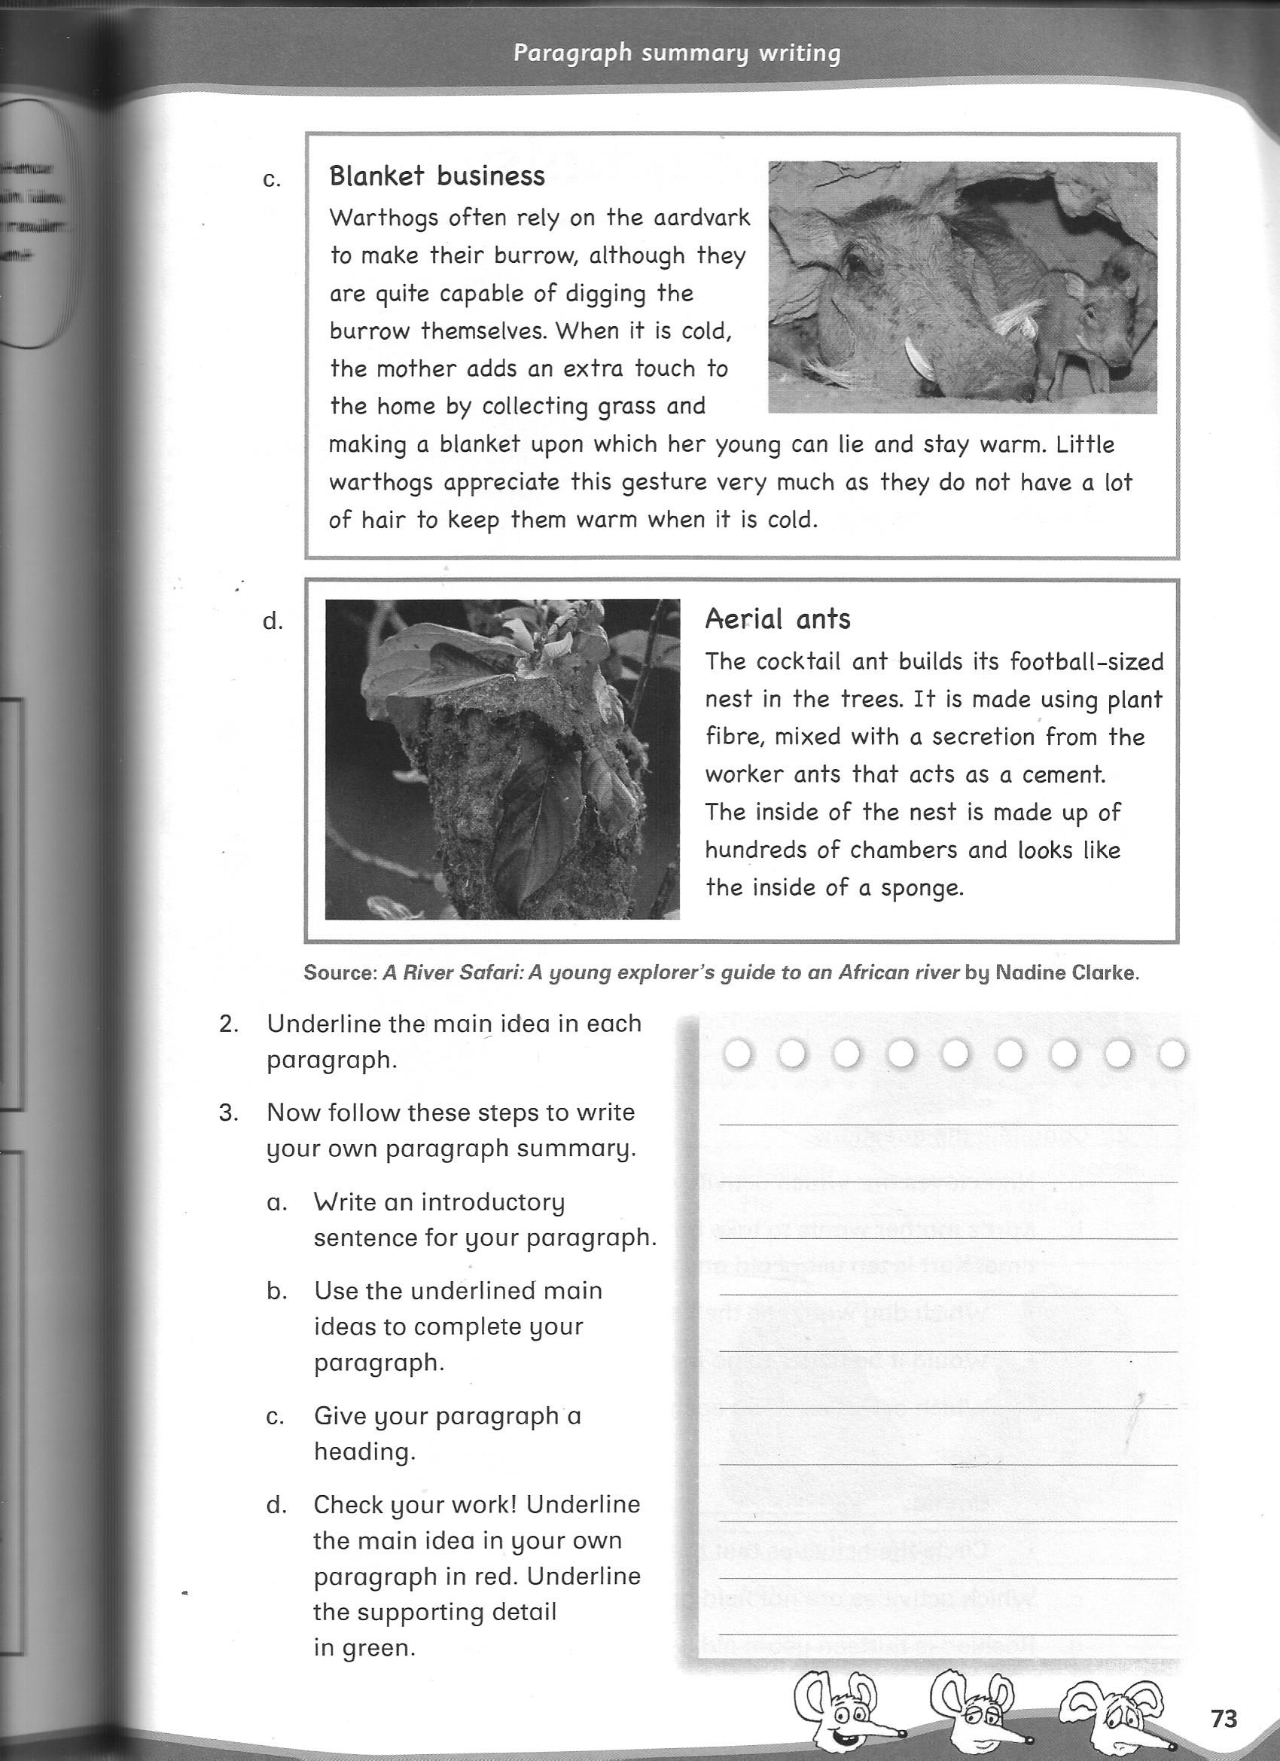

1. What is the bagworm’s home made of? (3)

Small sticks, pieces of grass or leaves

1. What does the bagworm do when he sees danger? (2)

It pulls its structure over its head and freezes.

1. Who do you call when you need a hole for a home? (1)

Aardvark

1. What does the claws of an aardvark look like? (2)

Razor sharp, spade- like claws.

1. What does the aardvark eat? (1)

Delicious termites.

1. How does it get hold of the food? (1)

Digs holes into the side of termite mounds.

1. Who else uses the aardvark’s home? (4)

Warthogs, hyenas, birds and reptiles.

1. How do the warthogs make their home warm when it is cold? (2)

They collect grass and make a blanket which their young can lie and stay warm.

1. How big is the aerial ant’s nest? (1)

Football – sized nest.

1. Where do they build their nests? (1)

They build their nest in the trees.

1. What does the inside of the nest look like? (2)

It’s has hundreds of chambers and looks like the inside of a sponge.

**Total: 20**

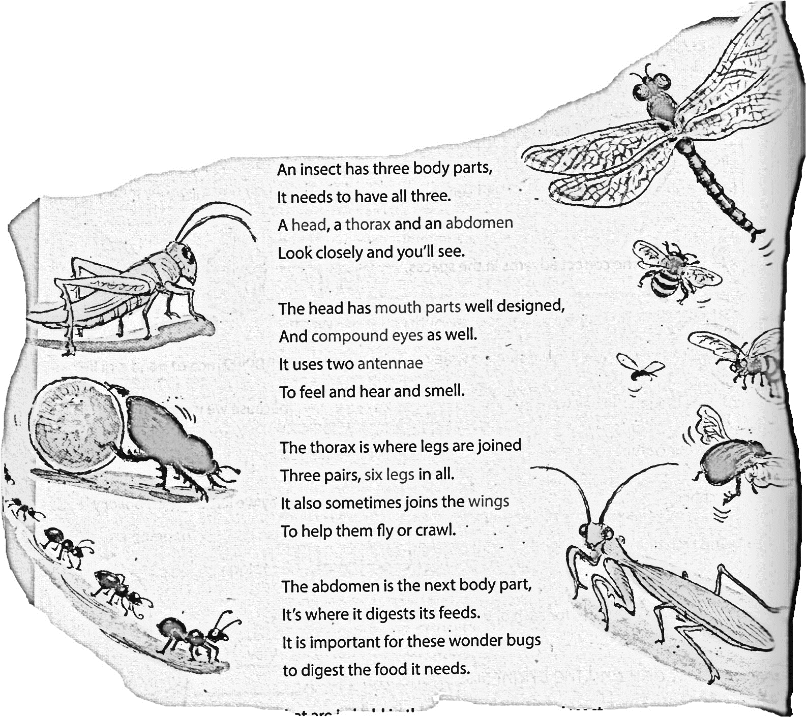**Question 2: Read the poem and answer the questions.**

**Insects**





1. How many body parts does an insect have? (1)

Three

1. Name the body parts. (3)

Head, thorax and abdomen.

1. List two things that is on an insect’s head? (2)

Mouth parts, compound eyes and two antennae. (any two)

1. How many legs does an insect have? (1)

Six legs.

1. What word in the poem RHYMES with THREE? (1)

See

1. What word in the poem RHYMES with WELL? (1)

Smell

1. What word in the poem RHYMES with FEEDS (1)

Needs **Total: 10 Total Marks: 30**

**Section B:**

**Question 1: Give the OPPOSITES of the following words.**

**Remember spelling counts! (5 x $1/2$ = 2,5)**

1. small: Big
2. empty: Full
3. cry: Laugh
4. sharp: Blunt
5. old (man): Young

**Question 2: Fill in the table**

**Remember spelling Counts! (5 x $1/2$ = 2,5)**

|  |  |
| --- | --- |
| **Animal** | **Where the animal lives.** |
| bird | 1. nest |
| 1. bee | hive |
| 1. horse | stable |
| pig | 1. sty |
| frog | 1. pond |

**Question 3 Rewrite the sentence and fill in the correct CAPITAL LETTERS, FULL STOP,**

**EXCLAMTION MARK AND QUESTION MARK. (10x $1/2$ = 5)**

1. frank and bill went to loftus versveld on saturday to watch rugby (6)

Frank and Bill went to Loftus Versveld on Saturday to watch rugby.

1. eben etzebeth was the man of the match at saturday’s game (4)

Eben Etzebeth was the man of the match at Saturday’s game.

**Question 4 Read the sentence and fill in the correct ARTICLE- AN, A or THE. (4 x $1/2$ = 2)**

1. There was a lot of frost that winter.
2. A snake handler came to take the/ a snake away.
3. She phoned an emergency service.
4. That is a helpful book about animals.

**Question 5: Read the sentence and shorten the words in brackets by using an**

**APHOSTROPHE. (3)**

1. He (does not) doesn’t like to read.
2. (They are) They’re good in maths.
3. (We have) We’ve been waiting for you.

**Question 6: Change into the PRESENT INDEFINITE TENSE. (5)**

1. Rico and and Marnus (to play) soccer during each break.

Rico and and Marnus play soccer during each break.

1. The boy (to walk) home every day after school.

The boy walks home every day after school.

1. She always (to sing) in the car.

She always sings in the car.

1. The dogs (to bark) at the postman.

The dogs bark at the postman.

1. The two girls (to do) their homework.

The two girls do their homework.

Total marks: 20