Grade 5

Mathematics test - TERM 1

Name and surname: ______________________

Date: ___________ Total: ___/50

QUESTION 1

Complete the mental maths:

1. 72 x 0 = ______
2. 56 ÷ 1 = ______
3. ____ ÷ 30 = 4
4. 12 x 10 = _____
5. 25 ÷ ____ = 1
6. 6 x 0 x 3 = _____
7. (12 x 10) + (5 x 10) = ______
8. 172 = 100 + ___ + 2
9. What is the place value of the underlined number?
10. 4**5**67 = _____________
11. 45**6**7 = _____________
12. Divide 1000 in half = _______
13. Double 250 = ________ (12)

_____________________________________________________

QUESTION 2

Round off the numbers to the nearest 100.

1. 6781 = _____________
2. 3067 = ____________ (2)

_____________________________________________________

QUESTION 3

Complete the number patterns.

1. 525, 500, _____, _____, _____, _____.
2. _____, _____, 950, 1000.
3. _____, 66, 69, _____. (8÷2=4)

_____________________________________________________

QUESTION 4

Complete the diagram.



___

___

___

36

45

40

60

110

___

___

+22

÷10

(5)

QUESTION 5

Fill in >, < or =

1. 1 011 ____ 11 011
2. 2days ____ 24hour
3. 6745 _____ 6000 + 700 + 40 + 5
4. 345 + 632 _____ 632 + 345
5. 4 minutes _____ 80 seconds (5)

_________________________________________________________

QUESTION 6

6.1. Write the following times in 24 hour digital time:

1. 20 past 4, pm __________
2. 5 to 9, am __________
3. Quarter to 11, pm __________

6.2. Write the time of the clock in 24 hour digital time, pm.

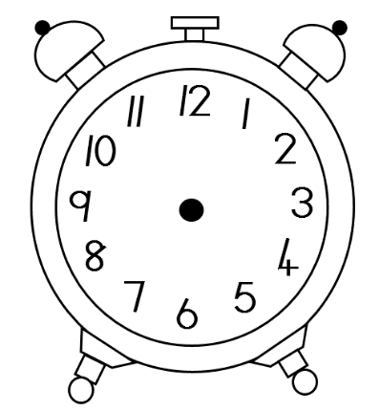 a. b.

_____________ _____________

6.3 Write the times in minutes and seconds:

a. 65 seconds = _________________________

b. 320 seconds = ________________________

(9)

_________________________________________________________

QUESTION 7

7.1. Wat is the difference between 4 687 – 2 143? Use a method of your

choice.

(3)

7.2. Calculate 53 x 5? Use a method of your choice.

(3)

7.3 Calculate 375 ÷ 5. Use a method of your choice.

(3)

7.3. Calculate 5 783 + 129. Use a method of your choice.

(3)

(12÷2=6)

QUESTION 9

Name the shape, colour which type of sides it has, draw the lines of symmetry and write how many lines of symmetry is has.

Name:

Colour:

|  |
| --- |
| Straight sides |
| Curved sides |

Number of symmetry lines:

(4÷2=2)

QUESTION 10

The teacher asked her class which fruit is their favourite and she made a pictograph to show the results. Look at the pictograph and answer the questions.

|  |  |
| --- | --- |
| Favourite fruit | |
| See the source image | See the source imageSee the source imageSee the source image |
|  | See the source imageSee the source imageSee the source imageSee the source imageSee the source imageSee the source image |
| See the source image | See the source imageSee the source image |
|  | See the source imageSee the source imageSee the source imageSee the source imageSee the source image |

1. What fruit was the learner’s favourite fruit? ________________(1)
2. What fruit was their least favourite fruit? __________________(1)
3. How many more bananas did the learner’s prefer to strawberries? Show your calculation.

____________________ (2)

1. How many learners is in the class? ________________(1)

(5)

Total: ___/50