Grade 5

Mathematics test - TERM 1

Name and surname: ______________________

Date: ___________ Total: ___/50

QUESTION 1

Complete the mental maths:

1. 72 x 0 = **0**
2. 56 ÷ 1 = **56**
3. 120 ÷ 30 = 4
4. 12 x 10 = **120**
5. 25 ÷ **25** = 1
6. 6 x 0 x 3 = **0**
7. (12 x 10) + (5 x 10) = **170**
8. 172 = 100 + 70 + 2
9. What is the place value of the underlined number?
10. 4**5**67 = **Hundred**
11. 45**6**7 = **Tens**
12. Divide 1000 in half = **500**
13. Double 250 = **500** (12)

_____________________________________________________

QUESTION 2

Round off the numbers to the nearest 100.

1. 6781 = **6800**
2. 3067 = **3100** (2)

_____________________________________________________

QUESTION 3

Complete the number patterns.

1. 525, 500, **475, 450, 425.**
2. **850, 900**, 950, 1000.
3. **63**, 66, 69, **72**. (8÷2=4)

_____________________________________________________

QUESTION 4

Complete the diagram.



**26**

**28**

**33**

36

45

40

60

110

**140**

**230**

+22

÷10

(5)

QUESTION 5

Fill in >, < or =

1. 1 011 **<** 11 011
2. 2days **>** 24hour
3. 6745 **=** 6000 + 700 + 40 + 5
4. 345 + 632 **=** 632 + 345
5. 4 minutes **>** 80 seconds (5)

_________________________________________________________

QUESTION 6

6.1. Write the following times in 24 hour digital time:

1. 20 past 4, pm = **16:20**
2. 5 to 9, am = **08:55**
3. Quarter to 11, pm = **22:45**

6.2. Write the time of the clock in 24 hour digital time, pm.

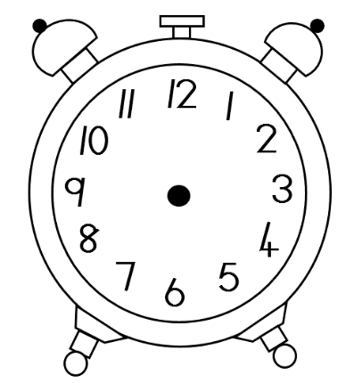 a. b.

**12:50 22:15**

6.3 Write the times in minutes and seconds:

a. 65 seconds = 1 minute√, 5 seconds√

b. 320 seconds = 5 minute√, 20 seconds√

(9)

_________________________________________________________

QUESTION 7

7.1. Wat is the difference between 4 687 – 2 143? Use a method of your

choice.

4 687 – 2 143

= (4000 – 2000) + (600 – 100) + (80 – 40) + (7 – 3) OR

= 2000 + 500 + 40 + 4

= 2544

2 point method, 1 point answer

(3)

4 6 8 7

- 2 1 4 3

4 (7-3)

4 0 (80 - 40)

5 0 0 (500 - 100)

- 2 0 0 0 (4000 - 2000)

2 5 4 4

7.2. Calculate 53 x 5? Use a method of your choice.

53 X 5

= (50 + 3) X 5

= (50x5) + (3x5) OR

= 250 + 15

= 265

2 point method, 1 point answer

(3)

5 3

x 5

1 5 (3x5)

2 5 0 (50 x 5)

2 6 5

7.3 Calculate 375 ÷ 5. Use a method of your choice.

375 ÷ 5

= (300 + 70 + 5) ÷ 5

= (300 ÷ 5) + (70 ÷ 5) + (5 ÷ 5)

= 60 + 14 + 5

= 79

(3)

7.3. Calculate 5 783 + 129. Use a method of your choice.

5 783 + 129

= 5 000 + 700 + 80 + 3 + 100 + 20 + 9

= 5 000 + 800 + 100 + 12 OR

= 5 000 + 900 + 10 + 2

= 5 912

2 point method, 1 point answer

(3)

5 7 8 3

+ 1 2 9

1 2 (9+3)

1 0 0 (80+20)

8 0 0 (700+100)

+ 5 0 0 0 (5000)

5 9 1 2

(12÷2=6)

QUESTION 9

Name the shape, colour which type of sides it has, draw the lines of symmetry and write how many lines of symmetry is has.

Name:

hexagon

Colour :

|  |
| --- |
| Straight sides |
| Curved sides |

Number of symmetry lines:

6

(4÷2=2)

QUESTION 10

The teacher asked her class which fruit is their favourite and she made a pictograph to show the results. Look at the pictograph and answer the questions.

|  |  |
| --- | --- |
| Favourite fruit | |
| See the source image | See the source imageSee the source imageSee the source image |
|  | See the source imageSee the source imageSee the source imageSee the source imageSee the source imageSee the source image |
| See the source image | See the source imageSee the source image |
|  | See the source imageSee the source imageSee the source imageSee the source imageSee the source image |

1. What fruit was the learner’s favourite fruit? bananas√
2. What fruit was their least favourite fruit? strawberry√
3. How many more bananas did the learner’s prefer to strawberries? Show your calculation.

6 – 2√ = 4 bananas√

1. How many learners is in the class? 16√

(5)

Total: ___/50