Life and living - Structures

Plants and animals on Earth

Investigation of different leaves

Assignment:

1. Investigate different leaves by collecting the different leaves from your environment.
2. Sort the leaves you think fit together in groups. Look at the shapes of leaves and the leaf margins.
3. Make a table or poster to show your results. The leaves you collected must be used on your poster or table. The size of your poster must be A3.
4. Use the pictures of the leaf margins and leaf shapes below to help you with your investigation.

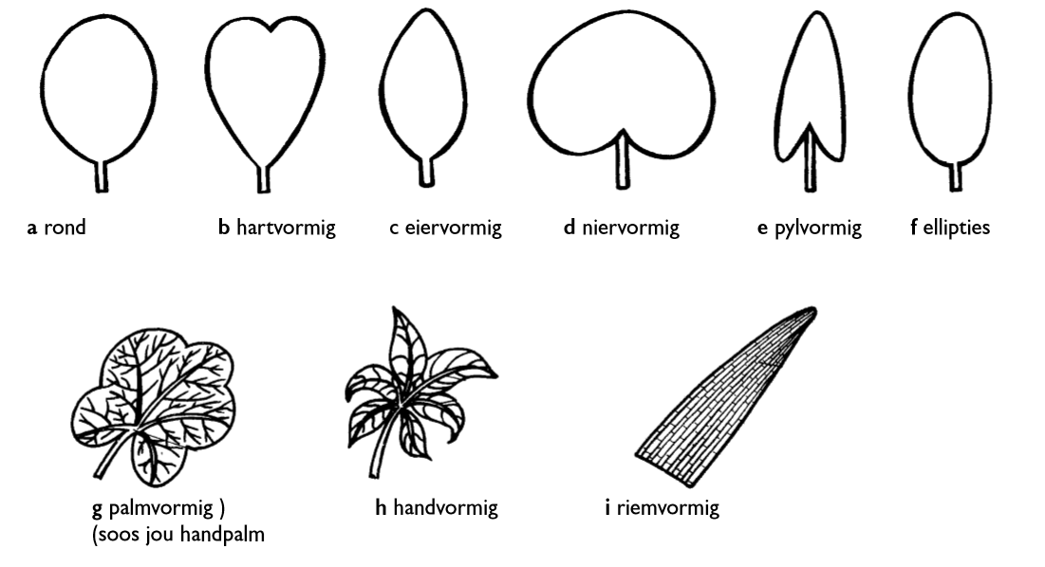Leaf shapes

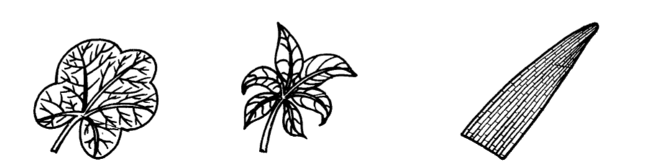 oval heart-shaped ovate cordate elliptical oblate

hand shaped parallel

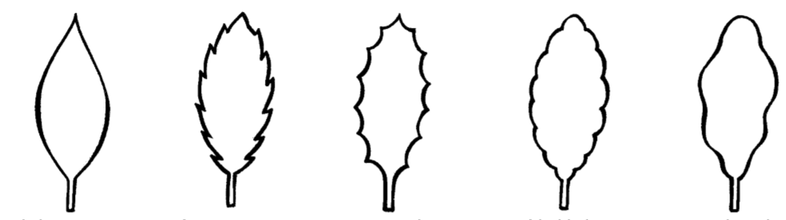Leaf margin

smooth toothed dentate lobed sinuate

You will be assessed according to the following rubric:

|  |  |  |  |  |  |
| --- | --- | --- | --- | --- | --- |
| Rubric: Investigation of different leaves | | | | | |
|  | 5 | 4 | 3 | 2 | 1 |
| 1. The learners' poster shows the different margins and leaf shapes. |  |  |  |  |  |
| 1. The leaves the learners collected from the environment was used on the poster. |  |  |  |  |  |
| 1. The learner has divided the leaves into the correct groups according leaf margin and leaf shape. |  |  |  |  |  |
| 1. The learner has collected a variety of different leaves. |  |  |  |  |  |
| **Total: __ / 20** | | | | | |

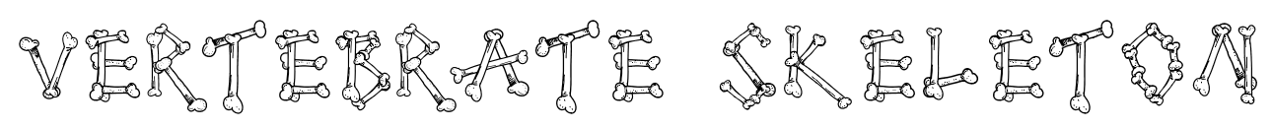

Life and living - frame and shell structures

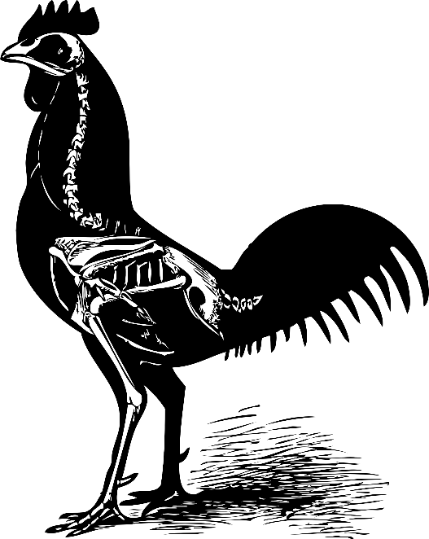Assignment:

1. Make a model of a vertebrate skeleton.
2. You must build your model in the class.
3. You can use one of the following materials to build your skeleton: Paper, drinking straws, wooden dowels or sticks (30cm X 10mm), sticky tape, metal paper fasteners
4. Your model should look realistic.
5. Remember!: Your model must be STRONG so that it is able to stand by itself for 2 minutes.
6. You have to make your model according to the steps of the technological process:

* 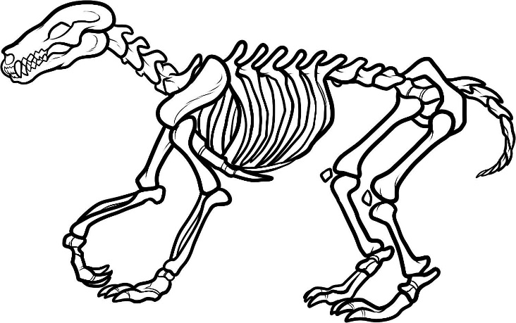**Research** - Do research on how to build your skeleton, and what type of shapes and structures you are going to use to make it stronger.
* **Design**- Make a list of materials and tools you will need. Draw 3 designs of how you want your skeleton to look.
* **Make** – Make the model of your skeleton according to the drawing of the skeleton you have chosen.
* **Evaluate** - When evaluating you must answer the following questions about your skeleton:

1. What would you improve on your skeleton?
2. What will you do differently when you have to build the project again?
3. Can your skeleton stand up by himself for two minutes without you supporting or holding it?

* **Communication** - You must tell your classmates how you built your skeleton and what worked and what did not work.

You must submit a written assignment of the technological process of the first four stages of the technological process. You can do this part at home.

You will be assessed according to the following categories:

|  |  |  |  |  |  |
| --- | --- | --- | --- | --- | --- |
| Rubric: Model vertebrate skeleton | | | | | |
|  | 5 | 4 | 3 | 2 | 1 |
| 1. The learner's model is built only from the materials they were allowed to use: Paper, drinking straws, wooden dowels or sticks (30cm X 10mm), sticky tape, metal paper fasteners |  |  |  |  |  |
| 1. The learner's model is realistic. |  |  |  |  |  |
| 1. The learner's model is 3D. |  |  |  |  |  |
| 1. The learner's model can stand for 2 minutes. |  |  |  |  |  |
| 1. The learner has submitted a written assignment of the technological process. The task includes the first four steps of the technological process. The steps are answered correctly. |  |  |  |  |  |
| 1. The learner has effectively communicated about his model as the last step of the technological process. |  |  |  |  |  |
| **Total: __ / 30** | | | | | |

Life and living - Structures

food Chain

Assignment:

1. Cut out the pictures of animals, plants and arrows on the next page and arrange them in the right order so that they form a food chain.
2. Paste them in the block on the worksheet that was provided to you.
3. Your food chain must be labeled.
4. Then describe the relationships of the various organisms in the food chain.

You will be assessed according to the following rubric:

|  |  |  |  |  |  |
| --- | --- | --- | --- | --- | --- |
| Rubric: Food Chain | | | | | |
|  | 5 | 4 | 3 | 2 | 1 |
| 1. The learner pasted the pictures of animals, plants and arrows in the correct order create a food chain. |  |  |  |  |  |
| 1. The learner's food chain has the correct labels. |  |  |  |  |  |
| 1. The student described the relationship of the various organisms in the food chain correctly. |  |  |  |  |  |
| **Total: __ / 15** | | | | | |

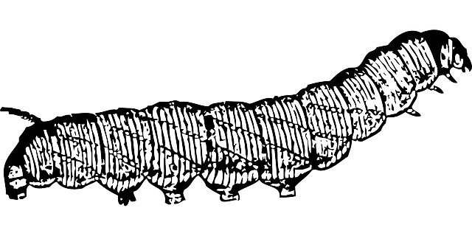

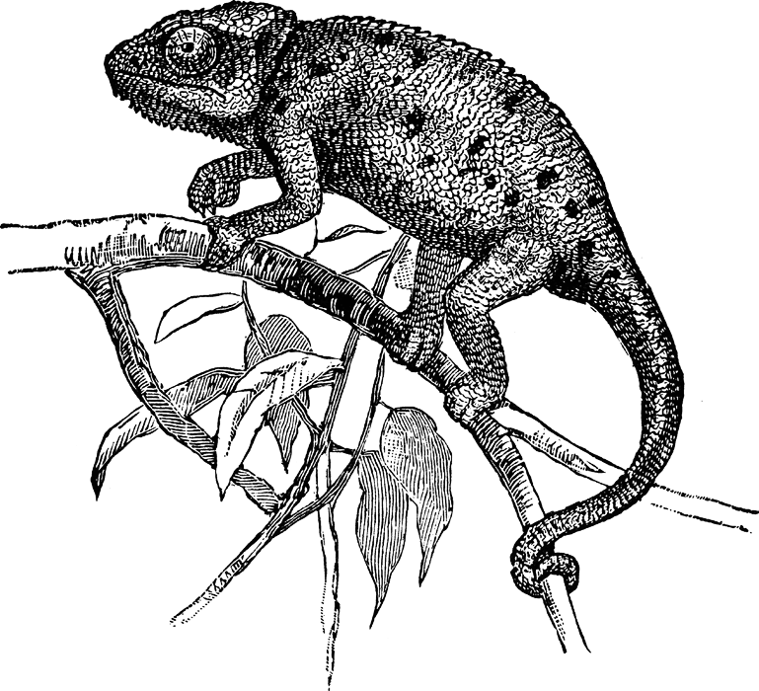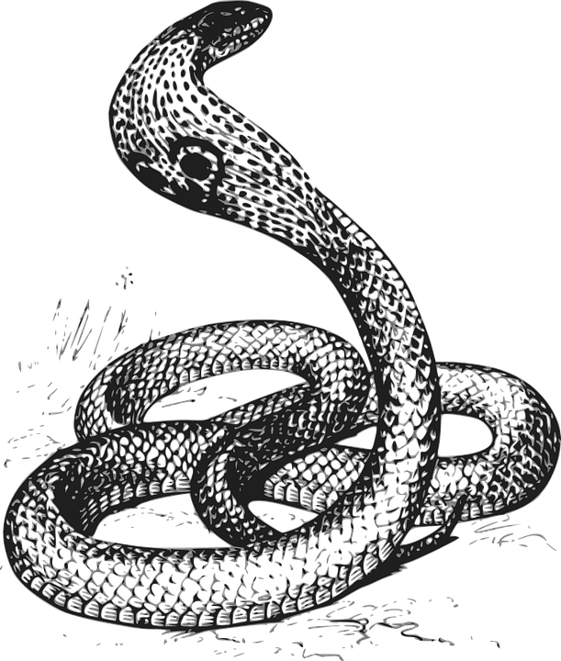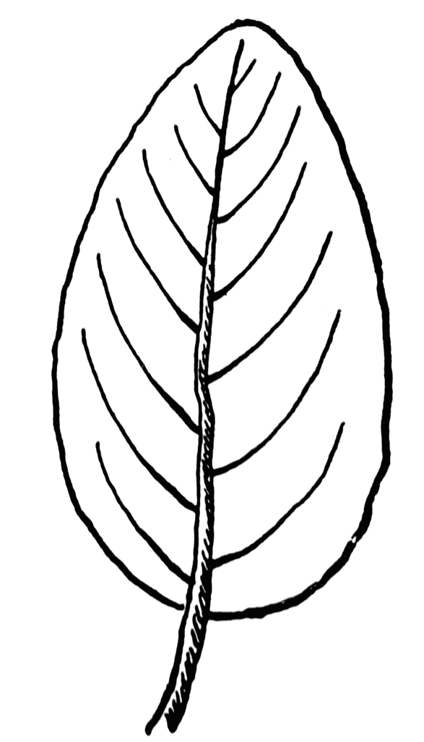

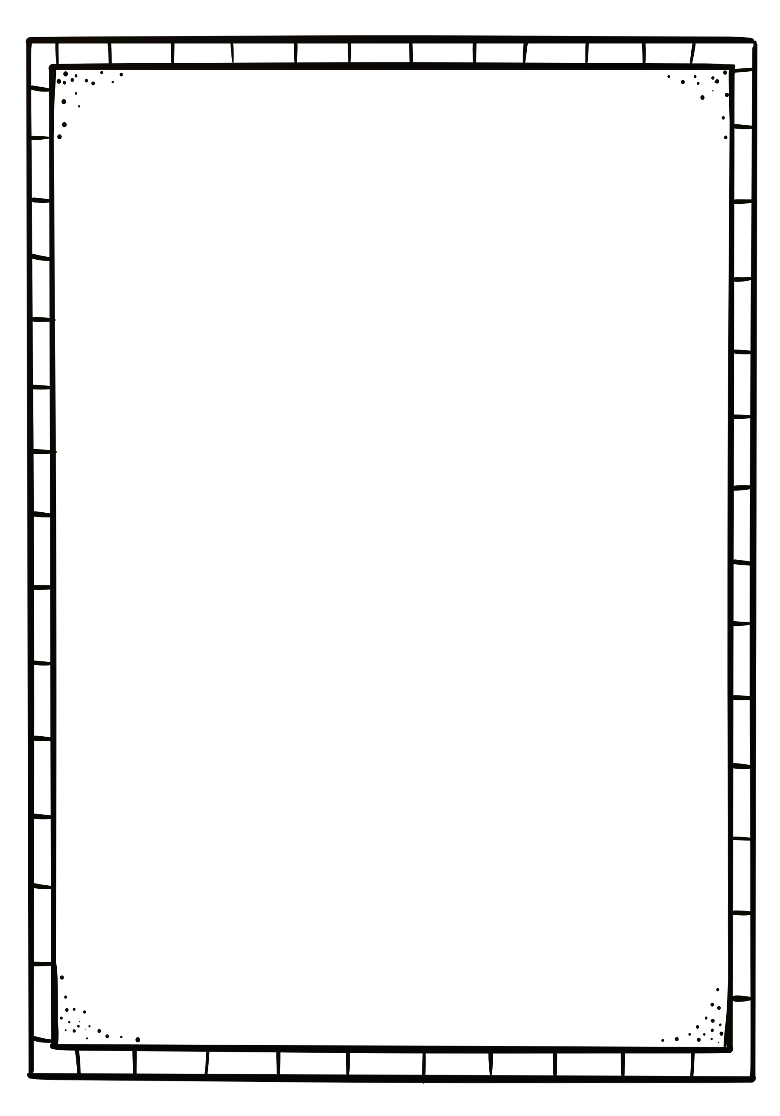

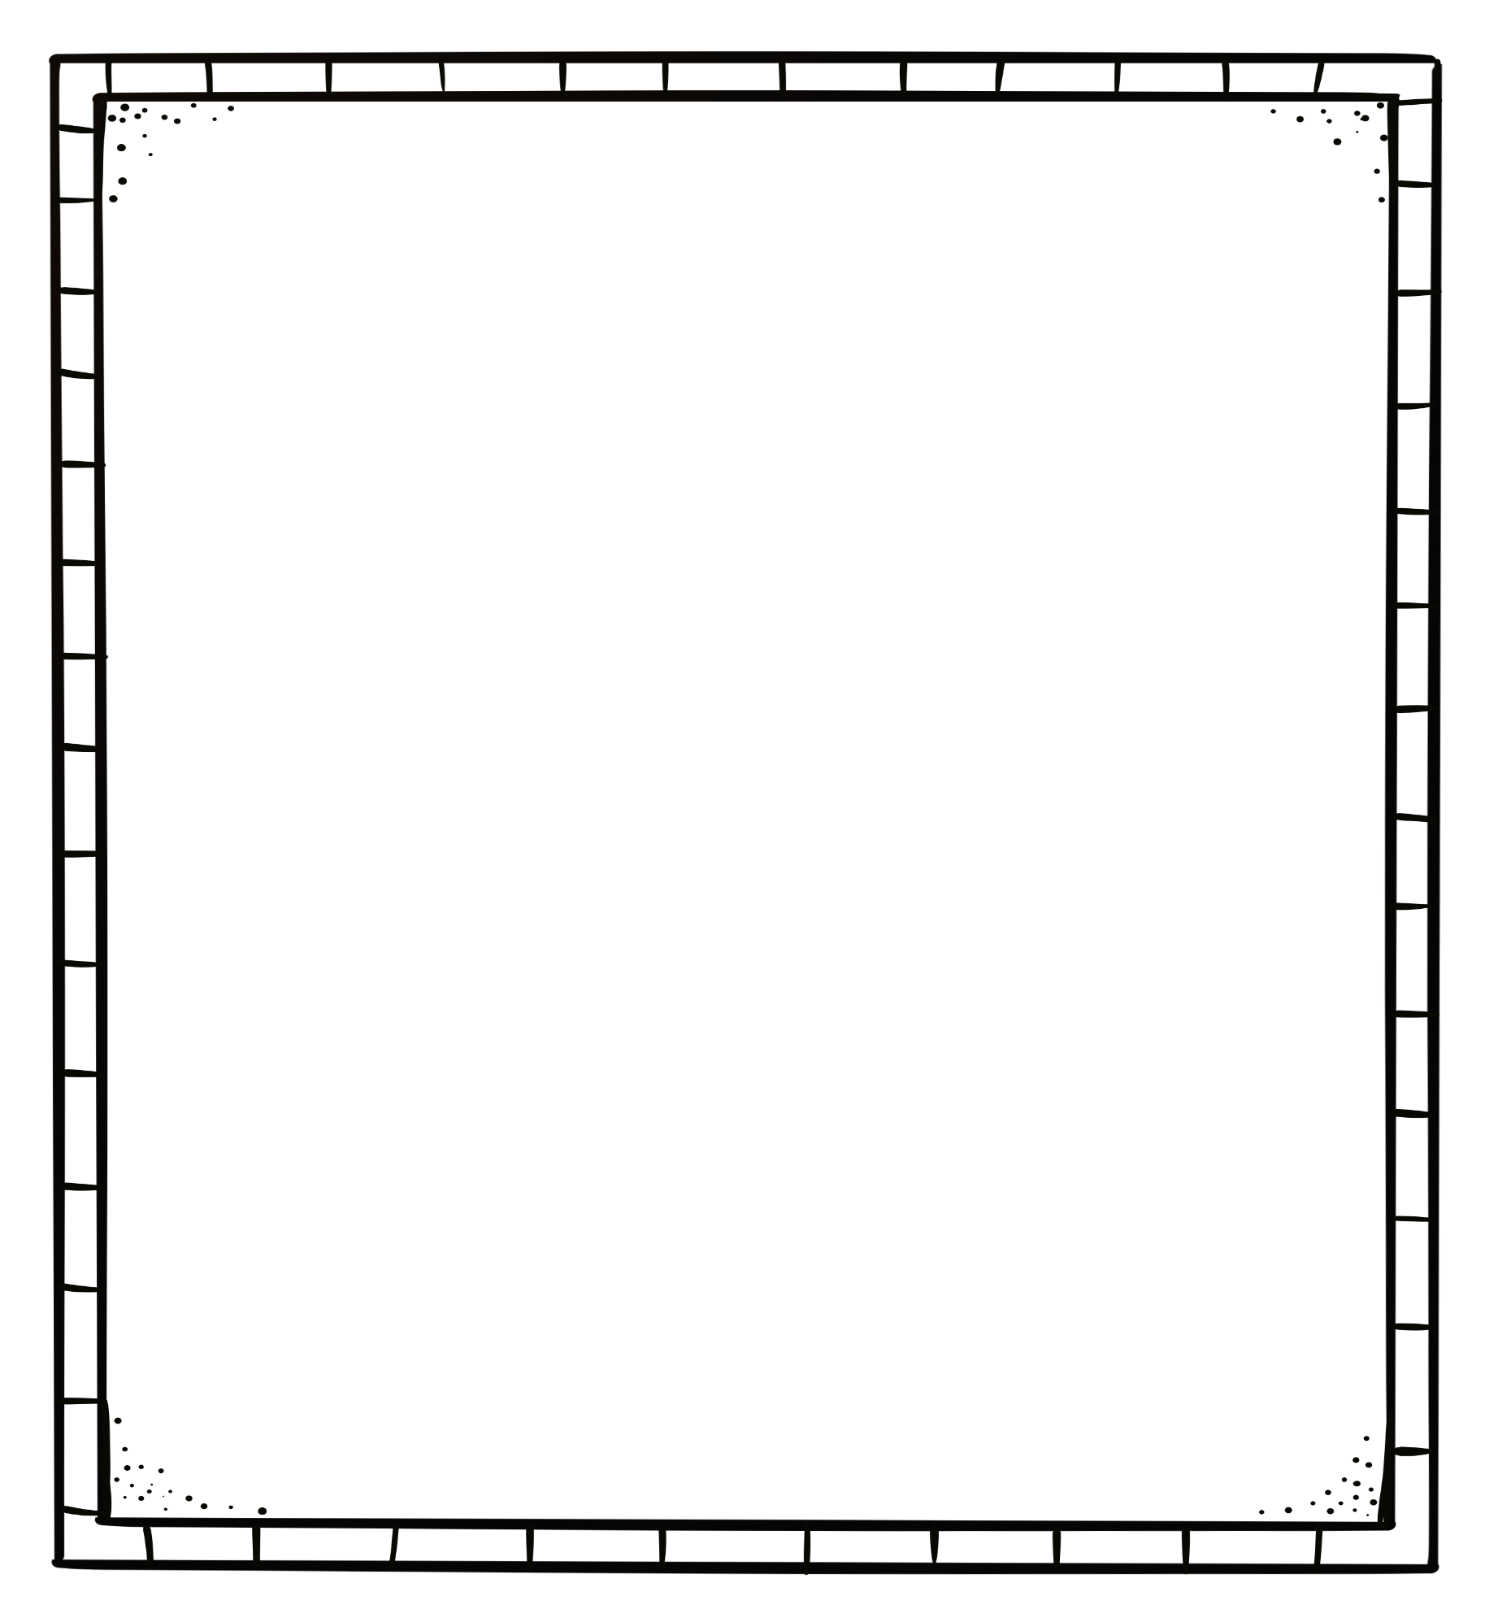

Description of food chain

__________________________________________________________________________________________________________________________________________________________________________________________________________________________________________________________________________________________________

__________________________________________________________________________________________________________________________________________________________________________________________________________________________________________________________________________________________________

__________________________________________________________________________________________________________________________________________________________________________________________________________________________________________________________________________________________________