
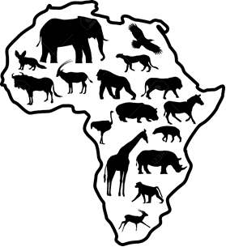

Assignment:
Choose three African wild animals and describe and write about their habitats and why they are suitable for life in these habitats.

Keep the following in mind when you write your investigation:
- There should be three wild African animals with their habitats.
- You must have pictures in your investigation.
- Your research should not be longer than 3 pages.

You will be assessed according to the following categories:
Rubric – Habitats of African animals
 |  | Mark
- The learner's investigation includes three African animals with their habitats. | 5
- The student's description of the animals' habitats are written extensively and there is evidence that the student did research. | 10
- The learner's investigation contains pictures. | 3
- The learner's investigation is neat. | 2
 | Total: __ / 20
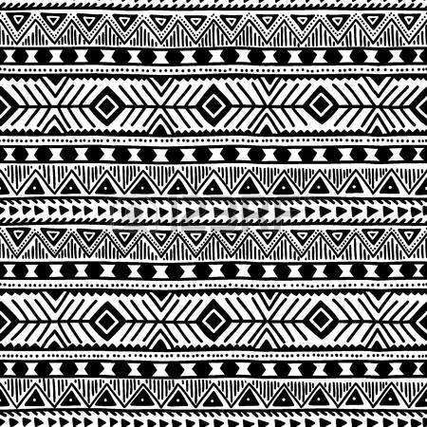

QUESTION 1

Look at the pictures in the block and then sort them in the table according to living and non-living
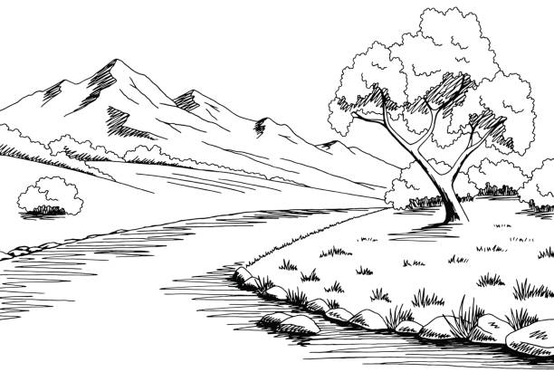
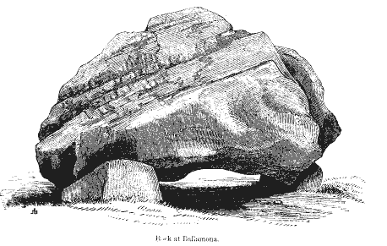
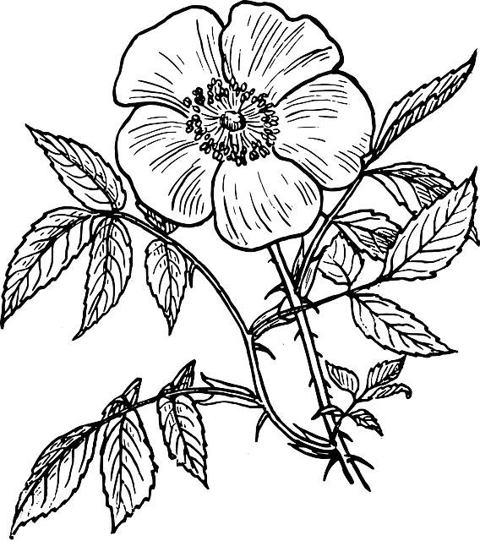

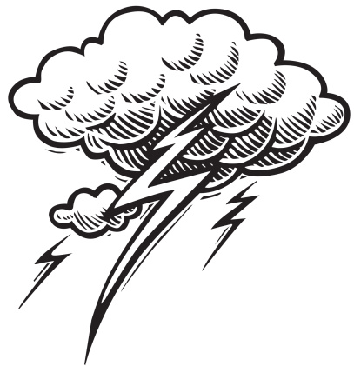
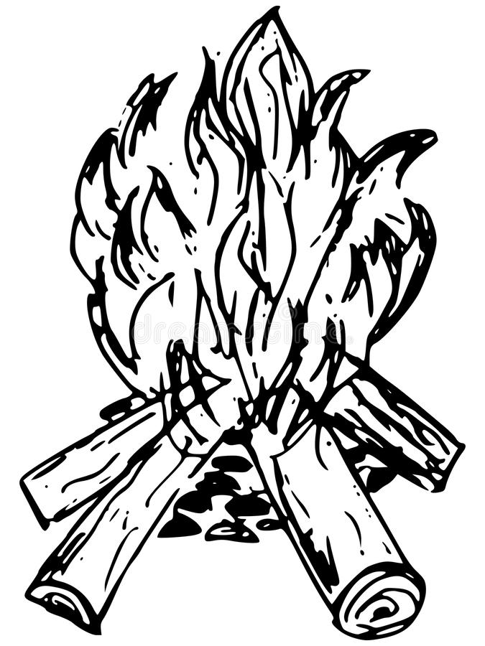
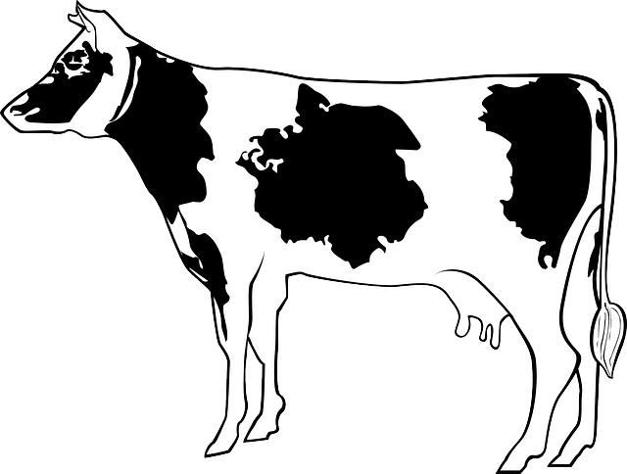
river
flower
television
Living | Non-living
Total question 1: ____/7
rock
fire
cow
thunder
QUESTION 2
river
flower
TV
fire
Write down 4 of the seven life processes and give a description of each.
Life process 1
__________________
______________________________________________________________________________________________________________________________________________________________________________

Life process 2
__________________
______________________________________________________________________________________________________________________________________________________________________________

Life process 3
__________________
______________________________________________________________________________________________________________________________________________________________________________

Life process 4
__________________
______________________________________________________________________________________________________________________________________________________________________________

Total Question 2: ____ / 8
Total Question 1 + Question 2: ___ / 15
QUESTION 1

Look at the pictures in the block and then sort them in the table according to living and non-living
river
flower
television
Living | Non-living
Cow  Flower | Thunder  Rock  Fire  Television  River
Total question 1: ____/7
rock
fire
cow
thunder
flower
fire
QUESTION 2
Write down 4 of the seven life processes and give a description of each

Learners can write any of the following 7 life processes with their descriptions.

Motion
All living things can move, for example, humans and animals use their bodies to move. Plants also grow towards the light of the sun.
Respire
Humans and animals breathe by using the oxygen in the air. The oxygen converts to carbon dioxide as it is exhaled.
Reproduce
Living things multiplied by reproduction. Humans and animals have babies. Some plants have seeds and other multiply by shoots or cuttings.
Food
Living things need food to live. Food is converted into energy.
Excrete
All living things excrete, this is how people and rid animals bodies from the waste products in our body.
Grow
All living things grow, such as a seedling which grows into a plant or babies of people and animals become adults.
Sensitive
All living things respond to external things that they experience, for example in the winter some animals hibernate or we will put on a jersey when we get cold.

Total Question 2: ____ / 8
Total Question 1 + Question 2: ___ / 15
Name and surname: ____________________ Date: _________

Look at the pictures below of the different animals and then sort them in the table.
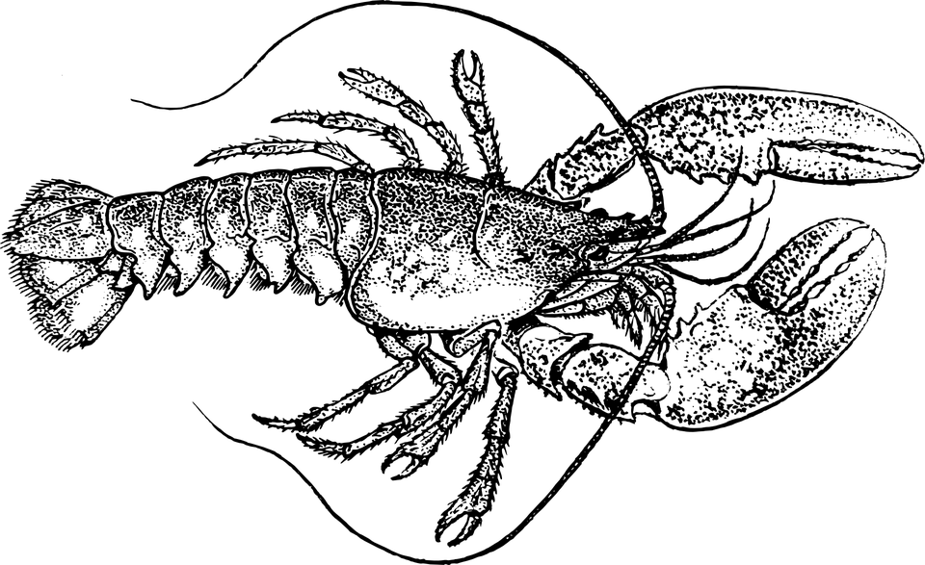
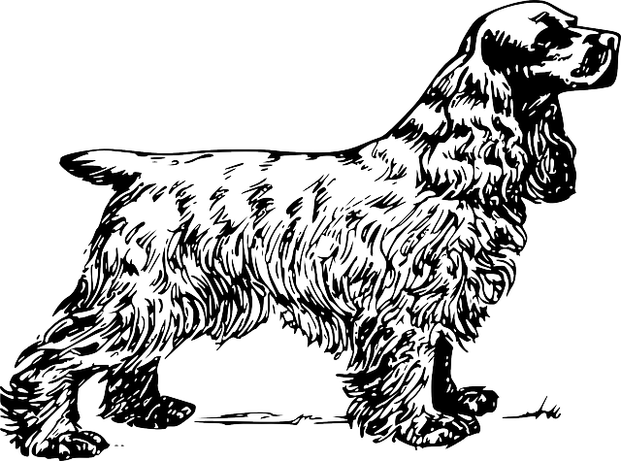

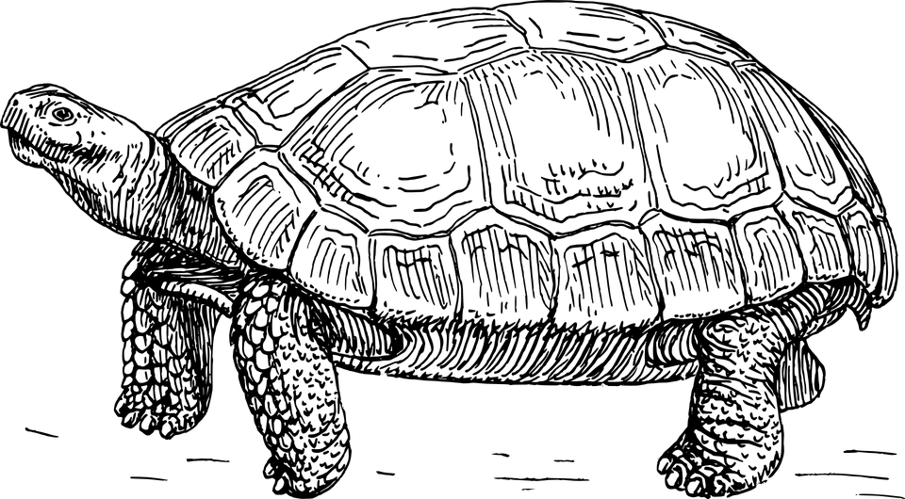
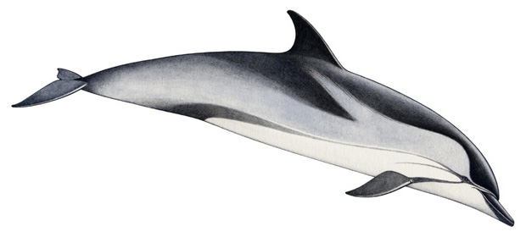

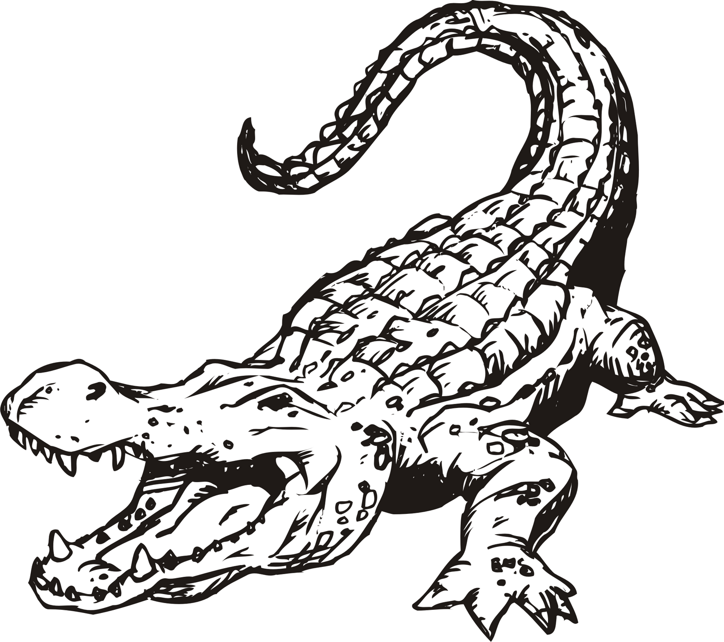
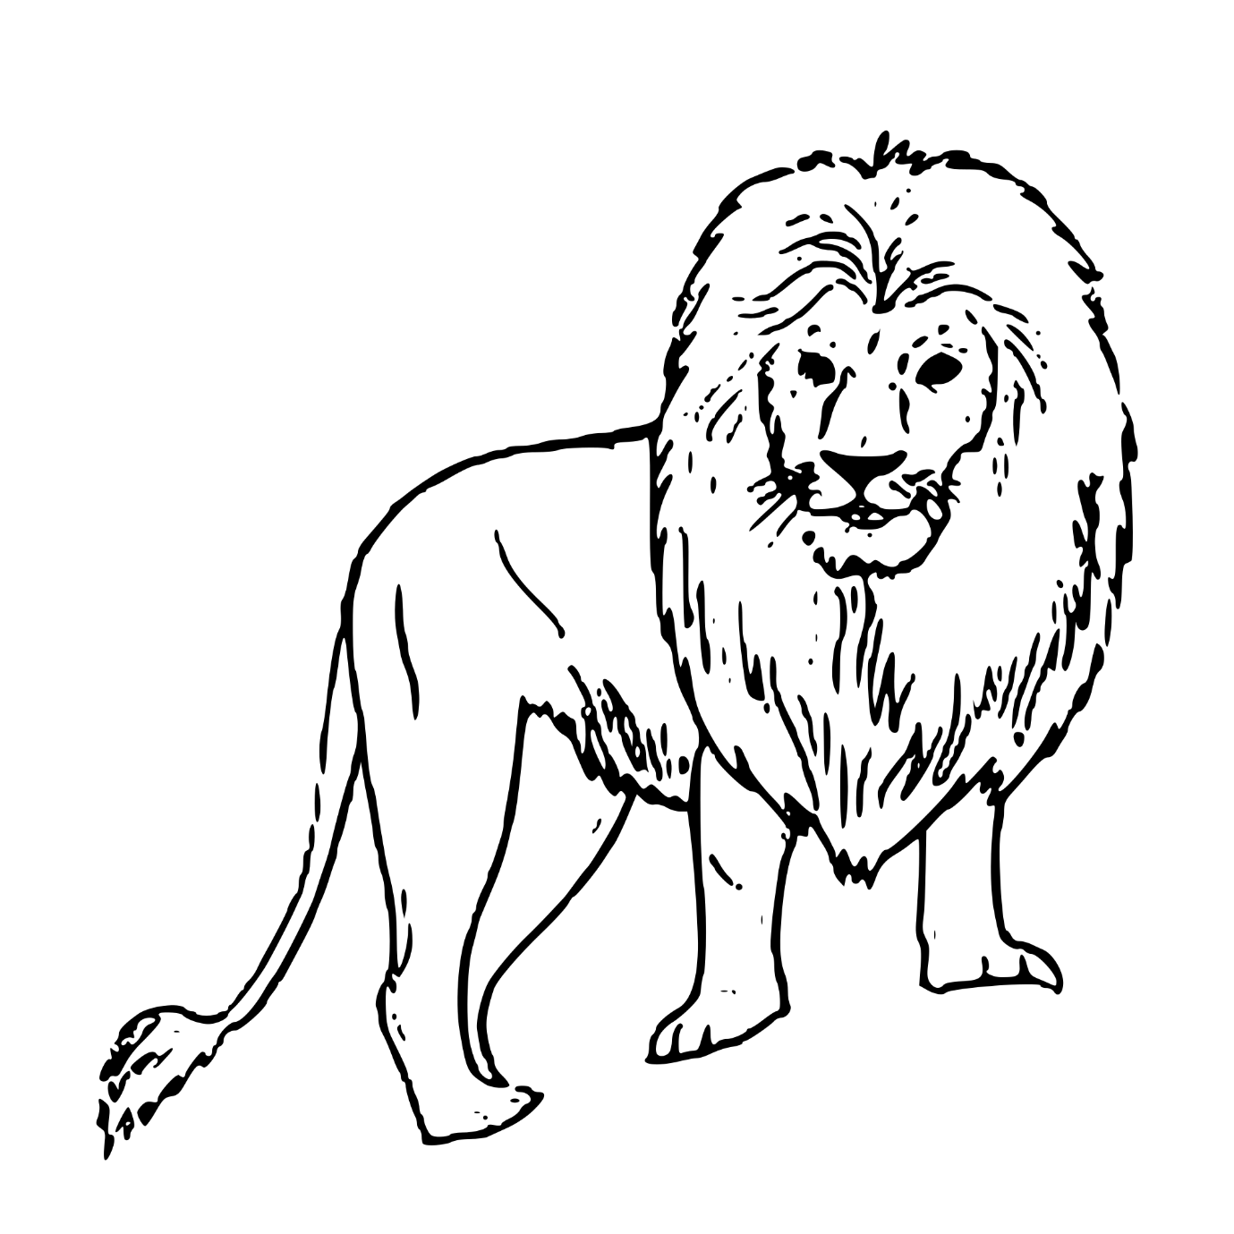

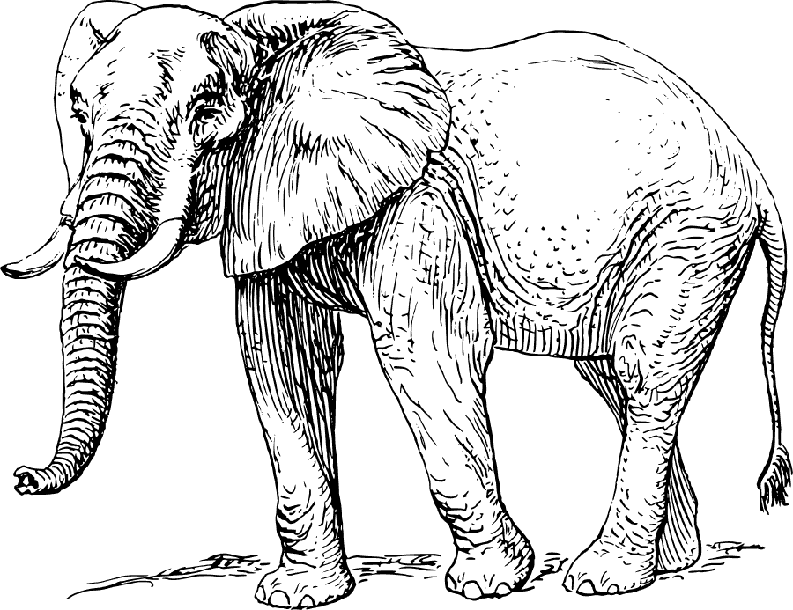

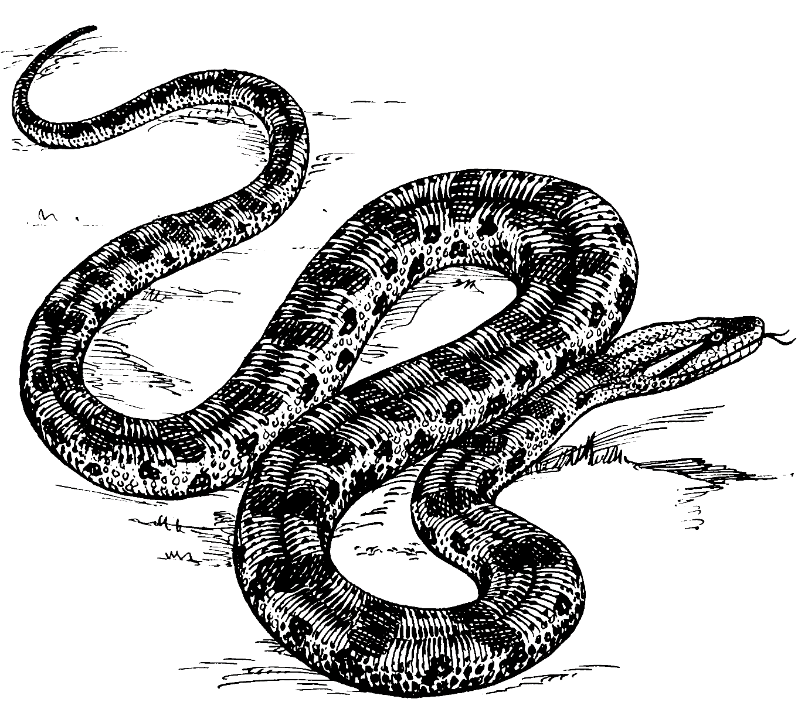
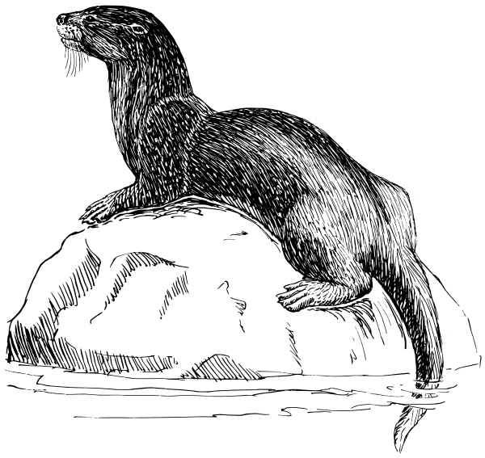
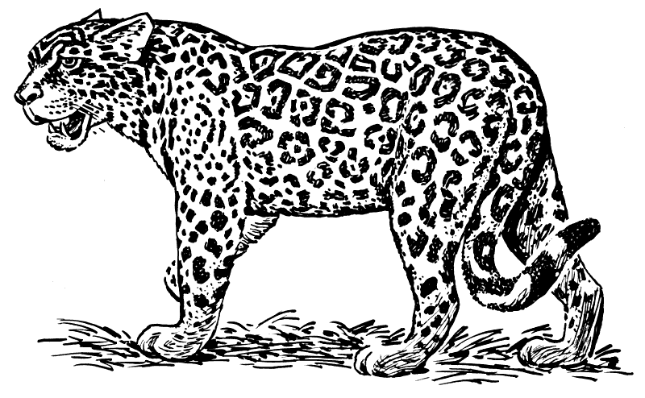

Animals that live on land | Animals that live in the sea | Animals that live in the river | herbivores
Animals with a backbone | Mammals | Carnivores | Reptiles

Memorandum
Animals that live on land | Animals that live in the sea | Animals that live in the river | herbivores
Leopard  Elephant  Lion  Tortoise  Cow  Snake  Dog | Crayfish  Dolphins | Crocodile  Snake  Otter | Cow  Elephant  Tortoise
Animals with a backbone | mammals | carnivores | reptiles
Cow  Lion  Leopard  Dog  Otter  Snake | Elephant  Dog  Cow  Dolphins  Lion  Leopard | Lion  Leopard  Snake  Crocodile  Otter | Crocodile  Snake

Growing yeast
ASSIGNMENT
Enter the following experiment by following the instructions below.
Take pictures of your experiment.
Answer the questions.

RESOURCES (What you will need)
- Packet of dry yeast
- Sugar
- Lukewarm water
- Empty glass
WARNING
Don’t use boiling water. You can burn yourself!

INSTRUCTIONS:
- Put a teaspoon of sugar and a teaspoon of dry yeast in your glass. Mix it with your spoon.
- Add 3 teaspoons of lukewarm water.
- Mix your sugar and yeast mixture with lukewarm water and make sure it is well mixed. See what happens.

Answer the following questions:

- What happened to the yeast and sugar mixture when you added lukewarm water? (2)
_______________________________________________________________________________________________________________________________________________________________
- What does yeast need to come alive? (1)
__________________________________________________________________________________________________________

- What is yeast used for? Give two examples. (2)
__________________________________________________________________________________________________________

- Paste your photos of your experiment of the growing yeast in the block. (5)

Total: __/10
Memorandum
Answer the following questions:

- What happened to the yeast and sugar mixture when you added lukewarm water?
The mixture began to foam.√ After a while it starts to rise.√

- What does yeast need to come alive?
Yeast needs heat to come alive. √ 1 point

- What is yeast used for? Give two examples.
- To help the dough of bread to rise. √ 1 point
- To make cakes rise.√ 1 point
- OR Used in making beer.√ 1 point

- Pate your photos of your experiment of growing yeast in the block.
The pictures of the learner is the proof that he had actually performed the experiment and therefore counts 5 marks.


Look at the different pictures below and decide if they are a solid, a liquid or a gas. Complete the table and give a reason why you say the object is a solid, a liquid or a gas.
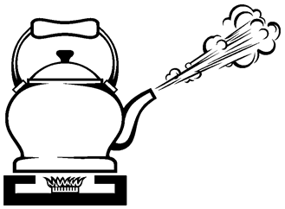
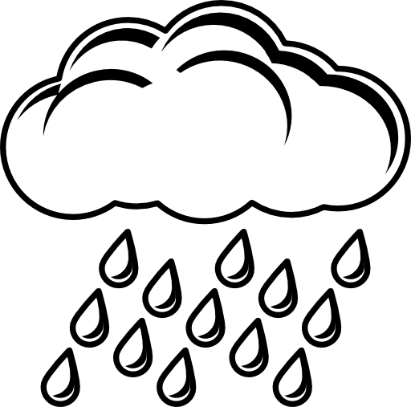

Rain

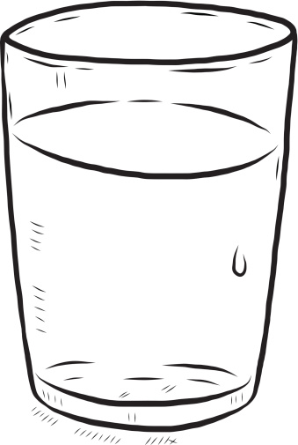

Water in glass
Steam from kettle

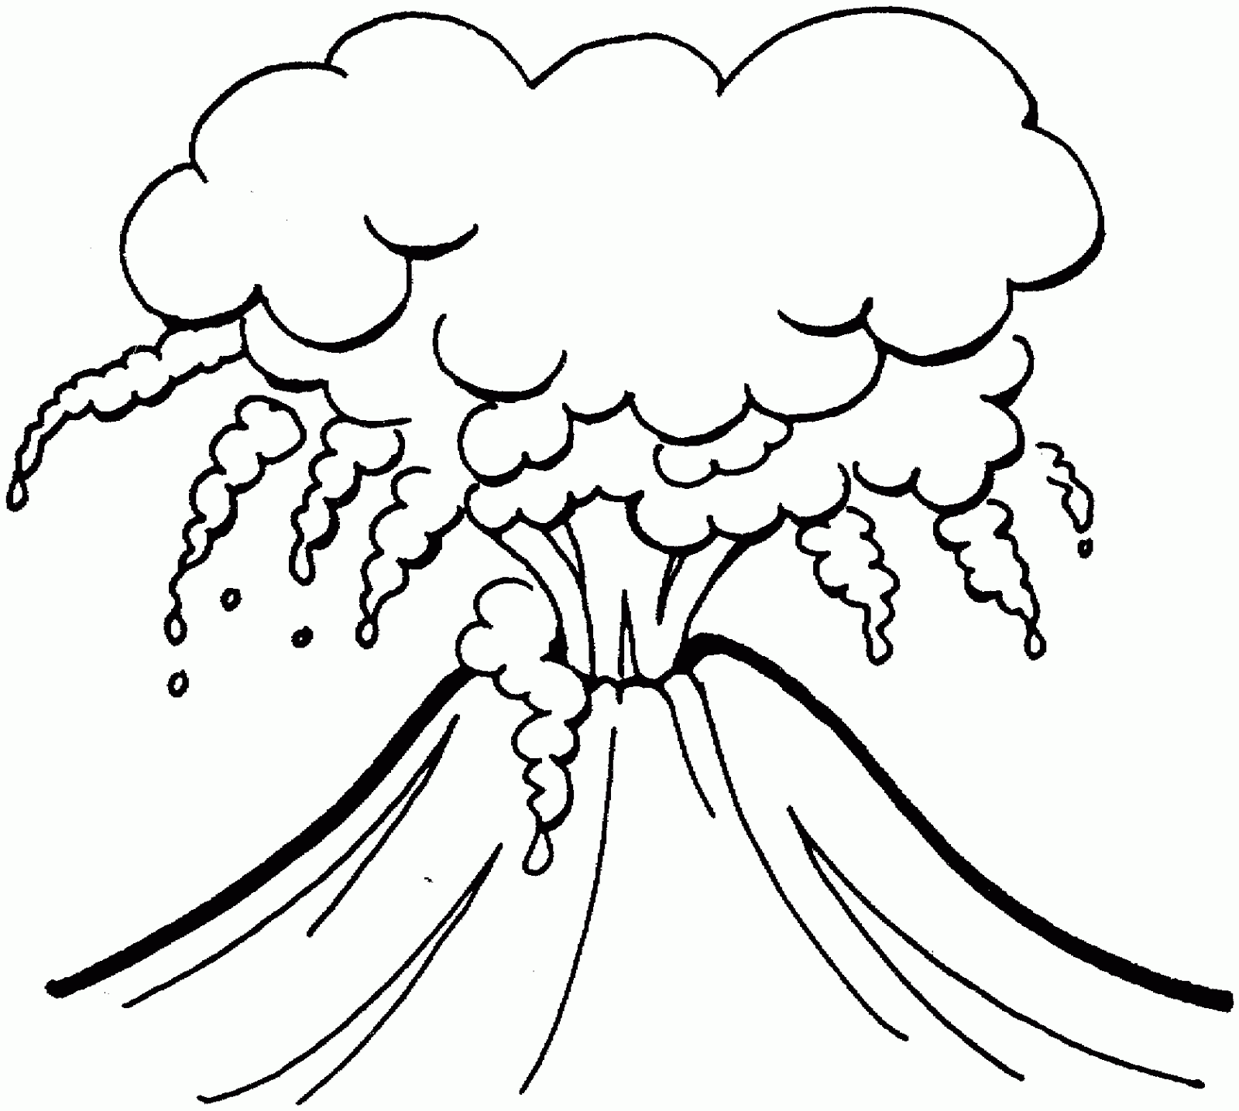
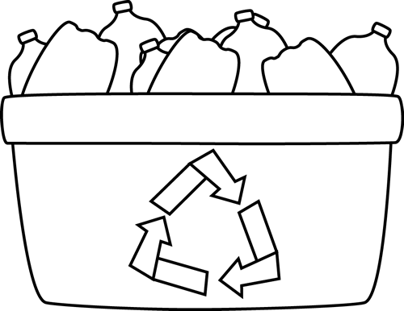

Plastic

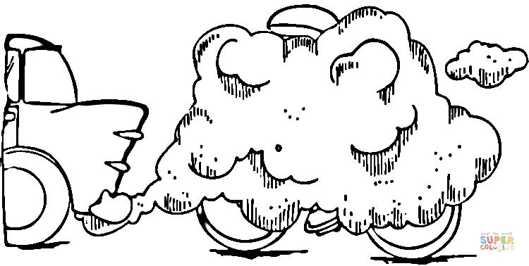

Lava from volcano
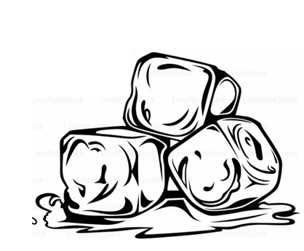
Fumes from car

Ice cubes
Rock

Object | Solid | Fluid | Gas
- Ice cube

- Water in a glass
- Steam from a kettle
- Rock
- Lava from a volcano
- Rain
- Cars fumes from exhaust
- Plastic

Object | Solid | Fluid | Gas
- Ice cube | An ice block is a solid, because it has a definite shape. It does not flow and it occupies a definite space.
- Water in a glass |  | Water is a liquid, because it flows. It does not have a definite form. It occupies a definite space.
- Steam from a kettle |  |  | Steam is a gas as it flows. It has no definite shape and occupies a definite space
- Rock | A rock is a solid, because it has a definite shape. It does not flow and it occupies a definite space.
- Lava from a volcano |  | Lava from a volcano is a liquid, because it flows. It does not have a definite form. It occupies a definite space.
- Rain |  | Rain is a liquid, because it flows. It does not have a definite form. It occupies a definite space.
- Cars fumes from exhaust |  |  | Car exhaust fumes is a gas as it flows. It has no definite shape and occupies a definite space.
- Plastic | Plastic is a solid, because it has a definite shape. It does not flow and it occupies a definite space.
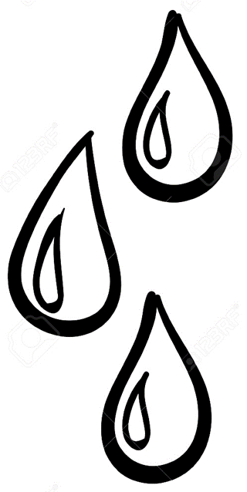
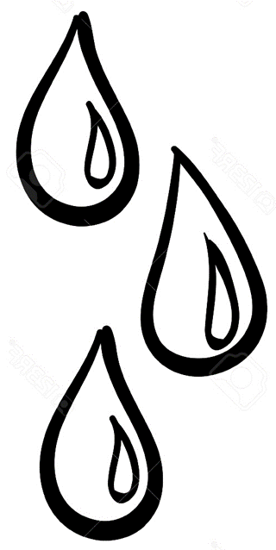

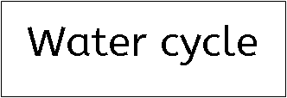
memorandum
Draw the water cycle in the block and describe the steps of the water cycle. Your drawing of the water cycle must be labeled.

_____________________________________________________________________________________________________________________________________________________________________________________________________________________________________________________________________________________________________________________________________________________________________________________________________________________________________________________________________________________________________________________________________________________________________________________________________________________________________________________________________________________________________________________________________________________________________
Rubric - Water Cycle
 | 5 | 4 | 3 | 2 | 1
- The student's drawing of the water cycle is correct and the student wrote the required labels on the drawing. | 5 | 4 | 3 | 2 | 1
- The student described the steps of the water cycle correctly. | 5 | 4 | 3 | 2 | 1
 | Total: __ / 10

Memorandum
Draw the water cycle in the block and describe the steps of the water cycle. Your drawing of the water cycle must be labeled.

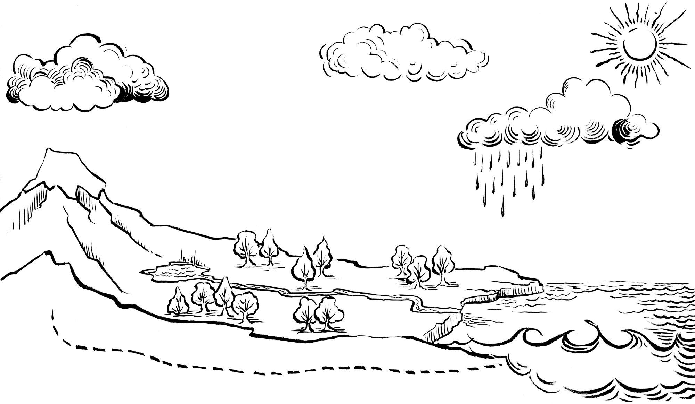
Condensation

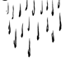
Precipitation

Evaporation

Run off

The sun's heat changes water into steam or gas. This is called evaporation. The water vapor then rises up into the atmosphere.
While the water vapor rises, it cools and it changes from a gas to a
liquid, and thus back to water droplets. This is called condensation.
These water droplets in the atmosphere, attach them to each other and form clouds. When these water droplets become to heavy to stay in the atmosphere, it falls as rain, hail or snow on earth. This is called precipitation. Some of these water droplets fall into oceans, rivers, streams, lakes and ponds, and some water droplets fall to the ground where they seep into the soil, and another run off into rivers, lakes and the ocean. These water droplets can then be heated by the sun again and so does the water cycle again.

