Mathematics

Assessment Task Term 2

Grade 3

Name and Surname: \_\_\_\_\_\_\_\_\_\_\_\_\_\_\_\_\_\_\_\_\_\_\_\_\_\_\_\_

School: \_\_\_\_\_\_\_\_\_\_\_\_\_\_\_\_\_\_\_\_\_\_\_\_\_\_\_\_\_\_\_\_\_\_

Date: \_\_\_\_\_\_\_\_\_\_\_\_\_\_\_\_\_\_\_\_\_\_\_\_\_\_\_\_\_\_\_\_\_

**MEMO**

|  |  |  |
| --- | --- | --- |
| Content Area |  | Marks |
| 1. Numbers, Operations and relationships | 60 |  |
| 1. Patterns, Algebra and Functions. | 30 |  |
| 1. Space and Shape | 40 |  |
| 1. Measurement | 40 |  |
| 1. Data Handling | 5 |  |
| Total | 175 |  |



Numbers, Operations and relationships

Activity 1

* 1. Count in multiples to help you find the answer. Write your answer in the block. (3)
     1. **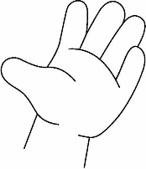**How many fingers? Count in 5’s.

****

= 60

* + 1. 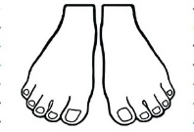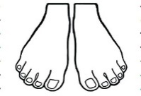How many toes altogether? Count in 10’s.







= 200

* + 1. 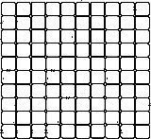How many blocks altogether? Count in 100’s.



= 1000

* 1. Complete - Count onwards and backwards. (16¸2=8)

arrow12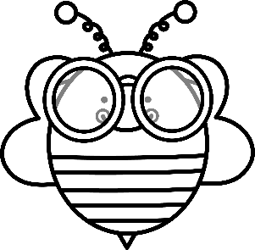

240

230

250

220

210

arrow12

329

335

333

331

327

arrow12

250

350

300

200

150

arrow12

195

180

185

190

200

arrow12

111

122

133

144

155

arrow12

520

420

320

220

120

* 1. Match the number name and number symbol. (4)

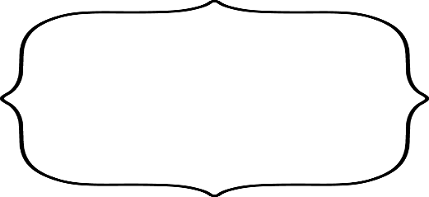

One hundred and thirty four

221



250

One hundred and forty seven



Two hundred and twenty one

134



Two hundred and fifty

147

* 1. Write the number name for every number symbol. (5)

Total: Activity 1 = \_\_\_/20

|  |  |
| --- | --- |
| 254 | Two hundred and fifty four |
| 187 | One hundred and eighty seven |
| 465 | Four hundred and sixty five |
| 350 | Three hundred and fifty |
| 448 | Four hundred and forty eight |



Numbers, Operations and relationships

Activity 2

1. Complete the tables. (18¸2=9)

|  |  |  |  |  |  |  |
| --- | --- | --- | --- | --- | --- | --- |
| Before | | Between | | | After | |
| 445 | 446 | 219 | 220 | 221 | 449 | 450 |
| 333 | 334 | 345 | 346 | 347 | 219 | 220 |

|  |  |  |  |  |  |  |  |
| --- | --- | --- | --- | --- | --- | --- | --- |
| What is 1 more than: | | What is 1 less than: | | What is 10 more than: | | What is 10 less than: | |
| 399 | 400 | 500 | 499 | 490 | 500 | 300 | 290 |
| 289 | 390 | 390 | 389 | 371 | 381 | 272 | 262 |
| 134 | 135 | 142 | 141 | 345 | 355 | 455 | 445 |

1. 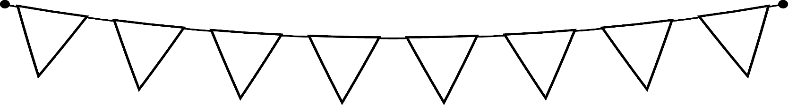 Look at the given numbers and answer the questions: (2)

285

291

389

281

196

199

1. Rearrange the numbers from small to big. (1)

196, 199, 281, 291, 285, 389.

1. Rearrange the numbers from big to small. (1)

389, 285, 291, 281, 199, 196.

1. Break up in hundreds, tens and units. (6¸3=2)

|  |  |  |  |
| --- | --- | --- | --- |
| Number | Hundreds | Tens | Units |
| 399 | 300 | 90 | 9 |
| 456 | 400 | 50 | 6 |

1. What fraction is coloured? Colour the correct answer (2¸2=1)

|  |  |  |  |  |
| --- | --- | --- | --- | --- |
|  |  |  |  |  |

|  |  |  |  |
| --- | --- | --- | --- |
|  |  |  |  |

|  |
| --- |
| 1 fifth |
| 2 fifths |
| 4 fifths |

|  |
| --- |
| 2 quarters |
| 1 quarter |
| 3 quarters |

1. 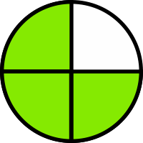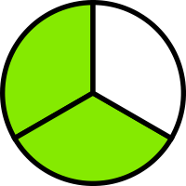Write the name of the fraction that is coloured. (2¸2=1)

3 quarters

2 thirds

|  |  |  |  |  |  |  |  |
| --- | --- | --- | --- | --- | --- | --- | --- |
| 1 whole | | | | | | | |
| ƒ | | | | ƒ | | | |
| ‰ | | ‰ | | ‰ | | ‰ | |
| † | | | † | | † | | |
| — | — | | — | — | — | | — |

1. Use the fraction wall to answer the questions. (4¸2=2)
2. There are **2** halves in 1 whole
3. There are **4** quarters in 1 whole
4. There are **3** thirds in 1 whole
5. There are **6** sixths in 1 whole
6. Mental Maths - Complete. (6 x ƒ = 3)
7. 6 + 6 + 6 = 18 (ƒ)
8. 187 + 0 = 187 (ƒ)
9. 10 less than 660 = 650 (ƒ)
10. 3 more than 477 = 480 (ƒ)
11. **30** + 70 = 100 (ƒ)
12. 389 + 10 = 399 (ƒ)
13. 234 + 5 = 239 (ƒ)

Total: Activity 2 = \_\_\_/20



Numbers, Operations and relationships

Activity 3

1. Solve the following problem. Use the space to calculate your answer. Write a number sentence for the sum. (4)

Jan reads 115 pages. Nandi reads 126 pages. How many more pages did Nandi read?

Any method can be used by the learner to calculate the sum.

Number sentence: 115 - 126 = 11 pages

1. Solve the following problems. Draw a picture. Show your calculation and write a number sentence. (8)

2.1. A vegetable garden has 12 rows of plants. Every row has 6 plants. How many plants are in the garden? (4)

Number sentence: 12 x 6 = 72 plants of 12 + 12 + 12 + 12 + 12 + 12 = 72

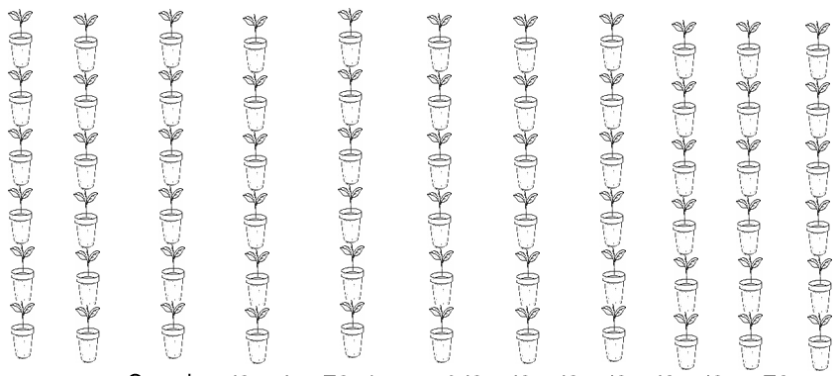

2.2. Share 8 chocolate bars between 3 friends so that each one gets the same number and that there is no left over. (4)

Answer: They each het 2 whole bars and two thirds.

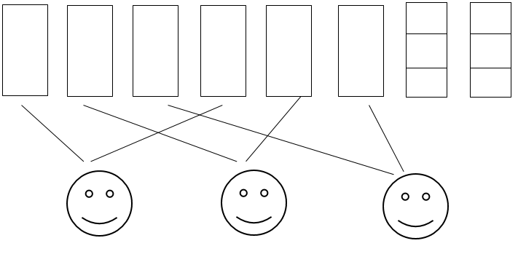

1. Addition and subtraction

Do the following. Show all calculations

1. 324 + 82 = (4) B. 389 - 137 = (4)

389 - 137 = (300 + 80 + 9) - (100 + 30 + 7)

= (300 - 100) + (80 - 30) + (9 - 7)

= 200 + 50 + 2

= 252

The learner can use any method learned in class to do the calculations.

324 + 82 = (300 + 20 + 4) + (80 + 2)

= 300 + (20 + 80) + (4 + 2)

= (300 + 100) + 6

= 400 + 6

= 406

The learner can use any method learned in class to do the calculations.

Total: Activity 3 = \_\_\_/20



Patterns, functions and algebra

Activity 1

2.1. Geometric patterns

a. Complete the following patterns. (24¸3=8)

|  |  |  |  |  |  |  |  |  |
| --- | --- | --- | --- | --- | --- | --- | --- | --- |
|  |  |  |  |  |  |  |  |  |
|  |  |  |  |  |  |  |  |  |
|  |  |  |  |  |  |  |  |  |
|  |  |  |  |  |  |  |  |  |
|  |  |  |  |  |  |  |  |  |
|  |  |  |  |  |  |  |  |  |

2.1. Extend the following patterns only once. (2)

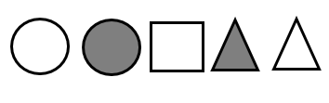





Total: Activity 1 = \_\_\_/10



Patterns, functions and algebra

Activity 2

1. Extend the pattern twice. Colour and use different colours to make a pattern (6)

|  |  |  |
| --- | --- | --- |
|  |  |  |
|  |  |  |
|  |  |  |

1. Complete the patterns in the table. (6¸2=3)

|  |  |  |  |  |
| --- | --- | --- | --- | --- |
|  |  |  |  |  |
|  |  |  |  |  |
|  |  |  |  |  |

1. Look at the pattern on the floor tiles and extend twice to the right. (1)

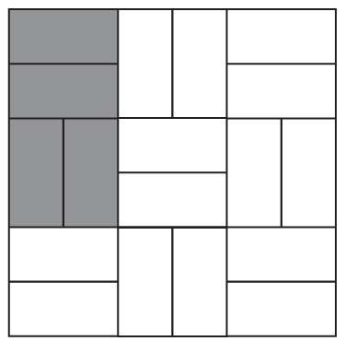

Total: Activity 2 = \_\_\_/10



Patterns, functions and algebra

Activity 3

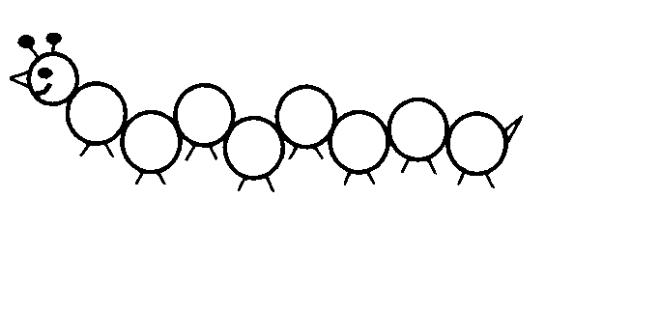Number patterns - Complete the number pattern. (30¸3=10)



154

152

150

148

146

403

503

603

703

803

903

303

203

140

144

142

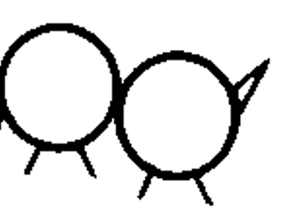

450

370

366

362

358

354

350

346

400

342

338

334





575

550

525

500

475

425

140

120



Total: Activity 3 = \_\_\_/10

280

240

260

220

200

180

160

**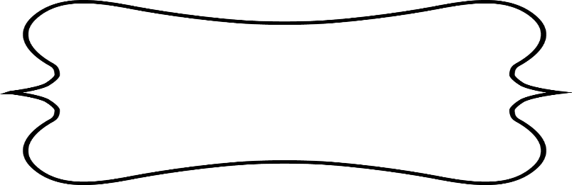**

Space and shape

Activity 1

1. Position and direction.

|  |  |  |  |  |  |
| --- | --- | --- | --- | --- | --- |
|  | 1 | 2 | 3 | 4 | 5 |
| A | See the source image |  | Bookshelf | See the source image |  |
| B |  |  |  |  |  |
| C |  | See the source imageTable 1 |  | Table 2See the source image |  |
| D |  | Table 3See the source image |  | Table 4See the source image |  |
| E |  |  |  |  | See the source image |

1. What are the positions of the tables? (4)
2. Table 1 - C2
3. Table 2 - C4
4. Table 3 - D2
5. Table 4 - D4
6. What is in A3 and A4? Bookshelf (1)
7. Where is teacher’s table situated? A1 (1)
8. How many chairs are there? 8 (1)
9. Draw a reading corner in E4 and E5. (2)
10. Make a √ on all the shapes with a correct symmetry line. (2¸2=1)

**√**

**√**

Total: Activity 1 = \_\_\_/10

Marks out of 20 (10x2) = \_\_\_/20

****

Space and Shape

Activity 2

1. 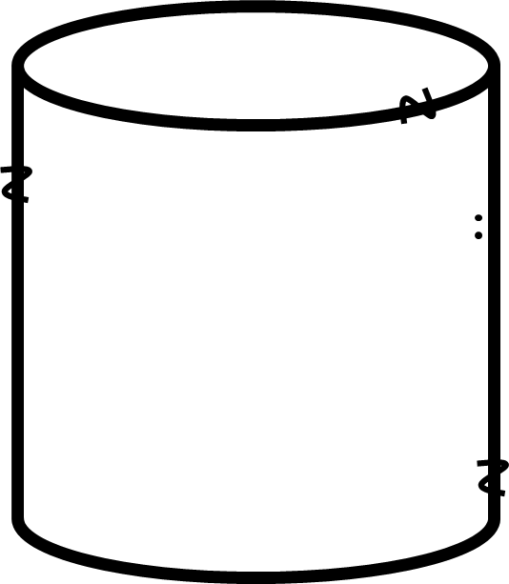Name the 3D objects. (2)

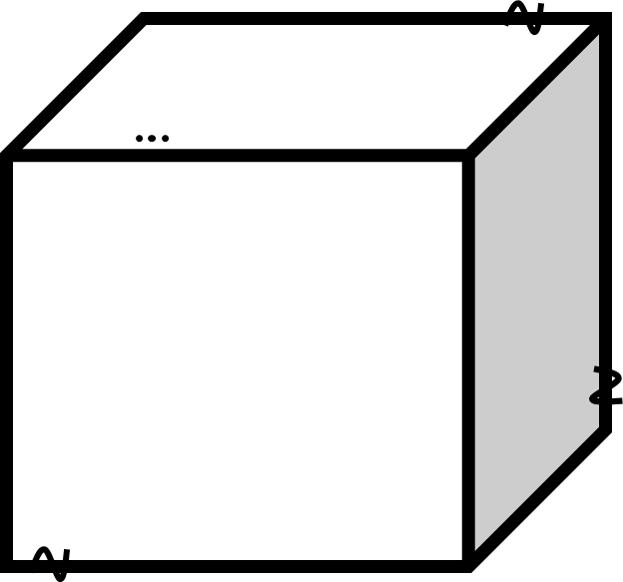

Name of object:

cylinder

Name of object:

cube

1. Look at the objects. Colour the following: (4)

* Can the object slide or roll?
* Does the object have curved or straight sides?

|  |
| --- |
| slide |
| roll |

|  |
| --- |
| curved |
| straight |

|  |
| --- |
| slide |
| roll |

|  |
| --- |
| curved |
| straight |

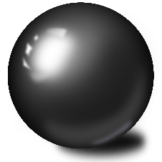

1. Look at the following objects in the block. (4)

* Colour all the spheres with blue. (2)
* Colour all the prisms with green. (2)

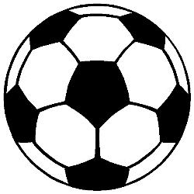

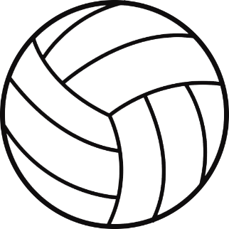

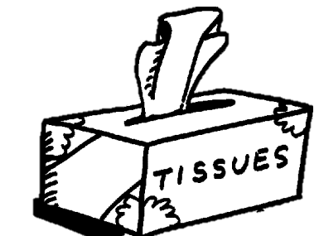

Total: Activity 2 = \_\_\_/10

Marks out of 20 (10x2) = \_\_\_/20

****

Measurement

Activity 1

1. Answer the questions. (8)
2. How many days in a week? 7
3. How many days in 2 weeks? 14
4. How many days in 3 weeks? 21
5. How many hours in 1 day? 24
6. How many hours in 2 days? 48
7. What is longer: 2 days or 45 hours? 2 days
8. How many months in 1 year? 12
9. How many months in 3 years? 36
10. 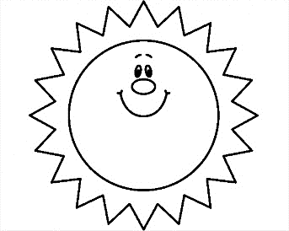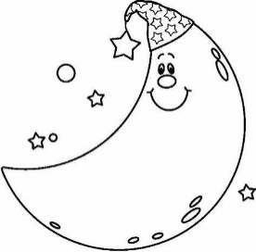What is the time? Write the analogue as well as the digital time. (4)

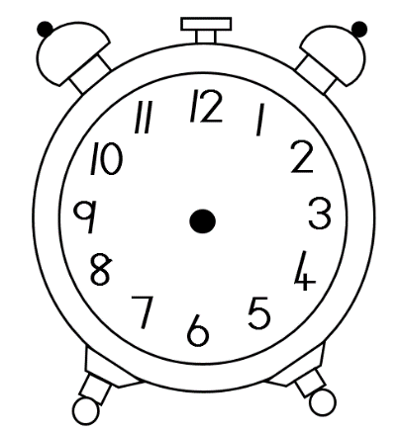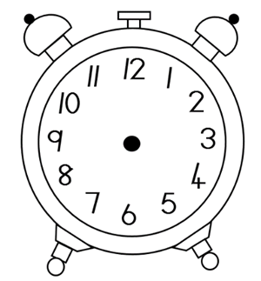

Analogue: Half past seven

Digital: 7:30

Analogue: Quarter past two

Digital: 02:15

1. Order the containers from the container with the least capacity to the container with the most. (4)

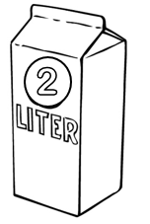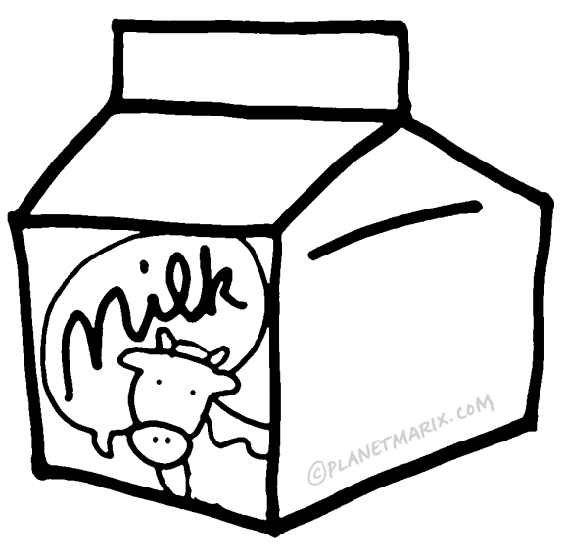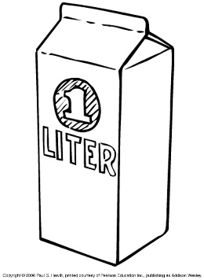

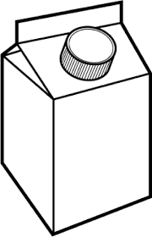

**250**

***ML***

500*ml*

container 1 container 2 container 3 container 4

* + 1. container 1
    2. container 3
    3. container 2
    4. container 4

1. Order the containers from the container with the most capacity to the container with the least. (4)





**250**

***ML***

500*ml*

container 1 container 2 container 3 container 4

1. container 4
2. container 2
3. container 3
4. container 1

Total: Activity 1 = \_\_\_/20

****

Measurement

Activity 2

1. Arrange the following containers’ mass from the lightest to the heaviest. (4)

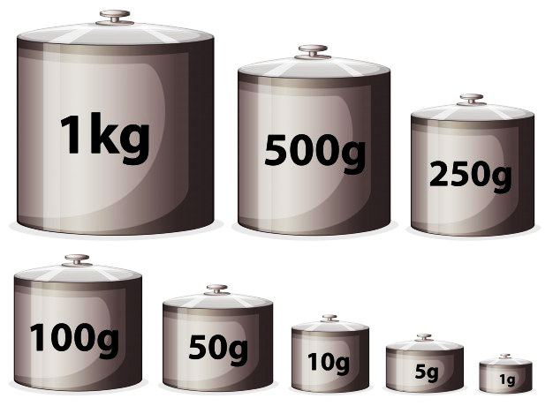



container 1 container 2 container 3 container 4

* + 1. container 4
    2. container 2
    3. container 1
    4. container 3

1. Arrange the weight from the items from the largest to the smallest in the table by writing down the item’s weight and name. (4)

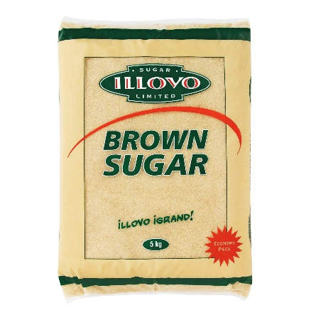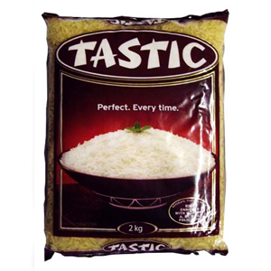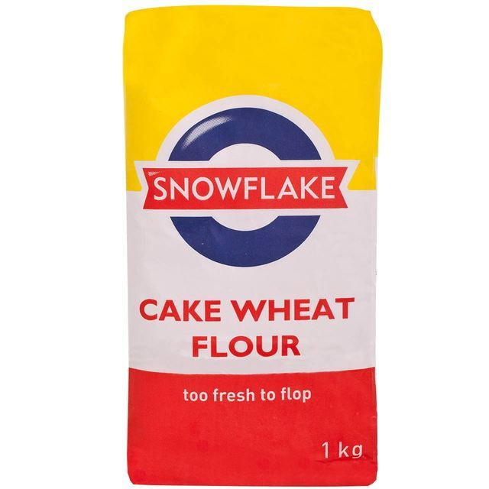

1. 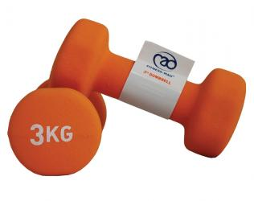

sugar

weights

flour

rice

|  |  |
| --- | --- |
| Item | Weight |
| sugar | 5kg |
| weights | 3kg |
| rice | 2kg |
| flour | 1kg |

1. Fill in >, < of = (4¸2=2)

<

1. 500gram 1 kilogram

>

1. 2 kilogram 1 kilogram

>

1. 5 kilogram 500 gram

=

1. 10 kilogram maize meal 10 kilogram samp

Total: Activity 2 = \_\_\_/10

Marks out of 20 (10x2) = \_\_\_/20

**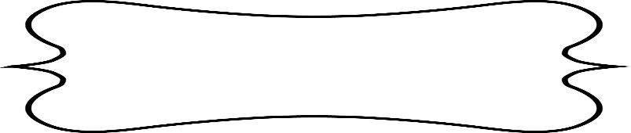**

Data Handling

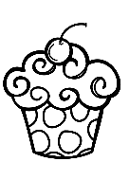The Grade 2 class held a cupcake sale. They sold cupcakes for the following days. Use the key to complete the graph:

Key : = 2 cupcakes

|  |  |
| --- | --- |
| Monday | C:\Users\MS\Downloads\UnwrapyourFREEBIEChristmasClipart3CreativeClipsClipart\Creative Clips_Freebie Christmas Cupcakes\Creative Clips_Christmas Cupcake Images\Christmas Cupcake_BW_4.pngC:\Users\MS\Downloads\UnwrapyourFREEBIEChristmasClipart3CreativeClipsClipart\Creative Clips_Freebie Christmas Cupcakes\Creative Clips_Christmas Cupcake Images\Christmas Cupcake_BW_4.pngC:\Users\MS\Downloads\UnwrapyourFREEBIEChristmasClipart3CreativeClipsClipart\Creative Clips_Freebie Christmas Cupcakes\Creative Clips_Christmas Cupcake Images\Christmas Cupcake_BW_4.pngC:\Users\MS\Downloads\UnwrapyourFREEBIEChristmasClipart3CreativeClipsClipart\Creative Clips_Freebie Christmas Cupcakes\Creative Clips_Christmas Cupcake Images\Christmas Cupcake_BW_4.pngC:\Users\MS\Downloads\UnwrapyourFREEBIEChristmasClipart3CreativeClipsClipart\Creative Clips_Freebie Christmas Cupcakes\Creative Clips_Christmas Cupcake Images\Christmas Cupcake_BW_4.png |
| Tuesday | C:\Users\MS\Downloads\UnwrapyourFREEBIEChristmasClipart3CreativeClipsClipart\Creative Clips_Freebie Christmas Cupcakes\Creative Clips_Christmas Cupcake Images\Christmas Cupcake_BW_4.pngC:\Users\MS\Downloads\UnwrapyourFREEBIEChristmasClipart3CreativeClipsClipart\Creative Clips_Freebie Christmas Cupcakes\Creative Clips_Christmas Cupcake Images\Christmas Cupcake_BW_4.png |
| Wednesday | C:\Users\MS\Downloads\UnwrapyourFREEBIEChristmasClipart3CreativeClipsClipart\Creative Clips_Freebie Christmas Cupcakes\Creative Clips_Christmas Cupcake Images\Christmas Cupcake_BW_4.pngC:\Users\MS\Downloads\UnwrapyourFREEBIEChristmasClipart3CreativeClipsClipart\Creative Clips_Freebie Christmas Cupcakes\Creative Clips_Christmas Cupcake Images\Christmas Cupcake_BW_4.pngC:\Users\MS\Downloads\UnwrapyourFREEBIEChristmasClipart3CreativeClipsClipart\Creative Clips_Freebie Christmas Cupcakes\Creative Clips_Christmas Cupcake Images\Christmas Cupcake_BW_4.png |
| Thursday | C:\Users\MS\Downloads\UnwrapyourFREEBIEChristmasClipart3CreativeClipsClipart\Creative Clips_Freebie Christmas Cupcakes\Creative Clips_Christmas Cupcake Images\Christmas Cupcake_BW_4.pngC:\Users\MS\Downloads\UnwrapyourFREEBIEChristmasClipart3CreativeClipsClipart\Creative Clips_Freebie Christmas Cupcakes\Creative Clips_Christmas Cupcake Images\Christmas Cupcake_BW_4.pngC:\Users\MS\Downloads\UnwrapyourFREEBIEChristmasClipart3CreativeClipsClipart\Creative Clips_Freebie Christmas Cupcakes\Creative Clips_Christmas Cupcake Images\Christmas Cupcake_BW_4.pngC:\Users\MS\Downloads\UnwrapyourFREEBIEChristmasClipart3CreativeClipsClipart\Creative Clips_Freebie Christmas Cupcakes\Creative Clips_Christmas Cupcake Images\Christmas Cupcake_BW_4.pngC:\Users\MS\Downloads\UnwrapyourFREEBIEChristmasClipart3CreativeClipsClipart\Creative Clips_Freebie Christmas Cupcakes\Creative Clips_Christmas Cupcake Images\Christmas Cupcake_BW_4.png |
| Friday | C:\Users\MS\Downloads\UnwrapyourFREEBIEChristmasClipart3CreativeClipsClipart\Creative Clips_Freebie Christmas Cupcakes\Creative Clips_Christmas Cupcake Images\Christmas Cupcake_BW_4.pngC:\Users\MS\Downloads\UnwrapyourFREEBIEChristmasClipart3CreativeClipsClipart\Creative Clips_Freebie Christmas Cupcakes\Creative Clips_Christmas Cupcake Images\Christmas Cupcake_BW_4.pngC:\Users\MS\Downloads\UnwrapyourFREEBIEChristmasClipart3CreativeClipsClipart\Creative Clips_Freebie Christmas Cupcakes\Creative Clips_Christmas Cupcake Images\Christmas Cupcake_BW_4.pngC:\Users\MS\Downloads\UnwrapyourFREEBIEChristmasClipart3CreativeClipsClipart\Creative Clips_Freebie Christmas Cupcakes\Creative Clips_Christmas Cupcake Images\Christmas Cupcake_BW_4.pngC:\Users\MS\Downloads\UnwrapyourFREEBIEChristmasClipart3CreativeClipsClipart\Creative Clips_Freebie Christmas Cupcakes\Creative Clips_Christmas Cupcake Images\Christmas Cupcake_BW_4.pngC:\Users\MS\Downloads\UnwrapyourFREEBIEChristmasClipart3CreativeClipsClipart\Creative Clips_Freebie Christmas Cupcakes\Creative Clips_Christmas Cupcake Images\Christmas Cupcake_BW_4.png |

* 1. Draw the information above on the bargraph. (5)

|  |  |  |  |  |  |
| --- | --- | --- | --- | --- | --- |
| 12 |  |  |  |  |  |
| 11 |  |  |  |  |  |
| 10 |  |  |  |  |  |
| 9 |  |  |  |  |  |
| 8 |  |  |  |  |  |
| 7 |  |  |  |  |  |
| 6 |  |  |  |  |  |
| 5 |  |  |  |  |  |
| 4 |  |  |  |  |  |
| 3 |  |  |  |  |  |
| 2 |  |  |  |  |  |
| 1 |  |  |  |  |  |
|  | Monday | Tuesday | Wednesday | Thursday | Friday |

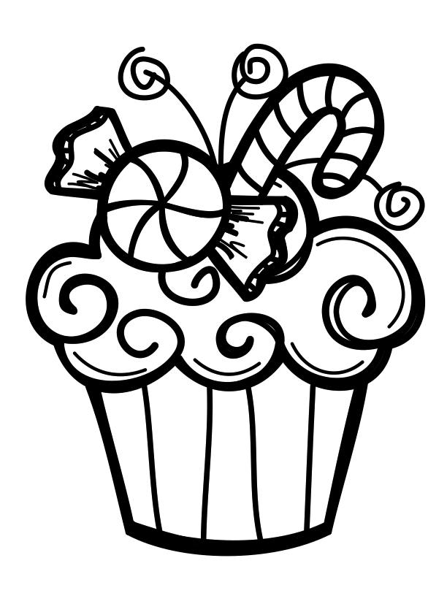

* 1. Write a title for your graph. (1)

Learners own title. For example: Cupcake sale

* 1. What is the difference in sales between Tuesday and Thursday? (1)

Number sentence: 10 - 4 = 6 cupcakes

* 1. If a cupcake costs R5, how much money was collected on Wednesday? (1)

R5 + R5 + R5 + R5 + R5 + R5 = R30 / R5 x 6 = R30

* 1. If a cupcake costs R5 how much money was collected on Friday? (1)

R5 + R5 + R5 + R5 + R5 + R5 + R5 + R5 + R5 + R5 + R5 + R5 = R60 / R5 x 12 = R60

* 1. How many cupcakes are sold for the whole week? (1)

Number sentence: 10 + 4 + 6 + 10 + 12 = 42 cupcakes

|  |  |  |
| --- | --- | --- |
| Data Handling |  | Marks |
| 1. 1 mark for each day that the correct amount of blocks were coloured. | 5 |  |
| 1. 1 mark for each correct answer. | 5 |  |
| Total | \_\_\_/10 | |
| Marks out of 5 = (10¸2=5) | \_\_\_/5 | |