English First Additional Language

Assessment Term 3

Grade 3

Name and Surname: ____________________________

Date: _________________________________

TASK 2 - MEMORANDUM

|  |  |  |
| --- | --- | --- |
| Content |  | Mark |
| 1. Listening and speaking | 10 |  |
| 1. Reading | 10 |  |
| 1. Phonics | ‘  10 |  |
| 1. Language | 20 |  |
| 1. Writing | 20 |  |
| Total | 100 |  |

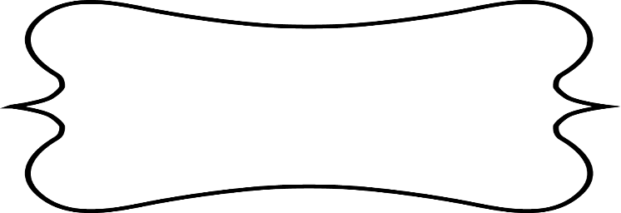

Listening and Speaking

Listen to a story and answer comprehension questions orally.

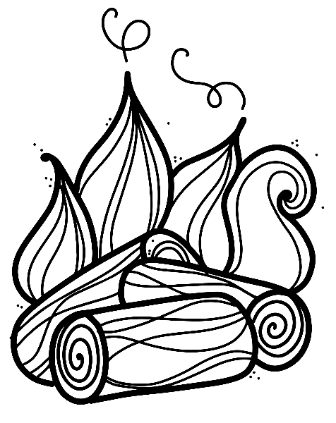

Go to your teacher’s desk and answer the questions

she is going to ask you:

1. Is it safe to play with matches? (1)

No, it is not save to play with matches.

1. What can happen when you play with matches? Give two examples. (2)

* You can burn yourself.
* You can set the house alight.

1. How many ways should you have to get out of a room? (1)

You should have two ways.

1. What should you do if there is fire and smoke in your house? (1)

If there is a fire in your house and lots of smoke you must crawl to avoid smoke and heat. Get out fast.

1. What should you avoid when there is a fire? Give two examples (2)

Smoke and heat.

1. True or false - You should can take your time to get out of the house if there is a fire. (1)

False. You should get out of the house fast.

1. Who should you phone when there is a fire? (1)

The fire brigade.

1. What will the fire brigade do when they arrive? (1)

They will extinguish the fire.



Reading

Shared reading

Instructions:

Retell the story that your Teacher told you about the road safety rules. You must tell it in full sentences.

Road Safety

➀ Look for a safe place to cross.

Look all around you before

you cross a road.

➁ Listen for any traffic.

If you hear any traffic coming, WAIT,

Then look all around again.

➂ If there is no traffic, walk across the road.

Look and listen for traffic while you cross

the road.

You will be assessed according to the following rubric:

|  |  |  |
| --- | --- | --- |
| Rubric : Retelling of road safety rules |  | Mark obtained |
| 1. Was the learner able to retell the story? | 2 |  |
| 1. Learner speaks clearly and pronounces words correct. | 1 |  |
| 1. The learner speaks with confidence and makes eye contact and uses facial expressions. | 2 |  |
| Total | 5 |  |
| Processed mark out of 10(5x2) | 10 |  |



Phonics

3.1. Colour the correct block to complete the words. (8)

|  |  |  |  |  |  |  |  |  |  |
| --- | --- | --- | --- | --- | --- | --- | --- | --- | --- |
| Image result for clock clipart black and white   |  |  |  |  | | --- | --- | --- | --- | | tr | bl | cl | fl | | Image result for flower clipart black and white   |  |  |  |  | | --- | --- | --- | --- | | tr | bl | cl | fl |   _ _ ock  _ _ ower |
| Image result for crab clipart black and white  _ _ ab   |  |  |  |  | | --- | --- | --- | --- | | gr | cr | cl | th | | Image result for crow clipart black and white   |  |  |  |  | | --- | --- | --- | --- | | cr | gr | cl | tr |   _ _ ow |
| Image result for brush clipart black and white  _ _ ush     |  |  |  |  | | --- | --- | --- | --- | | br | cr | tr | cr | | Image result for fly clipart black and white   |  |  |  |  | | --- | --- | --- | --- | | br | fl | cl | bl |   _ _ y |

3.2. Build your own words with **ai** and **ay** in the table.

(4¸2=2)

|  |  |
| --- | --- |
| ai | ay |
| rain  train  wait  paint  snail  Any other correct words will be accepted. | say  day  hay  pay  pray  clay  Any other correct words will be accepted. |

Phonics activity: __/10



Language

* 1. Complete the following sentences by using **these** and **those**. (4)

If things are near, use these. If they are far, use those.

1. **These** are my books.
2. 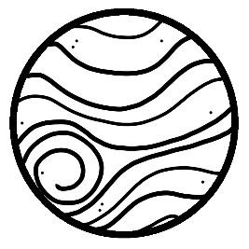 **Those** are planets.
3. 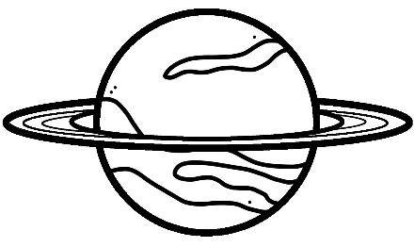**Those** are planes.
4. **These** are vegetables.
   1. Write down the plurals of the following words in the table. (4)

|  |  |  |  |
| --- | --- | --- | --- |
| chair | chairs | brush | brushes |
| bus | busses | tooth | teeth |

* 1. Write the words in the blocks in the correct column. (4¸2=2)

|  |  |
| --- | --- |
| rocks | sand |
| flour | apples |

|  |  |
| --- | --- |
| Countable nouns | Uncountable nouns |
| rocks | sand |
| apples | flour |

Total out of 10 = ___/10

Processed mark out of 20 (10x2) = ___/20

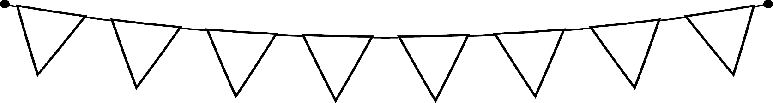

Writing

Look at the picture and use the words in the blocks to complete the sentences. Remember to write neatly.

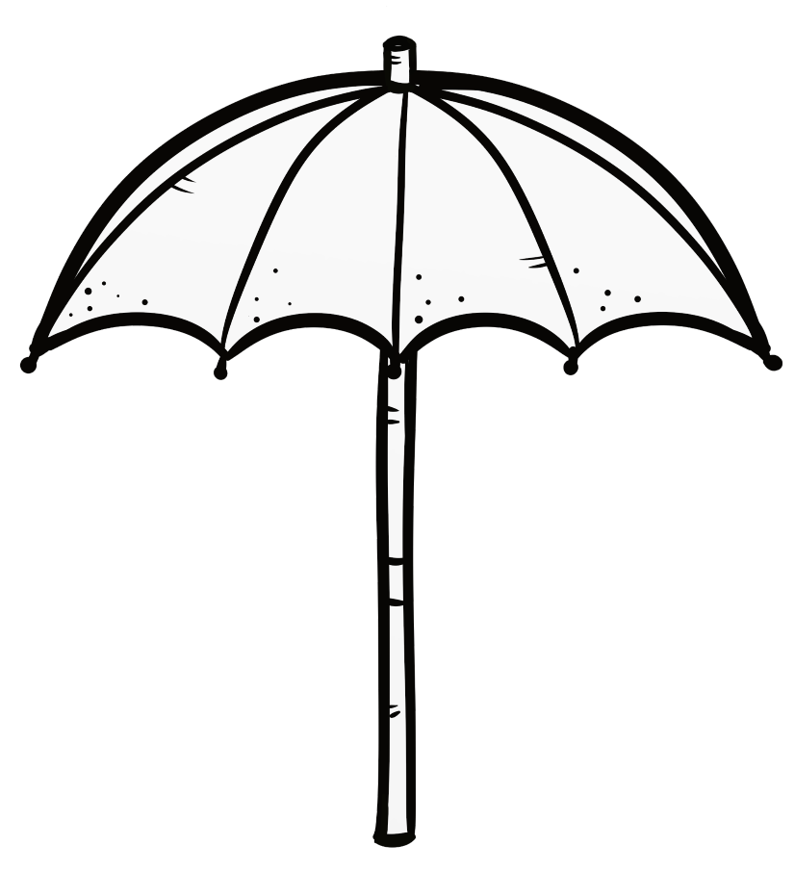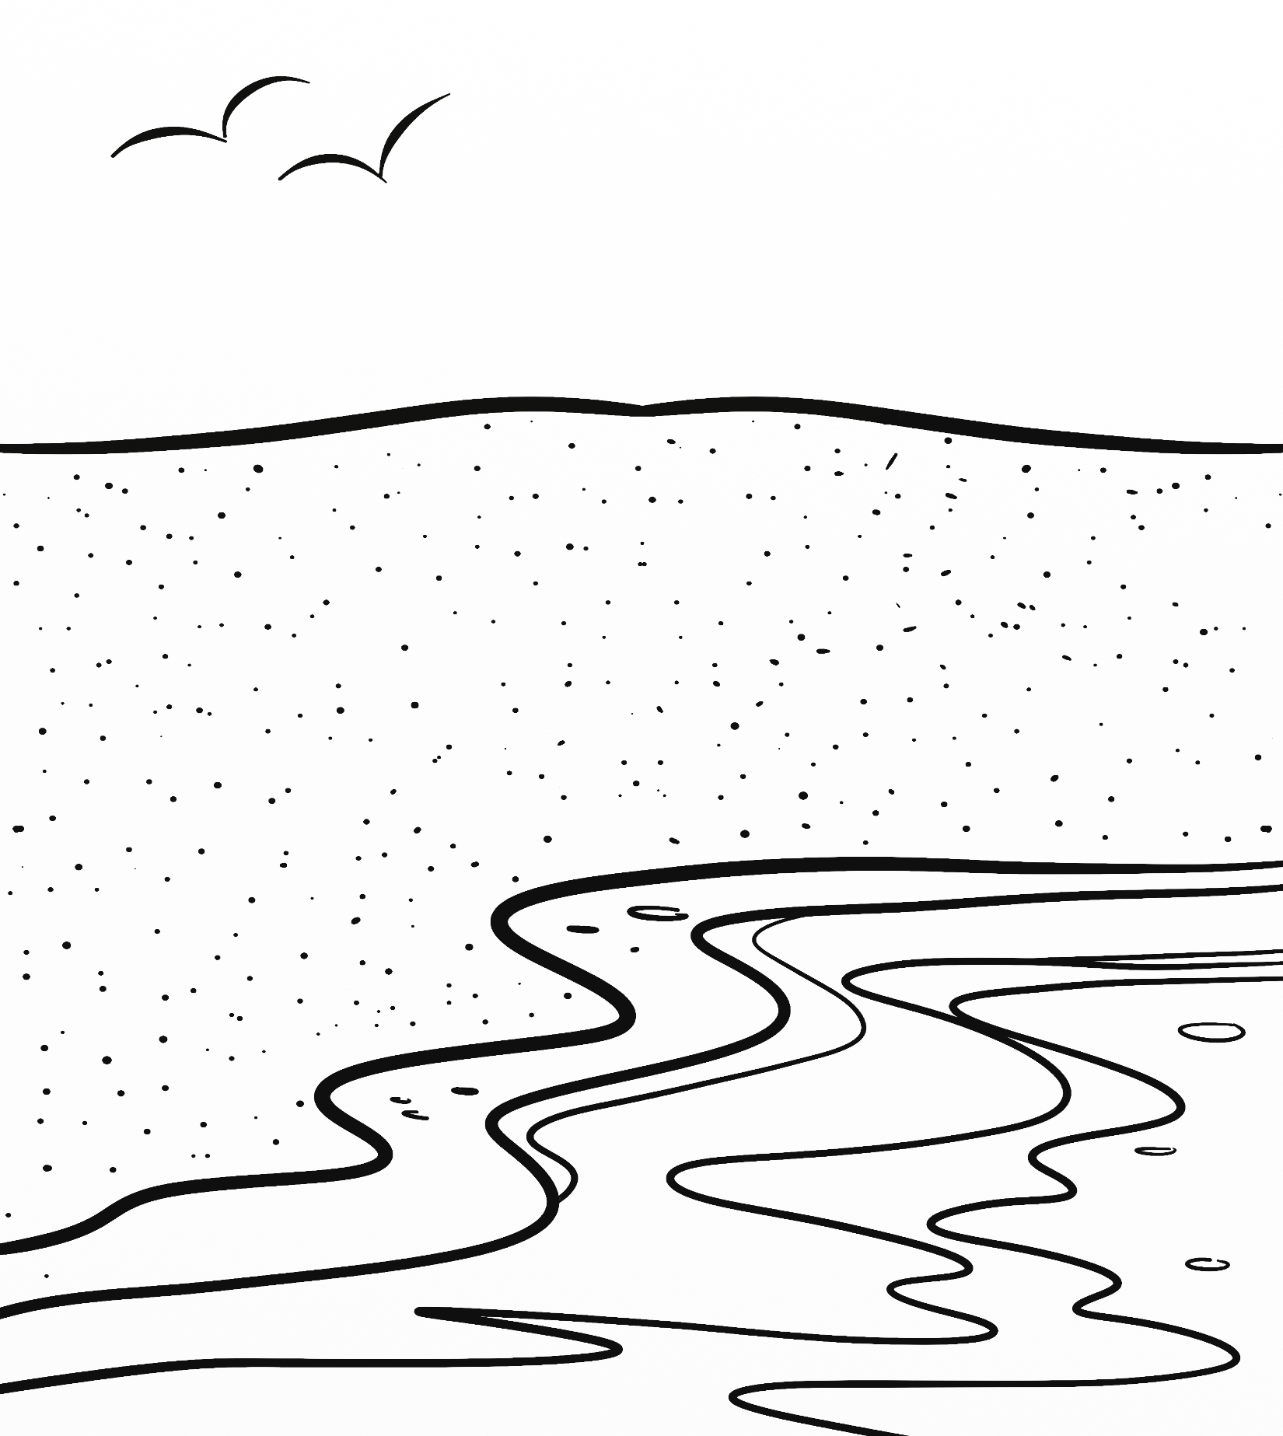

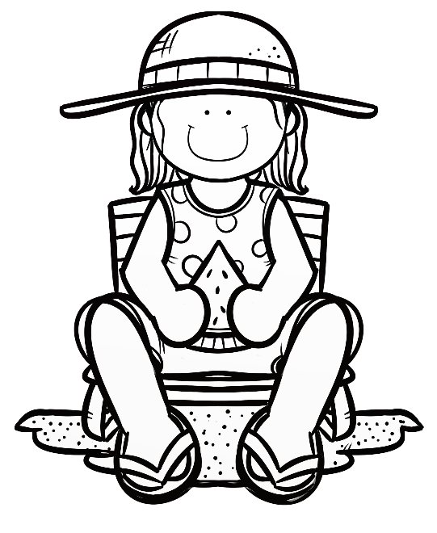

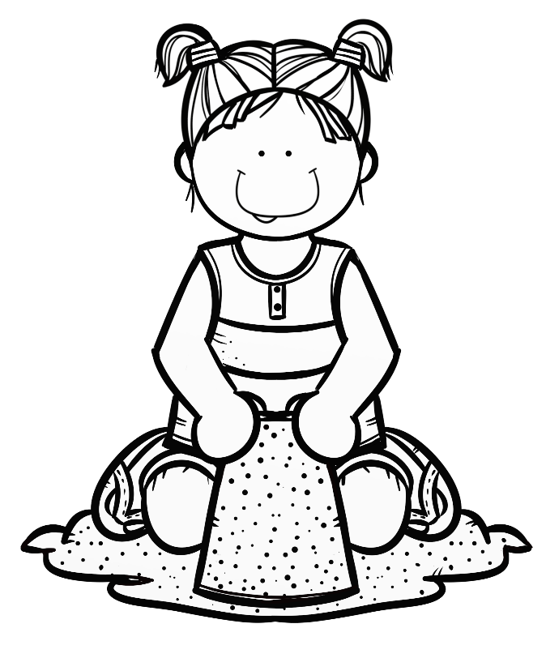

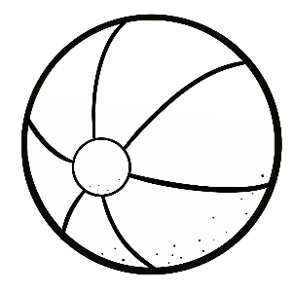

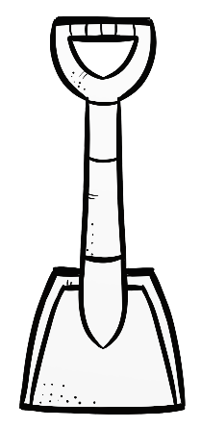

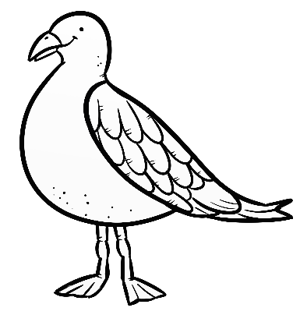

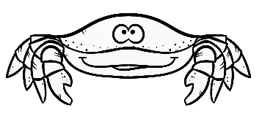

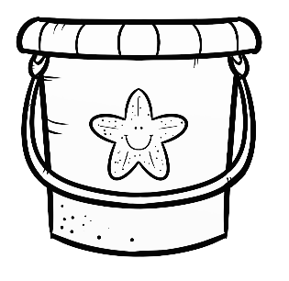

1. Write the words in the blocks in the correct order to create a sentence. Use the picture on the previous page for clues.

|  |  |  |  |  |
| --- | --- | --- | --- | --- |
| the | We | at | are | beach |

We are at the beach. (5)

|  |  |  |  |  |
| --- | --- | --- | --- | --- |
| am | I | a | building | sandcastle |

I am building a sandcastle. (5)

|  |  |  |  |  |
| --- | --- | --- | --- | --- |
| My | eating | sister | is | watermelon |

My sister is eating watermelon. (5)

1. Complete the following sentences by using the words in the blocks. (5)

|  |  |  |  |  |
| --- | --- | --- | --- | --- |
| ball | seagull | hat | crab | hot |

1. My sister is wearing a **hat**.
2. There is a **crab** and a **seagull** on the beach.
3. We are going to play with the **ball**.
4. The sun is **hot**.

Total out of 20 = ___/20

|  |  |  |  |  |  |
| --- | --- | --- | --- | --- | --- |
| Rubric – Writing activity | 1 | 2 | 3 | 4 | 5 |
| 1. Line usage and spacing –  * How well did the learner use his writing lines? * How well did the learner space their letters and/or words? | Many errors in line usage. Many errors in spacing. | Some errors in line usage. Some errors in spacing. | Few errors using lines correctly. Few errors using spacing correctly. | Uses lines correctly most of the time. Uses proper spacing most of the time | Always uses lines correctly. Always uses proper spacing. |
| 1. Letter formation-   Did the learner form his letters correctly? | Many errors in letter formation. Incorrect letter formations**.** | Some errors in letter formation. Letters formed incorrectly. | Few errors in letter formation. Few letters are formed incorrectly. | Most letters are formed correctly. | Consistently forms all letters correctly. |
| 1. Readability – How easy is it to read the learners handwriting? | Many errors in readability. | Some errors in readability. | Few errors in readability. | Very easy to read. | Always easy to read. |
| 1. Neatness - How neat is the learner’s handwriting? | Difficult to read. | Not neatly done. | Not as neatly done. | Writes neatly. | Always writes neatly. |
| Total: ___/20 | | | | | |

Total for writing section = Total out of 20 + Rubric mark

= Mark out of 20 + Mark out of 20

= _____/40

Processed mark out of 20 (40¸2) = ______/20