English First Additional Language

Assessment Term 3

Grade 3

Name and Surname: ____________________________

Date: _________________________________

TASK 1

|  |  |  |
| --- | --- | --- |
| Content |  | Mark |
| 1. Listening and speaking | 10 |  |
| 1. Reading | 10 |  |
| 1. Phonics | ‘10 |  |
| 1. Language | 20 |  |
| 1. Writing | 50 |  |
| Total | 100 |  |



Listening and Speaking

Gives a short oral recount of a personal experience or event. Draw a picture of your experience.

|  |  |  |  |  |
| --- | --- | --- | --- | --- |
| Listening and Speaking Rubric | | | | |
|  | 1 | 2 | 3 | 4 |
| Vocabulary and language use | Struggles to communicate effectively, limited vocabulary. Cannot print himself/herself. | Uses a limited vocabulary. Makes many grammatical errors. | Uses appropriate vocabulary. Talks in full sentences and speaks in the correct time, eg. Past, future or present. | Uses a comprehensive vocabulary. Talks in full sentences and uses correct and good language. Use descriptive words. |
| Appropriate volume and intonation | Talks too soft or mumbles. Difficult to understand and hear. | Talks too fast. Sometimes difficult to understand. | Talks slowly and clearly. Easy to understand. Can be heard clearly most of the time. | Talks slowly and clearly. Can be easily heard and understood at all times. |
| Content | Learner doesn’t participate. Doesn’t want to try to give an oral recount. | Limited content. Teacher must ask questions to get clarity. | Spontaneous. Provides adequate content which is expected of the learner. | Spontaneous and elaborative. Content provides more information than expected. |
| Eye contact and body language | The learner doesn’t make eye contact and doesn’t make use of body language. | The learner’s eye contact and body language are limited. | The learner makes eye contact some of the time and sometimes makes use of body language. | The learner makes eye contact with the class and teacher and makes use of appropriate body language. |
| Ask questions for clarity | The learner has to ask questions the whole time for clarity because he seldom gives attention when given instructions. | The learner has to ask questions some times for clarity because he seldom gives attention when given instructions. | The learner has to ask questions seldom for clarity because he gives attention when instructions are given. | The learner never has to ask questions for clarity because he gives attention when instructions are given. |
|  | | | Total /20 |  |
|  | | | Total out of 10 | 20 ¸ 2 = ___/10 |



Reading

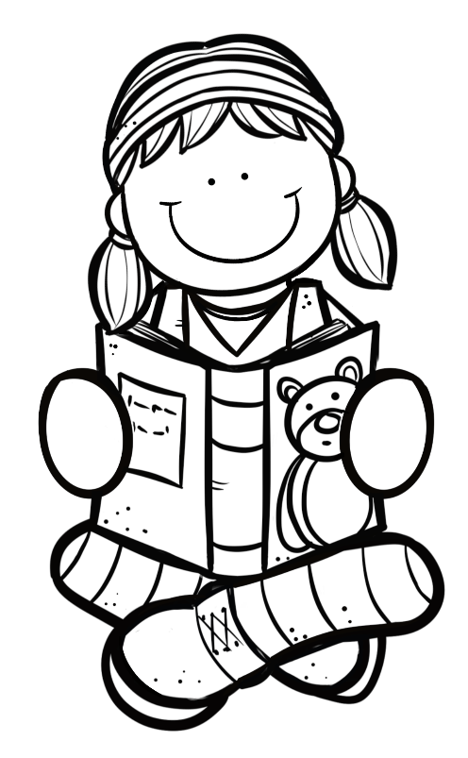

Group Guided Reading

Read aloud from your own book in a guided reading group with the teacher. This means the whole group reads the same story or non-fiction text with the teacher. You will be marked according to this rubric:

|  |  |  |
| --- | --- | --- |
| Rubric – Group Guided Reading |  |  |
| 1. Words are pronounced correctly. | 2 |  |
| 1. Learner makes use of the reading strategies taught in the Home Language to make sense and monitor self when reading (phonics, context clues, structural analysis, sight words) | 2 |  |
| 1. Learner reads with increasing fluency and expression. | 2 |  |
| 1. Shows an understanding of punctuation when reading aloud. | 2 |  |
| 1. Reads with feeling and intonation. | 2 |  |
| Total | 10 |  |



Phonics

* 1. Sort the consonant digraphs in the box in the correct column. (12¸2=6)

kiss cliff class elephant bell dress

nephew doll wall stuff trophy boss

|  |  |  |  |
| --- | --- | --- | --- |
| -ff | -ll | -ss | -ph- |
|  |  |  |  |
|  |  |  |  |
|  |  |  |  |
|  |  |  |  |

3.2. Use some of the words above to complete the sentences.

(4¸2=2)

a. The boy received a _________ when he won the race.

b. My _________ and niece are coming to visit.

c. There is about 23 children in each ________.

d. The cow has a golden ______ around his neck.

3.3. Use the three-letter consonant blends at the beginning and

end of the words to complete the words. (4¸2=2)

**str-, scr-, -tch, -nch**

|  |  |
| --- | --- |
| Image result for watch clipart black and whiteRelated image  wa _ _ _ | _ _ _ ew |
| Image result for strong clipart black and white  _ _ _ ong | Image result for lunch clipart black and white  lu _ _ _ |

Total: ___/10

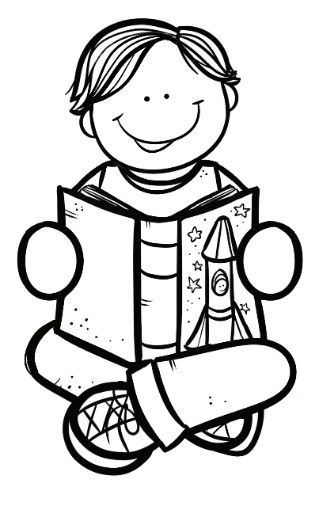

Language

4.1. Complete the sentences by filling in “a” or “the”. (4)

1. I am going to _____ park after school.
2. I would love to tell you ____ story.
3. We will go to ____ movies on Saturday.
4. I am reading ____ book.

4.2. Write the sentences in the past tense. Use the words in the

blocks to help you. (3)

walking

were

was

1. It is cold.

Yesterday ______________________________________

1. Ben walks to school.

Yesterday_______________________________________

1. Today we are at a camp.

Yesterday_______________________________________

4.3. Read the sentences and colour in the correct word. (3)

|  |  |
| --- | --- |
| is | are |

1. The dog barking at the boy.

|  |  |
| --- | --- |
| is | are |

1. They practicing for the school concert.

|  |  |
| --- | --- |
| is | are |

1. The girl walking to school.

Total out of 10 = ___/10

Processed mark out of 20 (10x2) = ___/20

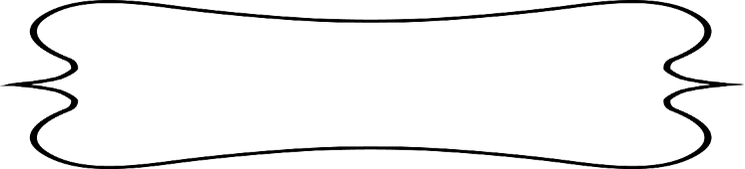

Writing

Make a list in the table of five things you like and five things you don’t like. Remember to write neatly. (10)

|  |  |
| --- | --- |
| Things I like | Things I don’t like |
|  |  |
|  |  |
|  |  |
|  |  |
|  |  |

1. Choose one thing you like and say why you like it. Draw a picture of it. (2ƒ)

_____________________________________________________________________________________________________________________________

1. Choose one thing you don’t like and say why you don’t like it. Draw a picture of it. (2ƒ)

_____________________________________________________________________________________________________________________________

Total out of 15 for completion of sentences= ___/15

Processed mark out of 30 (15x2) = ___/30

|  |  |  |  |  |  |
| --- | --- | --- | --- | --- | --- |
| Rubric – Writing activity | 1 | 2 | 3 | 4 | 5 |
| 1. Line usage and spacing –  * How well did the learner use his writing lines? * How well did the learner space their letters and/or words? | Many errors in line usage. Many errors in spacing. | Some errors in line usage. Some errors in spacing. | Few errors using lines correctly. Few errors using spacing correctly. | Uses lines correctly most of the time. Uses proper spacing most of the time | Always uses lines correctly. Always uses proper spacing. |
| 1. Letter formation-   Did the learner form his letters correctly? | Many errors in letter formation. Incorrect letter formations**.** | Some errors in letter formation. Letters formed incorrectly. | Few errors in letter formation. Few letters are formed incorrectly. | Most letters are formed correctly. | Consistently forms all letters correctly. |
| 1. Readability – How easy is it to read the learners handwriting? | Many errors in readability. | Some errors in readability. | Few errors in readability. | Very easy to read. | Always easy to read. |
| 1. Neatness - How neat is the learner’s handwriting? | Difficult to read. | Not neatly done. | Not as neatly done. | Writes neatly. | Always writes neatly. |
| Total: ___/20 | | | | | |

Total for writing section = Complete sentences + Rubric mark

= Mark out of 30 + Mark out of 20

= _____/50