English First Additional Language

Assessment Term 3

Grade 3

Name and Surname: ____________________________

Date: _________________________________

TASK 1 - MEMORANDUM

|  |  |  |
| --- | --- | --- |
| Content |  | Mark |
| 1. Listening and speaking | 10 |  |
| 1. Reading | 10 |  |
| 1. Phonics | ‘10 |  |
| 1. Language | 20 |  |
| 1. Writing | 50 |  |
| Total | 100 |  |

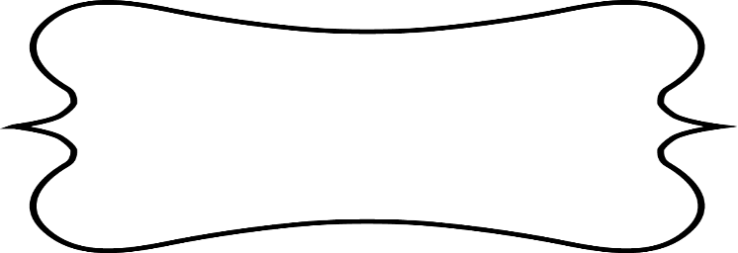

Listening and Speaking

Gives a short oral recount of a personal experience or event. Draw a picture of your experience.

Learners own drawing.

|  |  |  |  |  |
| --- | --- | --- | --- | --- |
| Listening and Speaking Rubric | | | | |
|  | 1 | 2 | 3 | 4 |
| Vocabulary and language use | Struggles to communicate effectively, limited vocabulary. Cannot print himself/herself. | Uses a limited vocabulary. Makes many grammatical errors. | Uses appropriate vocabulary. Talks in full sentences and speaks in the correct time, eg. Past, future or present. | Uses a comprehensive vocabulary. Talks in full sentences and uses correct and good language. Use descriptive words. |
| Appropriate volume and intonation | Talks too soft or mumbles. Difficult to understand and hear. | Talks too fast. Sometimes difficult to understand. | Talks slowly and clearly. Easy to understand. Can be heard clearly most of the time. | Talks slowly and clearly. Can be easily heard and understood at all times. |
| Content | Learner doesn’t participate. Doesn’t want to try to give an oral recount. | Limited content. Teacher must ask questions to get clarity. | Spontaneous. Provides adequate content which is expected of the learner. | Spontaneous and elaborative. Content provides more information than expected. |
| Eye contact and body language | The learner doesn’t make eye contact and doesn’t make use of body language. | The learner’s eye contact and body language are limited. | The learner makes eye contact some of the time and sometimes makes use of body language. | The learner makes eye contact with the class and teacher and makes use of appropriate body language. |
| Ask questions for clarity | The learner has to ask questions the whole time for clarity because he seldom gives attention when given instructions. | The learner has to ask questions some times for clarity because he seldom gives attention when given instructions. | The learner has to ask questions seldom for clarity because he gives attention when instructions are given. | The learner never has to ask questions for clarity because he gives attention when instructions are given. |
|  | | | Total /20 |  |
|  | | | Total out of 10 | 20 ¸ 2 = ___/10 |



Reading

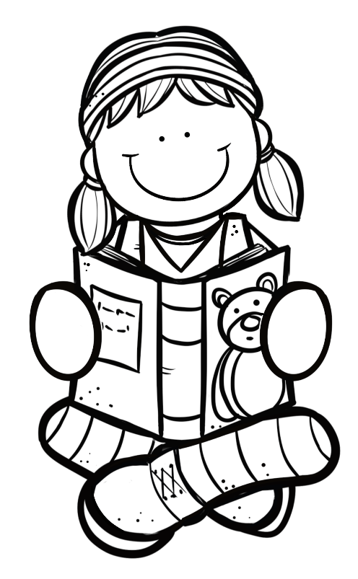

Group Guided Reading

Read aloud from your own book in a guided reading group with the teacher. This means the whole group reads the same story or non-fiction text with the teacher. You will be marked according to this rubric:

|  |  |  |
| --- | --- | --- |
| Rubric – Group Guided Reading |  |  |
| 1. Words are pronounced correctly. | 2 |  |
| 1. Learner makes use of the reading strategies taught in the Home Language to make sense and monitor self when reading (phonics, context clues, structural analysis, sight words) | 2 |  |
| 1. Learner reads with increasing fluency and expression. | 2 |  |
| 1. Shows an understanding of punctuation when reading aloud. | 2 |  |
| 1. Reads with feeling and intonation. | 2 |  |
| Total | 10 |  |



Phonics

* 1. Sort the consonant digraphs in the box in the correct column. (12¸2=6)

kiss cliff class elephant bell dress

nephew doll wall stuff trophy boss

|  |  |  |  |
| --- | --- | --- | --- |
| -ff | -ll | -ss | -ph- |
| cliff | bell | dress | trophy |
| stuff | wall | class | nephew |
|  | doll | kiss | elephant |
|  |  | boss |  |

3.2. Use some of the words above to complete the sentences.

(4¸2=2)

a. The boy received a **trophy** when he won the race.

b. My **nephew** and niece are coming to visit.

c. There is about 23 children in each **class**.

d. The cow has a golden **bell** around his neck.

3.3. Use the three-letter consonant blends at the beginning and

end of the words to complete the words. (4¸2=2)

**str-, scr-, -tch, -nch**

|  |  |
| --- | --- |
| Image result for watch clipart black and whiteRelated image  wa**tch** | **scr**ew |
| Image result for strong clipart black and white  **str**ong | Image result for lunch clipart black and white  lu**nch** |

Total: ___/10

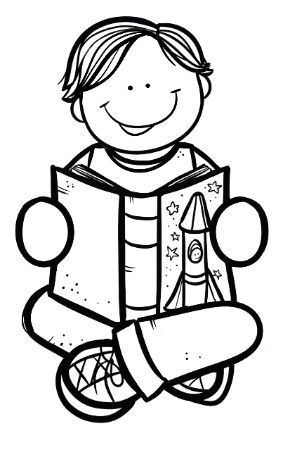

Language

4.1. Complete the sentences by filling in “a” or “the”. (4)

1. I am going to **the** park after school.
2. I would love to tell you **a** story.
3. We will go to **the** movies on Saturday.
4. I am reading **a** book.

4.2. Write the sentences in the past tense. Use the words in the

blocks to help you. (3)

walking

were

was

1. It is cold.

Yesterday it was cold.

1. Ben walks to school.

Yesterday Ben was walking to school.

1. Today we are at a camp.

Yesterday we were at a camp.

4.3. Read the sentences and colour in the correct word. (3)

|  |  |
| --- | --- |
| is | are |

1. The dog barking at the boy.

|  |  |
| --- | --- |
| is | are |

1. They practicing for the school concert.

|  |  |
| --- | --- |
| is | are |

1. The girl walking to school.

Total out of 10 = ___/10

Processed mark out of 20 (10x2) = ___/20

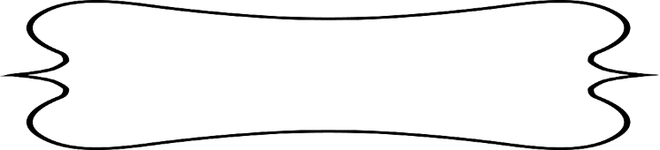

Writing

Make a list in the table of five things you like and five things you don’t like. Remember to write neatly. (10)

|  |  |
| --- | --- |
| Things I like | Things I don’t like |
| Learners own answers. | Learners own answer. |
|  |  |
|  |  |
|  |  |
|  |  |

1. Choose one thing you like and say why you like it. Draw a picture of it. (2ƒ)

Learners own answer and drawing.

1. Choose one thing you don’t like and say why you don’t like it. Draw a picture of it. (2ƒ)

Learners own answer and drawing.

Total out of 15 for completion of sentences= ___/15

Processed mark out of 30 (15x2) = ___/30

|  |  |  |  |  |  |
| --- | --- | --- | --- | --- | --- |
| Rubric – Writing activity | 1 | 2 | 3 | 4 | 5 |
| 1. Line usage and spacing –  * How well did the learner use his writing lines? * How well did the learner space their letters and/or words? | Many errors in line usage. Many errors in spacing. | Some errors in line usage. Some errors in spacing. | Few errors using lines correctly. Few errors using spacing correctly. | Uses lines correctly most of the time. Uses proper spacing most of the time | Always uses lines correctly. Always uses proper spacing. |
| 1. Letter formation-   Did the learner form his letters correctly? | Many errors in letter formation. Incorrect letter formations**.** | Some errors in letter formation. Letters formed incorrectly. | Few errors in letter formation. Few letters are formed incorrectly. | Most letters are formed correctly. | Consistently forms all letters correctly. |
| 1. Readability – How easy is it to read the learners handwriting? | Many errors in readability. | Some errors in readability. | Few errors in readability. | Very easy to read. | Always easy to read. |
| 1. Neatness - How neat is the learner’s handwriting? | Difficult to read. | Not neatly done. | Not as neatly done. | Writes neatly. | Always writes neatly. |
| Total: ___/20 | | | | | |

Total for writing section = Complete sentences + Rubric mark

= Mark out of 30 + Mark out of 20

= _____/50