**First Additional Language**

**Assessment Term 1**

**Grade 3**

**Name and Surname: ____________________________**

**Date: _________________________________**

**MEMORANDUM**

|  |  |  |
| --- | --- | --- |
| **Content** |  | **Mark** |
| 1. Listening and speaking | 20 |  |
| 1. Reading | 20 |  |
| 1. Phonics | 20 |  |
| 1. Writing | 30 |  |
| Total | 90 |  |



Listening

and speaking

Listening Comprehension

Your teacher is going to read you a story about David. Listen carefully to the story while she is reading. After the story you are going to tell your teacher about yourself. Use David’s story to help you.

About myself

My name is David. I am in Grade 3 and I am nine years old. I have curly, brown hair and blue eyes.

I live in Johannesburg. My favourite activity in Johannesburg is going to the zoo with my family. My favourite food is pizza with a cold Coke. I don’t like vegetables. Definitely NOT broccoli.

My favourite sport is rugby. Someday a want to be a famous rugby player. When I am not playing rugby I like to draw and paint. This is my favourite hobby.

This is who I am. Can you tell me about yourself?

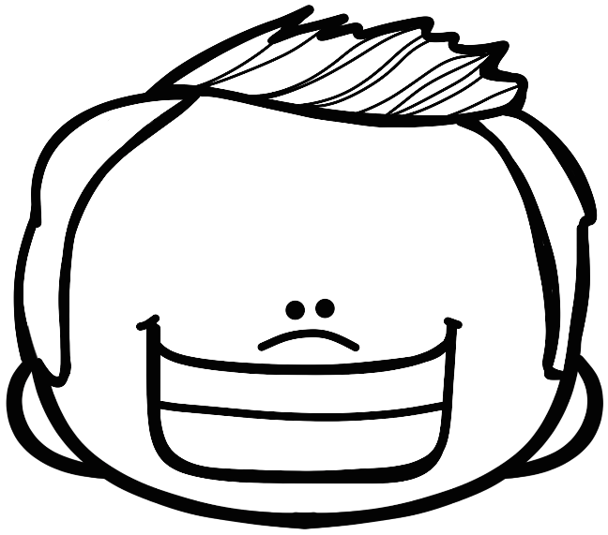

|  |  |  |  |  |
| --- | --- | --- | --- | --- |
| Listening and speaking rubric | | | | |
|  | 1 | 2 | 3 | 4 |
| 1. Learner is able to talk about himself and uses the subjects used by David in the story. |  |  |  |  |
| 1. The learner talks in full sentences. |  |  |  |  |
| 1. Learner speaks in a clear voice. |  |  |  |  |
| 1. Learners uses appropriate vocabulary, grammar and uses the correct tense. |  |  |  |  |
| 1. Learner speaks with confidence and makes eye contact. |  |  |  |  |
| Total | ___/20 | | | |

1. Needs assistance 2- Partial 3- Good 4- Excellent



Reading

Activity 1

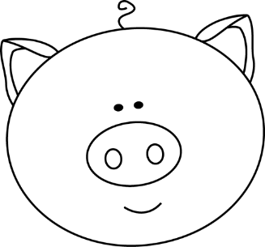Independent reading – Read the story below aloud to your Teacher.

**On the farm**

Farmer Fred stays on a very large farm. He farms with cows, corn and sheep. He has 100 cattle and 80 sheep.

On the farm he has chickens, horses and pigs. The chickens cluck, the horses neigh and the pigs oink. The farm is full of animal sounds. Farmer Fred goes to take out the eggs in the chickens nests every morning. This morning there were 10 eggs. He was so happy!

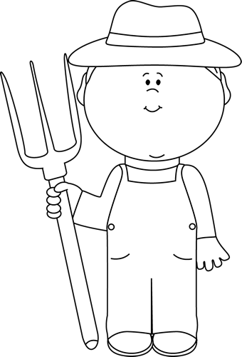

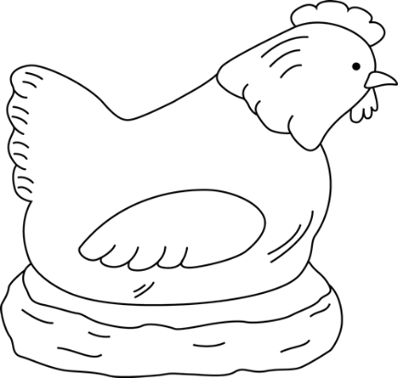

|  |  |  |
| --- | --- | --- |
| Rubric – Independent reading |  |  |
| 1. Words are pronounced correctly. | 2 |  |
| 1. Learner makes use of the reading strategies taught in the Home Language to make sense and monitor self when reading (phonics, contextual clues, structural analysis, sight words) | 2 |  |
| 1. Learner reads with increasing fluency and expression. | 2 |  |
| 1. Shows an understanding of punctuation when reading aloud. | 2 |  |
| 1. Reads with feeling and intonation. | 2 |  |
| Total | 10 |  |



Reading

Activity 2

Look at the pictures and sentences of the life cycle of a chicken. Read the sentences and match them with the correct picture by drawing a line with a ruler.

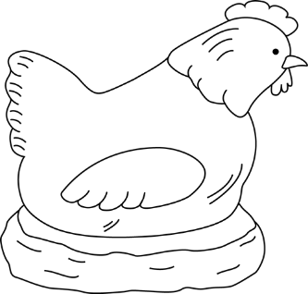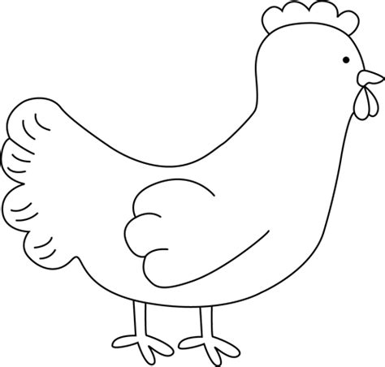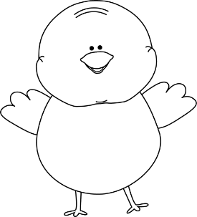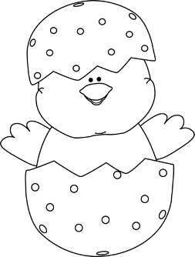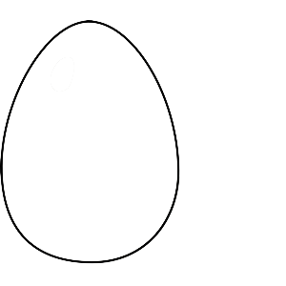

A baby chick.

A baby chick grows into a chicken.

The hen sits on the eggs to keep them warm.

Egg

The baby chick hatches from the egg.

|  |  |  |
| --- | --- | --- |
| Rubric – Reading: Life cycle of a chicken |  |  |
| 1. 1 mark for each sentence matched correctly to the picture. | 5 |  |
| Processed mark | 5x2 =10 | ___/10 |

|  |  |  |
| --- | --- | --- |
| Total mark for reading section |  |  |
| 1. Reading activity 1 | 10 |  |
| 1. Reading activity 2 | 10 |  |
| Total | 20 | ___/20 |



Phonics

1. Look at the pictures and fill in the correct beginning sound of each word by using **ch** or **sh**. (6)

|  |  |  |
| --- | --- | --- |
| C:\Users\MS\Downloads\SummerFunP4ClipsTrioriginalsDigitalClipArt\P4Clips Summer Fun\fan shell bw.png | See the source image | See the source image |
| **sh**ell | **ch**air | **sh**oe |
| See the source image | See the source image | See the source image |
| **sh**ark | **ch**eese | **ch**ip |

1. Build words below by using **th** at the beginning of the word. (3)

Any correct th word.

1. Complete the ending of each word by using ch, sh and th. (6¸2=3)
2. Every morning I brush my tee**th**.
3. I use a bru**sh** to paint.
4. My brother caught a big fi**sh** in the sea.
5. After rugby practice I take a long ba**th**.
6. On Sunday we go to chur**ch**.
7. I wi**sh** we can go on vacation.
8. Fill in the correct vowel for each word by using **a** or **o**. (6)

|  |  |  |  |
| --- | --- | --- | --- |
| C:\Users\MS\Downloads\FlashFreebieMathCliparttenframenumberlinebargraphsthermometer\clock BW.png | cl**o**ck | See the source image | c**a**ke |
| See the source image | p**o**t | See the source image | h**a**t |
| See the source image | g**a**te | See the source image | r**o**ck |

1. Write 4 of your own words using the vowels u and i. (4¸2 = 2)

|  |  |
| --- | --- |
| u | i |
| cut, cup, hug, duck, brush | sit, dip, hit, kid |
| bus, run, mug, drum, plum | bite, kite, fish, gift |

Any correct u and i word

|  |  |  |
| --- | --- | --- |
| Total mark for phonics section |  |  |
| 1. Complete the words - sh and ch | 6 |  |
| 1. Building words - th | 3 |  |
| 1. Complete the words | 3 |  |
| 1. Complete the middle sounds - u and i | 6 |  |
| 1. Write words with a and o as an middle sound. | 4¸2 = 2 |  |
| Total | 20 | ___/20 |



Writing

Activity 1: Language use

1. Colour the correct answer. (4)

|  |  |
| --- | --- |
|  | |
| The cow is brown. | The cow are brown. |

|  |  |
| --- | --- |
|  | |
| There is a book on the table. | There are a book on the table. |

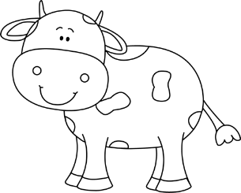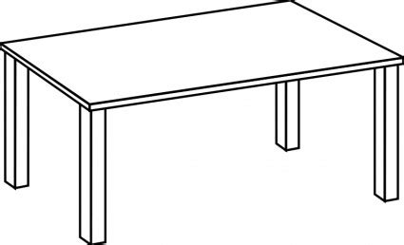



|  |  |
| --- | --- |
|  | |
| There are three children reading. | There is three children reading. |

|  |  |
| --- | --- |
|  | |
| There are 2 pigs. | There is 2 pigs. |

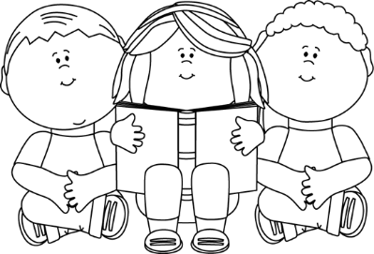

1. Use the words in the blocks to complete the sentences. (5)

|  |  |  |  |  |
| --- | --- | --- | --- | --- |
| what | where | why | when | who |

1. **Who** is 9 years old?
2. **Where** do you live?
3. **Why** is it so cold today?
4. **When** will we leave for school?
5. **What** is your name?
6. Colour the correct answer. (2)

|  |  |
| --- | --- |
|  | |
| pigs | pig |

|  |  |
| --- | --- |
|  | |
| cow | cows |

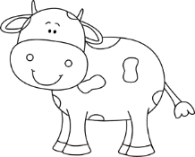

1. Write the words in the past tense. (4)
2. eat - ate
3. wash - washed
4. run - ran
5. play - played
6. Match the words with its opposite word by drawing a line with a ruler. (5)

win

rainy

short

hot

noisy

lose

tall

sunny

quiet

cold

|  |  |  |
| --- | --- | --- |
| Total mark for language use section |  |  |
| 1. Is and are | 4 |  |
| 1. When, why, what, where and who. | 5 |  |
| 1. Plurals | 2 |  |
| 1. Past tense | 4 |  |
| 1. Match the opposites | 5 |  |
| Total | 20 | ___/20 |



Writing

Activity 2: Writing

Complete the missing words by filling in things about yourself.

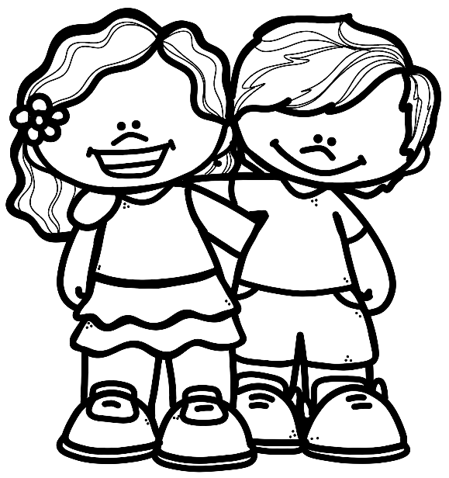

Each learners answer will be different.

I am in Grade ________. I am _________ years old. My birthday is on _____________________.

My hair is _________ and my eyes are _________.

I live in ________________. My favourite animal is ____________.

My favourite food is __________________________________. The food I like the least is ______________________________.

When I grow up I want to be a _____________________ because _________________________________________________________________________________________________________.

My favourite hobby is __________ because __________________

____________________________________________________

Something I am afraid of and why

_____________________________

_____________________________.

About myself

|  |  |  |  |  |  |
| --- | --- | --- | --- | --- | --- |
| **Rubric – Writing and Handwriting** | 1 | 2 | 3 | 4 | 5 |
| 1. Line usage – How well did the learner use his writing lines? | Many errors in line usage. | Some errors in line usage. | Few errors using lines correctly. | Uses lines correctly most of the time. | Always uses lines correctly. |
| 1. Spacing - How well did the learner space their letters and/or words? | Many errors in spacing. | Some errors in spacing. | Few errors using spacing correctly. | Uses proper spacing most of the time. | Always uses proper spacing. |
| 1. Letter formation-   Did the learner form his letters correctly? | Many errors in letter formation. Incorrect letter formations**.** | Some errors in letter formation. Letters formed incorrectly. | Few errors in letter formation. Few letters are formed incorrectly. | Most letters are formed correctly. | Consistently forms all letters correctly. |
| 1. Readability and neatness – How easy is it to read the learners handwriting? | Many errors in readability.  Difficult to read. | Some errors in readability.  Not neatly done. | Few errors in readability.  Not as neatly done. | Very easy to read. Writes neatly. | Always easy to read. Always writes neatly. |
| Total: ___/20 | | | | | |
| Processed mark: 20¸2 = ____/10 | | | | | |

|  |  |  |
| --- | --- | --- |
| Total mark for writing section |  |  |
| 1. Language use | 20 |  |
| 1. Writing | 10 |  |
| Total | 30 | ___/30 |