First Additional Language

Assessment Term 2

Grade 3

|  |  |  |
| --- | --- | --- |
| Content |  | Mark |
| 1. Listening and speaking | 20 |  |
| 1. Phonics | 20 |  |
| 1. Reading | 20 |  |
| 1. Writing | 60 |  |
| Total | 120 |  |

Name and Surname: \_\_\_\_\_\_\_\_\_\_\_\_\_\_\_\_\_\_\_\_\_\_\_\_\_\_\_\_

Date: \_\_\_\_\_\_\_\_\_\_\_\_\_\_\_\_\_\_\_\_\_\_\_\_\_\_\_\_\_\_\_\_\_



Listening

and speaking

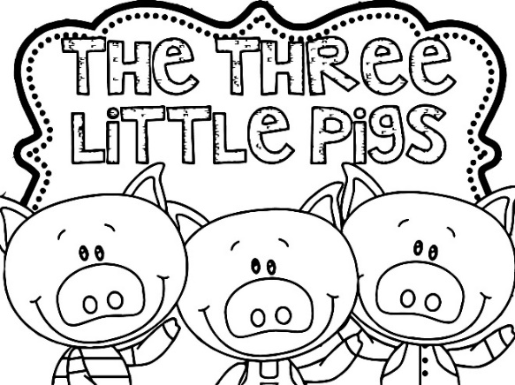

Activity 1

Listen to the story of the three little

pigs and answer the questions your

teacher is going to ask you.

|  |  |  |  |  |
| --- | --- | --- | --- | --- |
| Rubric: Listening and speaking: Activity 1 | | | | |
|  | 1 | 2 | 3 | 4 |
| 1. The learner is able to answer simple questions about the story, |  |  |  |  |
| 1. The learner answers in full sentences. |  |  |  |  |
| 1. Learner speaks in a clear voice. |  |  |  |  |
| 1. Learner uses appropriate vocabulary, grammar and uses the correct tense. |  |  |  |  |
| 1. Learner speaks with confidence and makes eye contact. |  |  |  |  |
| Total | \_\_\_/20 | | | |
| Processed mark out of 10 | 1. ¸ 2 = \_\_\_/10 | | | |

1 - Needs assistance 2- Partial 3- Good 4- Excellent



Listening

and speaking

Activity 2

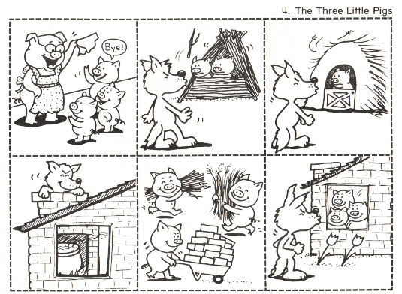Look at the pictures of the three little pigs and decide in which order they must be placed. Cut them out and paste them in the correct order on the next page.

Colour the pictures in.

The three little pigs

|  |  |  |
| --- | --- | --- |
| Listening and speaking - Activity 2 |  | Mark |
| 1. The learner pasted the pictures in the correct order. | 6 |  |
| 1. The learner coloured the pictures and it is neat. | 2 |  |
| 1. The learner cut the pictures neatly. | 1 |  |
| 1. The learner pasted the pictures neatly. | 1 |  |
| Total | \_\_\_/10 | |

|  |  |  |
| --- | --- | --- |
| Total mark for listening and speaking section |  |  |
| 1. Activity 1 | 10 |  |
| 1. Activity 2 | 10 |  |
| Total | \_\_\_/20 | |
| Processed mark out of 10 | 20 ¸ 2 =\_\_\_\_/10 | |

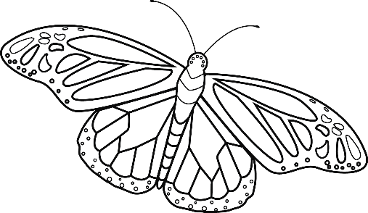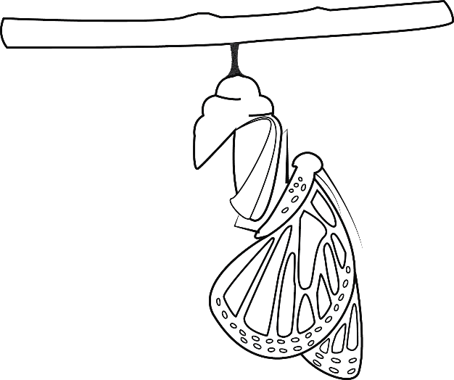

Reading

Activity 1

Answers literal questions about a story or non-fiction text.

Read the story and answer the questions.

Life cycles of animals

Animals have life cycles. A frog begins as an egg. When the egg hatches, it turns into a tadpole. The tadpoles grow legs and arms, and eventually grow into adult frogs. The adult frogs lay eggs, so that new frogs can live even after the frog grows old and dies.

A dog’s life cycle is a little different than a frog’s, because a dog does not start out as an egg. It is born from its mother’s belly. The puppy keeps on growing and is eventually an adult dog. Then the adult dog might have puppies to continue the life cycle!

Insects like caterpillars go through life cycles too. Caterpillars begin as eggs. When they hatch, they are larva. The caterpillar becomes a pupa, and inside of the pupa it turns into an adult. The adult is not a caterpillar; it is a butterfly! Then the butterfly lays eggs, so that new caterpillars and butterflies can live even after the butterfly grows old and dies.

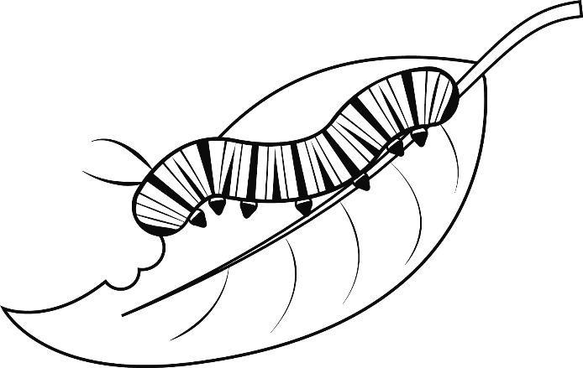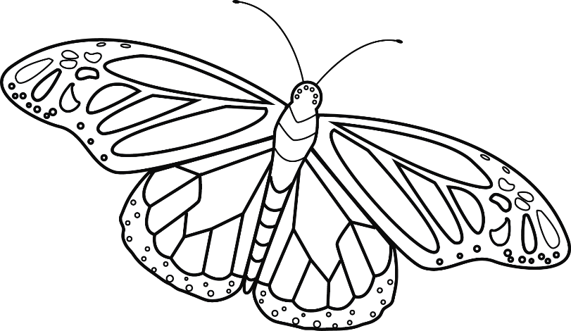

1. What does a frog begin as? \_\_\_\_\_\_\_\_\_\_\_\_\_\_\_\_\_ (1)
2. What does a frog’s egg turn into? \_\_\_\_\_\_\_\_\_\_\_\_\_\_\_ (1)
3. A dog is born from \_\_\_\_\_\_\_\_\_\_\_\_\_\_\_\_\_\_\_\_\_. (1)
4. What is a dog’s baby called? \_\_\_\_\_\_\_\_\_\_\_\_\_\_\_\_\_\_\_\_\_\_\_\_(1)
5. Complete the life cycle of a butterfly. (2)

\_\_\_\_\_\_\_\_\_ larva pupa \_\_\_\_\_\_\_\_\_\_

1. True or false. (4)
2. Animals do not have life cycles. \_\_\_\_\_\_\_\_\_\_\_\_\_\_ (1)
3. A dog’s life cycle start as a puppy. \_\_\_\_\_\_\_\_\_\_\_\_\_\_ (1)
4. Caterpillars are not insects. \_\_\_\_\_\_\_\_\_\_\_\_\_\_ (1)
5. A butterfly turns into a caterpillar. \_\_\_\_\_\_\_\_\_\_\_\_\_\_ (1)

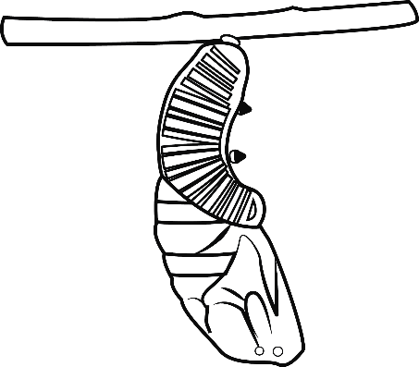

Total: \_\_\_\_\_\_/10



Reading

Activity 2

Group Guided Reading

Read aloud from your own book in a guided reading group with the teacher. This means the whole group reads the same story or non-fiction text with the teacher. You will be marked according to this rubric:

|  |  |  |
| --- | --- | --- |
| Rubric – Group Guided Reading |  |  |
| 1. Words are pronounced correctly. | 2 |  |
| 1. Learner makes use of the reading strategies taught in the Home Language to make sense and monitors self when reading (phonics, context clues, structural analysis, sight words) | 2 |  |
| 1. Learner reads with increasing fluency and expression. | 2 |  |
| 1. Shows an understanding of punctuation when reading aloud. | 2 |  |
| 1. Reads with feeling and intonation. | 2 |  |
| Total | 10 |  |



Phonics

Activity 1

1. Colour the pictures with the same beginning sound. (8¸2=4)

sh-, ch-, th- and wh-

|  |
| --- |
| See the source imageSee the source imageSee the source imageSee the source image1. |
| See the source imageSee the source imageSee the source imageSee the source image2. |
| 1. See the source imageSee the source imageSee the source image |
| 1. See the source imageSee the source imageSee the source imageSee the source image |

1. Colour the correct ending sound. (6)

-ng, -ck, -nk, -sh, -ar

|  |  |
| --- | --- |
| See the source image | See the source image |
| |  |  |  |  |  | | --- | --- | --- | --- | --- | | ng | ck | nk | sh | ar | | |  |  |  |  |  | | --- | --- | --- | --- | --- | | ng | ck | nk | sh | ar | |
| See the source image | See the source image |
| |  |  |  |  |  | | --- | --- | --- | --- | --- | | ng | ck | nk | sh | ar | | |  |  |  |  |  | | --- | --- | --- | --- | --- | | ng | ck | nk | sh | ar | |
| See the source imageWhat is the colour of the cat? | C:\Users\MS\Downloads\FREESuperheroCreativeKitCreativeClipsDigitalClipart\Creative Clips_Superhero Creative Kit\Creative Clips_Superhero Kit Images\Superhero Star_BW.png |
| |  |  |  |  |  | | --- | --- | --- | --- | --- | | ng | ck | nk | sh | ar | | |  |  |  |  |  | | --- | --- | --- | --- | --- | | ng | ck | nk | sh | ar | |

Total Activity 1: \_\_\_/10



Phonics

Activity 2

* 1. Listen to the words that your teacher is going to read and write them down. (6¸2=3)

1. \_\_\_\_\_\_\_\_\_\_\_\_\_\_\_
2. \_\_\_\_\_\_\_\_\_\_\_\_\_\_\_
3. \_\_\_\_\_\_\_\_\_\_\_\_\_\_\_
4. \_\_\_\_\_\_\_\_\_\_\_\_\_\_\_
5. \_\_\_\_\_\_\_\_\_\_\_\_\_\_\_
6. \_\_\_\_\_\_\_\_\_\_\_\_\_\_\_
   1. 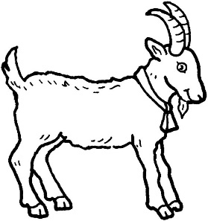Match the picture with the correct middle sound. (4) 

oo

****

ee

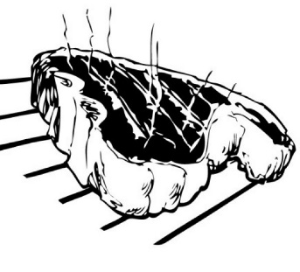****

oa

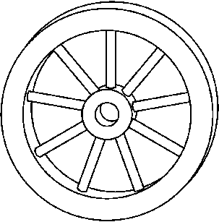****

ea

* 1. Colour all the words that rhyme with “cry”. (3)

fry

that

feet

fly

boat

shy

deal

this

Total Activity 2: \_\_\_/10

|  |  |  |
| --- | --- | --- |
| Total mark phonics section |  |  |
| 1. Activity 1 | 10 |  |
| 1. Activity 2 | 10 |  |
| Total | \_\_\_/20 | |



Writing

Language: Activity 1

1. Fill in the correct present progressive tense on the lines to complete the sentences. (5)
2. I am ( plant / planting ) \_\_\_\_\_\_\_\_\_\_\_ a seed.
3. I am ( counting / count ) \_\_\_\_\_\_\_\_\_\_the apples in the tree.
4. It is ( raining / rain ) \_\_\_\_\_\_\_\_\_\_\_ a lot.
5. It is ( snow / snowing ) \_\_\_\_\_\_\_\_\_\_\_ on the mountains.
6. We are ( walking / walk ) \_\_\_\_\_\_\_\_\_\_ to school.
7. Complete the sentences by using **is**, **am** or **are**. (5)
8. I \_\_\_\_\_ on the bus.
9. We \_\_\_\_\_ going to the beach.
10. It \_\_\_\_\_ a big house.
11. They \_\_\_\_\_ going up the mountain.
12. He \_\_\_\_\_ on the boat.
13. Complete the sentences by using **has** or **have**.
14. I \_\_\_\_\_\_ a book about wild animals.
15. My parents \_\_\_\_\_\_ a car.
16. My friend \_\_\_\_\_ to go home now.
17. Do you \_\_\_\_\_ any money left?
18. David \_\_\_\_\_ to write a test today.
19. Fill in **this**, **that**, **these** or **those**. (5)
20. \_\_\_\_\_\_\_ is my cat.
21. \_\_\_\_\_\_\_ is the moon.
22. \_\_\_\_\_\_\_ are my new shoes.
23. \_\_\_\_\_\_\_ are cars.
24. \_\_\_\_\_\_\_ is my teacher’s car.

|  |  |  |
| --- | --- | --- |
| Total mark language activity 1 |  | Mark |
| 1. Present progressive tense | 5 |  |
| 1. Fill in is, am or are. | 5 |  |
| 1. Fill in has or have. | 5 |  |
| 1. Fill in this, that, those or these. | 5 |  |
| Total | \_\_\_/20 | |
| Processed mark out of 10 = 20¸2 | \_\_\_/10 | |



Writing

Language: Activity 2

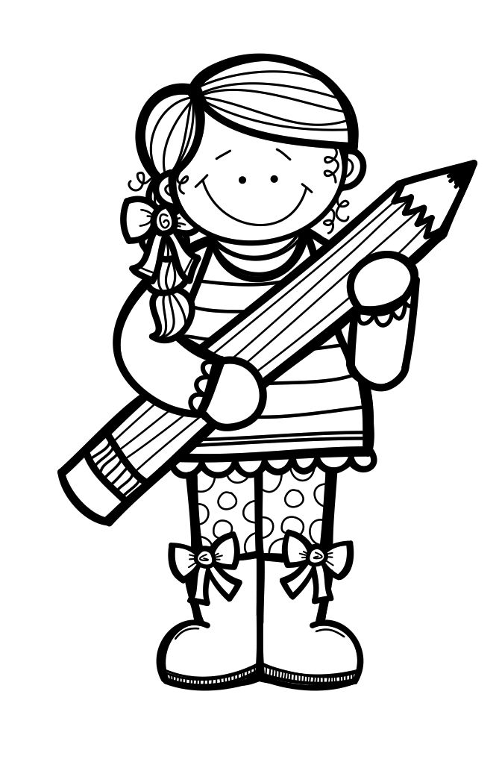

1. Fill in either **in** or **on**. (4)
2. My birthday is \_\_\_\_\_\_\_\_\_ July.
3. We go to church \_\_\_\_\_\_\_\_\_ Sunday.
4. We play soccer \_\_\_\_\_\_\_\_\_ Tuesday.
5. We swim \_\_\_\_\_\_\_\_\_ the summer.
6. Underline the correct answer. (4)
7. There is/There are one teacher in the class.
8. There is/There are a board in the front of the class.
9. There is/There are four boys in the class.
10. There is/There are three desks in the class.
11. Punctuate the sentence using capital letters and these punctuation marks. (4¸2=2)
12. have you seen my new shoes

\_\_\_\_\_\_\_\_\_\_\_\_\_\_\_\_\_\_\_\_\_\_\_\_\_\_\_\_\_\_\_\_\_\_\_\_\_\_\_\_\_\_\_\_\_\_\_\_\_\_\_\_\_

1. ann and nomsa wanted to cry.

\_\_\_\_\_\_\_\_\_\_\_\_\_\_\_\_\_\_\_\_\_\_\_\_\_\_\_\_\_\_\_\_\_\_\_\_\_\_\_\_\_\_\_\_\_\_\_\_\_\_\_\_\_

|  |  |  |
| --- | --- | --- |
| Total mark language activity 2 |  | Mark |
| 1. Fill in either in or on. | 4 |  |
| 1. Underline the correct answer. | 4 |  |
| 1. Punctuate the sentences. | 2 |  |
| Total | \_\_\_/10 | |

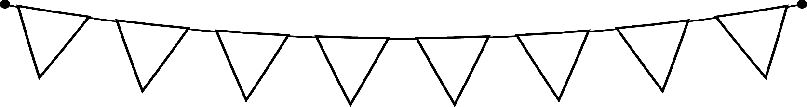

Writing

Activity 1

With support, write a simple set of instructions.

You have to write a recipe about: “How to make a peanut butter sandwich”. Write how you will make the sandwich on the lines. You must write a list of steps.

How to make a peanut butter sandwich

What will you need?

* 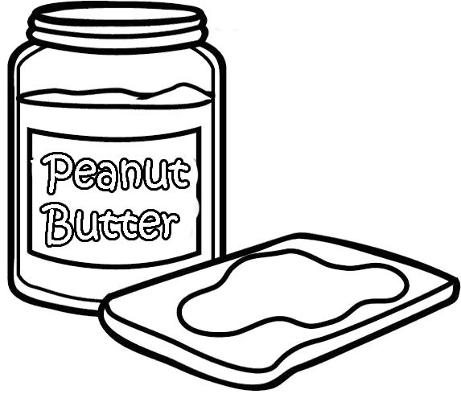2 slices of bread
* Peanut butter
* Margarine
* Knife
* Plate

How to make a peanut butter sandwich

\_\_\_\_\_\_\_\_\_\_\_\_\_\_\_\_\_\_\_\_\_\_\_\_\_\_\_\_\_\_\_\_\_\_\_\_\_\_\_\_\_\_\_\_\_\_\_\_\_\_\_\_\_\_\_\_\_\_\_\_\_\_\_\_\_\_\_\_\_\_\_\_\_\_\_\_\_\_\_\_\_\_\_\_\_\_\_\_\_\_\_\_\_\_\_\_\_\_\_\_\_\_\_\_\_\_\_\_\_\_\_\_\_\_\_\_\_\_\_\_\_\_\_\_\_\_\_\_\_\_\_\_\_\_\_\_\_\_\_\_\_\_\_\_\_\_\_\_\_\_\_\_\_\_\_\_\_\_\_\_\_\_\_\_\_\_\_\_\_\_\_\_\_\_\_\_\_\_\_\_\_\_\_\_\_\_\_\_\_\_\_\_\_\_\_\_\_\_\_\_\_\_\_\_\_\_\_\_\_\_\_\_\_\_\_\_\_\_\_\_\_\_\_\_\_\_\_\_\_\_\_\_\_\_\_\_\_\_\_\_\_\_\_\_\_\_\_\_\_\_\_\_\_\_\_\_\_\_\_\_\_\_\_\_\_\_\_\_\_\_\_\_\_\_\_\_\_\_\_\_\_\_\_\_\_\_\_\_\_\_\_\_\_\_\_\_\_\_\_\_\_\_\_\_\_\_\_\_\_\_\_\_\_\_\_\_\_\_\_\_\_\_\_\_\_\_\_\_\_\_\_\_\_\_\_\_\_\_\_\_\_\_\_\_\_\_\_\_\_\_\_\_\_\_\_\_\_\_\_\_\_\_\_\_\_\_\_\_\_\_\_\_\_\_\_\_\_\_\_\_\_\_\_\_\_\_\_\_\_\_\_\_\_\_\_\_\_\_\_\_\_\_\_\_\_\_\_\_\_\_\_\_\_\_\_\_\_\_\_\_\_\_\_\_\_\_\_\_\_\_\_\_\_\_\_\_\_\_\_\_\_\_\_\_\_\_\_\_\_\_\_\_\_\_\_\_\_\_\_\_\_\_\_\_\_\_\_\_\_\_\_\_\_\_\_\_\_\_\_\_\_\_\_\_\_\_\_\_\_\_\_\_\_\_\_\_\_\_\_\_\_\_\_\_\_\_\_\_\_\_\_\_\_\_\_\_\_\_\_\_\_\_\_\_\_\_\_\_\_\_\_\_\_\_\_\_\_\_\_\_\_\_\_\_\_\_\_\_\_\_\_\_\_\_\_\_\_\_\_\_\_\_\_\_\_\_\_\_\_\_\_\_\_\_\_\_\_\_\_\_\_\_\_\_\_\_\_\_\_\_\_\_\_\_\_\_\_\_\_\_\_\_\_\_\_\_\_\_\_\_\_\_\_\_\_\_\_\_\_\_\_\_\_\_\_\_\_\_\_\_\_\_\_\_\_\_\_\_\_\_\_\_\_\_\_\_\_\_\_\_\_\_\_\_\_\_\_\_\_\_\_\_\_\_\_\_\_\_\_\_\_\_\_\_\_\_\_\_\_\_\_\_\_\_\_\_\_\_\_\_\_\_\_\_\_\_\_\_\_\_\_\_\_\_\_\_\_\_\_\_\_\_\_\_\_\_\_\_\_\_\_\_\_\_\_\_\_\_\_\_\_\_\_\_\_\_\_\_\_\_\_\_\_\_\_\_\_\_\_\_\_\_\_\_\_\_\_\_\_\_\_\_\_\_\_\_\_\_\_\_\_\_\_\_\_\_\_\_\_\_\_\_\_\_\_\_\_\_\_\_\_\_\_\_\_\_\_\_\_\_\_\_\_\_\_\_\_\_\_\_\_\_\_\_\_\_\_\_\_\_\_\_\_\_\_\_\_\_\_\_\_\_\_\_\_\_\_\_\_\_\_\_\_\_\_\_\_\_\_\_\_\_\_\_\_\_\_\_\_\_\_\_\_\_\_\_\_\_\_\_\_\_\_\_\_\_\_\_\_\_\_\_\_\_\_\_\_\_\_\_\_\_\_\_\_\_\_\_\_\_\_\_\_\_\_\_\_\_\_\_\_\_\_\_\_\_\_\_\_\_\_\_\_\_\_\_\_\_\_\_\_\_\_\_\_\_\_\_\_\_\_\_\_\_\_\_\_\_\_\_\_\_\_\_\_\_\_\_\_\_\_\_\_\_\_\_\_\_\_\_\_\_\_\_\_\_\_\_\_\_\_\_\_\_\_\_\_\_\_\_\_\_\_\_\_\_\_\_\_\_\_\_\_\_\_\_\_\_\_\_\_\_\_\_\_\_\_\_\_\_\_\_\_\_\_\_\_\_\_\_\_\_\_\_\_\_\_\_\_\_\_\_\_\_\_\_\_\_\_\_\_\_\_\_\_\_\_\_\_\_\_\_\_\_\_\_\_\_\_\_\_\_\_\_\_\_\_\_\_\_\_\_\_\_\_\_\_\_\_\_\_\_\_\_\_\_\_\_\_\_\_\_\_\_\_\_\_\_\_\_\_\_\_\_\_\_\_\_\_\_\_\_\_\_\_\_\_\_\_\_\_\_\_\_\_\_\_\_\_\_\_\_\_\_\_\_\_\_\_\_\_\_\_\_\_\_\_\_\_\_\_\_\_\_\_\_\_\_\_\_\_\_\_\_\_\_\_\_\_\_\_\_\_\_\_\_\_\_\_\_\_\_\_\_\_\_\_\_\_\_\_\_\_\_\_\_\_\_\_\_\_\_\_\_\_\_\_\_\_\_\_\_\_\_\_\_\_\_\_\_\_\_\_\_\_\_\_\_\_\_\_\_\_\_\_\_\_\_\_\_\_\_\_\_\_\_\_\_\_\_\_\_\_\_\_\_\_\_\_\_\_\_\_\_\_\_\_\_\_\_\_\_\_\_\_\_\_\_\_\_\_\_\_\_\_\_\_\_\_\_\_\_\_\_\_\_\_\_\_\_\_\_\_\_\_\_\_\_\_\_\_\_\_\_\_\_\_\_\_\_\_\_\_\_\_\_\_\_\_\_\_\_\_\_\_\_\_\_\_\_\_\_\_\_\_\_\_\_\_\_\_\_\_\_\_\_\_\_\_\_\_\_\_\_\_\_\_\_\_\_\_\_\_\_\_\_\_\_\_\_\_\_\_\_\_\_\_\_\_\_\_\_\_\_\_\_\_\_\_\_\_\_\_\_\_\_\_\_\_\_\_\_\_\_\_\_\_\_\_\_\_\_\_\_\_\_\_\_\_\_\_\_\_\_\_\_\_\_\_\_\_\_\_\_\_\_\_\_\_\_\_\_\_\_\_\_\_\_\_\_\_\_\_\_\_\_\_\_\_\_\_\_\_\_\_\_\_\_\_\_\_\_\_\_\_\_\_\_\_\_\_\_\_\_\_\_\_\_\_\_\_\_\_\_\_\_\_\_\_\_\_\_\_\_\_\_\_\_\_\_\_\_\_\_\_\_\_\_\_\_\_\_\_\_\_\_\_\_\_\_\_\_\_\_\_\_\_\_\_\_\_\_\_\_\_\_\_\_\_\_\_\_\_\_\_\_\_\_\_\_\_\_\_\_\_\_\_\_\_\_\_\_\_\_\_\_\_\_\_\_\_\_\_\_\_\_\_\_\_\_\_\_\_\_\_\_\_\_\_\_\_\_\_\_\_\_\_\_\_\_\_\_\_\_\_\_\_\_\_\_\_\_\_\_\_\_\_\_\_\_\_\_\_\_\_\_\_\_\_\_\_\_\_\_\_\_\_\_\_\_\_\_\_\_\_\_\_\_\_\_\_\_\_\_\_\_\_\_\_\_\_\_\_\_\_\_\_\_\_\_\_\_\_\_\_\_\_\_\_\_\_\_\_\_\_\_\_\_\_\_\_\_\_\_\_\_\_\_\_\_\_\_\_\_\_\_\_\_\_\_\_\_\_\_\_\_\_\_\_\_\_\_\_\_\_\_\_\_\_\_\_\_\_\_\_\_\_\_\_\_\_\_\_\_\_\_\_\_\_\_\_\_\_\_\_\_\_\_\_\_\_\_\_\_\_\_\_\_\_\_\_\_\_\_\_\_\_\_\_\_\_\_\_\_\_\_\_\_\_\_\_\_\_\_\_\_\_\_\_\_\_\_\_\_\_\_\_\_\_\_\_\_\_\_\_\_\_\_\_\_\_\_\_\_\_\_\_\_\_\_\_\_\_\_\_\_\_\_\_\_\_\_\_\_\_\_\_\_\_\_\_\_\_\_\_\_\_\_\_\_\_\_\_\_\_\_\_\_\_\_\_\_\_\_\_\_\_\_\_\_\_\_\_\_\_\_\_\_\_\_\_\_\_\_\_\_\_\_\_\_\_\_\_\_\_\_\_\_\_\_\_\_\_\_\_\_\_\_\_\_\_\_\_\_\_\_\_\_\_\_\_\_\_\_\_\_\_\_\_\_\_\_\_\_\_\_\_\_\_\_\_\_\_\_\_\_\_\_\_\_\_\_\_\_\_\_\_\_\_\_\_\_\_\_\_\_\_\_\_\_\_\_\_\_\_\_\_\_\_\_\_\_\_\_\_\_\_\_\_\_\_\_\_\_\_\_\_\_\_\_\_\_\_\_\_\_\_\_\_\_\_\_\_\_\_\_\_\_\_\_\_\_\_\_\_\_\_\_\_\_\_\_\_\_\_\_\_\_\_\_\_\_\_\_\_\_\_\_\_\_\_\_\_\_\_\_\_\_\_\_\_\_\_\_\_\_\_\_\_\_\_\_\_\_\_\_\_\_\_\_\_\_\_\_\_\_\_\_\_\_\_\_\_\_\_\_\_\_\_\_\_\_\_\_\_\_\_\_\_\_\_\_\_\_\_\_\_\_\_\_\_\_\_\_\_\_\_\_\_\_\_\_\_\_\_\_

|  |  |  |  |  |  |
| --- | --- | --- | --- | --- | --- |
| Rubric – Writing activity 1 | 1 | 2 | 3 | 4 | 5 |
| 1. Line usage and spacing –  * How well did the learner use his writing lines? * How well did the learner space their letters and/or words? | Many errors in line usage. Many errors in spacing. | Some errors in line usage. Some errors in spacing. | Few errors using lines correctly. Few errors using spacing correctly. | Uses lines correctly most of the time. Uses proper spacing most of the time | Always uses lines correctly. Always uses proper spacing. |
| 1. Letter formation-   Did the learner form his letters correctly? | Many errors in letter formation. Incorrect letter formations**.** | Some errors in letter formation. Letters formed incorrectly. | Few errors in letter formation. Few letters are formed incorrectly. | Most letters are formed correctly. | Consistently forms all letters correctly. |
| 1. Readability – How easy is it to read the learners handwriting? | Many errors in readability. | Some errors in readability. | Few errors in readability. | Very easy to read. | Always easy to read. |
| 1. Neatness - How neat is the learner’s handwriting? | Difficult to read. | Not neatly done. | Not as neatly done. | Writes neatly. | Always writes neatly. |
| Total: \_\_\_/20 | | | | | |



Writing

Activity 2

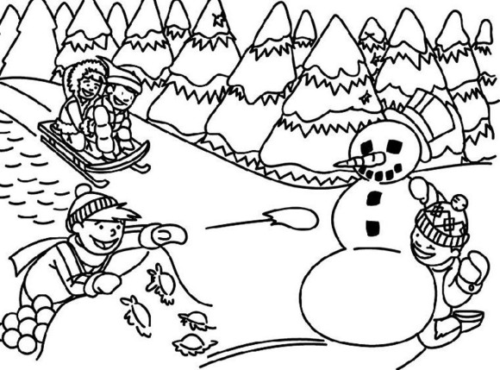Write a paragraph of 6-8 sentences about the picture.

\_\_\_\_\_\_\_\_\_\_\_\_\_\_\_\_\_\_\_\_\_\_\_\_\_\_\_\_\_\_\_\_\_\_\_\_\_\_\_\_\_\_\_\_\_\_\_\_\_\_\_\_\_\_\_\_\_\_\_\_\_\_\_\_\_\_\_\_\_\_\_\_\_\_\_\_\_\_\_\_\_\_\_\_\_\_\_\_\_\_\_\_\_\_\_\_\_\_\_\_\_\_\_\_\_\_\_\_\_\_\_\_\_\_\_\_\_\_\_\_\_\_\_\_\_\_\_\_\_\_\_\_\_\_\_\_\_\_\_\_\_\_\_\_\_\_\_\_\_\_\_\_\_\_\_\_\_\_\_\_\_\_\_\_\_\_\_\_\_\_\_\_\_\_\_\_\_\_\_\_\_\_\_\_\_\_\_\_\_\_\_\_\_\_\_\_\_\_\_\_\_\_\_\_\_\_\_\_\_\_\_\_\_\_\_\_\_\_\_\_\_\_\_\_\_\_\_\_\_\_\_\_\_\_\_\_\_\_\_\_\_\_\_\_\_\_\_\_\_\_\_\_\_\_\_\_\_\_\_\_\_\_\_\_\_\_\_\_\_\_\_\_\_\_\_\_\_\_\_\_\_\_\_\_\_\_\_\_\_\_\_\_\_\_\_\_\_\_\_\_\_\_\_\_\_\_\_\_\_\_\_\_\_\_\_\_\_\_\_\_\_\_\_\_\_\_\_\_\_\_\_\_\_\_\_\_\_\_\_\_\_\_\_\_\_\_\_\_\_\_\_\_\_\_\_\_\_\_\_\_\_\_\_\_\_\_\_\_\_\_\_\_\_\_\_\_\_\_\_\_\_\_\_\_\_\_\_\_\_\_\_\_\_\_\_\_\_\_\_\_\_\_\_\_\_\_\_\_\_\_\_\_\_\_\_\_\_\_\_\_\_\_\_\_\_\_\_\_\_\_\_\_\_\_\_\_\_\_\_\_\_\_\_\_\_\_\_\_\_\_\_\_\_\_\_\_\_\_\_\_\_\_\_\_\_\_\_\_\_\_\_\_\_\_\_\_\_\_\_\_\_\_\_\_\_\_\_\_\_\_\_\_\_\_\_\_\_\_\_\_\_\_\_\_\_\_\_\_\_\_\_\_\_\_\_\_\_\_\_\_\_\_\_\_\_\_\_\_\_\_\_\_\_\_\_\_\_\_\_\_\_\_\_\_\_\_\_\_\_\_\_\_\_\_\_\_\_\_\_\_\_\_\_\_\_\_\_\_\_\_\_\_\_\_\_\_\_\_\_\_\_\_\_\_\_\_\_\_\_\_\_\_\_\_\_\_\_\_\_\_\_\_\_\_\_\_\_\_\_\_\_\_\_\_\_\_\_\_\_\_\_\_\_\_\_\_\_\_\_\_\_\_\_\_\_\_\_\_\_\_\_\_\_\_\_\_\_\_\_\_\_\_\_\_\_\_\_\_\_\_\_\_\_\_\_\_\_\_\_\_\_\_\_\_\_\_\_\_\_\_\_\_\_\_\_\_\_\_\_\_\_\_\_\_\_\_\_\_\_\_\_\_\_\_\_\_\_\_\_\_\_\_\_\_\_\_\_\_\_\_\_\_\_\_\_\_\_\_\_\_\_\_\_\_\_\_\_\_\_\_\_\_\_\_\_\_\_\_\_\_\_\_\_\_\_\_\_\_\_\_\_\_\_\_\_\_\_\_\_\_\_\_\_\_\_\_\_\_\_\_\_\_\_\_\_\_\_\_\_\_\_\_\_\_\_\_\_\_\_\_\_\_\_\_\_\_\_\_\_\_\_\_\_\_\_\_\_\_\_\_\_\_\_\_\_\_\_\_\_\_\_\_\_\_\_\_\_\_\_\_\_\_\_\_\_\_\_\_\_\_\_\_\_\_\_\_\_\_\_\_\_\_\_\_\_\_\_\_\_\_\_\_\_\_\_\_\_\_\_\_\_\_\_\_\_\_\_\_\_\_\_\_\_\_\_\_\_\_\_\_\_\_\_\_\_\_\_\_\_\_\_\_\_\_\_\_\_\_\_\_\_\_\_\_\_\_\_\_\_\_\_\_\_\_\_\_\_\_\_\_\_\_\_\_\_\_\_\_\_\_\_\_\_\_\_\_\_\_\_\_\_\_\_\_\_\_\_\_\_\_\_\_\_\_\_\_\_\_\_\_\_\_\_\_\_\_\_\_\_\_\_\_\_\_\_\_\_\_\_\_\_\_\_\_\_\_\_\_\_\_\_\_\_\_\_\_\_\_\_\_\_\_\_\_\_\_\_\_\_\_\_\_\_\_\_\_\_\_\_\_\_\_\_\_\_\_\_\_\_\_\_\_\_\_\_\_\_\_\_\_\_\_\_\_\_\_\_\_\_\_\_\_\_\_\_\_\_\_\_\_\_\_\_\_\_\_\_\_\_\_\_\_\_\_\_\_\_\_\_\_\_\_\_\_\_\_\_\_\_\_\_\_\_\_\_\_\_\_\_\_\_\_\_\_\_\_\_\_\_\_\_\_\_\_\_\_\_\_\_\_\_\_\_\_\_\_\_\_\_\_\_\_

|  |  |  |  |  |  |
| --- | --- | --- | --- | --- | --- |
| Rubric – Writing activity 2 | 1 | 2 | 3 | 4 | 5 |
| 1. Line usage and spacing –  * How well did the learner use his writing lines? * How well did the learner space their letters and/or words? | Many errors in line usage. Many errors in spacing. | Some errors in line usage. Some errors in spacing. | Few errors using lines correctly. Few errors using spacing correctly. | Uses lines correctly most of the time. Uses proper spacing most of the time | Always uses lines correctly. Always uses proper spacing. |
| 1. Letter formation-   Did the learner form his letters correctly? | Many errors in letter formation. Incorrect letter formations**.** | Some errors in letter formation. Letters formed incorrectly. | Few errors in letter formation. Few letters are formed incorrectly. | Most letters are formed correctly. | Consistently forms all letters correctly. |
| 1. Readability – How easy is it to read the learners handwriting? | Many errors in readability. | Some errors in readability. | Few errors in readability. | Very easy to read. | Always easy to read. |
| 1. Neatness - How neat is the learner’s handwriting? | Difficult to read. | Not neatly done. | Not as neatly done. | Writes neatly. | Always writes neatly. |
| Total: \_\_\_/20 | | | | | |