

Writing

Language: Activity 2

1. Fill in either **in** or **on**. (4)
2. My birthday is **in** July.
3. We go to church **on** Sunday.
4. We play soccer **on** Tuesday.
5. We swim **in** the summer.
6. Underline the correct answer. (4)
7. **There is**/There are one teacher in the class.
8. **There is**/There are a board in the front of the class.
9. There is/**There are** four boys in the class.
10. There is/**There are** three desks in the class.
11. Punctuate the sentence using capital letters and these punctuation marks. (4¸2=2)
12. have you seen my new shoes

Have√ you seen my new shoes?√

1. ann and nomsa wanted to cry.

Ann√ and Nomsa√ wanted to cry.

|  |  |  |
| --- | --- | --- |
| Total mark language activity 2 |  | Mark |
| 1. Fill in either in or on. | 4 |  |
| 1. Underline the correct answer. | 4 |  |
| 1. Punctuate the sentences. | 2 |  |
| Total | ___/10 | |

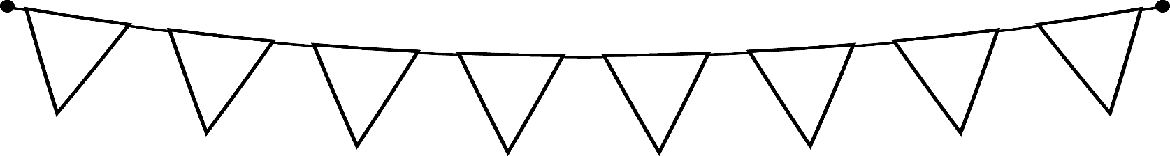

Writing

Activity 2

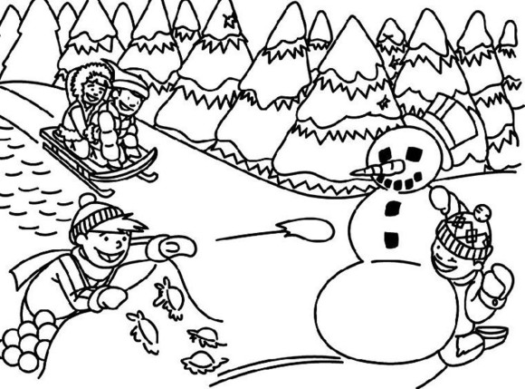Write a paragraph of 6-8 sentences about the picture.

________________________________________________________________________________________________________________________________________________________________________________________________________________________________________________________________________________________________________________________________________________________________________________________________________________________________________________________________________________________________________________________________________________________________________________________________________________________________________________________________________________________________________________________________________________________________________________________________________________________________________________________________________________________________________________________________________________________________________________________________________________________________________________________________________________________________________________________________________________________________________________________________

Learners own sentences and creativity.

|  |  |  |  |  |  |
| --- | --- | --- | --- | --- | --- |
| Rubric – Writing activity 2 | 1 | 2 | 3 | 4 | 5 |
| 1. Line usage and spacing –  * How well did the learner use his writing lines? * How well did the learner space their letters and/or words? | Many errors in line usage. Many errors in spacing. | Some errors in line usage. Some errors in spacing. | Few errors using lines correctly. Few errors using spacing correctly. | Uses lines correctly most of the time. Uses proper spacing most of the time | Always uses lines correctly. Always uses proper spacing. |
| 1. Letter formation-   Did the learner form his letters correctly? | Many errors in letter formation. Incorrect letter formations**.** | Some errors in letter formation. Letters formed incorrectly. | Few errors in letter formation. Few letters are formed incorrectly. | Most letters are formed correctly. | Consistently forms all letters correctly. |
| 1. Readability – How easy is it to read the learners handwriting? | Many errors in readability. | Some errors in readability. | Few errors in readability. | Very easy to read. | Always easy to read. |
| 1. Neatness - How neat is the learner’s handwriting? | Difficult to read. | Not neatly done. | Not as neatly done. | Writes neatly. | Always writes neatly. |
| Total: ___/20 | | | | | |