
Mathematics
Assessment term 2
Grade 2

Name and surname: ____________________________
School: __________________________________
Date: _________________________________

Content area |  | Mark
- Numbers, operations and relationships | 60
- Patterns, functions and algebra | 10
- Space and shape | 13
- Measurement | 12
- Data handling | 5
Total | 100

Numbers, operations and relationships

  - Count in multiples to work out the answer. Write down your answer in the block. (3)

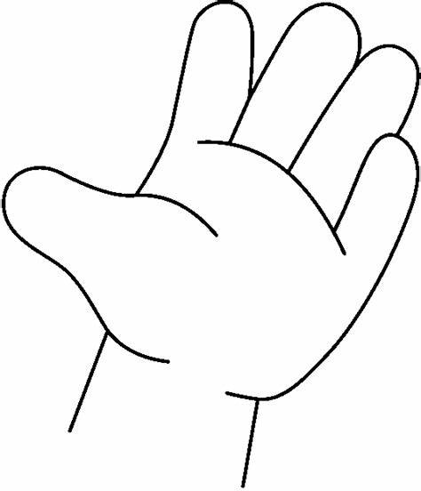
    - How many fingers are there in total? Count in 5’s.

=

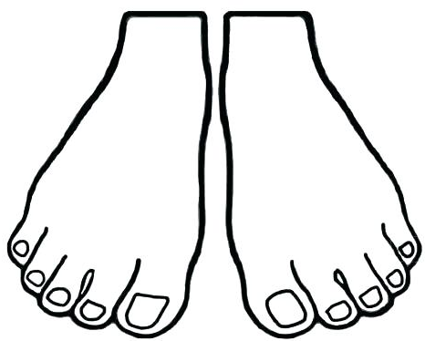
    - How many toes are there in total? Count in 10’s

=


    - How many eyes are there in total? Count in 2’s

=
  - Complete - Count forwards and backwards. (16)
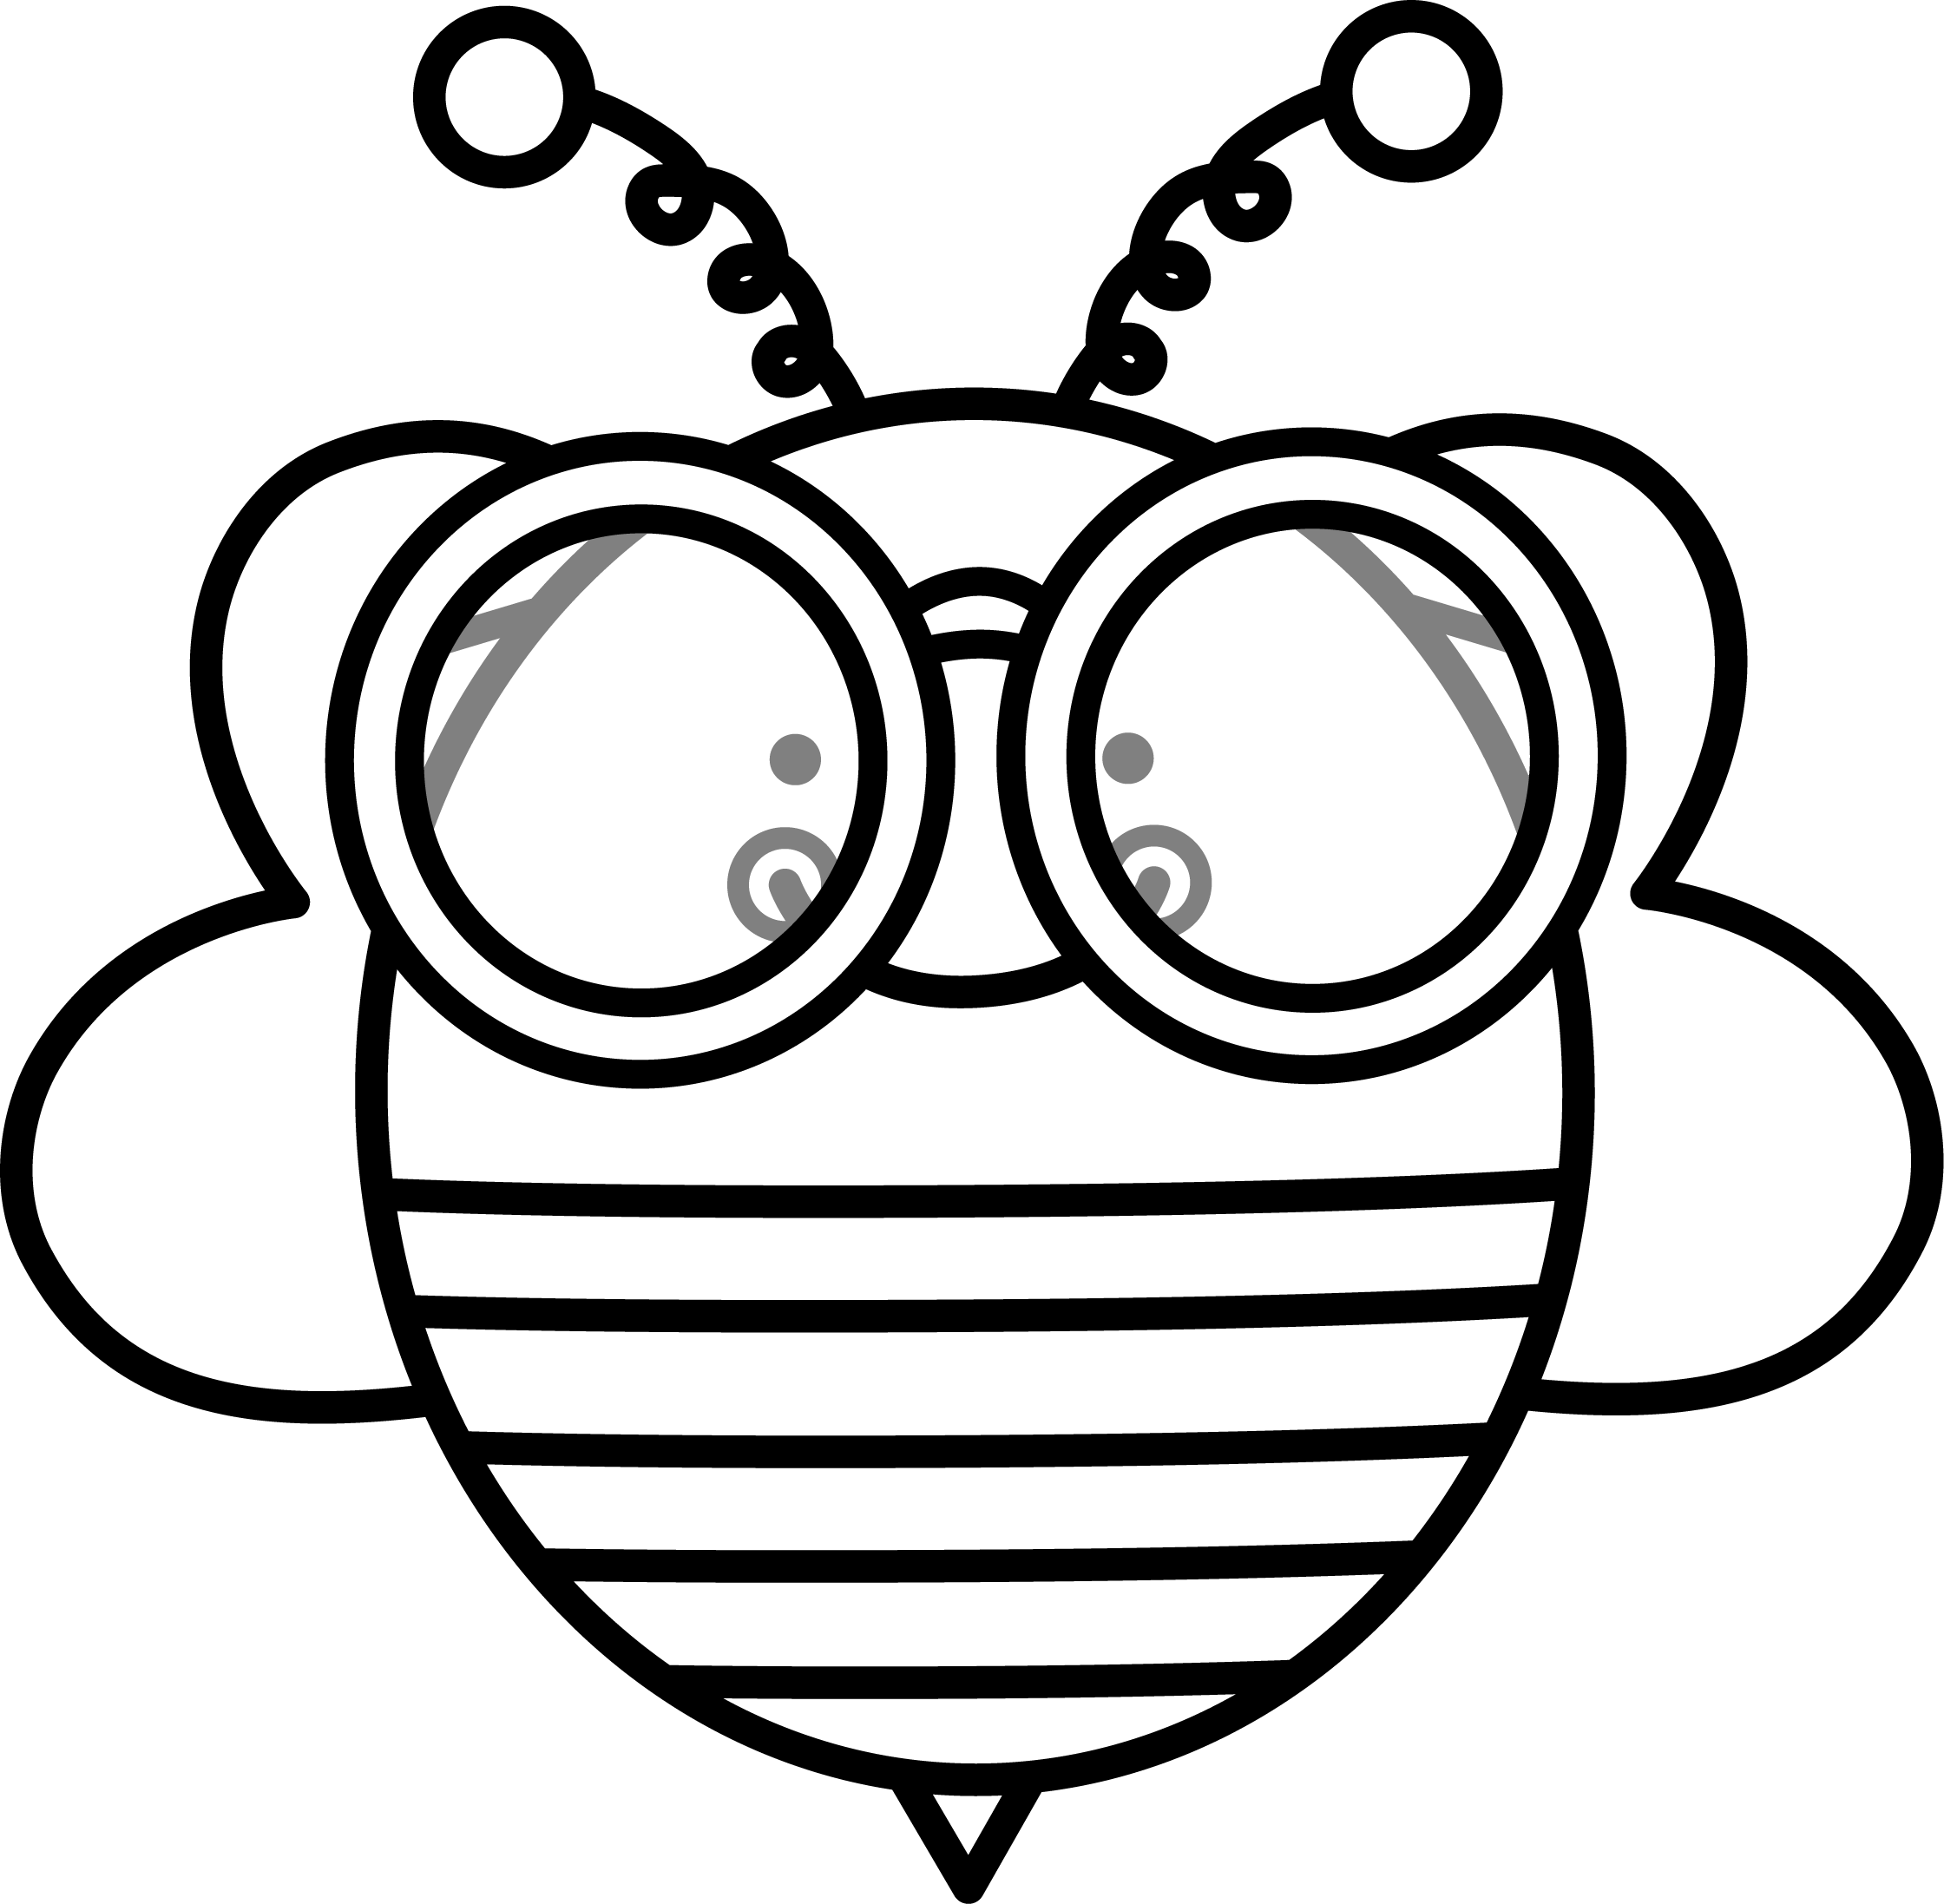
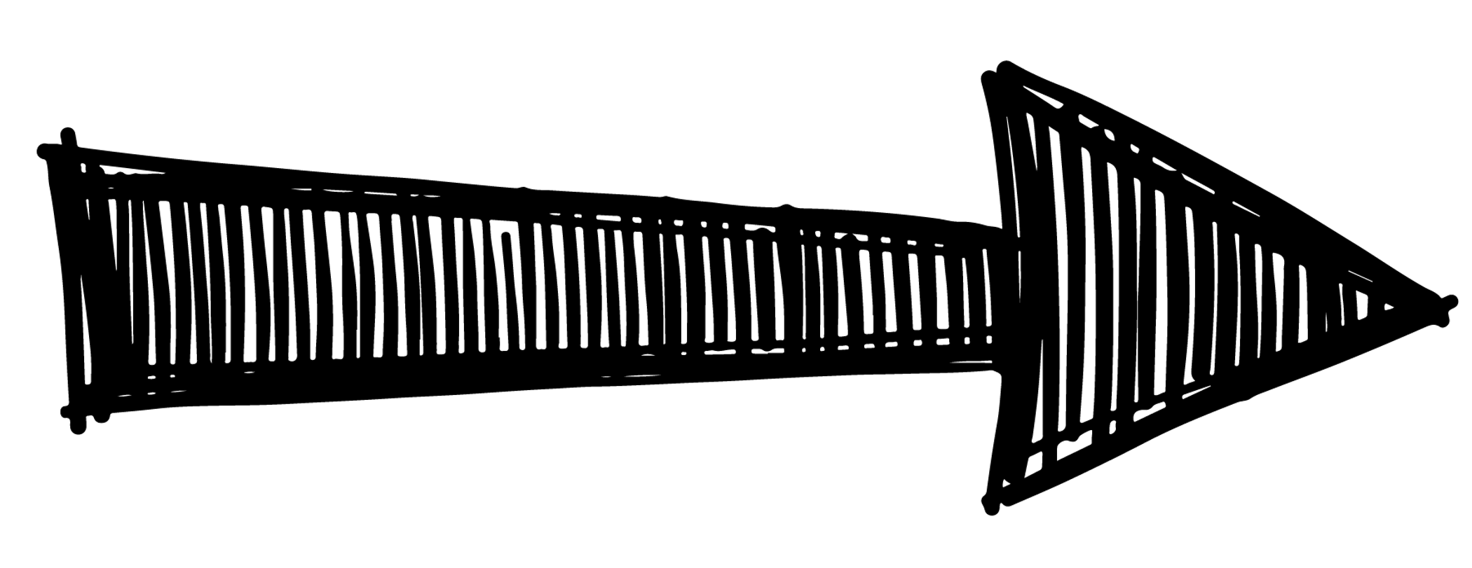

22
24

30
33

55
60
65

40
44

100
90
80

95
90

  - Match the number name to the number symbol. (4)

twenty-two
34

thirty-four
49

fifteen
22

forty-nine
15

  - Write down the number name for each number symbol. (5)
17
25
37
50
48

1.5 Complete the table. (21)
before |  | between |  |  | after
 | 46 | 19 |  | 21 | 49
 | 34 | 45 |  | 47 | 19
 | 19 | 22 |  | 24 | 35

What is 1 more than? |  | What is 1 less than? |  | What is 10 more than? |  | What is 10 less than?
23 |  | 20 |  | 20 |  | 50
29 |  | 31 |  | 30 |  | 20
49 |  | 42 |  | 40 |  | 40

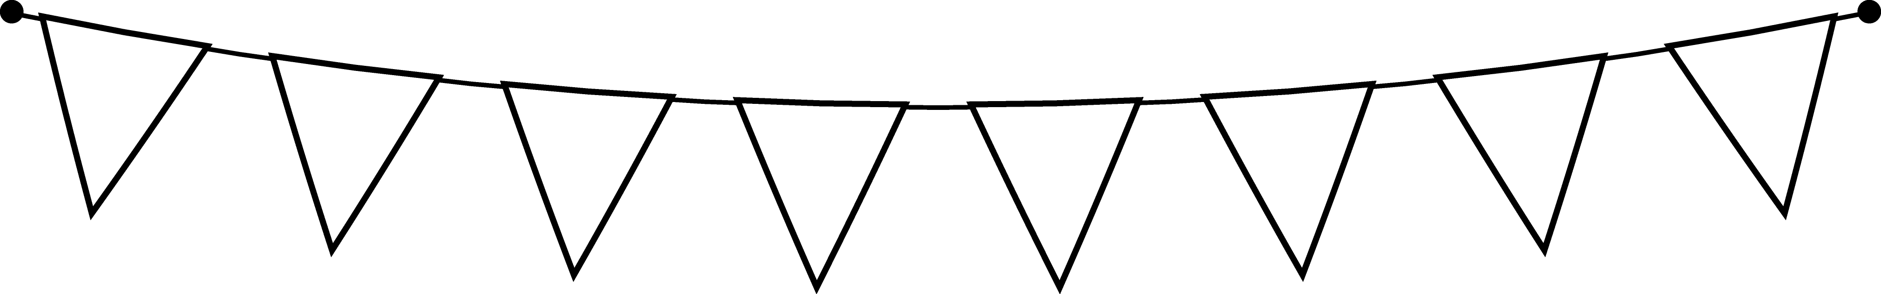
1.6 Study the numbers and complete the questions. (2)
15
23
43
3
11
50

- Write down the numbers from the smallest to the biggest. (1)
________________________________________
- Write down the numbers from the biggest to the smallest. (1)
________________________________________
1.7 Break up the following numbers into tens and ones.(4¸2=2)
Number | Tens | Ones
48
27

  - Mary and David have a slab of chocolate that they want to divide equally between the two of them.
- Colour the blocks to show your answer. (1)

- How many blocks do each one get? ____________ (1)

  - Match the fraction with the correct name. (4¸2=2)

ƒ
quarters

halves
å

†
fifths

‰
thirds

  - Answer the following questions: (6 x ƒ = 3)
- 2 groups of 5 is ______________ (ƒ)
- 4 groups of 4 is ______________ (ƒ)
- Double 15 = _________ (ƒ)
- Half 20 = _________ (ƒ)
- 20 + 5 = _________ (ƒ)
- 11 - 9 = _________ (ƒ)
Numbers, operations and relationships |  | Mark
- Counting | 3
- Count forwards and backwards | 16
- Number names and number symbols | 4
- Write down the number name | 5
- Before, after, between, 1 more, 1 less, 10 more, 10 less | 21
- Order of numbers. | 2
- Break up the numbers in tens and ones. | 2
- Division of fractions | 2
- Fraction names | 2
- Answer the questions | 3
Total | ___/60

Patterns, functions and algebra

2.1. Geometric patterns
red | yellow | blue | red |  |  | red
yellow | blue | blue | yellow |  | blue
a. Complete the following patterns. (24¸2=12)

b. Complete the following patterns. Colour the shapes in
different colours to form a pattern. (6¸2=3)
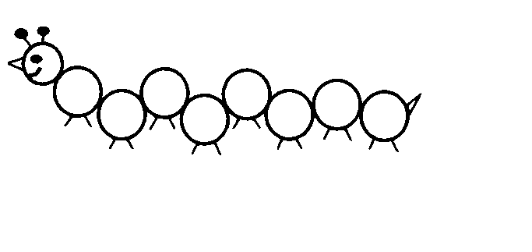
2.2. Number patterns - Complete the patterns. (5)
40
42
44
113
114
115




100
4
8
12
50
60
105

Pattern, functions and algebra |  | Mark
- Geometric patterns | 12
- Geometric patterns - complete | 3
- Number patterns | 5
Total | ___/20
Amended mark out of 10 (20¸2=10) | ___/10

Space and shape

3.1 Count the shapes and write down the name of each shape.
(8)

 | Name of shape | How many shapes do you count

  - Does the shapes have straight or round sides? Colour the correct answer. (2)

straight
round

straight
round

Space and shape |  | Mark
- Complete the table 2D shapes | 8
- Straight and round sides | 2
- Symmetry | 3
Total | ___/13

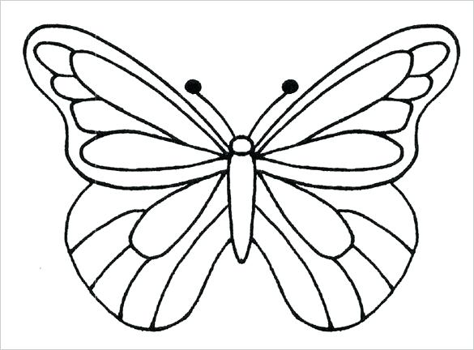
3.3. Divide the pictures in half. (3)

Measurement

4.1. Study the calendar and answer the questions. (6¸2=3)
May 2019
Sunday | Monday | Tuesday | Wednesday | Thursday | Friday | Saturday
 |  | 1 | 2 | 3 | 4 | 5
6 | 7 | 8 | 9 | 10 | 11 | 12
13 | 14 | 15 | 16 | 17 | 18 | 19
20 | 21 | 22 | 23 | 24 | 25 | 26
27 | 28 | 29 | 30 | 31

a. For which month is this calendar? __________ (1)
b. How many days are there in this month? __________ (1)
c. What day is after Monday? __________ (1)
c. What day is before Friday? _________ (1)
d. What day is between Friday and Sunday? ________ (1)
e. Write the following special days on the calendar: (2 x ƒ = 1)
- Jana’s birthday on 7 May 2019. (ƒ)
- Mark’s birthday on 31 May 2019. (ƒ)
4
4.2. What is the time? Write down the hours and half hours in
analog time. (2)
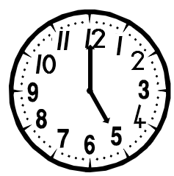
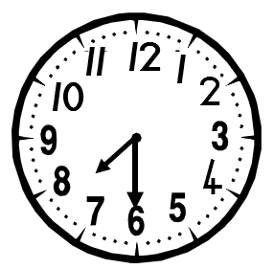

4.3. Draw the hands for the clocks. (2)
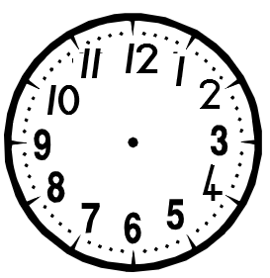

1 o’clock
half past 3

1 uur
1 uur
1 uur
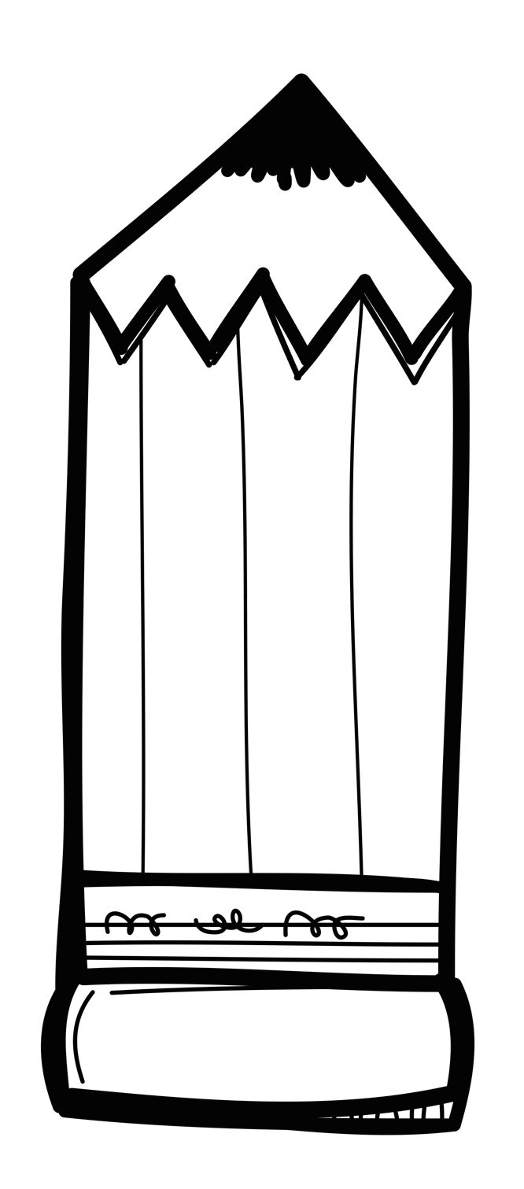
4.4. Study the pictures and decide if the second pencil is longer
or shorter than the first one. (2)

longer
shorter

longer
shorter

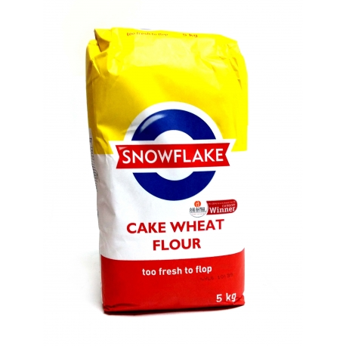
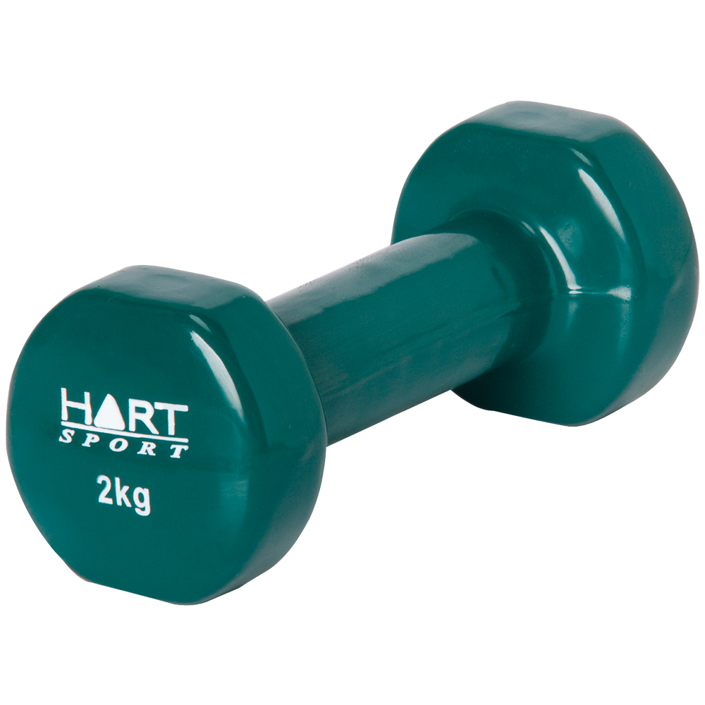

4.4. Write down the objects from the heaviest to the lightest.
rice
(3)

weight

flour

Measurement |  | Mark
- Time -  - Calendar. (3)  - What is the time? (2)  - Draw in the clock hands. (2) | 7
- Length | 2
- Mass | 3
Total out of 12 | ___/12

Data handling

Count the pets and then colour it on the graph. Answer the questions below.

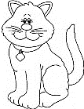
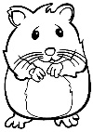

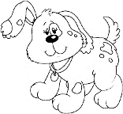
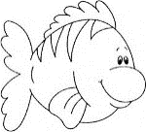
dog | cat | fish | hamster

- How many dogs are there? _____
- How many fish are there? _____
- How many more dogs are there than fish? _____

- Of which pet is there the most? Colour the picture.

- Of which pet is there the least? Colour the picture.

Data handling |  | Mark
- 1 mark for each correct block coloured in on the graph. | 5
- 1 mark for each question answered correctly. | 5
Total | ___/10
Amended mark out of 5 = (10¸2=5) | ___/5

