**Mathematics**

**Assessment task – Term 3**

**Grade 2**

**Name and Surname: ____________________________**

**Date: _________________________________**

|  |  |  |
| --- | --- | --- |
| **Question** |  | **Mark** |
| 1. Data Handling | **4** |  |
| 1. Measurement | **7** |  |
| 1. Numbers, Operations and Relationships | **24** |  |
| 1. Patterns, Functions and Algebra | **6** |  |
| 1. Space and Shape (Geometry) | **9** |  |
| **Total** | **50** |  |

1. **Data Handling**

Favorite cold drink

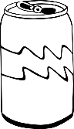

|  |  |  |  |  |
| --- | --- | --- | --- | --- |
|  |  |  |  |  |
|  |  |  |  |  |
|  |  |  |  |  |
|  |  |  |  |  |
|  |  |  |  |  |
|  |  |  |  |  |
|  |  |  |  |  |
|  |  |  |  |  |

Coke Fanta Grape Cream Soda Pepsi Sparberry

8

7

6

5

4

3

2

1

**Answer the following sentences:**

1. Which cold drink did the children like the **most**?

__________________________________________________

1. Which cold drink did the children like the **least**?

__________________________________________________

1. Which cold drink did the children like **equally**?

__________________________________________________

1. There is ___ more children who prefer Coke to Fanta Grape.

**Total question 1 = ___/4**

**Total = ___/4**

1. **Measurement**
   1. Order the containers weight from the least to the most.

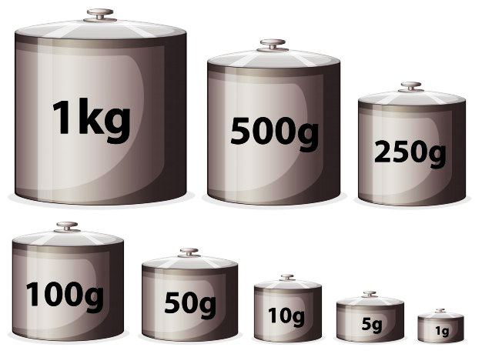



container 1 container 2 container 3 container 4

* + 1. ___________
    2. ___________
    3. ___________

**Total ( x 4) = ___/2**

* + 1. ___________
  1. Which month comes after January? ______________
  2. What day comes before Sunday? ________________
  3. What is the last day of the school week? __________________
  4. What is the first month of the year?

**Total = ___/4**

__________________

* 1. Draw the arms of the clock to show the time.

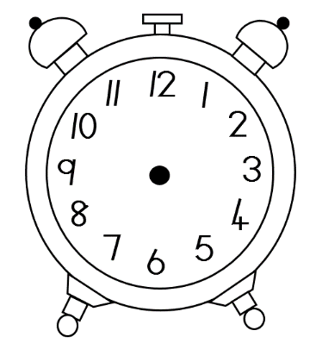**Half past 2**

**Total question 2 = ___/7**

**Total = ___/1**

1. **1. Numbers, Operations and Relationships**
   1. **Operations – Write down the answer.**

3.1.6. 2 less than 138 = ___

3.1.7. 2 more than 149 = ___

3.1.8. 4 groups of 5 = ___

3.1.9. 60 – 10 – 10 = ___

3.1.10. 4 more than 54 = ___

* + 1. 20 – 13 = ___
    2. 2 + 2 + 2 = ___
    3. 10 + 5 + 4 = ___
    4. Divide 100 in half= ___
    5. Double 25 = ___

**Total = ___/5**

* 1. **Geld**
     1. 50c + 10c + 5c + 1c = _____
     2. R100 - R50 + R5 = ____
     3. Match the money with their names by drawing a line with a ruler.

|  |  |  |  |
| --- | --- | --- | --- |
| Five rand | Two hundred rand | Fifty cent | Hundred rand |

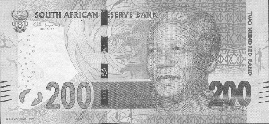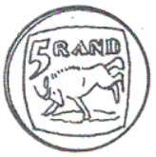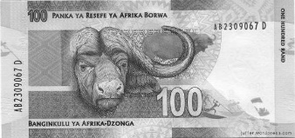

**Total = ___/6**

* 1. **Word problems**
     1. My mother bakes 24 cupcakes. She bakes another 24 cupcake. How many cupcakes did she bake altogether?

____________________________________________

* + 1. A truck has 28 bricks loaded on it. 9 of the bricks fell of the truck. How many bricks are left on the truck?

____________________________________________

**Total = ___/6**

* 1. **Rename numbers – Break up the numbers in hundreds, tens and units.**
     1. 125 = ________ + _______ + _______
     2. 60 = ________ + _______

**Total = ___/5**

* 1. **Number names – Write down the number names of the number symbols.**
     1. 74 - __________________________________
     2. 66 - __________________________________

**Total = ___/2**

**Total question 3 = ___/24**

1. **Patterns, Functions and Algebra**
   1. **Patterns – Complete the patterns below.**
      1. 215, 220, ___, ____, ____, 240.
      2. 190, 180, 170, ___, ___, ___, 130.
      3. 50, 52, 54, ___, ___, 60, ___.
      4. 2, 12, 22, ___, ___, ___, 62.
      5. Expand the pattern only once.

a)

b)

**Total = ___/6**

**Total question 4 = ___/6**

1. **Space and Shape**
   1. Match the 3D item with its 2D shape.

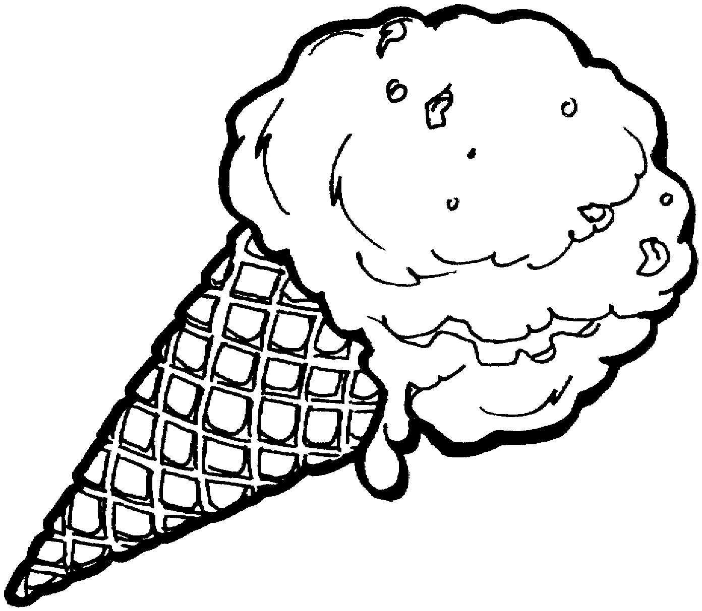

**Total = ___/1**

* 1. Look at the shapes below. Color in the following:
* Can the shapes roll or slide?
* Does the shapes have curved or straight sides?

|  |
| --- |
| slide |
| roll |

|  |
| --- |
| curved |
| straight |

|  |
| --- |
| slide |
| roll |

|  |
| --- |
| curved |
| straight |

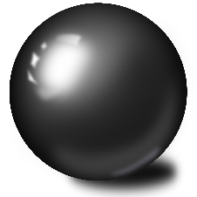

**Total = ___/4**

* 1. Draw a triangle and color it orange. Then draw a rectangle under the triangle and color it red.

**Total = ___/4**

**Total question 5 = ___/9**