Life skills

Assessment term 2

Grade 2

Name and surname: ____________________________

Date: _________________________________

|  |  |  |
| --- | --- | --- |
| Content area |  | Mark |
| 1. Beginning knowledge and Personal and Social well-being | 40 |  |
| 1. Creative arts | 20 |  |
| 1. Physical education | 30 |  |
| Total | 90 |  |



Beginning knowledge

Total: 20

QUESTION 1 - The seasons

* 1. 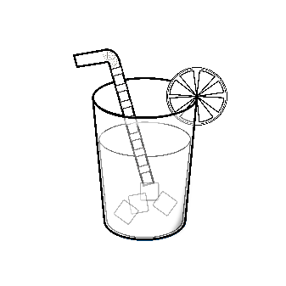Study the pictures and write down the correct season. (4)

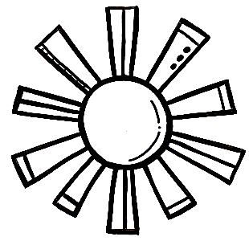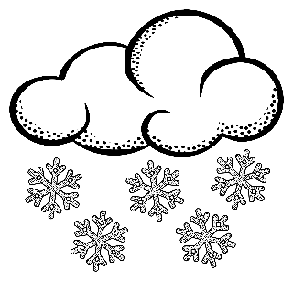

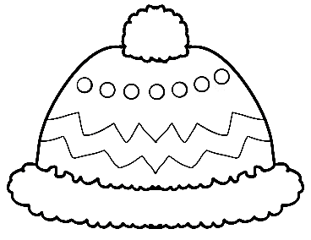

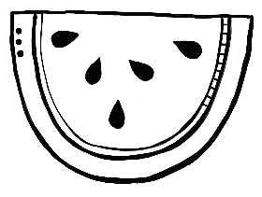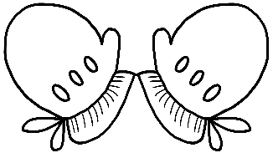

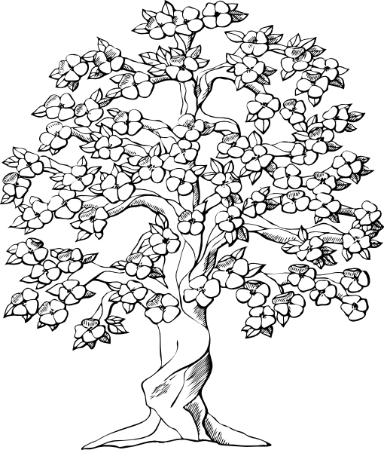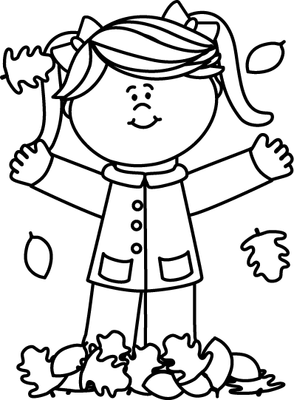

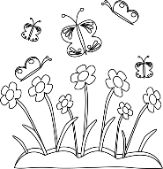

* 1. 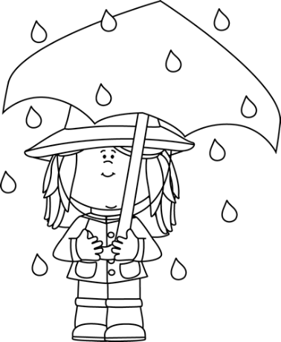Match the sentences to the correct pictures by drawing a line with your ruler. (4)

When it is sunny outside we wear hats to protect us from the sun.



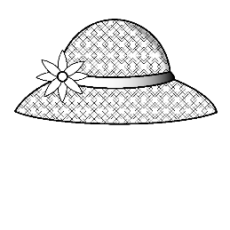

[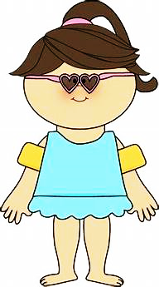](https://www.bing.com/images/search?view=detailV2&id=00D92ECC3337FDC3C8915B0169B3AC04F7A39623&thid=OIP.M52VmoIJa4GxzDRPSOiLQwAAAA&mediaurl=https://s-media-cache-ak0.pinimg.com/236x/67/a3/89/67a38931ac67bfbbd2e188c48c6b43af.jpg&exph=424&expw=236&q=summervclothes+clipart+black+and+white&selectedindex=12&ajaxhist=0&vt=2&eim=0,1,6&ccid=M52VmoIJ&simid=608043406521075222)

When it is cold outside we wear warm woolen clothing.

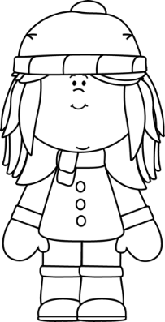

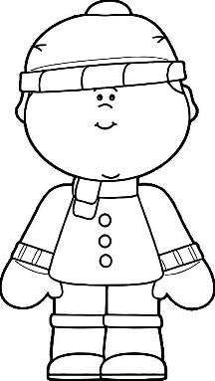

When it is hot outside we wear cool clothing.

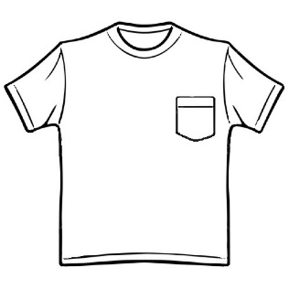

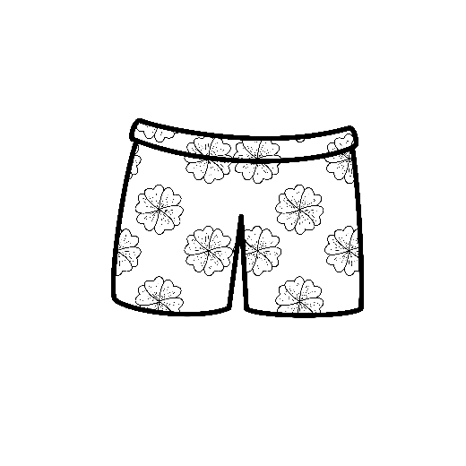

On rainy days we wear a rain coat and use an umbrella.

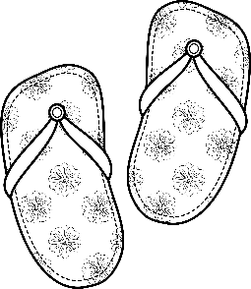

* 1. 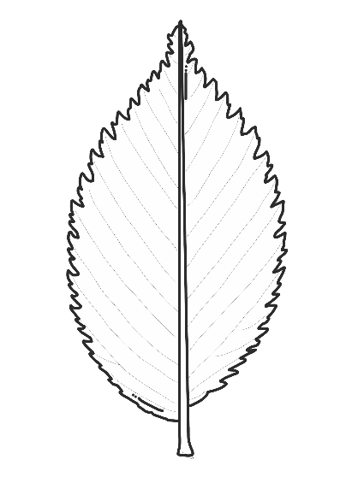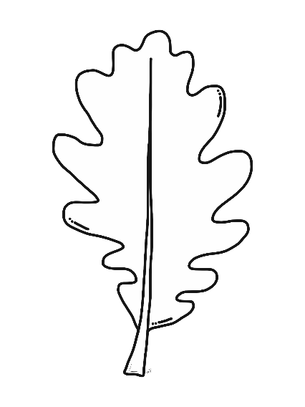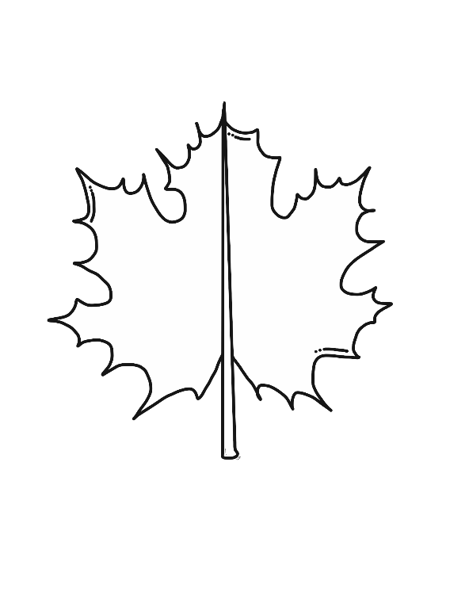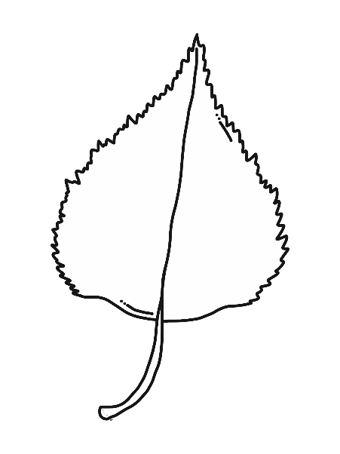Colour the leaves the colours of autumn. (4)
  2. What does some animals do the entire winter? (2)

____________________________________________________________________________________________

* 1. How does some animals protect themselves against the cold? (1)

____________________________________________________________________________________________

QUESTION 2- Farm animals

2.1. Complete the tables below. (10¸2=5)

|  |  |
| --- | --- |
| Male |  |
| Female |  |
| Baby |  |
| Sound |  |
| Shelter |  |

|  |  |
| --- | --- |
| Male |  |
| Female |  |
| Baby |  |
| Sound |  |
| Shelter |  |

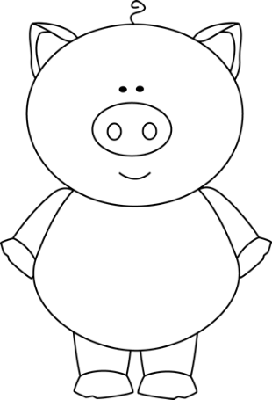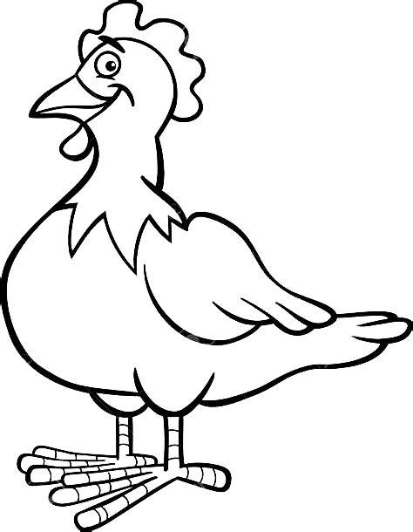

|  |  |  |
| --- | --- | --- |
| Rubric: Beginning knowledge |  | Mark |
| Question 1 - Seasons | 15 |  |
| Question 2 - Farm animals | 5 |  |
| Total | ____/20 | |



Personal and Social well-being

Total: 20

QUESTION 1 - Wild animals

* 1. Use the words in the blocks to complete the sentences. (10¸2 =5)

poachers

ivory tusks

bulls

smell

mammal

horns

tree

cat family

herds

see

1. The lion belong to the ___________.
2. Elephants are the biggest ___________ on land. They are endangered because poachers hunt them for their _______________.
3. Rhinos can’t _________ very well, but they have a very good sense of ________. They are hunted by ________ for their ___________.
4. A leopard drags it’s prey into a ___________ to eat it.
5. 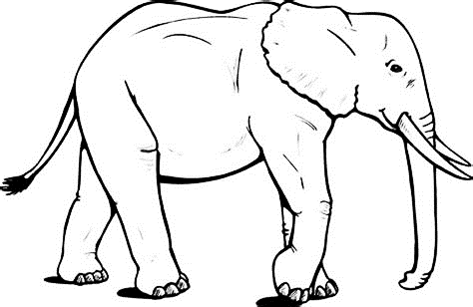 Buffaloes live in _________. When they see danger the cows and calves stay in the center of the herd while the _________ protect them.

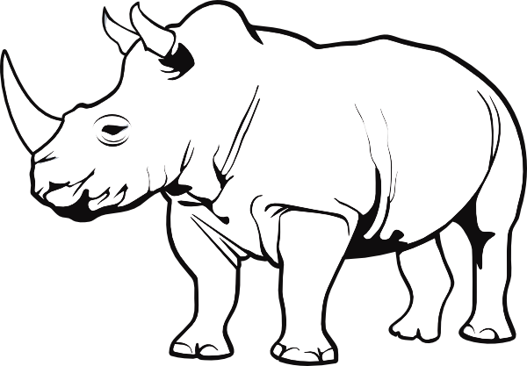

* 1. Draw a wild animal and write down a sentence on how the animal camouflages itself. (2)

Sentence: ___________________________________  
___________________________________

QUESTION 2 - Animals that live in a dam, river or the sea

2.1. Write down the names of animals that live in a dam, a river or the sea. (6¸2=3)

|  |  |  |
| --- | --- | --- |
| dam | river | sea |
|  |  |  |
|  |  |  |

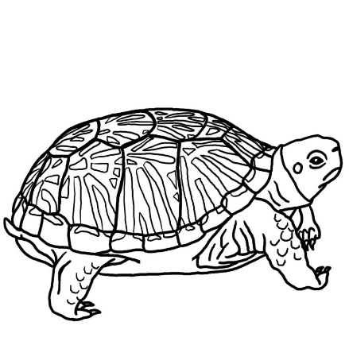

2.2. Where does the following reptiles live? (3)

1. Turtle - ________________________________________
2. Terrapin - ________________________________________
3. Tortoise - ________________________________________

2.3. Fill in the parts of the snail. (6¸2=3)

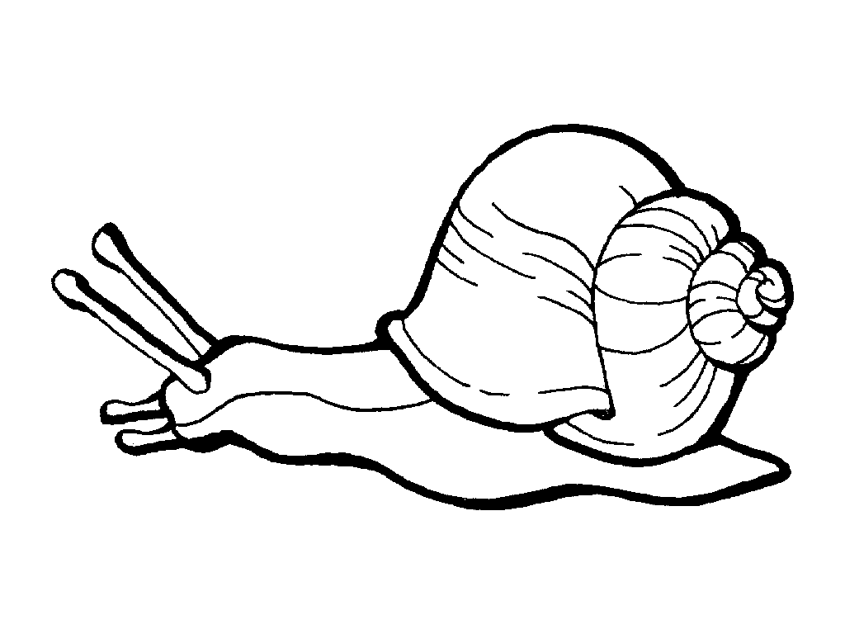

2.4. Answer the following questions: (4)

1. Where do bees live? ______________
2. What do bees build their shelter from? __________
3. Why do birds build nests? Give 2 reasons.

_________________________________

_________________________________

|  |  |  |
| --- | --- | --- |
| Rubric: Personal and Social well-being |  | Mark |
| Question 1.1. Wild animals - complete the sentences | 5 |  |
| Question 1.2. Draw a wild animal and write a sentence | 2 |  |
| Question 2.1. Names for animals that live in dam, river or sea. | 3 |  |
| Question 2.2. Where do the following reptiles live? | 3 |  |
| Question 2.3. Fill in the parts of a snail. | 3 |  |
| Question 2.2. Answer the questions. | 4 |  |
| Total | ____/20 | |

|  |  |  |
| --- | --- | --- |
| Total: Section 1 - Beginning knowledge and Personal and Social well-being |  | Mark |
| 1. Beginning knowledge | 20 |  |
| 1. Personal and Social well-being | 20 |  |
| Total | ____/40 | |



Creative arts

* Performing arts -

Activity: Improvise and interpret

Assignment: Role play

* 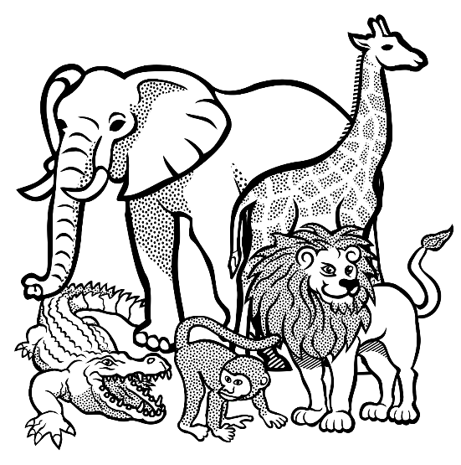Use the mask you made to do a role play with your friends. Your teacher will assign you to a group.
* The theme is: “In the wild.”
* Your performance must include the

different characteristic of your animal.

You will be marked according to the following rubric:

|  |  |  |  |  |  |  |
| --- | --- | --- | --- | --- | --- | --- |
|  | Rubric – Role play | Mark | | | | |
|  |  | 5 | 4 | 3 | 2 | 1 |
| 1. | Speaking: Was the learner’s speech clear with appropriate volume? | 5 | 4 | 3 | 2 | 1 |
| 2. | Imagination and Creativity | 5 | 4 | 3 | 2 | 1 |
| 3. | Did the learner make eye contact? | 5 | 4 | 3 | 2 | 1 |
| 4. | Did the learner perform with confidence? | 5 | 4 | 3 | 2 | 1 |
| Total | | /20 | | | | |
| Amended mark (20 ¸ 2 = 10) | | ___/10 | | | | |
|  | |  | | | | |

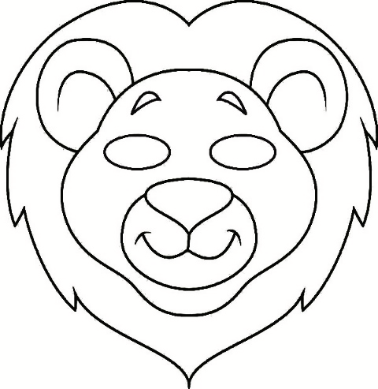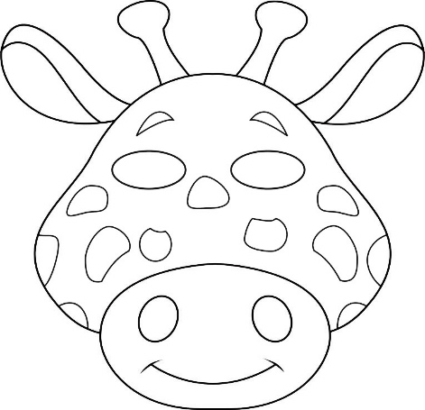

Creative arts

* Visual arts -

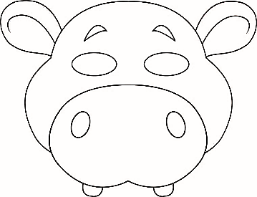

Assignment 3D design:

Make a mask of a wild animal. Use different materials to make your mask.

You will be marked according to the following rubric:

|  |  |  |  |  |
| --- | --- | --- | --- | --- |
| Rubric - Visual arts | 1 | 2 | 3 | 4 |
|  | Needs help | Adequate | Proficient | Outstanding |
| 1. The learner’s mask is colourfull. |  |  |  |  |
| 1. The learner kept to the theme and made a wild animal mask. |  |  |  |  |
| 1. Did the learner use different materials to make the mask? |  |  |  |  |
| 1. Was the learner creative? |  |  |  |  |
| 1. The mask is neat and the end product is of high quality. |  |  |  |  |
| Total | ___/20 | | | |
| Amended mark (20 ¸ 2 = 10) | ___/10 | | | |

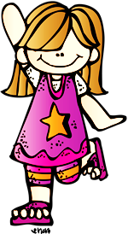

Physical Education

Activity 1

Activity 1 - Movement

Assignment:

Play follow the leader. Your teacher will choose the leaders. Copy the movements of the leader.

|  |  |  |  |  |
| --- | --- | --- | --- | --- |
| Rubric: Physical Education - Activity 1 | 1 | 2 | 3 | 4 |
|  | Needs help | Adequate | Proficient | Excellent |
| 1. Can the learner do the different movements? |  |  |  |  |
| 1. Listening skills - learner listens to assignments and takes part. |  |  |  |  |
| 1. The learner enjoys taking part and is enthusiastic. |  |  |  |  |
| 1. The learner shows respect towards the learner presenting the activity. |  |  |  |  |
| 1. The learner shows respect towards his / her fellow class mates. |  |  |  |  |
| Total | ___/20 | | | |

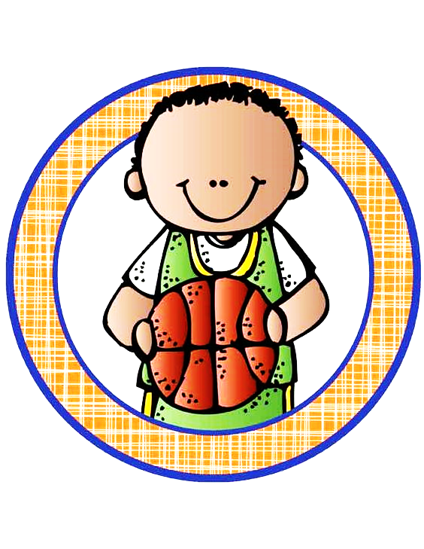

Physical Education

Activity 2

Activity 2 - Ball skills

Assignment:

* Stand in a circle.
* Pass the ball in the circle.
* Pass the ball to your friend over your head.
* Pass the ball to your friend between your legs.
* Break into groups of two. Stand a few steps away from each other.
* Throw the ball to your friend. Catch the ball when your friend throws it.
* Bounce the ball to your friend. Catch the ball when your friend bounces it.

|  |  |  |
| --- | --- | --- |
| Rubric: Physical Education - Activity 2 |  | Mark |
| 1. Did the learner pass the ball in the circle? | 2 |  |
| 1. Did the learner pass the ball over his / her head? | 2 |  |
| 1. Did the learner pass the ball between his / her legs? | 2 |  |
| 1. Could the learner throw and catch the ball? | 2 |  |
| 1. Could the learner bounce and catch the ball? | 2 |  |
| Total | ____/10 | |