Life skills

Assessment term 2

Grade 2

Name and surname: ____________________________

Date: _________________________________

MEMORANDUM

|  |  |  |
| --- | --- | --- |
| Content area |  | Mark |
| 1. Beginning knowledge and Personal and Social well-being | 40 |  |
| 1. Creative arts | 20 |  |
| 1. Physical education | 30 |  |
| Total | 90 |  |



Beginning knowledge

Total: 20

QUESTION 1 - The seasons

* 1. 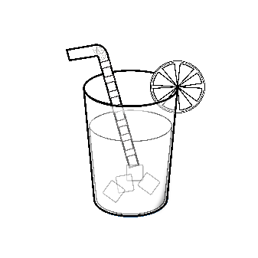Study the pictures and write down the correct season. (4)

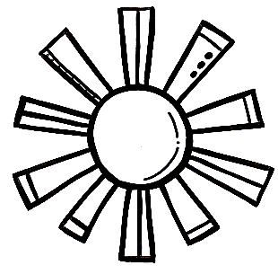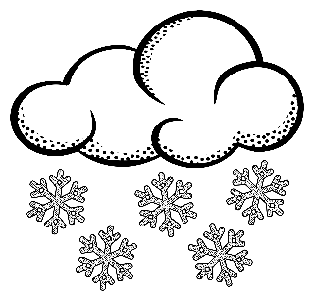

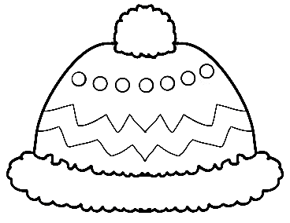

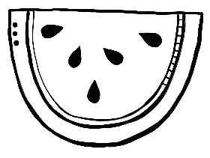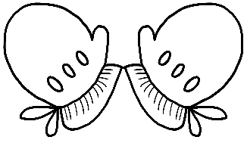

summer

winter

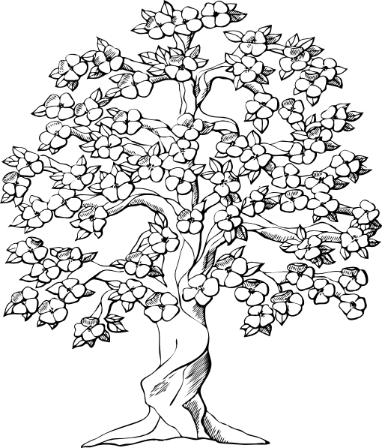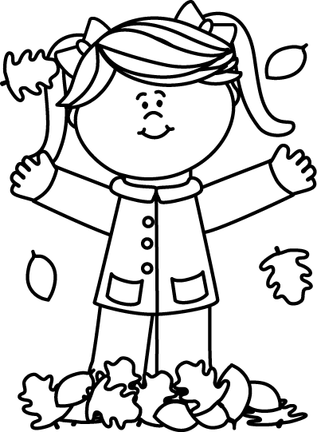

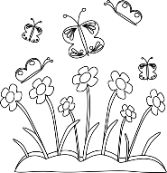

spring

autumn

* 1. 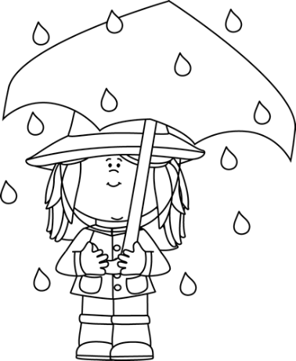Match the sentences to the correct pictures by drawing a line with your ruler. (4)

When it is sunny outside we wear hats to protect us from the sun.



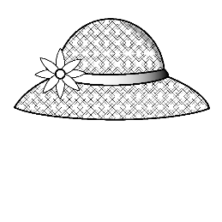

[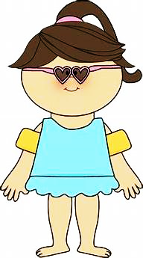](https://www.bing.com/images/search?view=detailV2&id=00D92ECC3337FDC3C8915B0169B3AC04F7A39623&thid=OIP.M52VmoIJa4GxzDRPSOiLQwAAAA&mediaurl=https://s-media-cache-ak0.pinimg.com/236x/67/a3/89/67a38931ac67bfbbd2e188c48c6b43af.jpg&exph=424&expw=236&q=summervclothes+clipart+black+and+white&selectedindex=12&ajaxhist=0&vt=2&eim=0,1,6&ccid=M52VmoIJ&simid=608043406521075222)

When it is cold outside we wear warm woolen clothing.

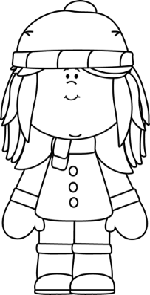

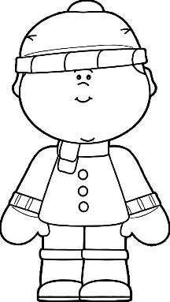

When it is hot outside we wear cool clothing.

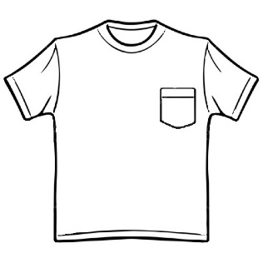

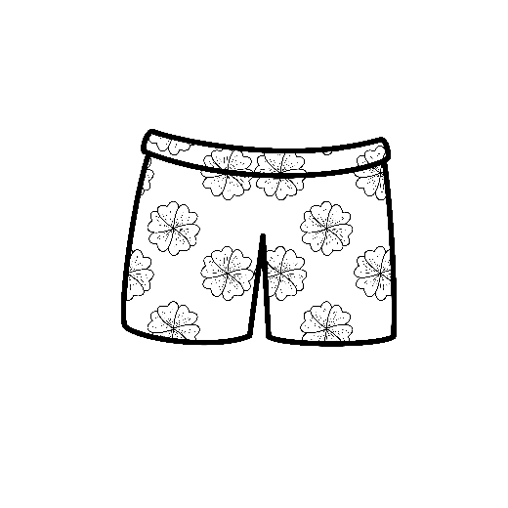

On rainy days we wear a rain coat and use an umbrella.

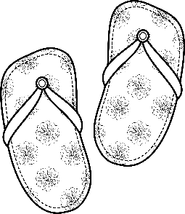

* 1. 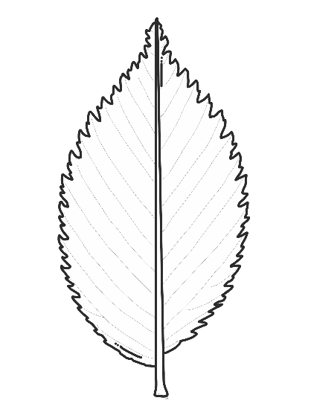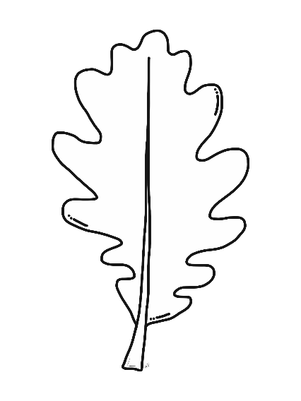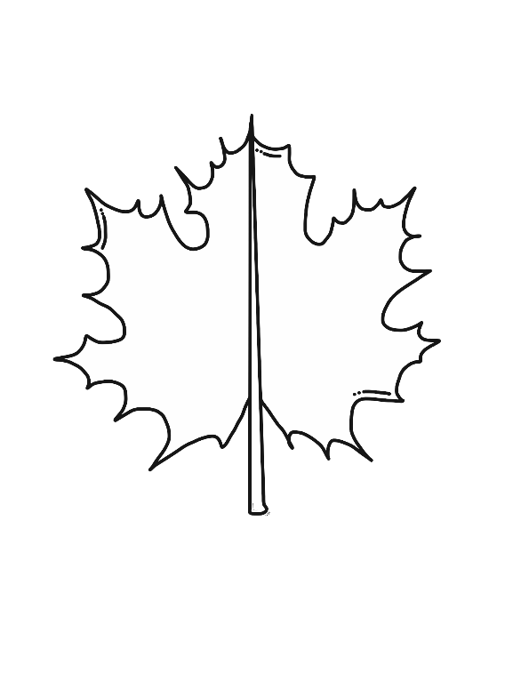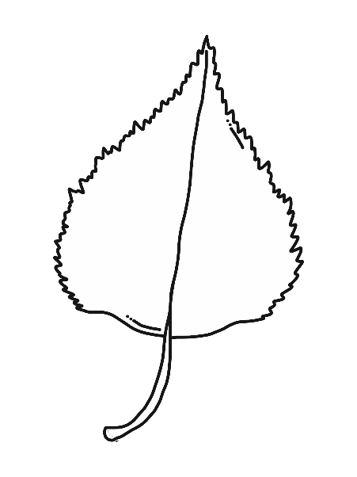Colour the leaves the colours of autumn. (4)
  2. What does some animals do the entire winter? (2)

Some animals sleep through the winter.√ We say they hibernate.√

* 1. How does some animals protect themselves against the cold? (1)

They have thick furs that keep them warm.

QUESTION 2- Farm animals

2.1. Complete the tables below. (10¸2=5)

|  |  |
| --- | --- |
| Male | boar |
| Female | sow |
| Baby | piglet |
| Sound | oink |
| Shelter | pigsty |

|  |  |
| --- | --- |
| Male | rooster |
| Female | hen |
| Baby | chick |
| Sound | cluck |
| Shelter | chicken coop |

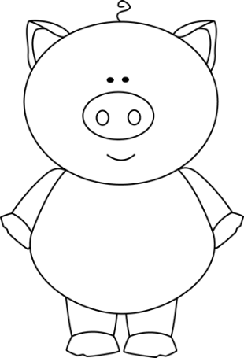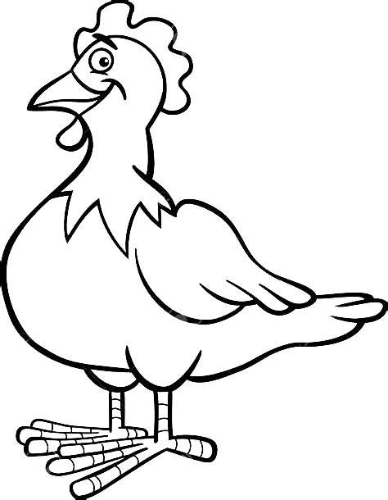

|  |  |  |
| --- | --- | --- |
| Rubric: Beginning knowledge |  | Mark |
| Question 1 - Seasons | 15 |  |
| Question 2 - Farm animals | 5 |  |
| Total | ____/20 | |



Personal and Social well-being

Total: 20

QUESTION 1 - Wild animals

* 1. Use the words in the blocks to complete the sentences. (10¸2 =5)

poachers

ivory tusks

bulls

smell

mammal

horns

tree

cat family

herds

see

cat family

1. The lion belong to the

mammal

1. Elephants are the biggest on land. They are endangered because poachers hunt them for their

see

ivory tusks

1. Rhinos can’t very well, but they have a very good sense of . They are hunted by for their

horns

poachers

smell

tree

1. A leopard drags it’s prey into a to eat it.

herds

1. 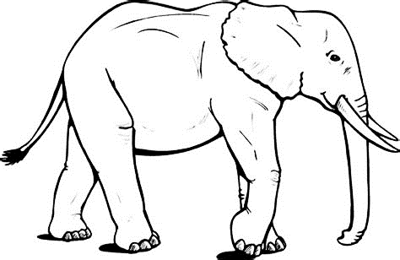 Buffaloes live in . When they see danger the cows and calves stay in the center of the herd while the protect them.

bulls

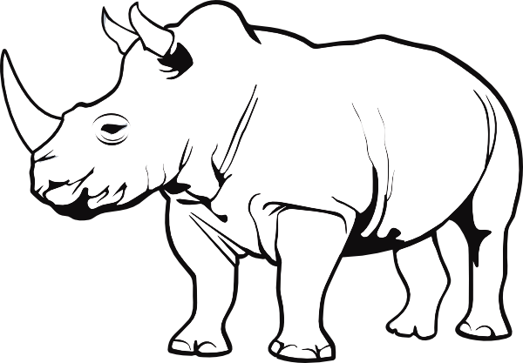

* 1. Draw a wild animal and write down a sentence on how the animal camouflages itself. (2)
* Chameleons can change their colour to match the trees they climb.
* Zebra stripes make it very difficult to see a zebra in the bush.
* Leopard: The coats of a leopard are adapted in such a way that it makes them difficult to spot.
* Owl: The feathers of an owl are adapted in such a way that it makes them difficult to spot.

Any of the above answers are correct.

Sentence: ___________________________________  
___________________________________

QUESTION 2 - Animals that live in a dam, river or the sea

2.1. Write down the names of animals that live in a dam, a river

or the sea. (6¸2=3)

|  |  |  |
| --- | --- | --- |
| dam | river | sea |
| Ducks, crab, fish, insects, turtle and frogs. | Crocodile, crab, fish, snake and otter. | Crab, whale, fish, jellyfish, starfish etc. |
| Any other relevant answer can be marked correct. | | |

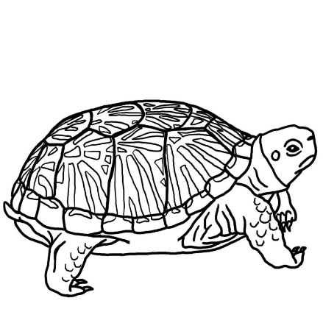2.2. Where does the following reptiles live? (3)

1. Turtle - I live in the sea.
2. Terrapin - I live in fresh water in the wetlands.
3. Tortoise - I live on land.

2.3. Fill in the parts of the snail. (6¸2=3)

shell

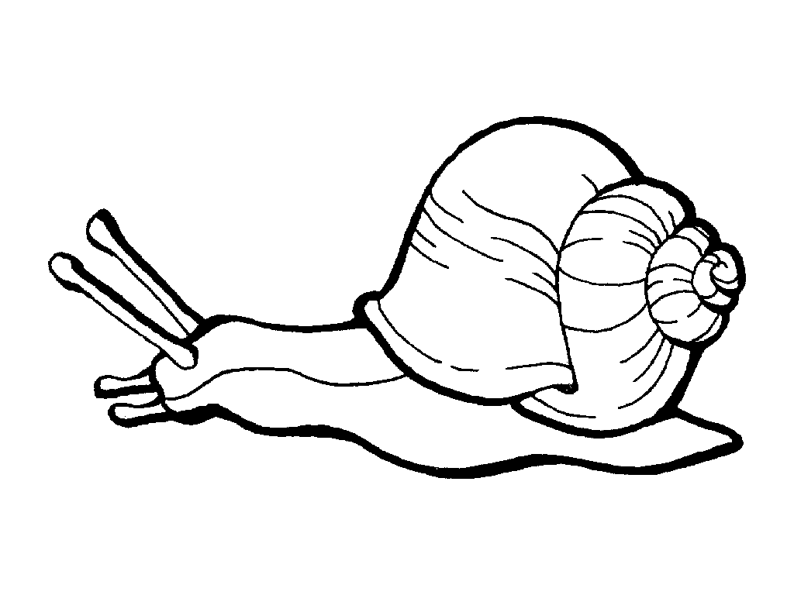

eye

long atenna

opening for breathing

foot

short atenna

2.4. Answer the following questions: (4)

1. Where do bees live? Hive
2. What do bees build their shelter from? Wax
3. Why do birds build nests? Give 2 reasons.

* Shelter
* Place to lay their eggs.

|  |  |  |
| --- | --- | --- |
| Rubric: Personal and Social well-being |  | Mark |
| Question 1.1. Wild animals - complete the sentences | 5 |  |
| Question 1.2. Draw a wild animal and write a sentence | 2 |  |
| Question 2.1. Names for animals that live in dam, river or sea. | 3 |  |
| Question 2.2. Where do the following reptiles live? | 3 |  |
| Question 2.3. Fill in the parts of a snail. | 3 |  |
| Question 2.2. Answer the questions. | 4 |  |
| Total | ____/20 | |

|  |  |  |
| --- | --- | --- |
| Total: Section 1 - Beginning knowledge and Personal and Social well-being |  | Mark |
| 1. Beginning knowledge | 20 |  |
| 1. Personal and Social well-being | 20 |  |
| Total | ____/40 | |