First Additional Language

Assessment Term 2

Grade 2

|  |  |  |
| --- | --- | --- |
| Content |  | Mark |
| 1. Listening and speaking | 10 |  |
| 1. Reading and phonics | 10 |  |
| Total | 20 |  |

Name and Surname: \_\_\_\_\_\_\_\_\_\_\_\_\_\_\_\_\_\_\_\_\_\_\_\_\_\_\_\_

Date: \_\_\_\_\_\_\_\_\_\_\_\_\_\_\_\_\_\_\_\_\_\_\_\_\_\_\_\_\_\_\_\_\_



Listening

and speaking

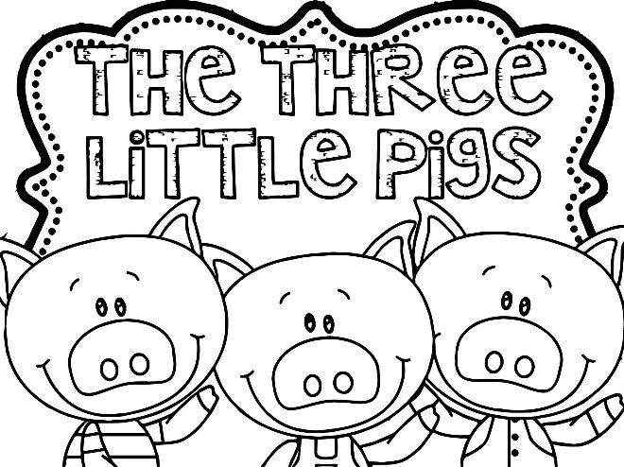

Activity 1

Listen to the story of the three little

pigs and answer the questions your

teacher is going to ask you.

|  |  |  |  |  |
| --- | --- | --- | --- | --- |
| Rubric: Listening and speaking: Activity 1 | | | | |
|  | 1 | 2 | 3 | 4 |
| 1. The learner is able to answer simple questions about the story, |  |  |  |  |
| 1. The learner answers in full sentences. |  |  |  |  |
| 1. Learner speaks in a clear voice. |  |  |  |  |
| 1. Learners uses appropriate vocabulary, grammar and uses the correct tense. |  |  |  |  |
| 1. Learner speaks with confidence and makes eye contact. |  |  |  |  |
| Total | \_\_\_/20 | | | |
| Processed mark out of 10 | 1. ¸ 2 = \_\_\_/10 | | | |

1 - Needs assistance 2- Partial 3- Good 4- Excellent



Listening

and speaking

Activity 2

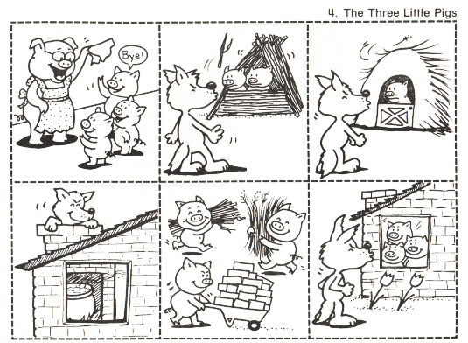Look at the pictures of the three little pigs and decide in which order they must be placed. Cut them out and paste them in the correct order on the next page.

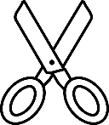Colour the pictures.

The three little pigs

|  |  |  |
| --- | --- | --- |
| Listening and speaking - Activity 2 |  | Mark |
| 1. The learner pasted the pictures in the correct order. | 6 |  |
| 1. The learner coloured the pictures and it is neat. | 2 |  |
| 1. The learner cut the pictures neatly. | 1 |  |
| 1. The learner pasted the pictures neatly. | 1 |  |
| Total | \_\_\_/10 | |

|  |  |  |
| --- | --- | --- |
| Total mark for listening and speaking section |  |  |
| 1. Activity 1 | 10 |  |
| 1. Activity 2 | 10 |  |
| Total | \_\_\_/20 | |
| Processed mark out of 10 | 20 ¸ 2 =\_\_\_\_/10 | |



Reading

Activity

Read the sentences on the next page. Cut them out and paste them under the picture which match them. **Total: \_\_\_/5**





The wolf came to the house of straw.

The wolf then came to the house of sticks.

The first little pig built his house out of straw. The second little pig built his house out of sticks. The third little pig built his house out of bricks.

The little pig saw the wolf climb up on the roof and lit fire in the fireplace and placed on it a large pot of water.

The wolf then came to the house of bricks. "Let me in, let me in" cried the wolf. "Or I will huff and I will puff till I blow your house in."



Phonics

1. Colour the pictures with the same beginning sound. (3)

|  |
| --- |
| See the source imageSee the source imageSee the source imageSee the source image1. |
| See the source imageSee the source imageSee the source imageSee the source image2. |
| 1. See the source imageSee the source image   See the source image |

1. Fill in the missing letters to complete these words. Use a, e, i, o and u. (4)

|  |  |  |  |
| --- | --- | --- | --- |
| See the source image | p\_\_n | See the source image | p\_\_g |
| C:\Users\MS\AppData\Local\Packages\microsoft.microsoftedge_8wekyb3d8bbwe\AC\#!001\MicrosoftEdge\Cache\5R5NX6UZ\white-cat-clipart-3[1].png | c\_\_t |  | l\_\_g |

1. 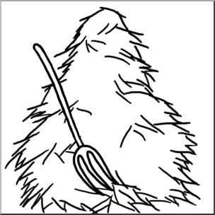**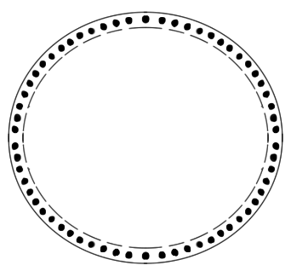**Match the picture to its ending sound by drawing a line with a ruler. (6¸2=3)

ot

****

og

**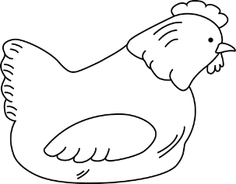**

**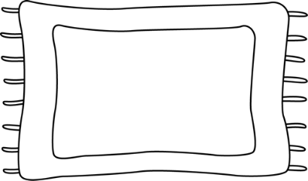**

an

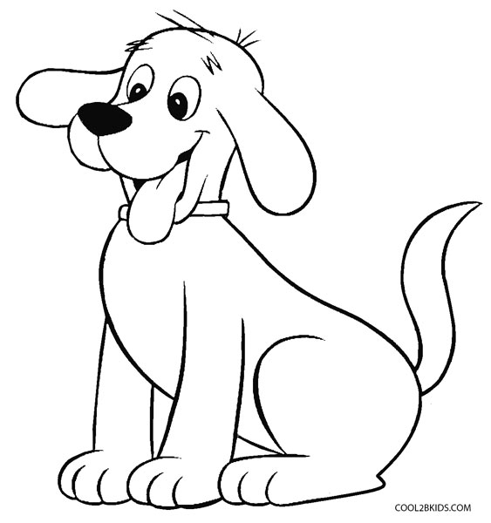****

en

**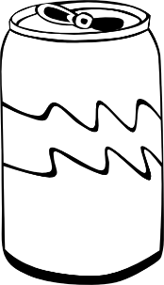**

ay

****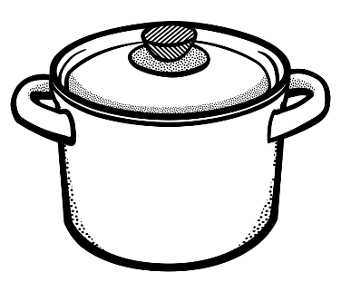

at

|  |  |  |
| --- | --- | --- |
| Total mark for phonics section |  |  |
| 1. Beginning sound | 3 |  |
| 1. Fill in the missing letters. | 4 |  |
| 1. Ending sound | 3 |  |
| Total | \_\_\_/10 | |
| Processed mark out of 5 | 10 ¸ 2 = \_\_\_/5 | |

|  |  |  |
| --- | --- | --- |
| Total mark for reading and phonics section |  |  |
| 1. Reading | 5 |  |
| 1. Phonics | 5 |  |
| Total | \_\_\_/10 | |