
Mathematics
Assessment Term 2
Grade 1

Name and surname: ____________________________
Date: _________________________________

TASK 1 - MEMORANDUM

Content area |  | Mark
- Numbers, operations and relationships | 20
- Patterns, functions and algebra. | 10
- Space and shape | 5
- Measurement | 10
- Data handling | 5
Total | 50
Numbers, operations and relationships

  - Count the blocks, count in groups to make it easier then write down your answer in the block. (3)
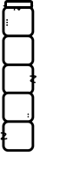
= 15

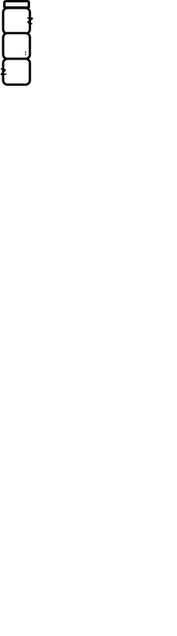
= 18



= 20

  - Complete - Count forwards and backwards (16¸2 =8)
    - 10, 20, 30, 40, 50. (3)
    - 15, 20, 25, 30, 35, 40, 45. (4)
    - 22, 24, 26, 28, 30. (3)
    - 50, 40, 30, 20, 10. (3)
    - 45, 40, 35, 30, 25, 20. (3)


  - Match the number names and number symbols. (3)
three
7

seven
10

ten
3

  - Write down the number name of the number symbol. (2)
8 - eight
5 - five

1.5 Study the numbers in the bees and answer the questions. (5)
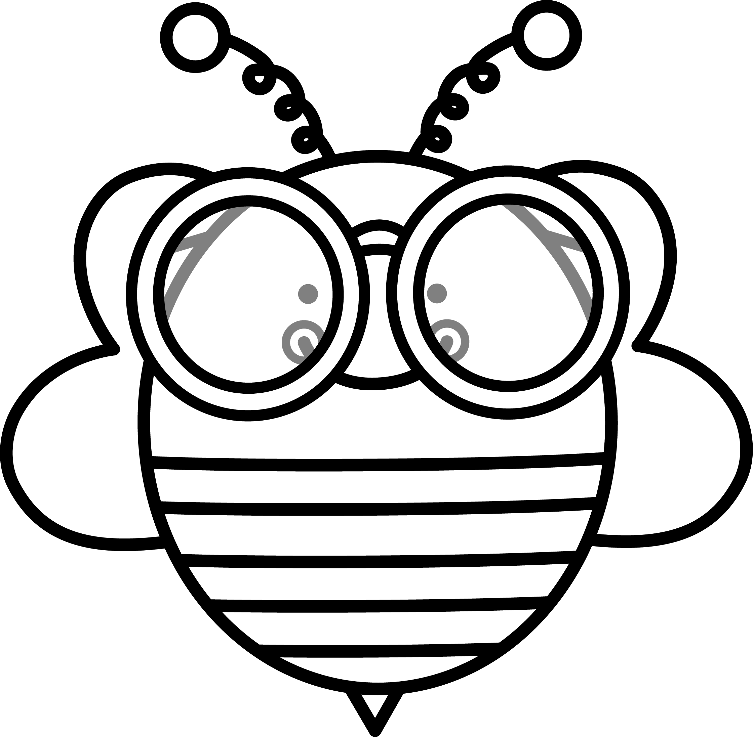

5
6
7
8
9

- What number is before 7? 6 (1)
- What number is after 6? 7 (1)
- What number is between 7 and 9? 8 (1)
- Write down the numbers from the smallest to the biggest. (1)
5, 6, 7, 8, 9.
- Write down the numbers from the biggest to the smallest. (1)
9, 8, 7, 6, 5.

1.6 Break down the numbers into tens and ones. (4¸2=2)
Numbers | Tens | Ones
17 | 10 | 7
13 | 10 | 3

  - Use the number line to solve the problem. Show your answer on the number line. You must also write down a number sentence for each problem. (3)
In the school there are 5 boys and 4 girls that take extra art lessons. How many learners are there in total in the art class?

Number sentence: 5 + 4 = 9

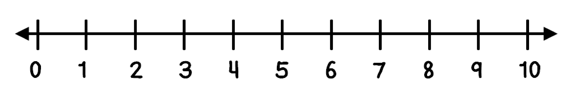
0 1 2 3 4 5 6 7 8 9 10

  - Answers the questions by counting in groups. (4)
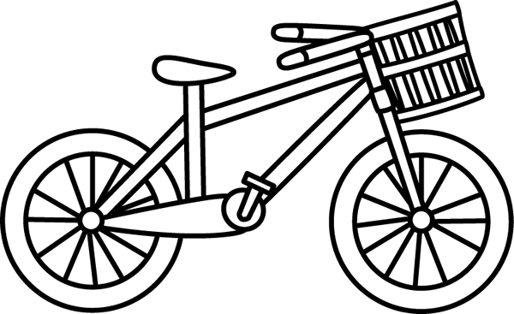
- One bicycle has 2 wheels. How many wheels do 5 bicycles have? (2)

Five bicycles have: 2 + 2 + 2 + 2 + 2 = 10

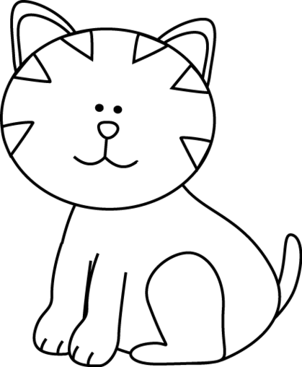
b. One cat has 2 eyes. How many eyes will 6 cats have? (2)

Six cats have: 2 + 2 + 2 + 2 + 2 + 2 = 12

1.9. Match the pictures with the correct word. (5)
Two rand
Money |  | Name
 |  | One rand
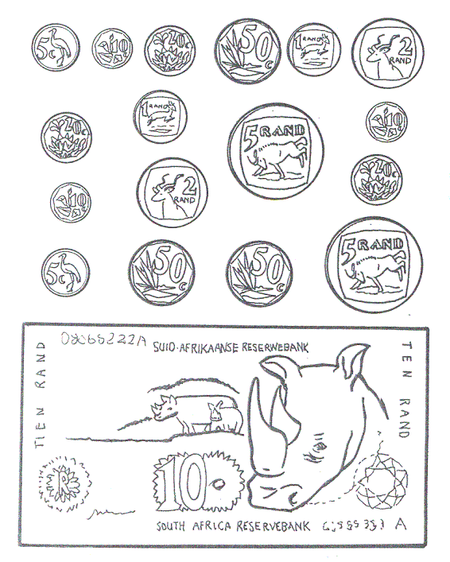 |  | Five cents
 |  | Five rand
 |  | Ten cents

1.10. Subtraction
Complete the following sum by taking away. Write a number sentence as well. (2)


Number sentence: 8 - 3 = 5

  - Mental math - complete. (6¸2 =3)

- Double 2 = 4
- Double 4 = 8
- 1 less than 10 = 9
- 1 more than 8 = 9
- 1 less than 5 = 4
- 1 more than 6 = 7

Numbers, operations and relationships |  | Mark
- Count | 3
- Count forwards and backwards | 8
- Number names and number symbols | 3
- Write number names | 2
- Order of numbers | 5
- Decomposing of numbers - place value | 2
- Problem solving | 3
- Repeated addition | 4
- Money | 5
- Subtraction | 2
- Mental math | 3
Total | ___/40
Processed mark out of 20 | 40¸2 = ___/20

Patterns, functions and algebra

2.1. Geometric patterns
Repeat the following patterns. (2)

2.2. Study the following patterns and write in words which
shapes will be next. (3)

a.
square rectangle

b.
sun

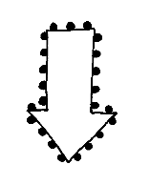
2.3. Number pattern - Start at the arrow and complete the
pattern. (10¸2 =5)
Patterns, functions and algebra |  | Mark
- Geometric patterns - draw | 2
- Geometric patterns - description | 3
- Number patterns | 5
Total | 10
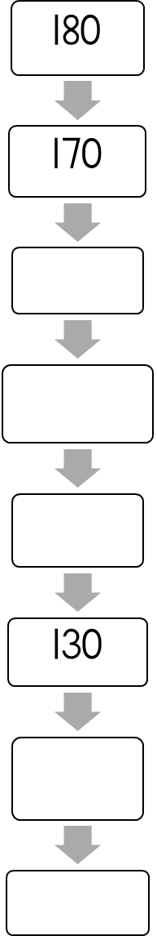
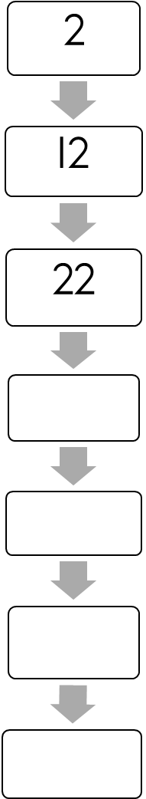
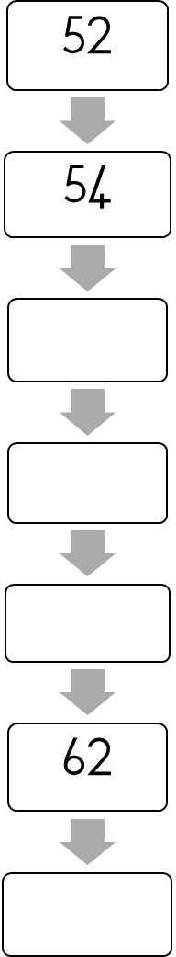
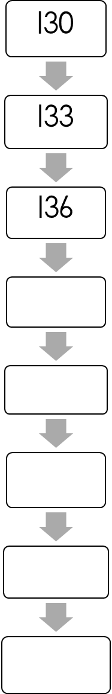
10
20
32
34
36
25
30
48
47
46

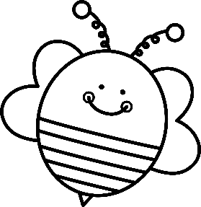
30
40
50
38
40

35
40
45
49
50

Space and shape

3.1 Name the following 2D shapes, write your answer in the
blocks. (2)


triangle
rectangle

  - Do these shapes have straight or round sides? (2)

straight
round

straight
round

3.5. Where is the ball?
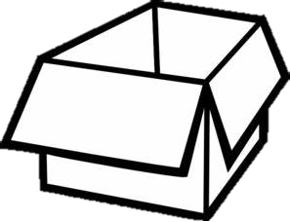
Write in front, behind, inside, between, over or next to. (6)



over
behind
in front



next to
inside

between

Space and shape |  | Mark
- Name the shapes | 2
- Straight or round | 2
- Position in space | 6
Total | ___/10
Processed mark out of 5 | 10 ¸ 2 = __/5

Measurement

4.1. Study the calendar and answer the following questions. (5)
January 2019
Sunday | Monday | Tuesday | Wednesday | Thursday | Friday | Saturday
 |  | 1 | 2 | 3 | 4 | 5
6 | 7 Marie | 8 | 9 | 10 Ben | 11 | 12
13 | 14 | 15 | 16 | 17 | 18 | 19
20 | 21 | 22 | 23 | 24 | 25 | 26
27 | 28 | 29 | 30 | 31

a. Which day comes after Wednesday? Thursday
b. Which day comes before Sunday? Saturday
c. Which day is between Tuesday and Thursday? Wednesday
d. Mark the following dates on the calendar:
- Marie’s birthday on 7 January 2019.
- Ben’s birthday on 10 January 2019.
4.2. Number the following actions in the sequence that you
would complete them in the morning. (5)
Learners answer may differ. This is just a guide.
5
1
2
4
3
I brush my teeth.
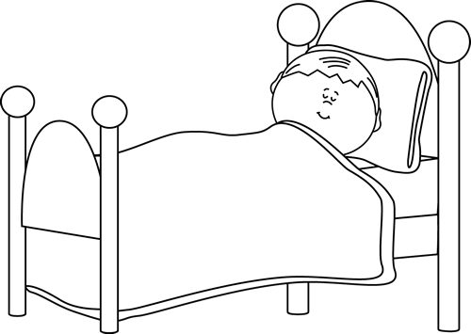
I wake up.
I get dressed in my school uniform.
I eat breakfast.
I brush my hair.

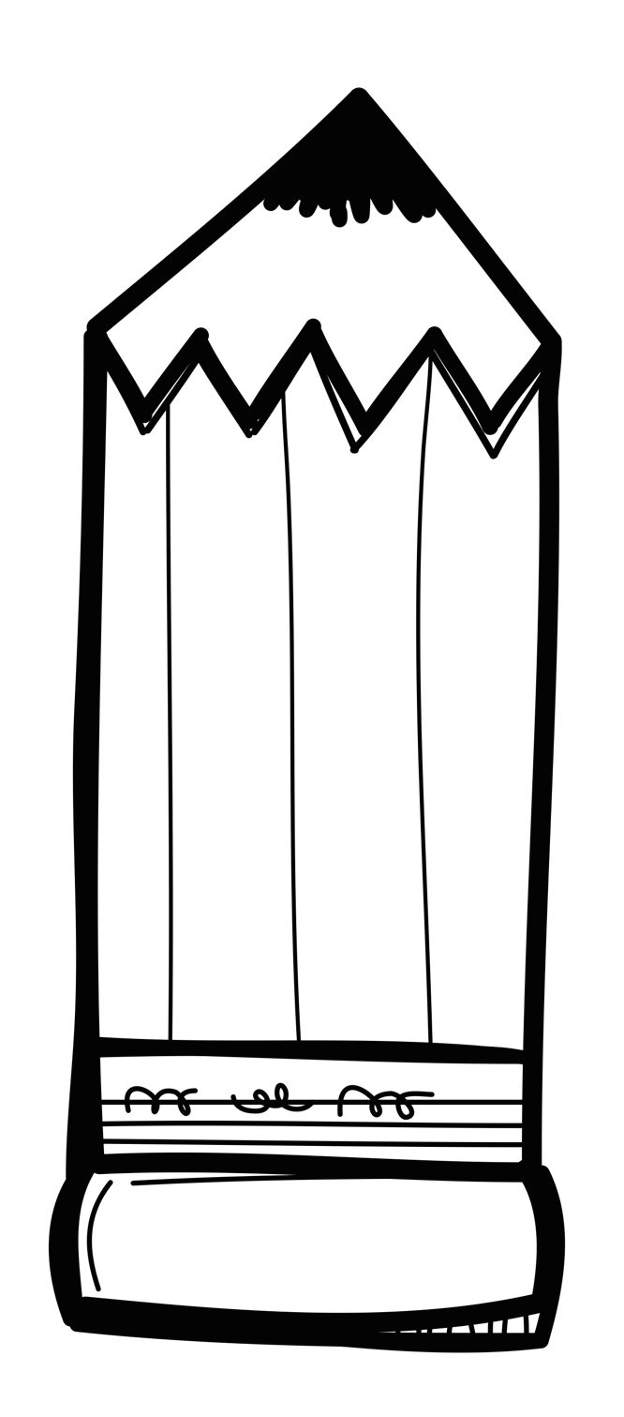
4.3. Study the pictures and colour if the pencil in the second
picture is shorter than, longer than or equal to the
first. (3)

longer
shorter
equal

longer
shorter
equal

longer
shorter
equal

4.4. Study the objects on the scale, answer the following
questions. (2)
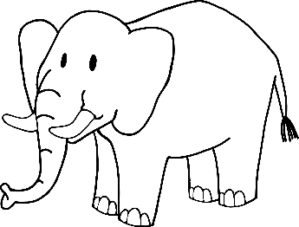


heavy
light

heavy
light

4.5. Study the glasses and decide if they are full or empty. (2)
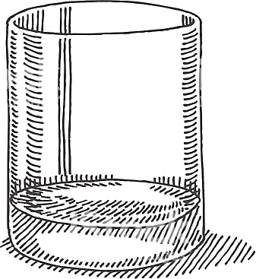
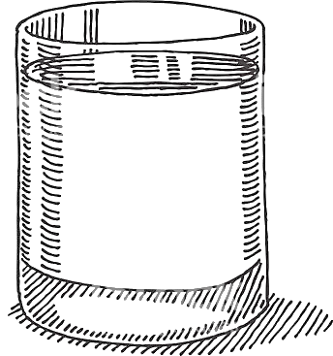

full
empty

full
empty

4.6. Write down if the second glass has more than, less than or
equal amount of water compared to the first glass. (3)

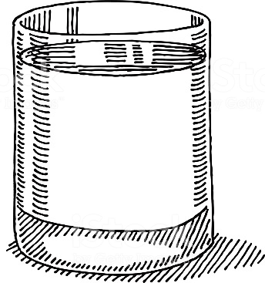
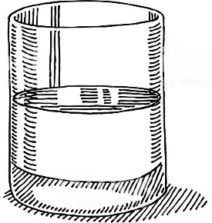
less than

Measurement |  | Mark
- Time-  - Calendar. (5)  - Sequence of events. (5) | 10
- Length | 3
- Mass | 2
- Volume/capacity | 5
Total out of 20 | ___/20
Processed mark out of 10 | 20¸2 = ___/10
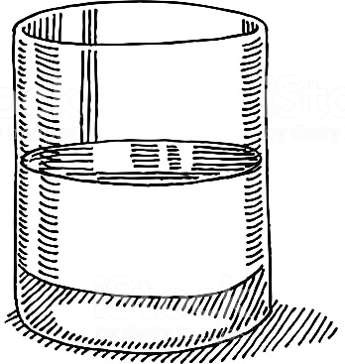
more than

equal

Data handling

Count the different sea animals and colour the blocks.

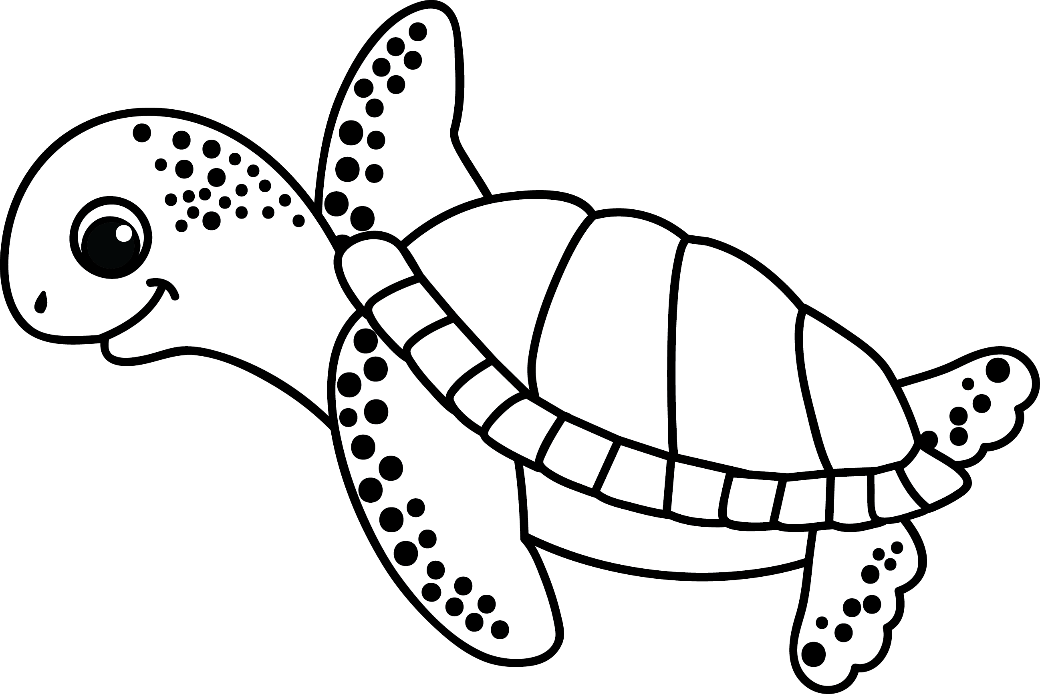
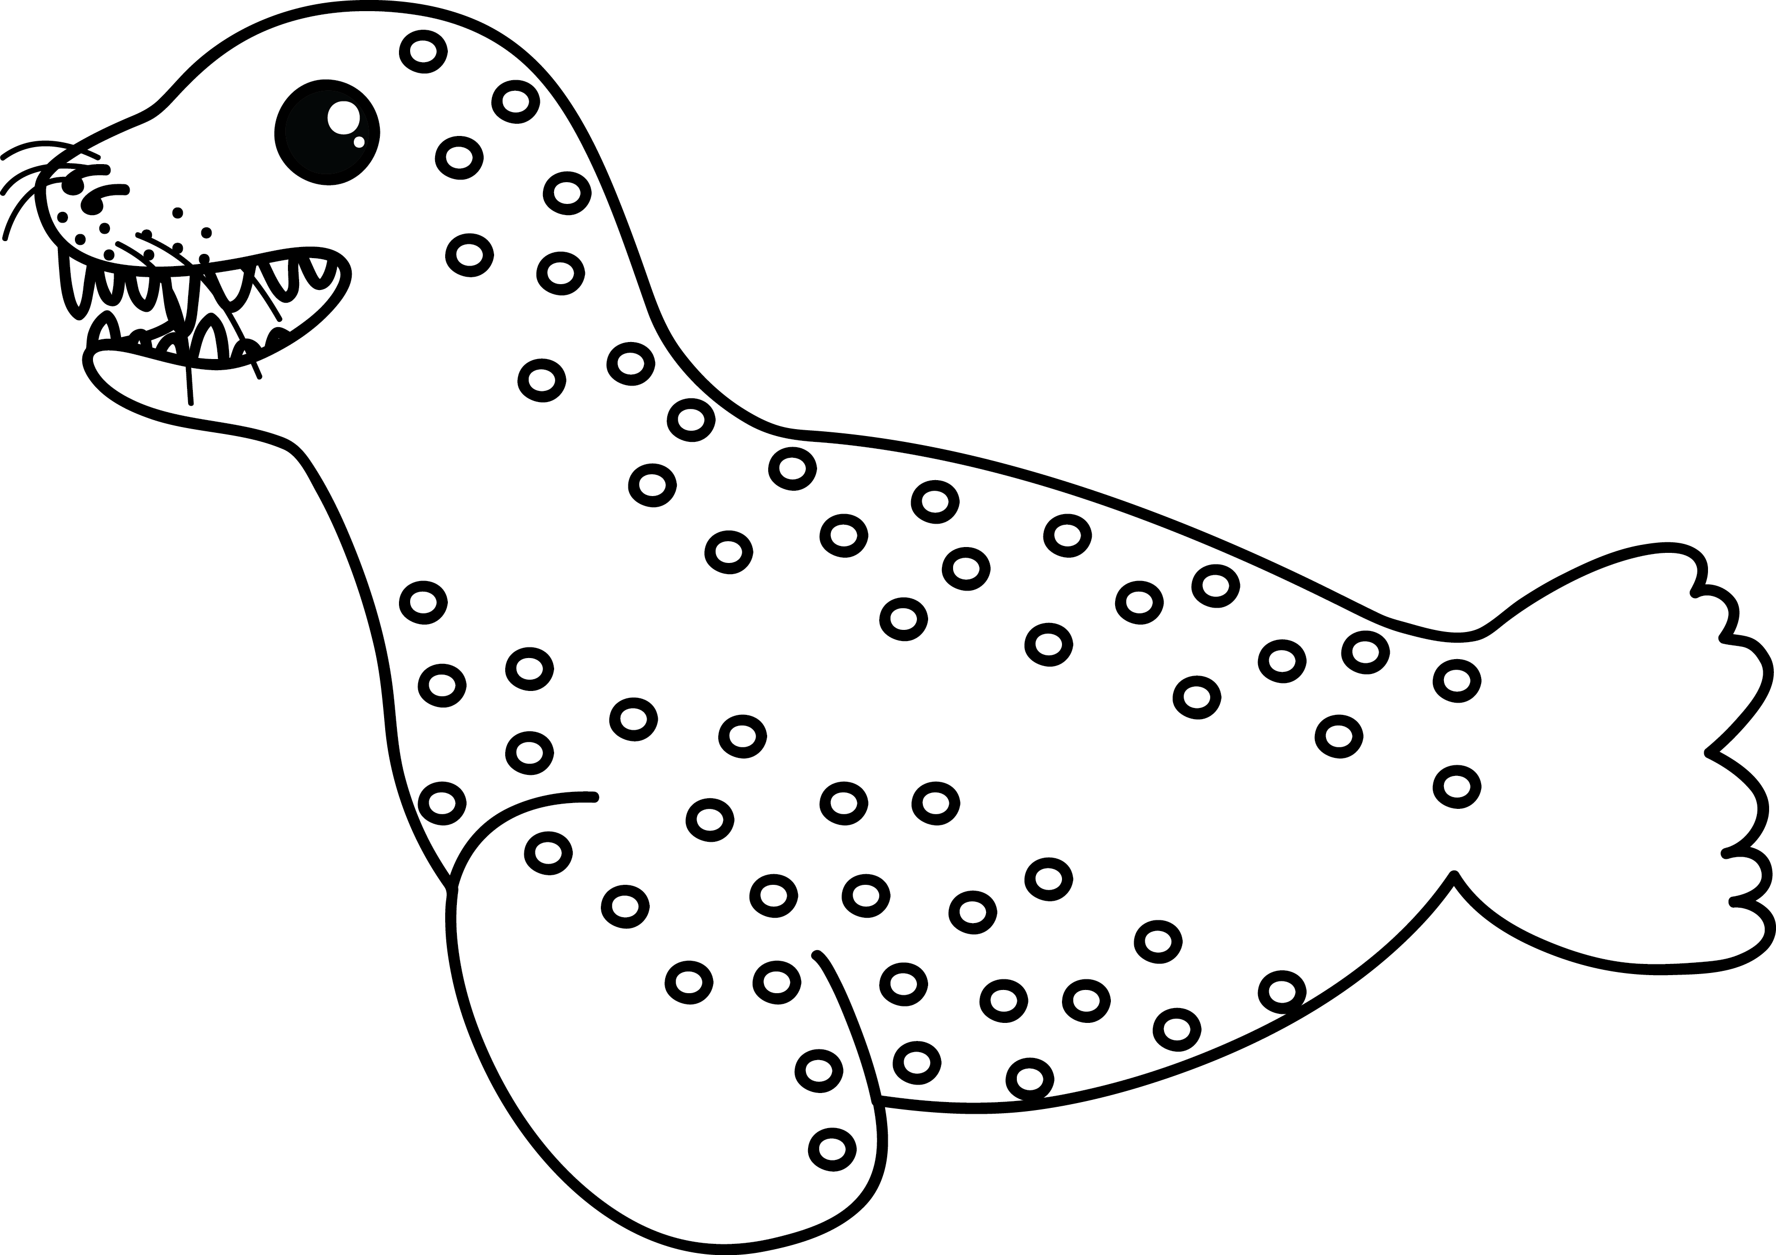
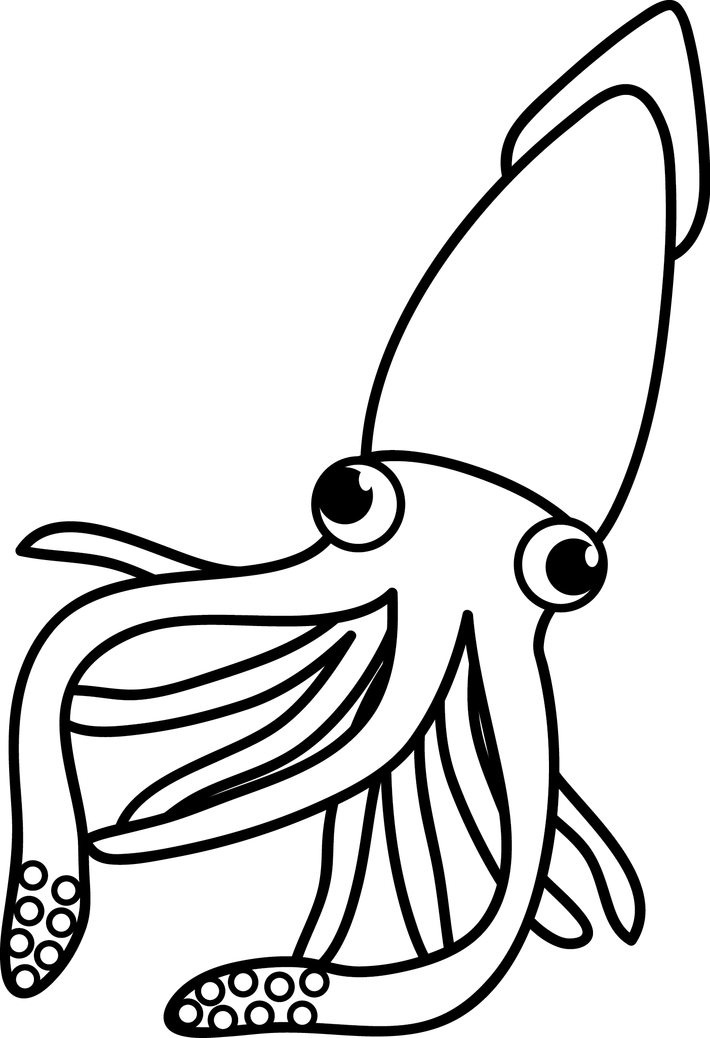
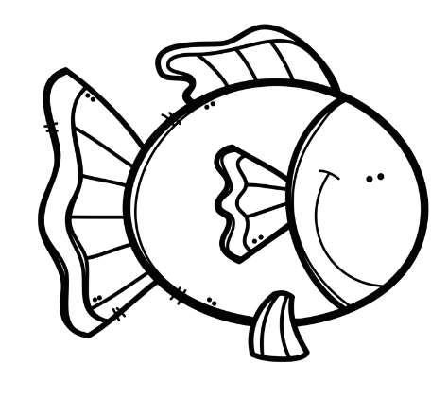

8
7
6
5
4
3
2
1
0
turtle octopus seal orca fish

Data handling |  | Mark
- 1 mark for the correct amount of blocks coloured for each sea animal. | 5
Total | 5

