Life skills

Assessment Term 2

Grade 1

Name and surname: ____________________________

Date: _________________________________

|  |  |  |
| --- | --- | --- |
| Content area |  | Mark |
| 1. Beginning knowledge and Personal and social well-being | 40 |  |
| 1. Creative arts | 20 |  |
| 1. Physical Education | 30 |  |
| Total | 90 |  |



Beginning knowledge

QUESTION 1 - My family

* 1. 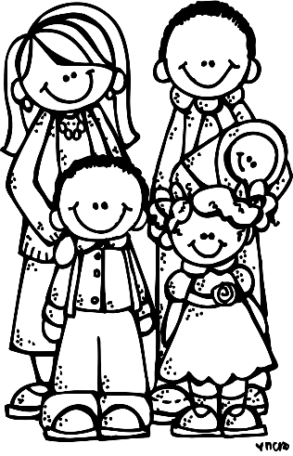Answer the following question regarding your family. (4)

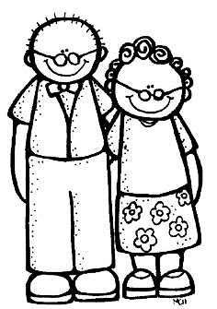

1. Who lives with you in your house?

_________________________________________

1. Who is the oldest in your house? ___________________
2. Who is the youngest in your house? __________________
3. What tasks do you have to complete at home?

____________________________________________________________________________________________

* 1. Read the questions and then colour in yes or no. (4)

no

yes

1. I like helping at home.

no

yes

1. I fight with my brother or sister.

no

yes

1. My family loves me.
2. I have my own tasks that I do at home.

no

yes

* 1. Family members should love one another and take care of each other. Use the words in the blocks and complete the sentences. (4)

friendly

responsible

tasks

help

1. We must ____________ each other.
2. We must be _____________ towards each other.
3. We must complete our ____________ at home.
4. We must be ___________.

QUESTION 2 - Safety in and around the home

2.1. True or false? Colour in the correct block.

(8¸2=4)

|  |  |  |
| --- | --- | --- |
|  | true | false |
| 1. It is safe to leave sharp knives lying around. |  |  |
| 1. Turn handles of pots and pans to the back of the stove. |  |  |
| 1. Do not share your toothbrush with anyone else. |  |  |
| 1. Stand under a tree if there is a storm. |  |  |
| 1. Don’t play near a swimming pool if there is no adult supervision. |  |  |
| 1. You can play with paraffin and poisonous materials. |  |  |
| 1. Ask your mom or dad to fix a broken electrical cord. |  |  |
| 1. It is safe to play near a swimming pool. |  |  |

2.2. Make a (√) next to the pictures that show a safe situation

and a (X) next to the pictures showing an unsafe situation. (4)

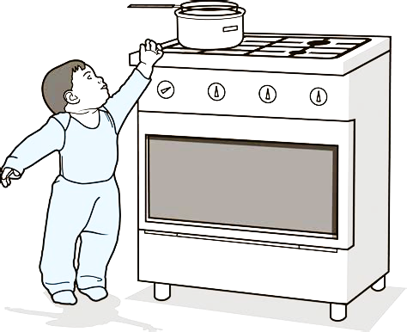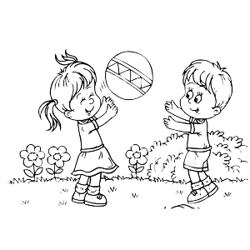

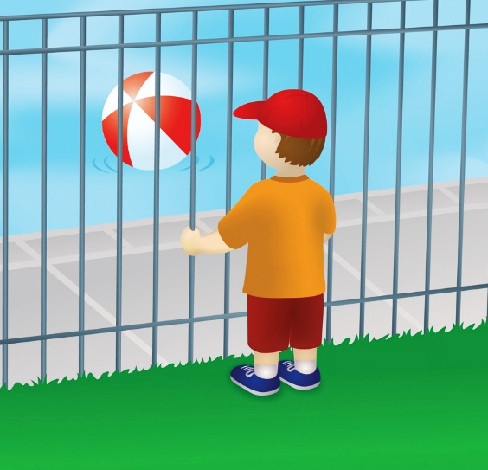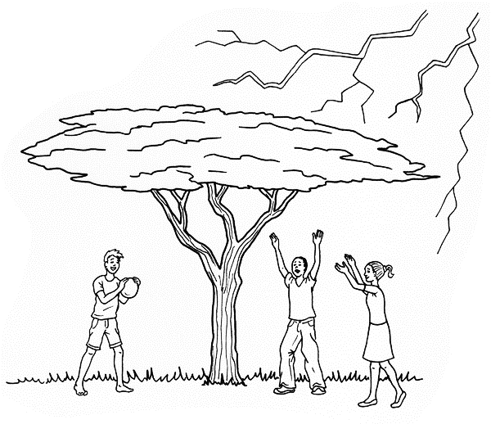

|  |  |  |
| --- | --- | --- |
| Rubric: Beginning knowledge |  | Mark |
| Question 1 - My family | 12 |  |
| Question 2 - Safety in and around the home | 8 |  |
| Total | ____/20 | |



Personal and Social well-being

QUESTION 1 - My body

* 1. Match the word in the blocks to the correct space on the picture. (6¸2 =3)

stomach

head

arm

foot

hand

leg

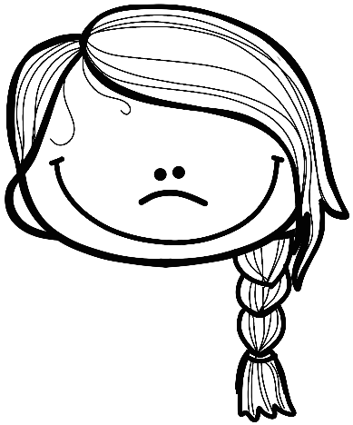

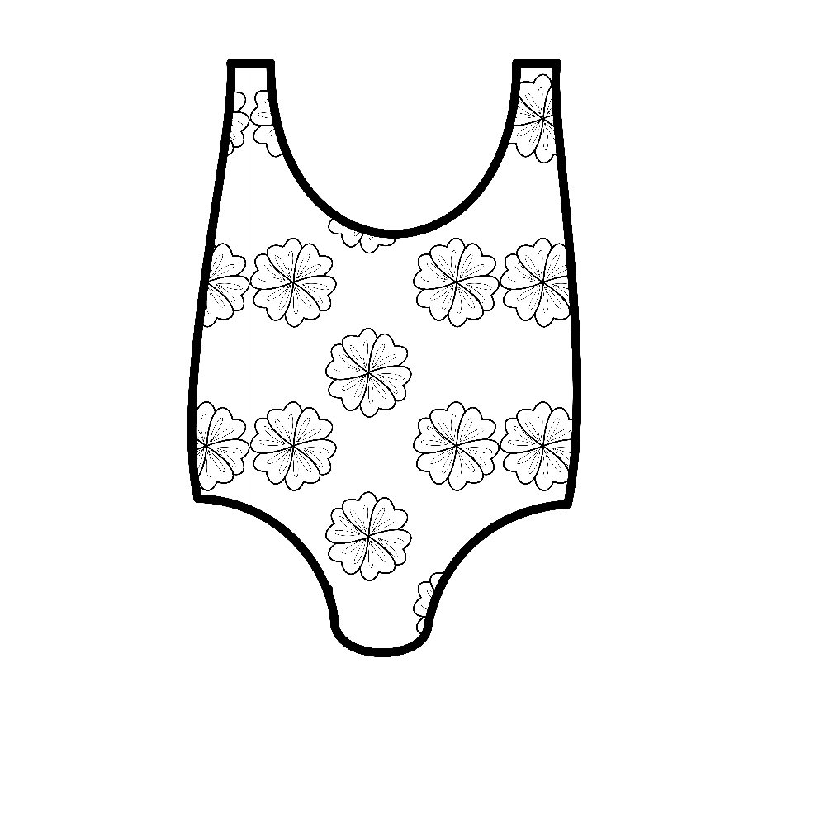

* 1. Study the pictures and write down the senses for each body part. (5)

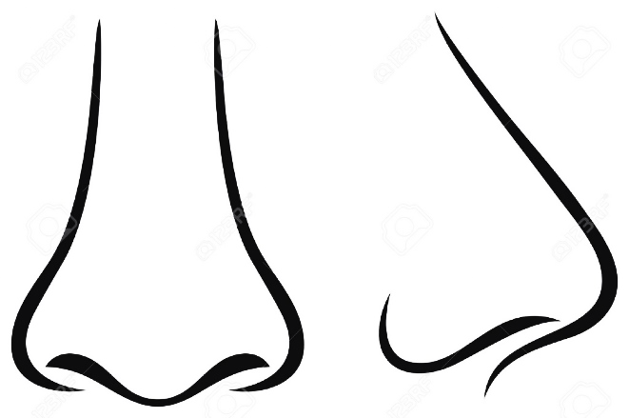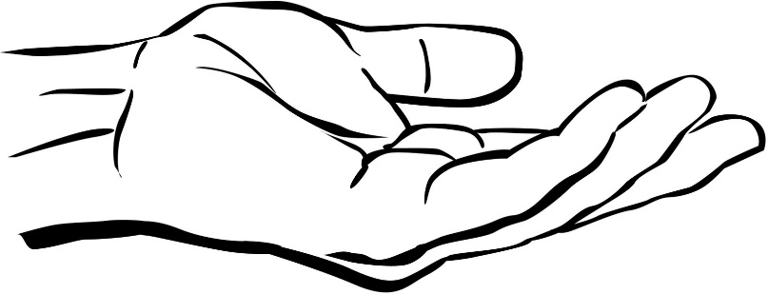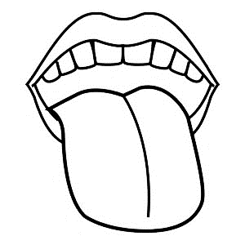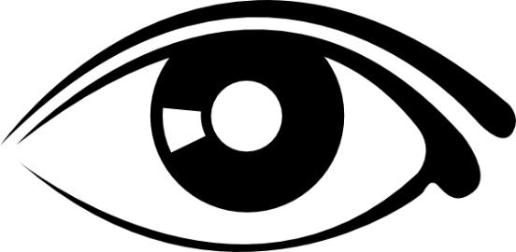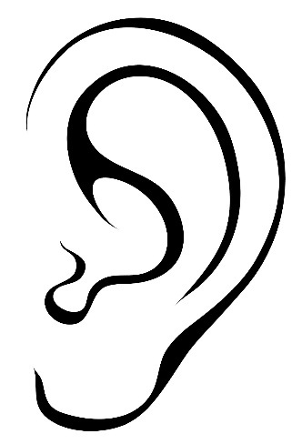

1.3. Give examples of: (2¸2 = 1)

a. What can you taste? ______________________________

b. What can you smell? ______________________________

* 1. Use the words in the blocks to name your respiratory system (parts that help you to breath). (4¸2 = 2)

nose

mouth

lung

throat

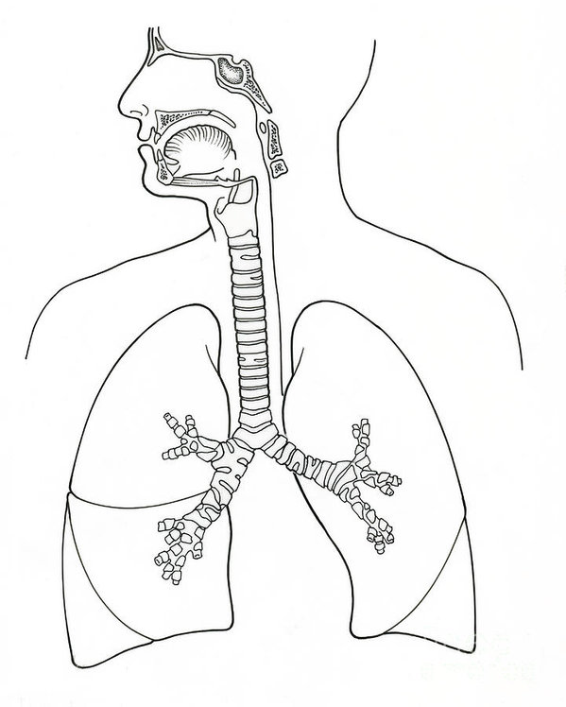

QUESTION 2 - Keep my body safe

2.1. Is it acceptable? Write yes or no. (6¸2 =3)

1. If someone that loves me gives me a hug? __________
2. Someone scary wants to hug me. __________
3. Don’t worry, it’s just a tickle! _________
4. You look so pretty, I love you so much. _________
5. Stop screaming! You are too old for that. __________
6. Don’t tell anyone, it is our secret. ________

2.2. Study the pictures and write down how you can keep your body healthy. (4¸2 = 2)

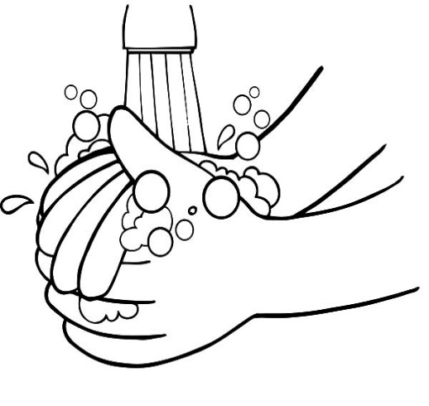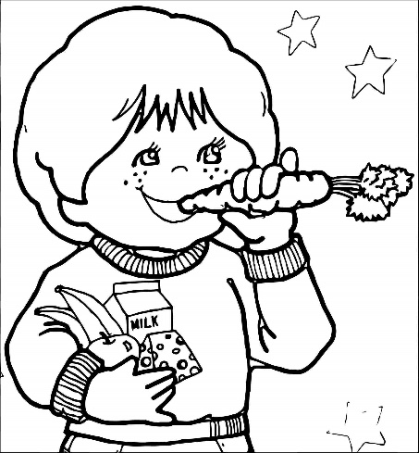

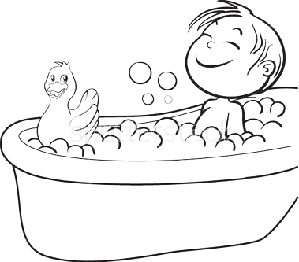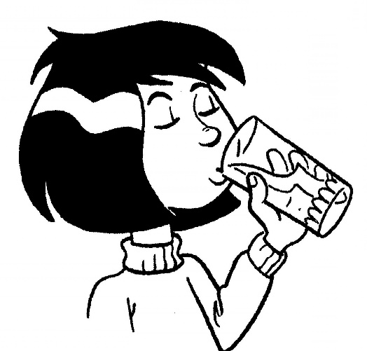

_______________________________________________________________________________________________________________

_______________________________________________________________________________________________________________

_______________________________________________________________________________________________________________

_______________________________________________________________________________________________________________

2.3. True or false? Colour in the correct block. (4¸2=2)

|  |  |  |
| --- | --- | --- |
|  | true | false |
| 1. We must cover our mouth when we sneeze or cough. |  |  |
| 1. It is save to touch someone else’s blood. |  |  |
| 1. Wash fruit and vegetables before eating it. |  |  |
| 1. It is safe to drink water from a pool on the ground. |  |  |

2.4. Some water sources are dirty and we must first clean the

water to make it safe to drink. Name 3 ways in which we

can make water safe to drink. (3)

1. ___________________________________________________________________________________________________________________________
2. ___________________________________________________________________________________________________________________________
3. ___________________________________________________________________________________________________________________________

|  |  |  |
| --- | --- | --- |
| Rubric: Personal and Social Well-being |  | Mark |
| 1.1. Name the parts of the body. | 3 |  |
| 1.2. Name the senses | 5 |  |
| 1.3. What can you taste and smell? | 1 |  |
| 1.4. Name the parts that help us breath | 2 |  |
| 2.1. Yes and no feelings | 2 |  |
| 2.2 How do I keep my body healthy? | 2 |  |
| 2.3. True or false | 2 |  |
| 2.4. How can I make water safe to drink? | 3 |  |
| Total | ____/20 | |

|  |  |  |
| --- | --- | --- |
| Total: Section 1 - Beginning knowledge and Personal and Social Well-being |  | Mark |
| 1. Beginning knowledge | 20 |  |
| 1. Personal and Social Well-being | 20 |  |
| Total | ____/40 | |



Creative arts

* Performing arts -

Activity: Improvise and interpret

Assignment:

Practice the following poem and recite it to your class with feeling and gestures.

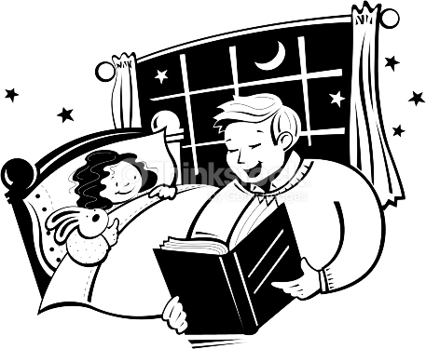

Mommy cooks the food. Daddy washes dishes. My brother and I help Mommy and Daddy. We help a lot. We put the milk and bread away. Then we are ready for bed. Please tell us a story!

|  |  |  |  |  |  |  |
| --- | --- | --- | --- | --- | --- | --- |
|  | Rubric – Recital of poem | Mark | | | | |
|  |  | 5 | 4 | 3 | 2 | 1 |
| 1. | Speaking: Tone and pace | 5 | 4 | 3 | 2 | 1 |
| 2. | Correct grammar and sentence structure. | 5 | 4 | 3 | 2 | 1 |
| 3. | Eye contact and preparation | 5 | 4 | 3 | 2 | 1 |
| 4. | Ability to interest learners and confidence. | 5 | 4 | 3 | 2 | 1 |
| Total | | /20 | | | | |
| Amended mark (20 ¸ 2 = 10) | | ___/10 | | | | |



Creative arts

* Visual arts -



Assignment:

Draw your family where you are busy performing a

task at home, write down a sentence explaining

what you are doing.

You will be marked according to the following rubric:

|  |  |  |  |  |
| --- | --- | --- | --- | --- |
| Rubric – Visual arts | 1 | 2 | 3 | 4 |
|  | Needs help | Adequate | Substantial | Outstanding |
| 1. The learner’s art is full of colour. |  |  |  |  |
| 1. The learner successfully showed his / her family. |  |  |  |  |
| 1. The learner successfully showed the family performing a task. |  |  |  |  |
| 1. Was the learner creative? |  |  |  |  |
| 1. Did the leaner write down a sentence to explain what they were doing? |  |  |  |  |
| Total | ___/20 | | | |
| Amended mark (20 ¸ 2 = 10) | ____/10 | | | |

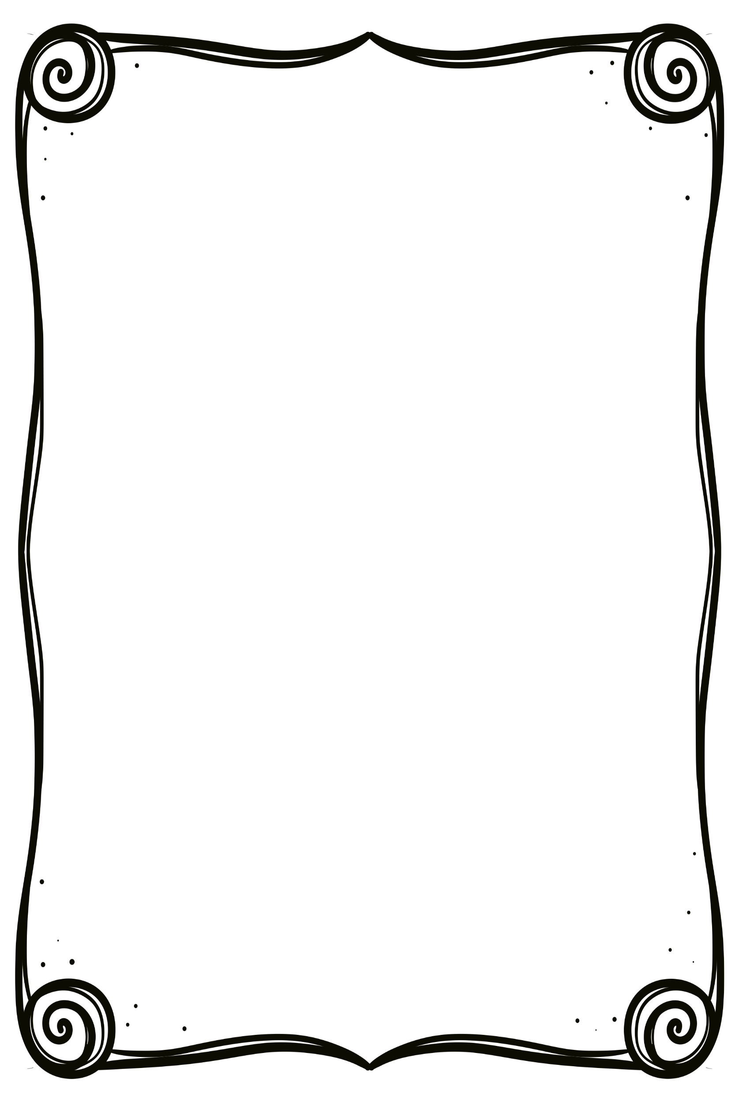

My family

Sentence: ____________________

____________________

________________________

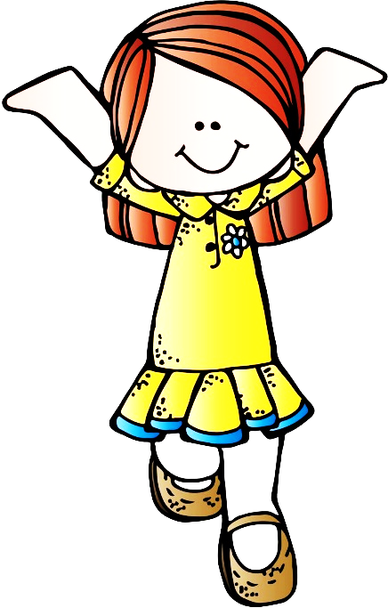

Physical Education

Activity 1

Activity 1 - Movement

Assignment:

We will play “Simon says”. Look at the movements that your teacher is making and copy her.

|  |  |  |  |  |
| --- | --- | --- | --- | --- |
| Rubric: Physical Education – Activity 1 | 1 | 2 | 3 | 4 |
|  | Needs help | Adequate | Substantial | Outstanding |
| 1. Learner can perform different movements. |  |  |  |  |
| 1. Listening skills - learner listens to assignments and takes part. |  |  |  |  |
| 1. The learner enjoys taking part and is enthusiastic. |  |  |  |  |
| 1. The learner shows respect towards the teacher presenting the activity. |  |  |  |  |
| 1. The learner shows respect towards his / her fellow classmates. |  |  |  |  |
| Total | ___/20 | | | |

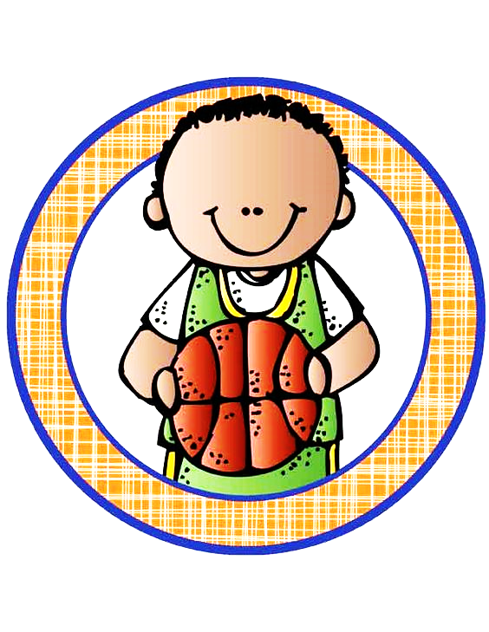

Physical Education

Activity 2

Activity 2 - Ball skills

Assignment:

* Stand in a circle.
* Throw the ball to the opposite person.
* Pass the ball to your friend over your head.
* Pass the ball to your friend between your legs.
* Break into groups of two, stand a few steps away from each other.
* Throw the ball to your friend, catch the ball when your friend throws it.
* Bounce the ball for your friend to catch, catch the ball when your friend bounces it.

|  |  |  |
| --- | --- | --- |
| Rubric: Physical Education - Activity 2 |  | Mark |
| 1. Did the learner pass the ball in the circle? | 2 |  |
| 1. Did the learner pass the ball over his / her head? | 2 |  |
| 1. Did the learner pass the ball between his / her legs? | 2 |  |
| 1. Could the learner throw and catch the ball? | 2 |  |
| 1. Could the learner bounce and catch the ball? | 2 |  |
| Total | ____/10 | |