Life skills

Assessment Term 2

Grade 1

Name and surname: ____________________________

Date: _________________________________

MEMORANDUM

|  |  |  |
| --- | --- | --- |
| Content area |  | Mark |
| 1. Beginning knowledge and Personal and social well-being | 40 |  |
| 1. Creative arts | 20 |  |
| 1. Physical Education | 30 |  |
| Total | 90 |  |



Beginning knowledge

QUESTION 1 - My family

* 1. 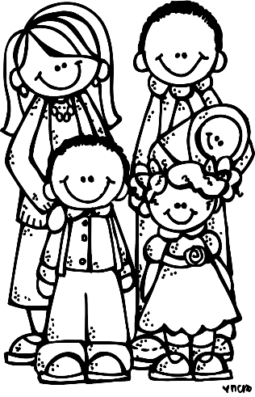Answer the following question regarding your family. (4)

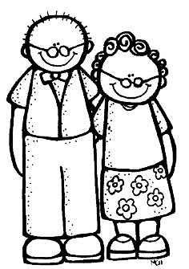

1. Who lives with you in your house?

_________________________________________

1. Who is the oldest in your house? ___________________

Learners own answer.

1. Who is the youngest in your house? __________________
2. What tasks do you have to complete at home?

____________________________________________________________________________________________

* 1. Read the questions and then colour in yes or no. (4)

no

yes

1. I like helping at home.

Learners own answer.

no

yes

1. I fight with my brother or sister.

no

yes

1. My family loves me.
2. I have my own tasks that I do at home.

no

yes

* 1. Family members should love one another and take care of each other. Use the words in the blocks and complete the sentences. (4)

friendly

responsible

tasks

help

1. We must **help** each other.
2. We must be **friendly** towards each other.
3. We must complete our **tasks** at home.
4. We must be **responsible**.

QUESTION 2 - Safety in and around the home

2.1. True or false? Colour in the correct block.

(8¸2=4)

|  |  |  |
| --- | --- | --- |
|  | true | false |
| 1. It is safe to leave sharp knives lying around. |  |  |
| 1. Turn handles of pots and pans to the back of the stove. |  |  |
| 1. Do not share your toothbrush with anyone else. |  |  |
| 1. Stand under a tree if there is a storm. |  |  |
| 1. Don’t play near a swimming pool if there is no adult supervision. |  |  |
| 1. You can play with paraffin and poisonous materials. |  |  |
| 1. Ask your mom or dad to fix a broken electrical cord. |  |  |
| 1. It is safe to play near a swimming pool. |  |  |

2.2. Make a (√) next to the pictures that show a safe situation

and a (X) next to the pictures showing an unsafe situation. (4)

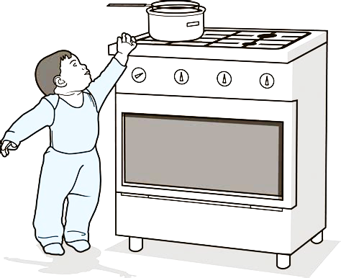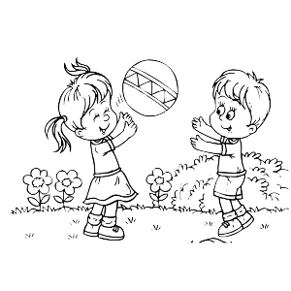

X

√

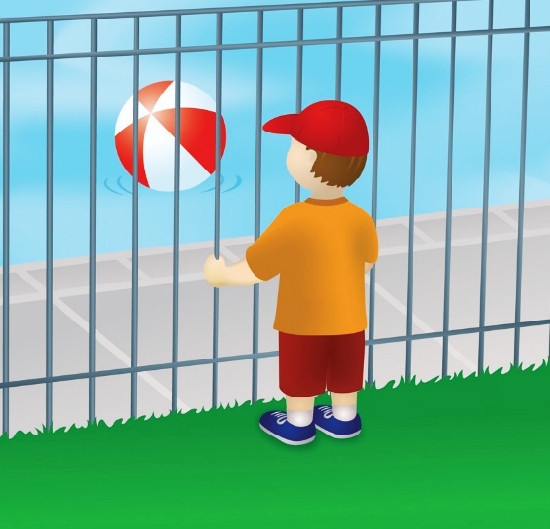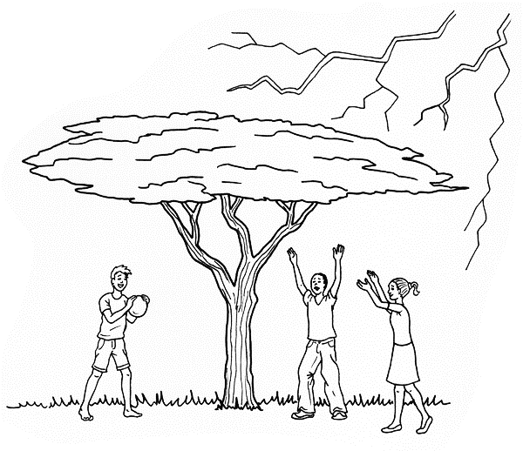

X

√

|  |  |  |
| --- | --- | --- |
| Rubric: Beginning knowledge |  | Mark |
| Question 1 - My family | 12 |  |
| Question 2 - Safety in and around the home | 8 |  |
| Total | ____/20 | |



Personal and Social well-being

QUESTION 1 - My body

* 1. Match the word in the blocks to the correct space on the picture. (6¸2 =3)

stomach

head

arm

foot

hand

leg

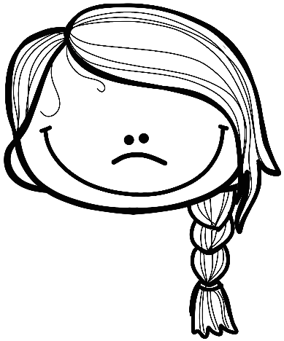

head

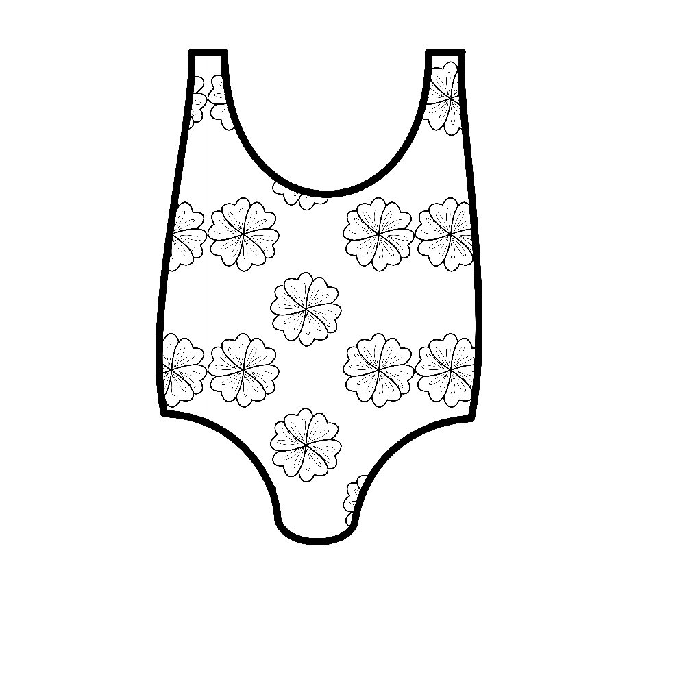

arm

stomach

hand

leg

foot

* 1. Study the pictures and write down the senses for each body part. (5)

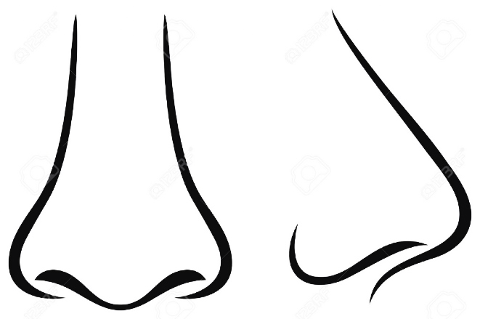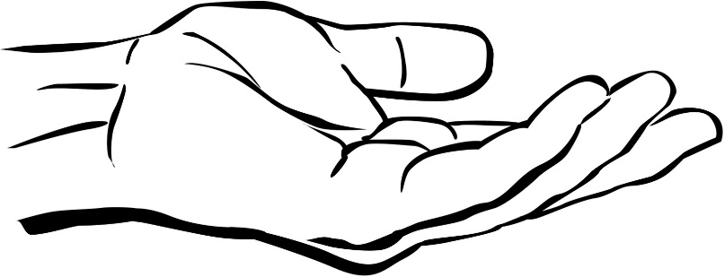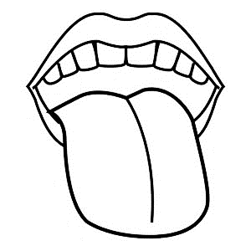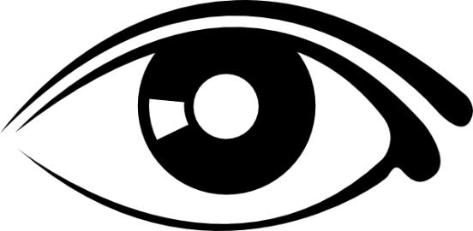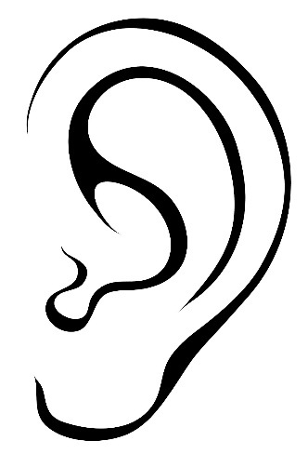

hearing

touch

smell

sight

taste

1.3. Give examples of: (2¸2 = 1)

a. What can you taste? Food, cold drink and sweets

b. What can you smell? Food, flower and perfume.

* 1. Use the words in the blocks to name your respiratory system (parts that help you to breath). (4¸2 = 2)

nose

mouth

lung

throat

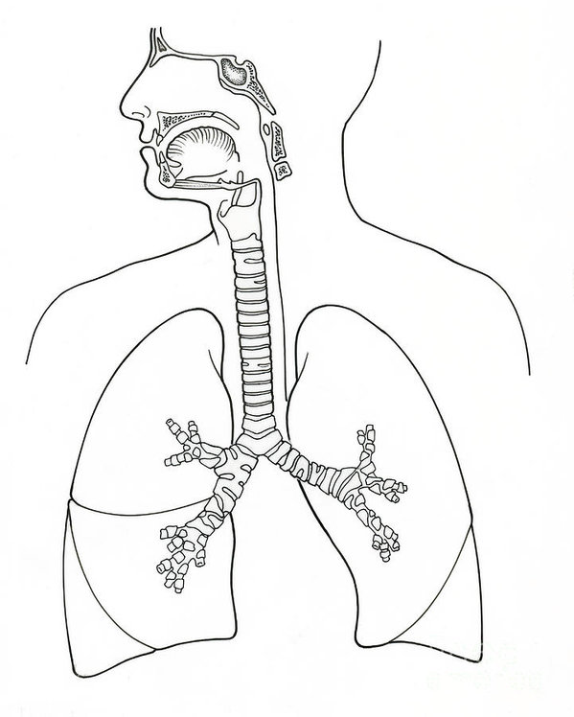

nose

mouth

throat

lung

QUESTION 2 - Keep my body safe

2.1. Is it acceptable? Write yes or no. (6¸2 =3)

1. If someone that loves me gives me a hug? YES
2. Someone scary wants to hug me. NO
3. Don’t worry, it’s just a tickle! NO
4. You look so pretty, I love you so much. YES
5. Stop screaming! You are too old for that. NO
6. Don’t tell anyone, it is our secret. NO

2.2. Study the pictures and write down how you can keep your body healthy. (4¸2 = 2)

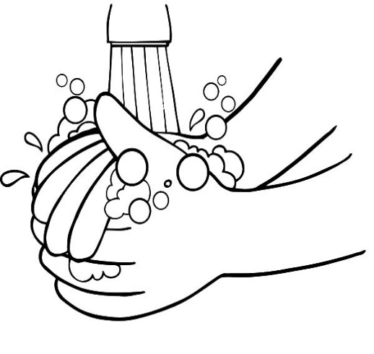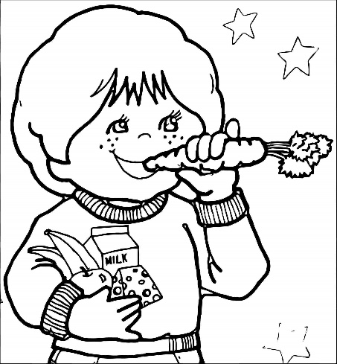

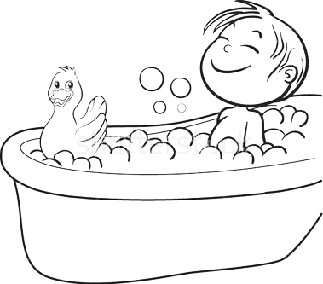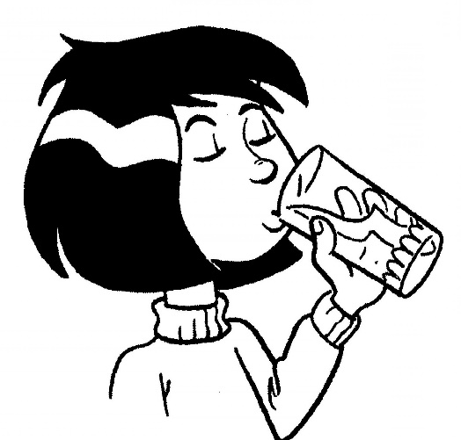

Drink water every day.

Wash your hands before you eat.

OR

Wash your hands after using the toilet.

Bath and shower every day to keep yourself clean.

Eat healthy. Eat your fruit and vegetables.

2.3. True or false? Colour in the correct block. (4¸2=2)

|  |  |  |
| --- | --- | --- |
|  | true | false |
| 1. We must cover our mouth when we sneeze or cough. |  |  |
| 1. It is save to touch someone else’s blood. |  |  |
| 1. Wash fruit and vegetables before eating it. |  |  |
| 1. It is safe to drink water from a pool on the ground. |  |  |

2.4. Some water sources are dirty and we must first clean the

water to make it safe to drink. Name 3 ways in which we

can make water safe to drink. (3)

1. You can boil the dirty water in a kettle to kill the germs.
2. You can filter the dirty water. Your teacher can show you how.
3. You can add 1 teaspoon of bleach (such as Jik) to a 20 liter bucket of river water. Close the bucket to keep flies out. Leave the water for 28 hours before you drink it.

|  |  |  |
| --- | --- | --- |
| Rubric: Personal and Social Well-being |  | Mark |
| 1.1. Name the parts of the body. | 3 |  |
| 1.2. Name the senses | 5 |  |
| 1.3. What can you taste and smell? | 1 |  |
| 1.4. Name the parts that help us breath | 2 |  |
| 2.1. Yes and no feelings | 2 |  |
| 2.2 How do I keep my body healthy? | 2 |  |
| 2.3. True or false | 2 |  |
| 2.4. How can I make water safe to drink? | 3 |  |
| Total | ____/20 | |

|  |  |  |
| --- | --- | --- |
| Total: Section 1 - Beginning knowledge and Personal and Social Well-being |  | Mark |
| 1. Beginning knowledge | 20 |  |
| 1. Personal and Social Well-being | 20 |  |
| Total | ____/40 | |



Creative arts

* Performing arts -

Activity: Improvise and interpret

Assignment:

Practice the following poem and recite it to your class with feeling and gestures.

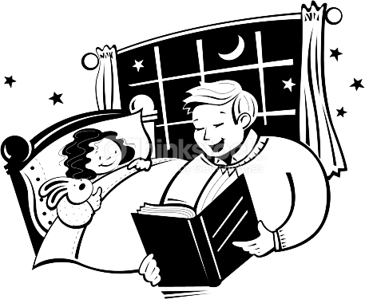

Mommy cooks the food. Daddy washes dishes. My brother and I help Mommy and Daddy. We help a lot. We put the milk and bread away. Then we are ready for bed. Please tell us a story!

|  |  |  |  |  |  |  |
| --- | --- | --- | --- | --- | --- | --- |
|  | Rubric – Recital of poem | Mark | | | | |
|  |  | 5 | 4 | 3 | 2 | 1 |
| 1. | Speaking: Tone and pace | 5 | 4 | 3 | 2 | 1 |
| 2. | Correct grammar and sentence structure. | 5 | 4 | 3 | 2 | 1 |
| 3. | Eye contact and preparation | 5 | 4 | 3 | 2 | 1 |
| 4. | Ability to interest learners and confidence. | 5 | 4 | 3 | 2 | 1 |
| Total | | /20 | | | | |
| Amended mark (20 ¸ 2 = 10) | | ___/10 | | | | |



Creative arts

* Visual arts -



Assignment:

Draw your family where you are busy performing a

task at home, write down a sentence explaining

what you are doing.

You will be marked according to the following rubric:

|  |  |  |  |  |
| --- | --- | --- | --- | --- |
| Rubric – Visual arts | 1 | 2 | 3 | 4 |
|  | Needs help | Adequate | Substantial | Outstanding |
| 1. The learner’s art is full of colour. |  |  |  |  |
| 1. The learner successfully showed his / her family. |  |  |  |  |
| 1. The learner successfully showed the family performing a task. |  |  |  |  |
| 1. Was the learner creative? |  |  |  |  |
| 1. Did the leaner write down a sentence to explain what they were doing? |  |  |  |  |
| Total | ___/20 | | | |
| Amended mark (20 ¸ 2 = 10) | ____/10 | | | |

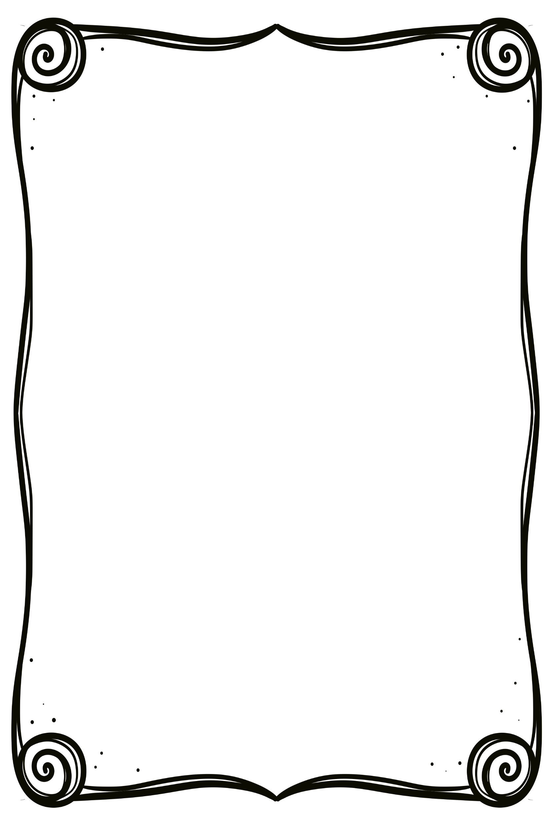

Learners own drawing and sentence.

My family

Sentence: ____________________

____________________

________________________

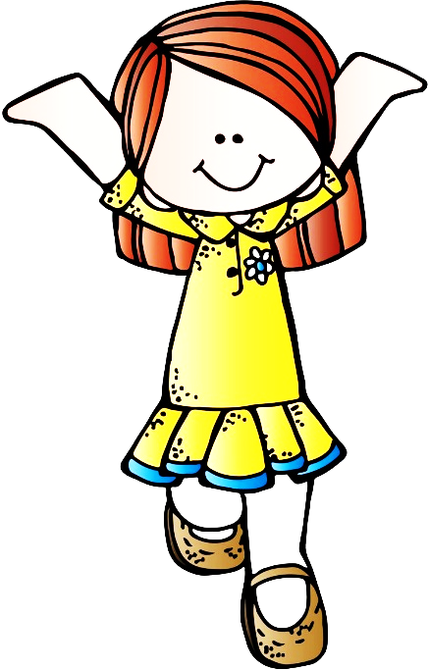

Physical Education

Activity 1

Activity 1 - Movement

Assignment:

We will play “Simon says”. Look at the movements that your teacher is making and copy her.

|  |  |  |  |  |
| --- | --- | --- | --- | --- |
| Rubric: Physical Education – Activity 1 | 1 | 2 | 3 | 4 |
|  | Needs help | Adequate | Substantial | Outstanding |
| 1. Learner can perform different movements. |  |  |  |  |
| 1. Listening skills - learner listens to assignments and takes part. |  |  |  |  |
| 1. The learner enjoys taking part and is enthusiastic. |  |  |  |  |
| 1. The learner shows respect towards the teacher presenting the activity. |  |  |  |  |
| 1. The learner shows respect towards his / her fellow classmates. |  |  |  |  |
| Total | ___/20 | | | |

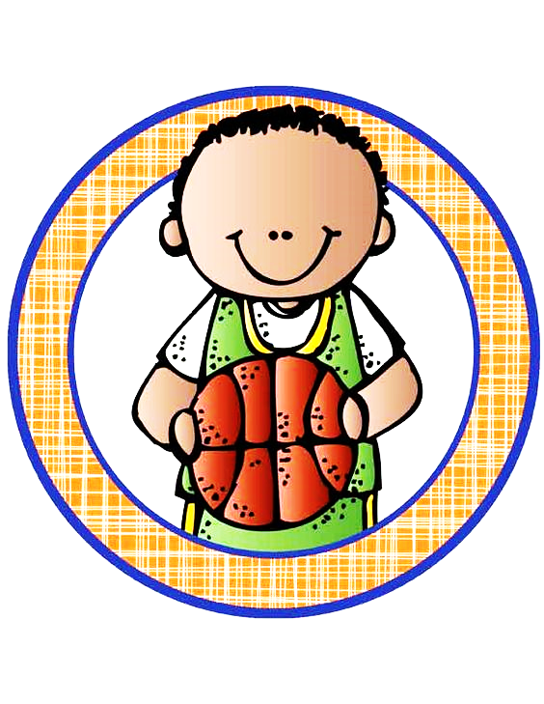

Physical Education

Activity 2

Activity 2 - Ball skills

Assignment:

* Stand in a circle.
* Throw the ball to the opposite person.
* Pass the ball to your friend over your head.
* Pass the ball to your friend between your legs.
* Break into groups of two, stand a few steps away from each other.
* Throw the ball to your friend, catch the ball when your friend throws it.
* Bounce the ball for your friend to catch, catch the ball when your friend bounces it.

|  |  |  |
| --- | --- | --- |
| Rubric: Physical Education - Activity 2 |  | Mark |
| 1. Did the learner pass the ball in the circle? | 2 |  |
| 1. Did the learner pass the ball over his / her head? | 2 |  |
| 1. Did the learner pass the ball between his / her legs? | 2 |  |
| 1. Could the learner throw and catch the ball? | 2 |  |
| 1. Could the learner bounce and catch the ball? | 2 |  |
| Total | ____/10 | |