First Additional Language

Assessment Term 2

Grade 1

|  |  |  |
| --- | --- | --- |
| Content |  | Mark |
| 1. Listening and speaking | 10 |  |
| 1. Reading and phonics | 10 |  |
| Total | 20 |  |

Name and Surname: ____________________________

Date: _________________________________

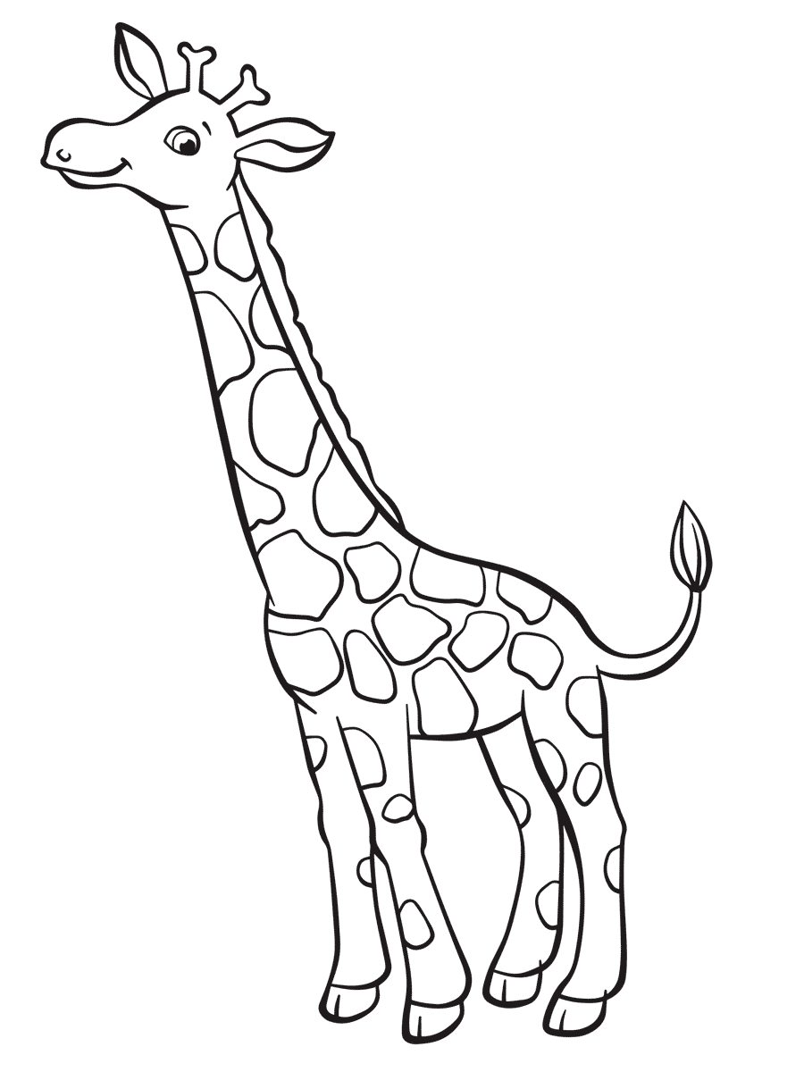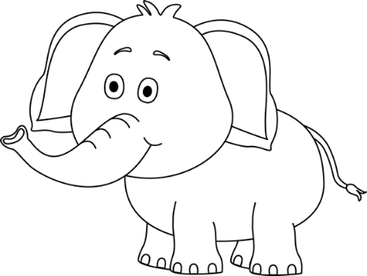

Listening

and speaking

Aim of activity - Respond to simple questions

and name objects in a picture.

Task

Look at the picture your teacher is going to show you about wild animals. Answer the questions she is going to ask you.

|  |  |  |  |  |
| --- | --- | --- | --- | --- |
| Rubric: Listening and speaking | | | | |
|  | 1 | 2 | 3 | 4 |
| 1. The learner is able to name objects in the picture. |  |  |  |  |
| 1. The learner is able to answer simple questions about the picture. |  |  |  |  |
| 1. Learner speaks in a clear voice. |  |  |  |  |
| 1. Learners uses appropriate vocabulary, grammar and uses the correct tense. |  |  |  |  |
| 1. Learner speaks with confidence and makes eye contact. |  |  |  |  |
| Total | ___/20 | | | |
| Processed mark out of 10 | 1. ¸ 2 = ___/10 | | | |

1 - Needs assistance 2- Partial 3- Good 4- Excellent

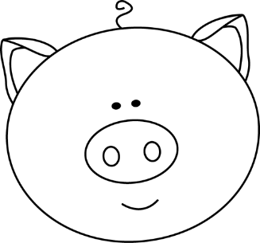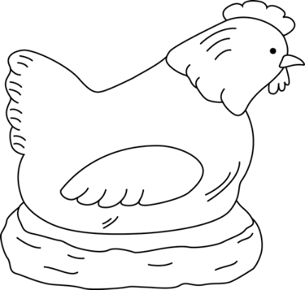

Reading

Activity 1

Listen carefully to the song of "Old MacDonald had a farm" that your teacher is going to play to you.

Answer the questions she is going to ask you about the song. Answer in full sentences.

|  |  |  |  |  |
| --- | --- | --- | --- | --- |
| Rubric: Listening and speaking | | | | |
|  | 1 | 2 | 3 | 4 |
| 1. The learner is able to name objects in the picture. |  |  |  |  |
| 1. The learner is able to answer simple questions about the picture. |  |  |  |  |
| 1. Learner speaks in a clear voice. |  |  |  |  |
| 1. Learners uses appropriate vocabulary, grammar and uses the correct tense. |  |  |  |  |
| 1. Learner speaks with confidence and makes eye contact. |  |  |  |  |
| Total | ___/20 | | | |
| Processed mark out of 10 | 20 ¸ 2 = ___/10 | | | |

1 - Needs assistance 2 - Partial 3 - Good 4- Excellent

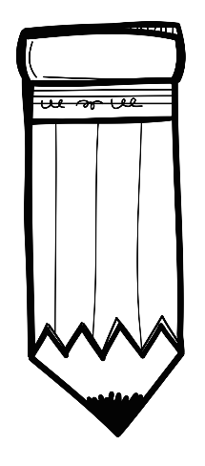

Reading

Activity 2

Draw a picture about the main idea of the song of Old Macdonald had a farm.

|  |  |  |  |  |  |
| --- | --- | --- | --- | --- | --- |
| Rubric - Reading activity 2 | 1 | 2 | 3 | 4 | 5 |
| 1. The learner kept to the topic: "Old Macdonald had a farm." |  |  |  |  |  |
| 1. The learner was creative. |  |  |  |  |  |
| 1. The learners drawing is colourful. |  |  |  |  |  |
| 1. The drawing is neat. |  |  |  |  |  |
| Total | ___/20 | | | | |
| Processed mark out of 10 | 20 ¸ 2 = ___/10 | | | | |

1 - Made no attempt 2 - Needs assistance 3 - Partial 4 - Good 5- Excellent

|  |  |  |
| --- | --- | --- |
| Total mark for reading section |  |  |
| 1. Reading activity 1 | 10 |  |
| 1. Reading activity 2 | 10 |  |
| Total | ___/20 | |
| Processed mark out of 5 | 20 ¸ 4 =____/5 | |



Phonics

1. Clap out the words in syllables to your teacher. (4¸2 = 2)

* If you clapped it correct circle the correct mark.
* If you clapped it wrong circle the incorrect mark.

|  |  |
| --- | --- |
| banana  x **√** | pencil  x √ |
| painting  x √ | carrot  x √ |

1. Look at the pictures and say the word out loud. Write down the beginning sound. (6)

|  |  |  |
| --- | --- | --- |
| See the source image | See the source image |  |
|  |  |  |
| See the source image | See the source image | See the source image |
|  |  |  |

1. Circle the words which rhymes with the word. (4¸2 = 2)

|  |  |
| --- | --- |
| cat | hat mad bad mat |
| run | sun bug fun rug |

|  |  |  |
| --- | --- | --- |
| Total mark for phonics section |  |  |
| 1. Clap words in syllables. | 2 |  |
| 1. Beginning sounds | 6 |  |
| 1. Rhyming words | 2 |  |
| Total | ___/10 | |
| Processed mark out of 5 | 10 ¸ 2 = ___/5 | |

|  |  |  |
| --- | --- | --- |
| Total mark for reading and phonics section |  |  |
| 1. Reading | 5 |  |
| 1. Phonics | 5 |  |
| Total | ___/10 | |