First Additional Language

Assessment Term 2

Grade 1

|  |  |  |
| --- | --- | --- |
| Content |  | Mark |
| 1. Listening and speaking | 10 |  |
| 1. Reading and phonics | 10 |  |
| Total | 20 |  |

Name and Surname: ____________________________

Date: _________________________________

MEMORANDUM

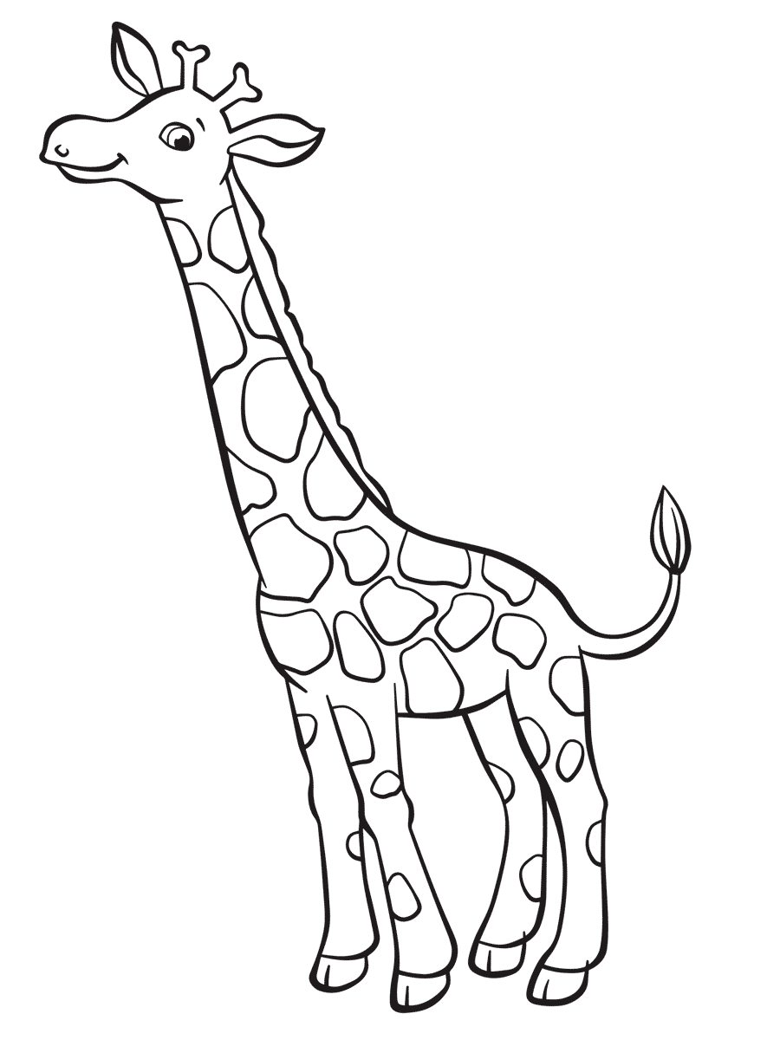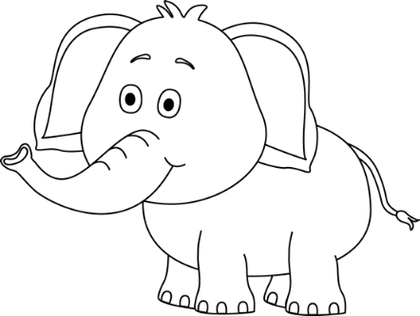

Listening

and speaking

Aim of activity - Respond to simple questions

and name objects in a picture.

Task

Look at the picture your teacher is going to show you about wild animals. Answer the questions she is going to ask you.

|  |  |  |  |  |
| --- | --- | --- | --- | --- |
| Rubric: Listening and speaking | | | | |
|  | 1 | 2 | 3 | 4 |
| 1. The learner is able to name objects in the picture. |  |  |  |  |
| 1. The learner is able to answer simple questions about the picture. |  |  |  |  |
| 1. Learner speaks in a clear voice. |  |  |  |  |
| 1. Learners uses appropriate vocabulary, grammar and uses the correct tense. |  |  |  |  |
| 1. Learner speaks with confidence and makes eye contact. |  |  |  |  |
| Total | ___/20 | | | |
| Processed mark out of 10 | 1. ¸ 2 = ___/10 | | | |

1 - Needs assistance 2- Partial 3- Good 4- Excellent

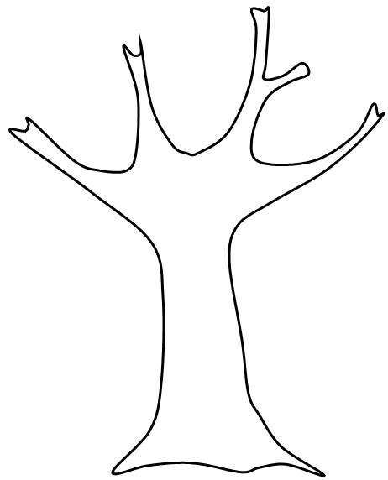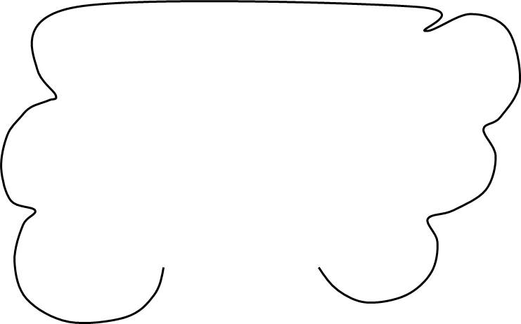

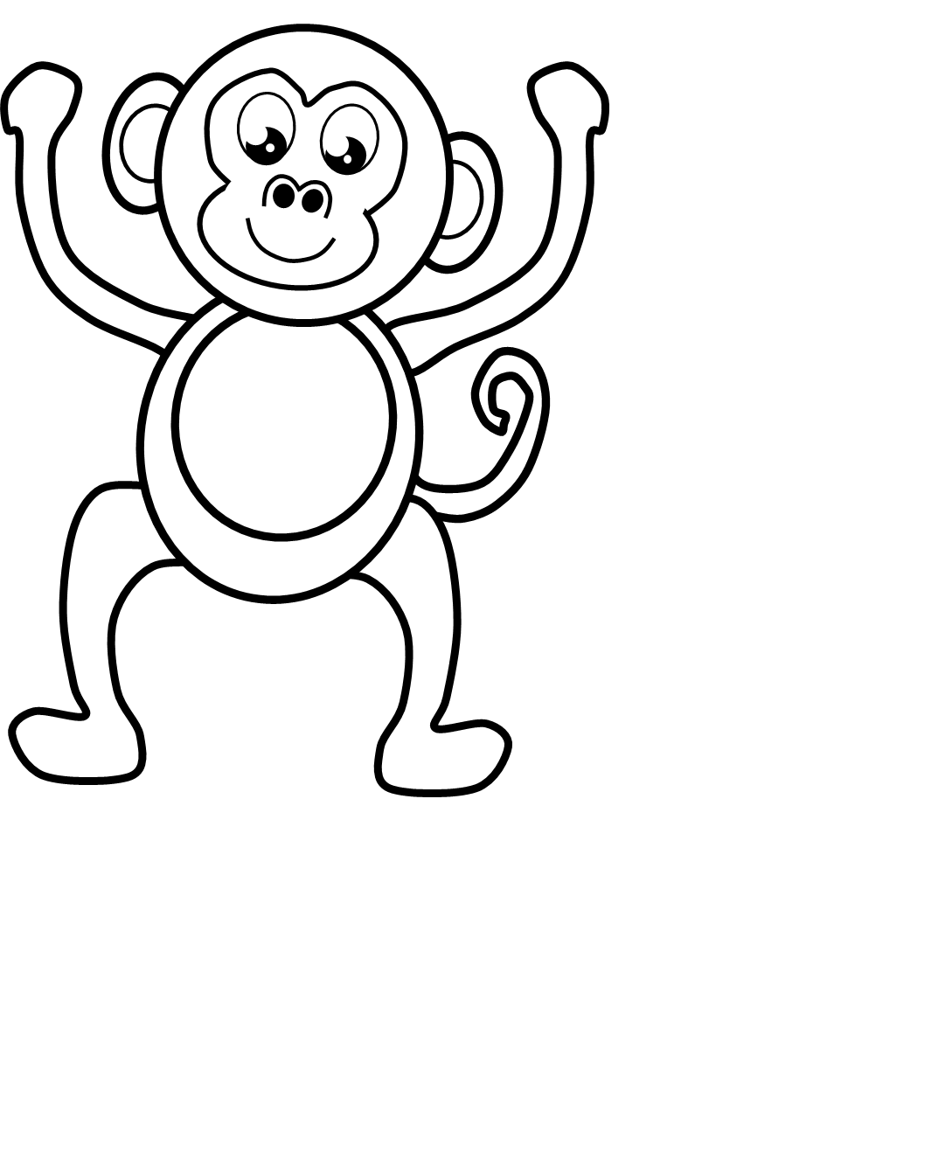

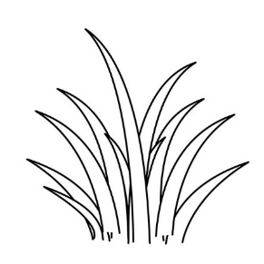



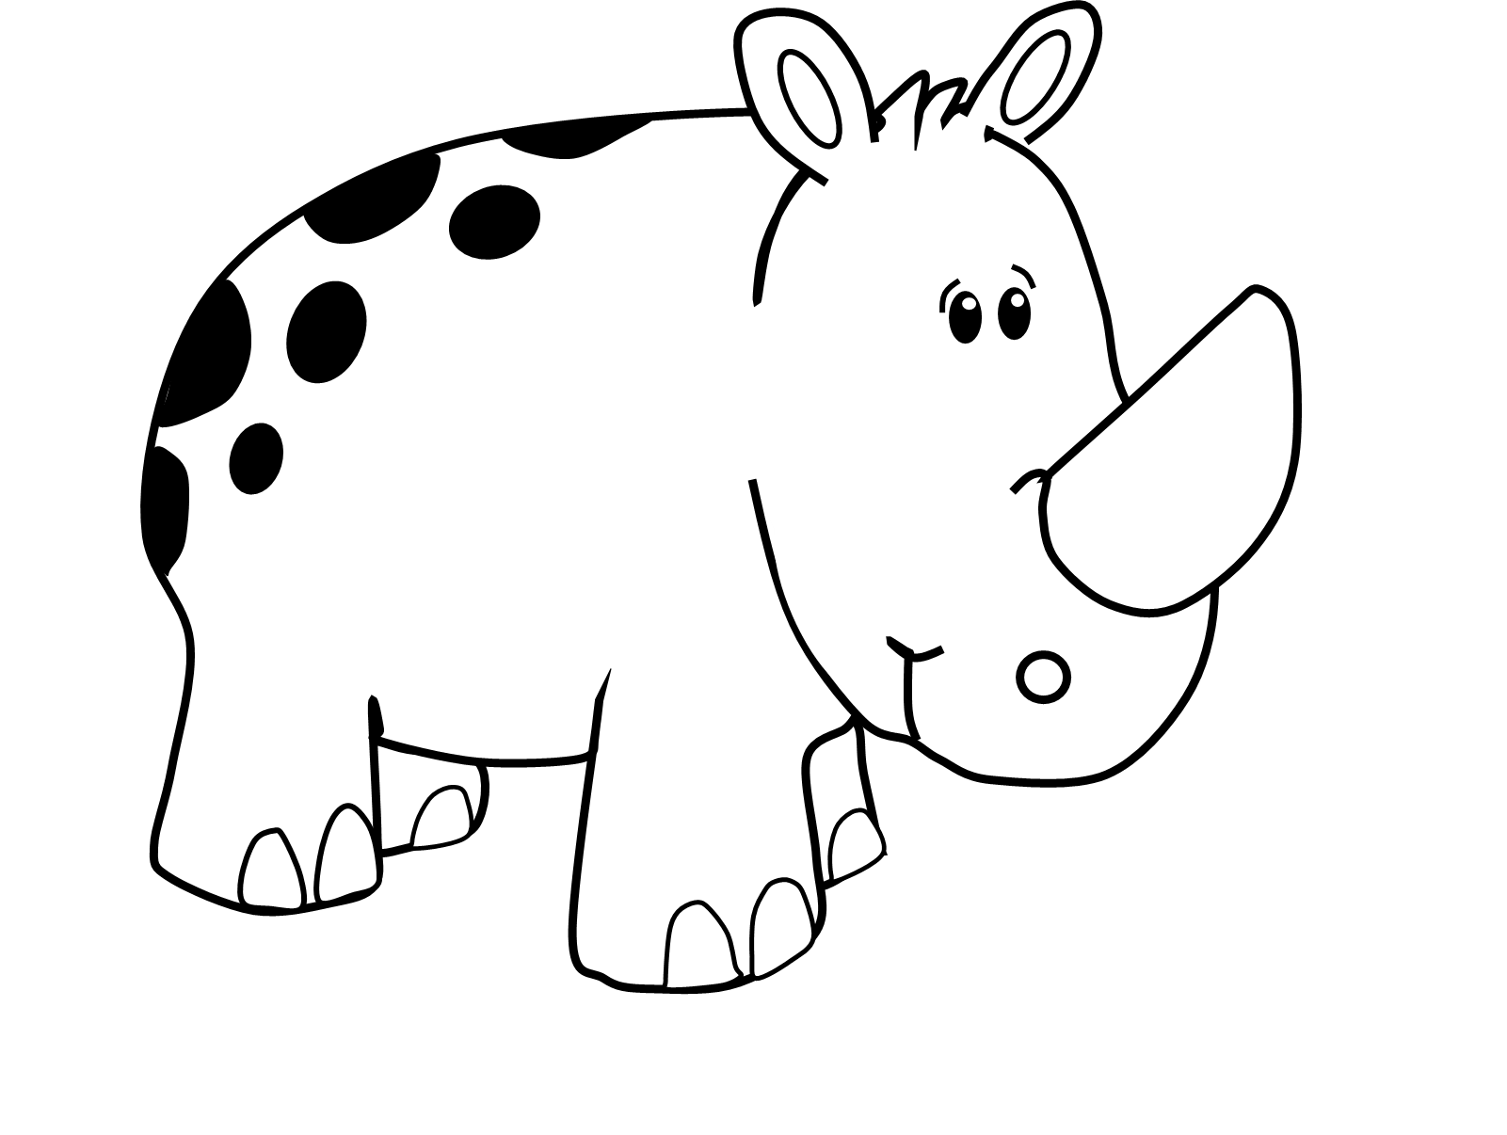



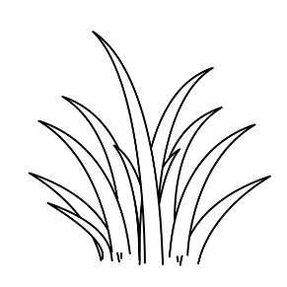

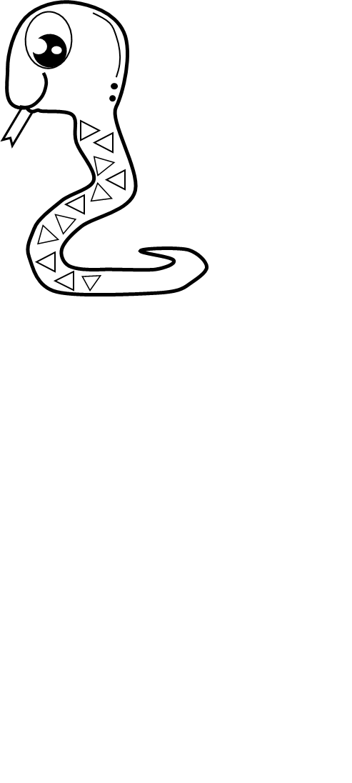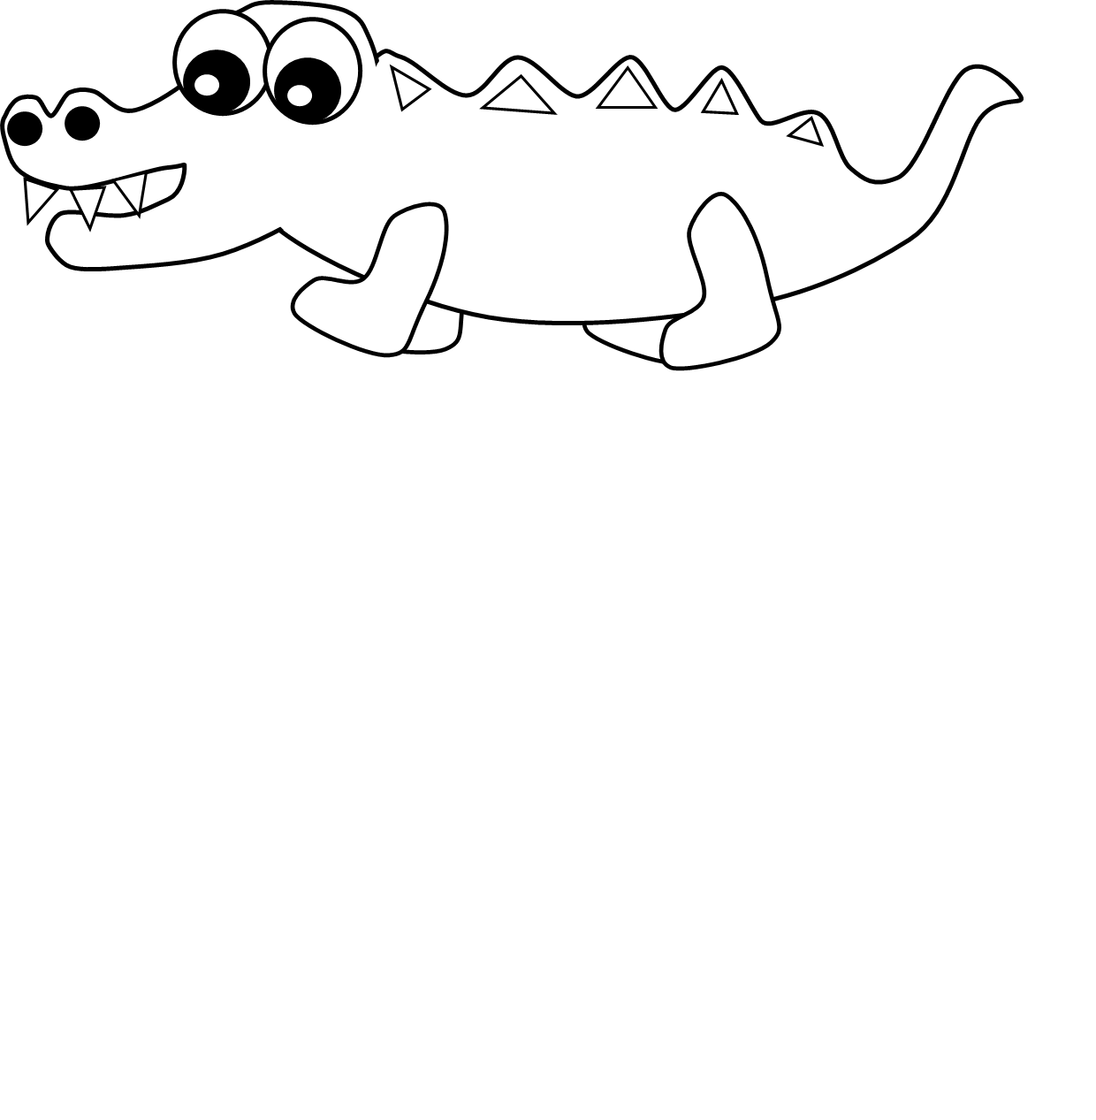

Examples of questions for teacher

1. What animal is this? (Point to the crocodile)
2. What animal is this? (Point to the giraffe)
3. What animal is this? (Point to the snake)
4. What animal is this? (Point to the monkey)
5. What animal is this? (Point to the rhino)
6. How many monkeys do you count in the picture?
7. How many animals do you count in the picture?
8. What colour is a rhino?
9. What colour is a tree?

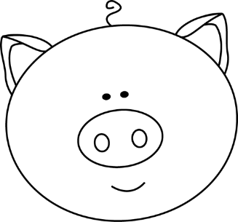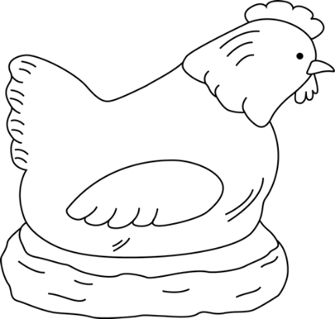

Reading

Activity 1

Listen carefully to the song of "Old MacDonald had a farm" that your teacher is going to play to you.

Answer the questions she is going to ask you about the song. Answer in full sentences.

|  |  |  |  |  |
| --- | --- | --- | --- | --- |
| Rubric: Reading activity 1 | | | | |
|  | 1 | 2 | 3 | 4 |
| 1. The learner is able to name objects in the picture. |  |  |  |  |
| 1. The learner is able to answer simple questions about the picture. |  |  |  |  |
| 1. Learner speaks in a clear voice. |  |  |  |  |
| 1. Learners uses appropriate vocabulary, grammar and uses the correct tense. |  |  |  |  |
| 1. Learner speaks with confidence and makes eye contact. |  |  |  |  |
| Total | ___/20 | | | |
| Processed mark out of 10 | 20 ¸ 2 = ___/10 | | | |

1 - Needs assistance 2 - Partial 3 - Good 4- Excellent

Examples of questions for teacher

1. What is the farmer in the songs name?

Macdonald

1. What farm animals is in the song?

Pig, duck, horse, sheep, cow and turkey.

1. What sound does a pig make?

Oink

1. What sound does a cow make?

Moo

1. What sound does a duck make?

Quack

1. What sound does a horse make?

Neigh

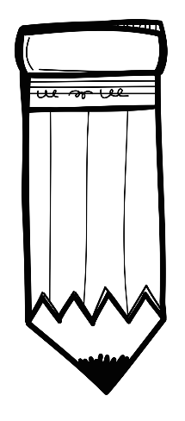

Reading

Activity 2

Draw a picture about the main idea of the song of Old Macdonald had a farm.

A drawing of animals on a farm

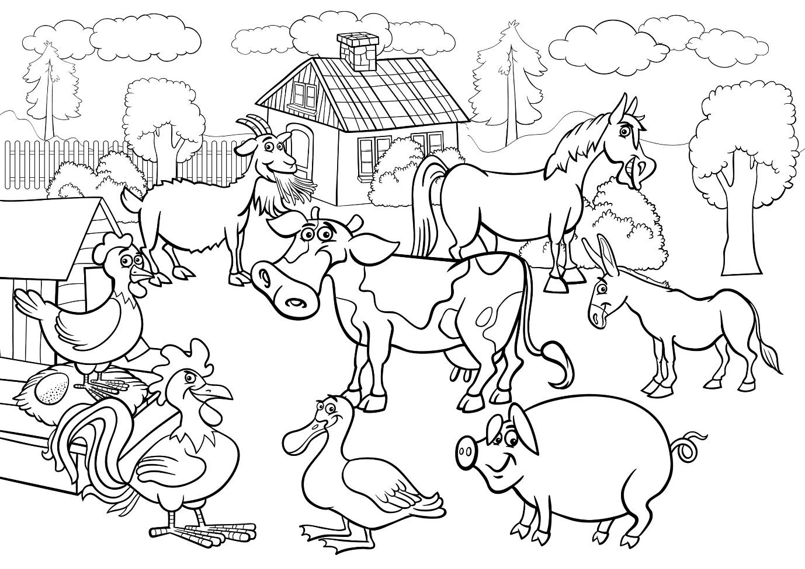

|  |  |  |  |  |  |
| --- | --- | --- | --- | --- | --- |
| Rubric - Reading activity 2 | 1 | 2 | 3 | 4 | 5 |
| 1. The learner kept to the topic: "Old Macdonald had a farm." |  |  |  |  |  |
| 1. The learner was creative. |  |  |  |  |  |
| 1. The learners drawing is colourful. |  |  |  |  |  |
| 1. The drawing is neat. |  |  |  |  |  |
| Total | ___/20 | | | | |
| Processed mark out of 10 | 20 ¸ 2 = ___/10 | | | | |

1 - Made no attempt 2 - Needs assistance 3 - Partial 4 - Good 5- Excellent

|  |  |  |
| --- | --- | --- |
| Total mark for reading section |  | Mark |
| 1. Reading activity 1 | 10 |  |
| 1. Reading activity 2 | 10 |  |
| Total | ___/20 | |
| Processed mark out of 5 | 20 ¸ 4 =____/5 | |



Phonics

1. Clap out the words in syllables to your teacher. (4¸2 = 2)

* If you clapped it correct circle the correct mark.
* If you clapped it wrong circle the incorrect mark.

|  |  |
| --- | --- |
| banana  x **√** | pencil  x √ |
| painting  x √ | carrot  x √ |

1. Look at the pictures and say the word out loud. Write down the beginning sound. (6)

|  |  |  |
| --- | --- | --- |
| See the source image | See the source image |  |
| s | a | s |
| See the source image | See the source image | See the source image |
| m | b | p |

1. Circle the words which rhymes with the word. (4¸2 = 2)

|  |  |
| --- | --- |
| cat | hat mad bad mat |
| run | sun bug fun rug |

|  |  |  |
| --- | --- | --- |
| Total mark for phonics section |  |  |
| 1. Clap words in syllables. | 2 |  |
| 1. Beginning sounds | 6 |  |
| 1. Rhyming words | 2 |  |
| Total | ___/10 | |
| Processed mark out of 5 | 10 ¸ 2 = ___/5 | |

|  |  |  |
| --- | --- | --- |
| Total mark for reading and phonics section |  |  |
| 1. Reading | 5 |  |
| 1. Phonics | 5 |  |
| Total | ___/10 | |