**GRADE 5 MATHEMATICS TEST – TERM 4**

**QUESTION PAPER 1**

**Name and surname: _______________________ Total: 50**

**Date: ____________________ Time: 1 hour**

**INSTRUCTIONS**

1. Show all your calculations.
2. You are not allowed to use a calculator.
3. Write neatly.

**___________________________________________________________________________**

**Question 1: Calculate – Addition, subtraction, division and multiplication (18)**

78943 – 65 349 345 378 + 76 563

__________________________________________________________________________________________________________________________________________________________________________________________________

_________________________________________________________________________________________________

56 736 x 67 87 550 ÷ 25 __________________________________________________________________________________________________________________________________________________________________________________________________

__________________________________________________________________________________________________________________________________________________________________________________________________

947 ÷ 9 R212,38 + R78, 45

__________________________________________________________________________________________________________________________________________________________________________________________________

__________________________________________________________________________________________________________________________________________________________________________________________________

**Question 2 – Number patters and geometric patterns (3)**

Complete the following questions:

2.1) $\frac{1}{8}$; $\frac{2}{8}$; $\frac{3}{8}$; ____ ; ____ ; $\frac{6}{8}$; $\frac{7}{8}$ (1)

2.2) 850; 800; 750; ____; ____; ____ (1)

2.3) How many circles are in the next pattern? (1)



**Vraag 3: Breuke 3**

1. $\frac{7}{8}$- $\frac{5}{8}$ = _______________________ (1)
2. $\frac{5}{6}$- $\frac{1}{3}$ = _______________________ (1)
3. $\frac{4}{5}$ of R125 = ____________________ (1)

**Question 4: Mass, length, capacity and volume (8)**

4.1 Complete the table by filling in the correct answer: (5)

|  |  |
| --- | --- |
| **Unit** | **Conversion** |
| 4.1.1 879 ml | ________ l |
| 4.1.2 18cm | ________mm |
| 4.1.3 4024 km | _____km _____ m |
| 4.1.2 2974 mm | ________ m |

* 1. Uncle Eddy has 45 543 liter water in a tank. Due to the drought he decided to water his garden from the tank. He uses 985 liter water. How many liters of water does he have left in his tank?

__________________

__________________

__________________(3)

**Question 5: Time (4)**

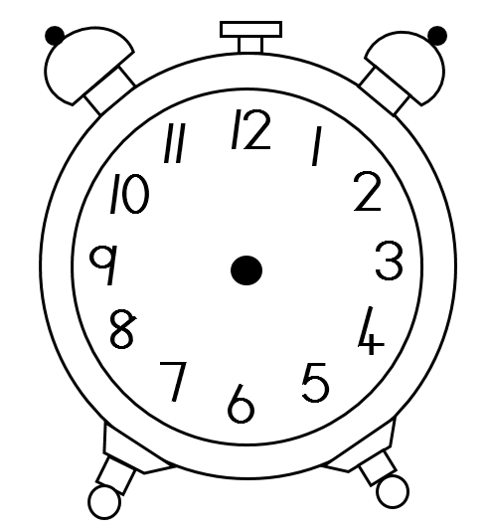5.1 Draw the hands on the clock to indicate 16:45. (1)

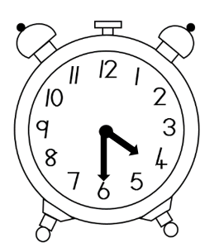5.2 Write the digital time in the box for the clock in p.m. (post midday). (1)

* 1. How many weeks are in a year? _______ (1)

5.4. How many hours are there in 5 days? ______ (1)

**Question 6: Word problems (7)**

1. There is 30 handbags with 5 lipsticks in each handbag. How many lipsticks are there altogether?

______________________________________________________________________________________________________________________________________________________________________________________________________________(3)

b) David saves R2 235 to buy a PlayStation with his brother Stephen. Stephen

saves R 3 016. How much money do the still have to save if the PlayStation costs R6000?

______________________________________________________________________________________________________________________________________________________________________________________________________________(4)

**Question 7: Temperature (3)**

Examine the chart with the minimum and maximum temperatures and answer the questions below.

|  |  |  |
| --- | --- | --- |
|  | Minimum temperature | Maximum temperature |
| Johannesburg | 5 °C | 23 °C |
| Bloemfontein | 3 °C | 19 °C |
| Cape Town | 12 °C | 28 °C |

7.1 Which city was the coldest? _______________________________ (1)

7.2 Which temperature was the highest of the 3 cities? ____________ (1)

7.3 At which degree does water start to boil? _________________ (1)

7.4. What is the difference between the maximum temperature of Johannesburg and the

maximum temperature of Bloemfontein? (1)

__________________________________________________

_________________________________________________________________________________________________________

**Total: ____/50**