**GRADE 5 MATHEMATICS TEST – TERM 4 (MEMORANDUM)**

**QUESTION PAPER 1**

**Name and surname: _______________________ Total: 50**

**Date: ____________________ Time: 1 hour**

**INSTRUCTIONS**

1. Show all your calculations.
2. You are not allowed to use a calculator.
3. Write neatly.

**___________________________________________________________________________**

**Question 1: Calculate – Addition, subtraction, division and multiplication (18)**

78943 - 65349 345378 + 76563

1

1

1

1

345 378√

+ 76 563

421 941√

1

8

1

3

78 943√

* 65349

13 594√

56,736 x 67 87 550 ÷ 25

$$25 \sqrt{87 550}$$

-75 √

125

-125 √

05

- 0 √

50

-50 √

0

3502 √

56 736√

X 67

397 152√

+ 3404160

3801 312√

4

4

2

3

4

5

2

4

1

1

1

947 ÷ 9

105 remaining 2 √

$$9 \sqrt{947}$$

-9 √

04

-0 √

47

-45 √

2

R212,38 + R78, 45

R 212,38√

+ R 78.45

R 290,83√

1

1

**Question 2: Number patterns and geometric patterns 3**

Complete the following patterns.

2.1) $\frac{1}{8}$; $\frac{2}{8} \frac{3}{8};$ $\frac{4}{8}$; $\frac{5}{8}$; $\frac{6}{8} \frac{7}{8}$ √ (1)

2.2) 850; 800; 750; 700; 650; 600 √ (1)

2.3) How many circles are in the next pattern?

12√ (1)



**Question 3: Fractions 3**

1. $\frac{7}{8}$- $\frac{5}{8}$ = $\frac{3}{8}√$ (1)
2. $\frac{5}{6}$- $\frac{1}{3}$ = $\frac{3}{6}=\frac{1}{2}√$ (1)
3. $\frac{4}{5}$ of R125 = _________100√___________ (1)

**Question 4: Mass, length, capacity and volume 8**

4.1 Complete the table by filling in the correct answers:

|  |  |
| --- | --- |
| **unit** | **conversion** |
| 4.1.1 879 ml | ___0,879√_____ l |
| 4.1.2 18cm | ___180√_____mm |
| 4.1.3 4024 km | __4√___km __24√___ m |
| 4.1.2 2974 mm | ___2,974√_____ m |

(5)

* 1. 4.2 Uncle Eddy has 45 543 liter water in a tank. Due to the drought he decided to water his garden from the tank. He uses 985 liter water. How many liters of water does he have left in his tank?

1

1

3

4

1

4

1. 543

* 985√

44 558√(3)

Uncle Eddy has 44,558 liters of water left in his tank.√

**Question 5: Time 4**

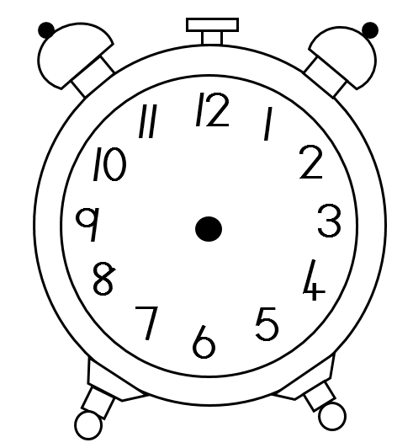5.1 Draw hands on the clock to indicate 16:45. (1)

√

5.2 Write the digital time in the box for the clock in p.m. (post midday). (1)

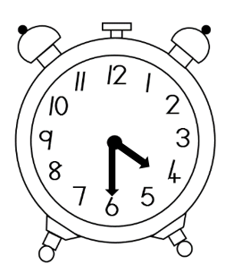

16:30 √

5.3 How many weeks are there in a year? ___52__√__ (1)

5.4 How many hours are there in 5 days? __120__√__ (1)

**Question 6: Number sentences 7**

1. There are 30 handbags with 5 lipsticks in every handbag. How many lipsticks are there altogether?

30

X 5 √

150 √ There are altogether 150 lipsticks √

______________________________________________________________________________________________________________________________________________________________________________________________________________(3)

b) David saves R2 235 to buy a PlayStation with his brother Stephen. Stephen

saves R 3 016. How much money do the still have to save if the PlayStation costs R6000?

1

9

9

R 2235

R 6000

* R 5251 √

R 749 √ They still have R749 to save.

1

1

1

5

+ R 3016 √

R 5251√ saved together (4)

**Question 7: Temperature 3**

Study the weather map and answer the questions that follow:

|  |  |  |
| --- | --- | --- |
|  | minimum temperature | maximum temperature |
| Johannesburg | 5 ° C | 23 ° C |
| Bloemfontein | 3 ° C | 19 ° C |
| Cape Town | 12 ° C | 28 ° C |

7.1 Which city was the coldest? ______Bloemfontein√______________ (1)

7.2 What was the highest temperature between the 3 cities? ____28 ° C √____ (1)

7.3 How many degrees starts to boil water? ______100 ° C√__________ (1)

**Total: ____/50**