GRADE 5 Natural Science and Technology – TERM 4
Name and surname: _______________________ Total: 45
Date: ____________________ Time: 1 hour
INSTRUCTIONS
- Read the questions carefully.
- Answer all the questions.
- All drawings must be done in pencil.
- Write neatly.
___________________________________________________________________________
QUESTION 1: Multiple choice
Read each question and circle the correct letter for each question. (7)
  - Which one of the following is not an example of fuel
A. Wood
B. Rocks
C. Wax
D. Coal

  - When plants are growing, they use light energy from the __________ as well as carbon dioxide and water to grow.
- moon
- sun
- earth
- plants

  - _________ is the fuel for our bodies.
- food
- animals
- diesel
- petrol

  - The earth rotates around its own axis from ________ to ________
- North to south
- West to East
- South to North
- East to West
  - Any fire needs ________ to burn.
- oxygen
- grass
- plants
- coal

  - Fire can be ________ if it is not controlled, especially inside the home.
- good
- useful
- dangerous
- warm

  - For the Earth to rotate around its own axis, it takes
- 24 hours
- 365 ‰ days
- 356 ‰ days
- 12 hours
___________________________________________________________________________
QUESTION 2
Give a description for the following words: (5)
  - Erosion:
______________________________________________________________________________________________________________________________________________(1)

  - Deposition:
______________________________________________________________________________________________________________________________________________(1)

  - Mantle:
______________________________________________________________________________________________________________________________________________(1)

  - Clay:
______________________________________________________________________________________________________________________________________________(1)

  - Loam:
______________________________________________________________________________________________________________________________________________(1)
QUESTION 3
Match the description in Column B with the word in Column A by writing the correct letter.
(5)
Column A | Answer | Column B
- Limestone |  | - The remains or traces of plants and animals that lived long ago
- Fossil |  | - A system that transfers electrical energy to where it is needed.
- Sandstone |  | - Made from grains of sand that are cemented together.
- Battery |  | - Made of layers of shells of sea-animals that died and sank to the bottom of the sea.
- Electrical circuit |  | - Two or more cells connected end to end.
___________________________________________________________________________
QUESTION 4: Soil
Answer the questions below:
  - There are 3 main types of particles which make up soil. Write them down. (3)
______________________
______________________
______________________

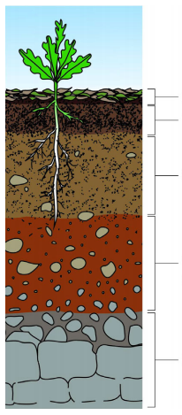
  - Look at the picture and complete the missing headings. (5)

- _____________________
- _____________________

- _____________________
- _____________________
- _____________________

QUESTION 5
  - Look at the picture below and label the picture. (7)
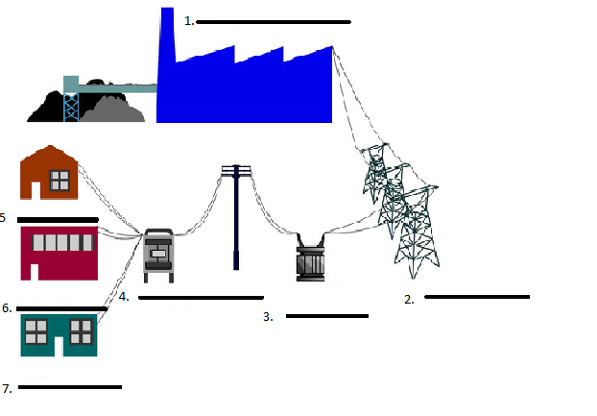
  - Give 6 rules how to use electricity safely. (6)
__________________________________________________________________________________________________________________________________________________________________________________________________________________________________________________________________________________________________________________________________________________________________________________________________________________________________________
___________________________________________________________________
QUESTION 6: Fossils
Give a description for the following words:
  - Body fossil:
________________________________________________________________________________________________________________________________________(1)
  - Trace fossil:
________________________________________________________________________________________________________________________________________(1)
  - Answer the questions below about the Cradle of humankind.

- Where can you find the Cradle of Humankind?
___________________________________________________________________(1)

- In the Cradle of Humankind about 1 000 fossils of __________________ have been discovered. (1)

- Altogether there are 15 major fossil sites in the Cradle of Humankind. The ________________________ Caves are the most famous. (1)

- The fossils of “Mrs _________________” and _____________________, were both discovered at Maropeng. (2)

___________________________________________________________________________

TOTAL: ___/45

