GRADE 5 Natural Science and Technology – TERM 4
Name and surname: _______________________ Total: 45
Date: ____________________ Time: 1 hour
INSTRUCTIONS
- Read the questions carefully.
- Answer all the questions.
- All drawings must be done in pencil.
- Write neatly.
___________________________________________________________________________
QUESTION 1: Multiple choice
Read each question and circle the correct letter for each question. (7)
  - Which one of the following is not an example of fuel
A. Wood
B. Rocks
C. Wax
D. Coal

  - When plants are growing, they use light energy from the __________ as well as carbon dioxide and water to grow.
- moon
- sun
- earth
- plants

  - _________ is the fuel for our bodies.
- food
- animals
- diesel
- petrol

  - The earth rotates around its own axis from ________ to ________
- North to south
- West to East
- South to North
- East to West
  - Any fire needs ________ to burn.
- oxygen
- grass
- plants
- coal

  - Fire can be ________ if it is not controlled, especially inside the home.
- good
- useful
- dangerous
- warm

  - For the Earth to rotate around its own axis, it takes
- 24 hours
- 365 ‰ days
- 356 ‰ days
- 12 hours
___________________________________________________________________________
QUESTION 2
Give a description for the following words: (5)
  - Erosion:
When wind and water move pieces away from the rock (1)

  - Deposition:
Wind and water erode the rock as they carry away the sand (1)

  - Mantle:
The mantle is the layer that lies underneath the crust. Mantle rock is much hotter
than the rock that is found in the crust. (1)

  - Clay:
Clay consists mainly of very fine particles which cling together. (1)

  - Loam:
Loam is a mixture of clay, sand and humus. (1)

QUESTION 3
Match the description in Column B with the word in Column A by writing the correct letter.
(5)
Column A | Answer | Column B
- Limestone | D | - The remains or traces of plants and animals that lived long ago
- Fossil | A | - A system that transfers electrical energy to where it is needed.
- Sandstone | C | - Made from grains of sand that are cemented together.
- Battery | E | - Made of layers of shells of sea-animals that died and sank to the bottom of the sea.
- Electrical circuit | B | - Two or more cells connected end to end.
___________________________________________________________________________
QUESTION 4: Soil
Answer the questions below:
  - There are 3 main types of particles which make up soil. Write them down. (3)
Clay
Silt
Sand

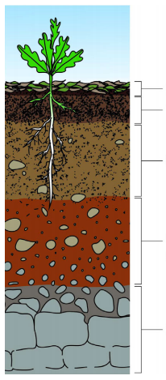
  - Look at the picture and complete the missing headings. (5)

- Humus
- Topsoil

- Subsoil
- Weathered rock fragments
- Bedrock

QUESTION 5
  - Look at the picture below and label the picture. (7)
Power station
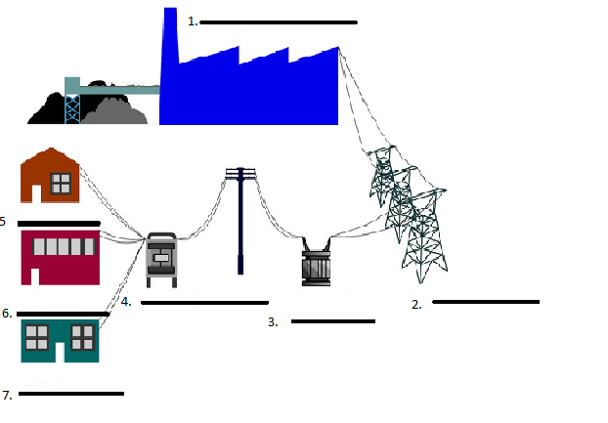
Pylon
Substation
Electricity box
Shop
School
Home
  - Give 6 rules how to use electricity safely. (6)
Here are some rules for using electricity safely:
1. Do not put anything into an outlet except a plug.
2. Do not pull on the cord to unplug an appliance, hold the plug and pull.
3. Dry your hands before you plug in or unplug a cord.
4. If a plug is broken or a cord is cut or worn, do not use it.
5. Do not plug too many cords into one outlet.
6. Keep appliances away from water. Do not use a hair dryer if there is water nearby.
7. If there is an electrical storm (with lightning), turn o and disconnect electrical appliances, like the TV and computer.
8. Do not touch any power lines.
9. Some power lines are buried underground. If you are digging and find a wire, do not touch it.
10. Do not fly a kite or climb a tree near a power line.
___________________________________________________________________
QUESTION 6: Fossils
Give a description for the following words:
  - Body fossil:
A body fossil shows you the shape of the body of the plant or animal. Body fossils include teeth, bones, shells, stems, leaves and seeds. (1)
  - Trace fossil:
Trace fossils show the evidence of how an animal or plant interacted with its environment. Some ancient animals, like dinosaurs, may have walked across wet mud and left footprints in the mud, this footprint can be preserved and become a trace fossil. (1)
  - Answer the questions below about the Cradle of humankind.

- Where can you find the Cradle of Humankind?
The Cradle of Humankind is found in Maropeng just outside of Johannesburg in Gauteng. (1)

- In the Cradle of Humankind about 1 000 fossils of pre-humans have been discovered. (1)

- Altogether there are 15 major fossil sites in the Cradle of Humankind. The Sterkfontein Caves are the most famous. (1)

- The fossils of "Mrs Pleis'' and "Little foot'', were both discovered at Maropeng (2)

___________________________________________________________________________

TOTAL: ___/45

