**GRADE 5 MATHEMATICS TEST – TERM 4**

**QUESTION PAPER 2**

**Name and surname: _______________________ Total: 50**

**Date: ____________________ Time: 1 hour**

**INSTRUCTIONS**

1. Show all your calculations.
2. You are not allowed to use a calculator.
3. Write neatly.

**___________________________________________________________________________**

**Question 1: 2D and 3D shapes properties 17**

1.1 Complete the tables below.

|  |  |  |
| --- | --- | --- |
| Shape | Number of corners | Number of sides |
|  |  |  |
|  |  |  |
|  |  |  |

|  |  |  |  |
| --- | --- | --- | --- |
| Shape | Name | Number sides | Number of faces |
|  |  |  |  |

|  |  |  |  |
| --- | --- | --- | --- |
|  |  |  |  |
|  |  |  |  |

1.2 Write down how many right angles are there in each figure. **2**

**______________________________________________________________________________**

**Question 2: Symmetry 6**

* 1. Draw the other half of the following images:

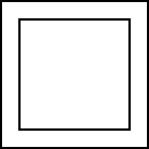

* 1. Draw the lines of symmetry of the following items:

**Question 3: Views 3**

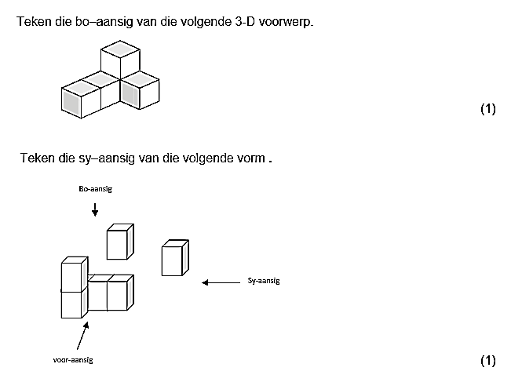

front view

* 1. Draw the top view of the 3D object.
  2. Draw the front of the 3D object.
  3. Draw the right view of the 3D object.

**__________________________________________________________________Question 4: Transformations 2**

Consider the following figures and say what type of transformation occurred. (Reflection, translation or rotation).

1. ________________________
2. ______________________

______________________________________________________________________________

**Question 5: Perimeter and Area 4**

Calculate the perimeter and area of ​​the following 4

4 m

4 m

9 m

5 m

8 m

________________________________________________________________________________________________________________________________________________________________________________________________________________________________________________________________________________________________________________________

(4)

______________________________________________________________________________

**Question 6: Position and movement 11**

|  |  |  |  |
| --- | --- | --- | --- |
|  |  | A B C D |  |
|  |  |  |  |
|  |  |  |  |
|  |  |  |  |

* 1. Figures and shapes appear on the grid. Answer the questions that follow.

1

2

3

4

* + 1. What shape is at C2? __________________________________________ 1
    2. What shape is at A1? __________________________________________ 1
    3. Draw a trapezium at D4. 1

6.2. Figures and shapes appear on the grid. Answer the questions that follow.

A B C D

|  |  |  |  |
| --- | --- | --- | --- |
|  |  |  |  |
|  |  |  |  |
|  |  |  |  |
|  |  |  |  |

1

2

3

4

6.2.1 Write down the position of all circles: ________________________ 3

6.2.2 Write down the position of all the rectangles: _____________________ 4

6.2.3. What is the name of the shape at C3? ___________________ 1

______________________________________________________________________________

**Question 7: Data Handling 7**

There is an investigation under the Grade 5 students about their favorite restaurant. The bar graph below represents their favorite restaurant. Answer the following questions:

7.1.1 What restaurant does the learners prefer the most?

_______________________________________________________________________(1)

7.1.2 How many students like Panarottis?

_______________________________________________________________________(1)

7.1.3 How many children prefer Spur to Wimpy?

_______________________________________________________________________(2)

7.1.4 Which restaurant does the learners prefer the least?

_______________________________________________________________________(1)

* + 1. On Monday Spur sold 11 hamburger. If Spur sells 5 more hamburgers every day, how many hamburgers will be sold by Friday?

_____________________________________________________________________(2)

**Total: ___/50**