**Mathematics**

**Assessment – Term 3**

**Grade 3**

**Name: ____________________________**

**Date: _________________________________**

|  |  |  |
| --- | --- | --- |
| **Questions** |  | **Marks** |
| 1. Numbers, Operations and Relationships | **58** |  |
| 1. Patterns, functions and Algebra | **10** |  |
| 1. Space and Shape | **13** |  |
| 1. Measurement | **14** |  |
| 1. Data Handling | **5** |  |
| **Total** | **100** |  |

1. **Numbers, operations and relationships**
   1. Count the following objects and write the answers in the block. (1)

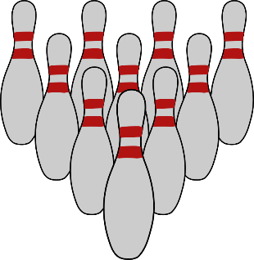





=

* 1. Order
     1. Order the following numbers from the smallest to the largest. (1)

206, 602, 622, 260, 620

__________________________________________

* + 1. Order the following numbers from the largest to the smallest. (1)

708, 701, 710, 718, 781,

__________________________________________

* 1. Complete the number line. (7)



889 879 829 809

* 1. Calculations – Write down the answer. (10)

f. What is 20 more than 547 = ___

g. What is 100 less than 899 = ___

h. 10 groups of 10 = ___

i. 60 – 20 + 6 + 3 = ___

j. 4 less than 402 = ___

1. 4 x 4 + 5 = ___
2. 49 - 5 = ___
3. Divide 44 in half= ___
4. Divide 100 in half = ___
5. Double 25 = ___
   1. Round off the numbers to the nearest 10. (2)
6. 79 - __________
7. 312 - __________
   1. Rename numbers – Break up the numbers in hundreds, tens and units. (5)
      1. 536 = ________ + _______ + _______
      2. ________ + 80 + _______ = 680
   2. Number names –Complete the table. (4)

|  |  |
| --- | --- |
| Number symbol | Number name |
| 830 |  |
|  | Six hundred and seventy |
| 436 |  |
|  | One hundred and forty-four |

* 1. Calculate the following sums. Show all your calculations. (15)

|  |  |
| --- | --- |
| 253 + 182= _____  (2) | 548 – 239 = _____  (2) |
| 45 x 6 = _____  (2) | 42 ¸ 3 = _____  (3) |
| 143 x 3 = _____  (4) | 700 – 99 = _____  (2) |

* 1. Calculate the following: (2)

1. 50c + 50c + 10c + 5c + 1c = _____
2. R50,00 + R2,00 + 50c = ____
   1. Match the names of the money with their coin or note. (4)

|  |  |  |  |
| --- | --- | --- | --- |
| Five rand | Two hundred rand | Fifty cent | Hundred rand |

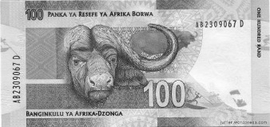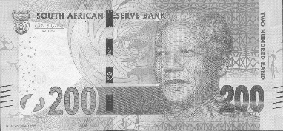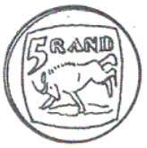

* 1. Word problems
     1. Farmer Joe buys 285 chickens. He wants to divide the

chickens equally between 5 chicken coops. How many chickens will be in each chicken coop? (3)

_________________________________________

* + 1. There is 681 springbucks in a camp. Two cheetahs comes inside the camp and bite 129 of the springbucks dead. How many springbucks are left? (3)

_________________________________________

**Total Question 3 = ___/58**

1. **Patterns, functions and Algebra**
   1. Patterns – Complete the patterns below. (4)
      1. 800, 700, ___, ____, ____, 300.
      2. 389, 379, 369, ___, ___, ___, 329.
      3. 555, 556, ___, ___, 559, ___.
      4. 350, 400, 450, ___, ___, ___, 650.
      5. Expand the pattern below only once. (1)

* + 1. Draw the star which comes next. (1)
    2. Complete the patterns in the squares. (4)

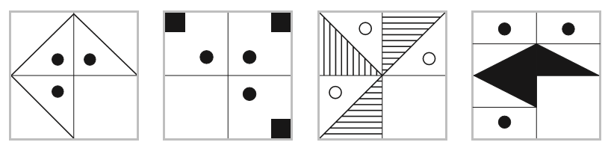

**Total Question 2 = ___/10**

1. **Space and Shape**
   1. Draw the top view of the birdhouse. (1)

|  |  |
| --- | --- |
| Image result for house clipart black and white |  |

* 1. Draw the following shapes in the blocks. (2)

triangle

square

* 1. Match the 3D shape with its name by drawing a line. (4)

|  |  |  |
| --- | --- | --- |
|  |  | oval |
|  | cube |
|  | rectangle |
|  | cylinder |

* 1. Is the following shapes flat or round. Color in the correct answer. (2)

|  |
| --- |
| flat |
| round |

* + 1. 

|  |
| --- |
| flat |
| round |

* 1. Which of the following shapes has a flat and round sides? Circle the shape. (1)
  2. 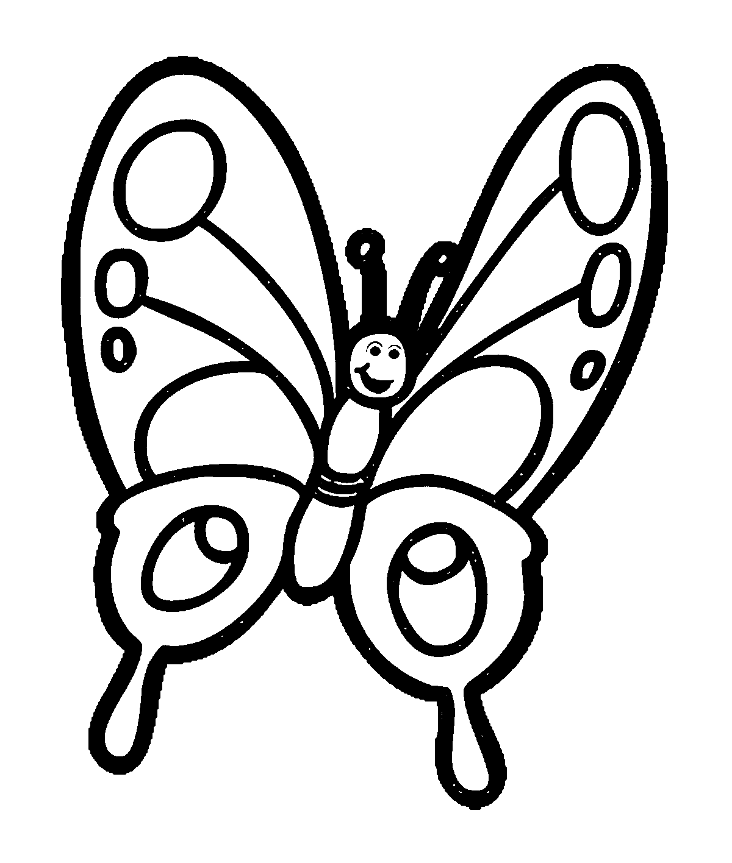Look at the butterflies and color in the butterfly which is symmetrical. (1)

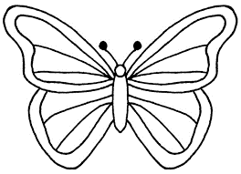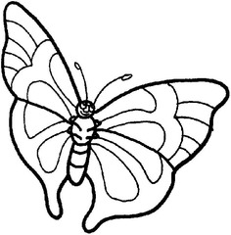

* 1. Divide the South African flag symmetrical. (1)

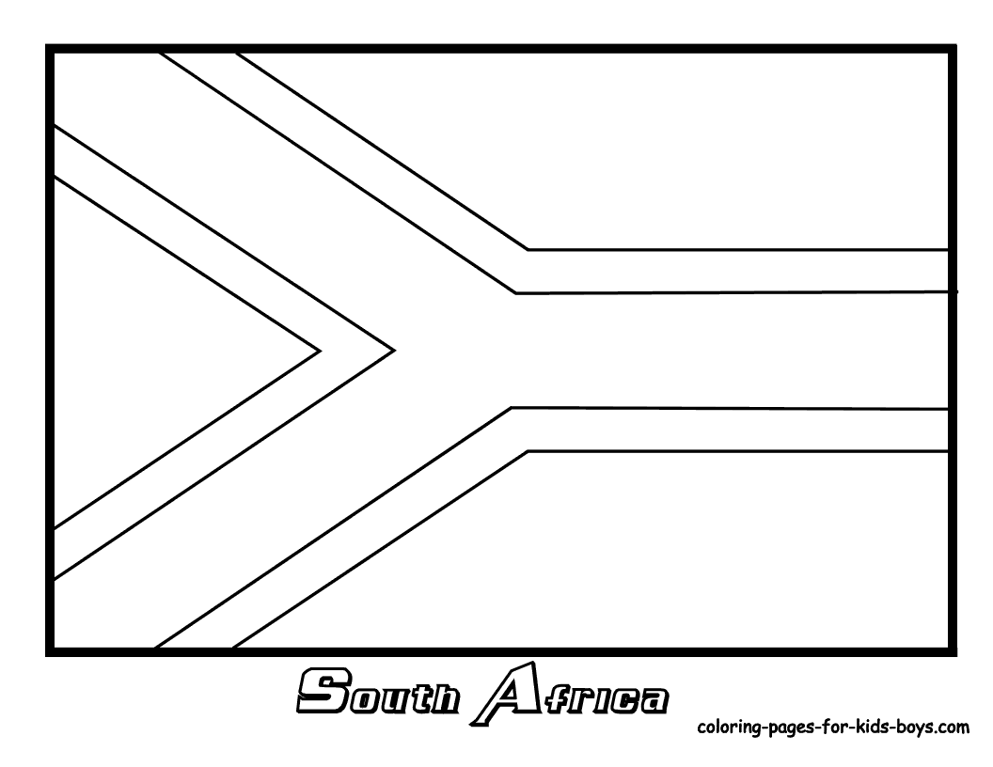

* 1. Describe in your own words what it means when a shape is symmetrical.

___________________________________________________________________________________________(1)

**Total Question 3 = ___/13**

1. **Measurement**
   1. 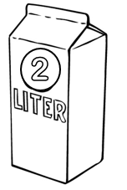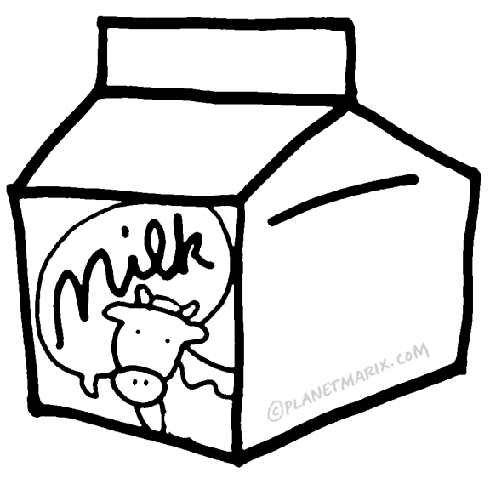Order the following containers from the largest to the smallest volume.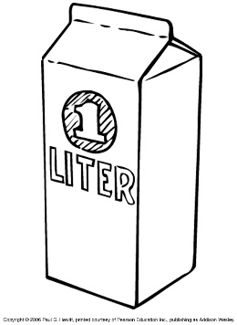

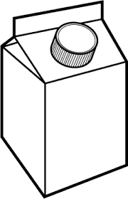

500*ml*

**250**

***ML***

container 1 container 2 container 3 container 4

* + 1. ___________
    2. ___________
    3. ___________
    4. ___________
  1. What measuring unit will you use to measure the distance between two cities? ____________
  2. Which measuring tool do you use to measure gram and kilogram? _______________
  3. Which one is the most? Underline the correct answer.

6 minutes 6 hours 60 seconds

* 1. Complete the following:
     + - 1. 2 hours = _____ minutes
         2. Half of a year = ______ months
         3. 1 day is = _____ hours
         4. 2 decades = _____ year
         5. 120 seconds = ______ minutes
  2. Draw the hands of the clock to show the time.

**Quarter past 12**

**10:45**

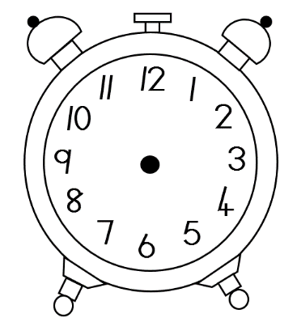

**Total Question 4 = ___/14**

1. **Data Handling**

________________________________

8

7

6

5

4

3

2

1

|  |  |  |  |  |
| --- | --- | --- | --- | --- |
|  |  |  |  |  |
|  |  |  |  |  |
|  |  |  |  |  |
|  |  |  |  |  |
|  |  |  |  |  |
|  |  |  |  |  |
|  |  |  |  |  |
|  |  |  |  |  |

cat motorcycle bicycle train taxi

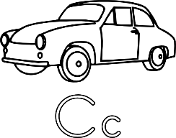





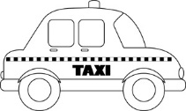

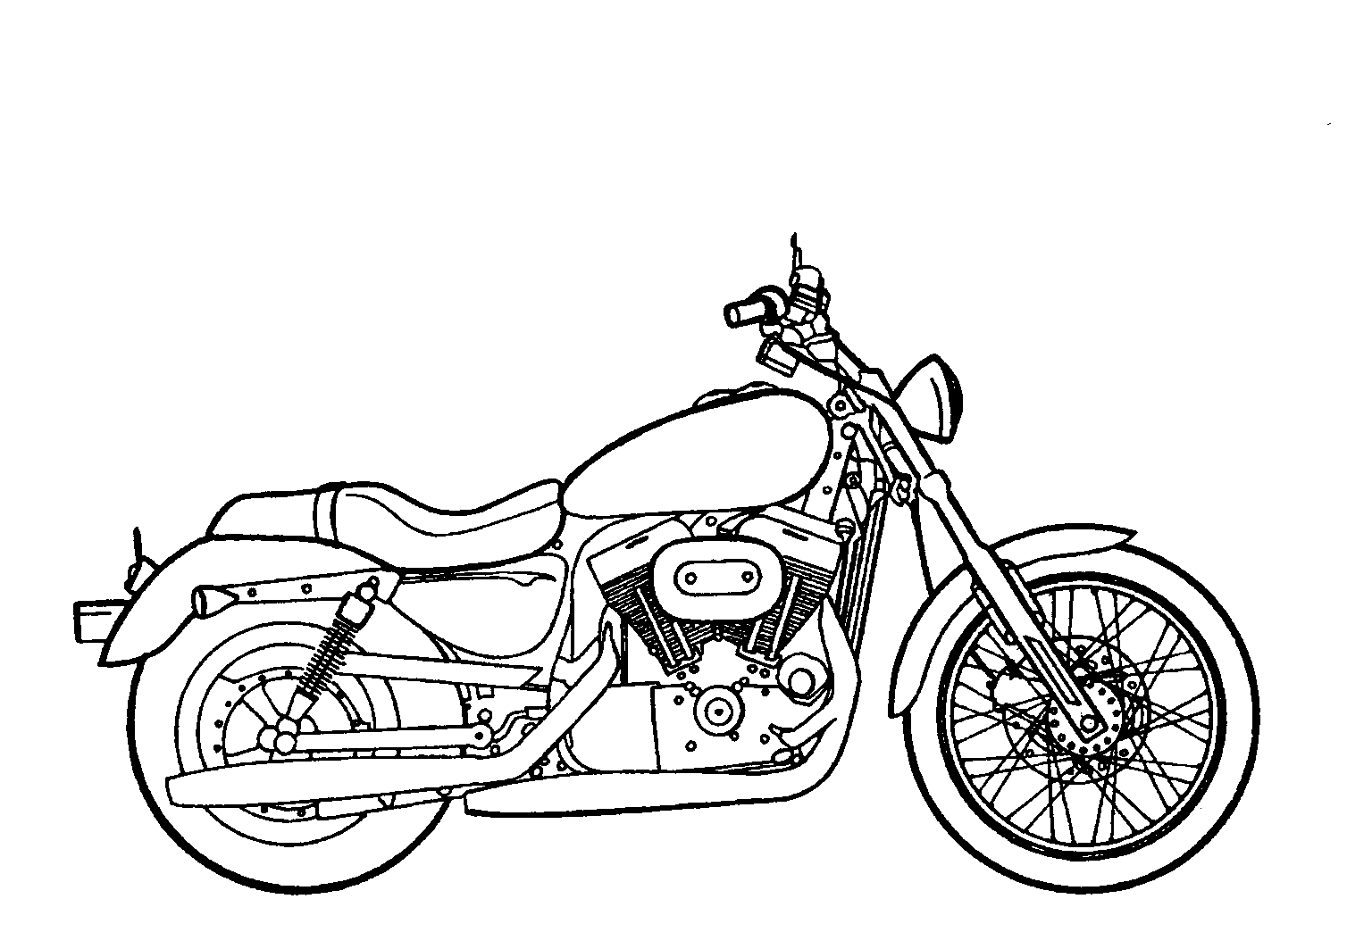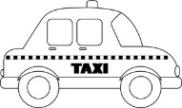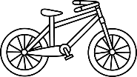

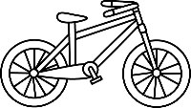

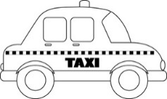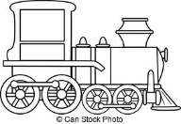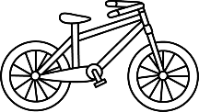

**Answer the following questions:**

1. Which type of transport does the people prefer the most?

__________________________________________________(1)

1. Which type of transport does the people prefer the least?

__________________________________________________(1)

1. Which type of transport do they prefer equally?

__________________________________________________(1)

1. There is ___ more people who use cars than taxi’s. (1)
2. Write your own heading for the graph on the line above the graph. (1)

**Total Question 5 = ___/5**