Mathematics
Assessment Task Term 4
Grade 3

Name and surname: ____________________________
Date: _________________________________

Section |  | Mark obtained
- Numbers, operations and relationships | 65
- Patterns, functions and algebra. | 10
- Space and Shape | 11
- Measurement | 9
- Data Handling | 5
Total | 100

Section 1: Numbers, operations and relationships

  - There is 100 small blocks in each block. Count in groups to help you. Write the total amount of blocks in the box. (1)
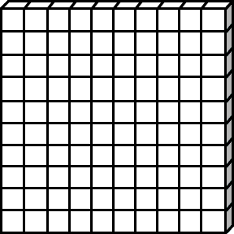

=

1.2. Complete- Count forwards and backwards. (5)
1.2.1. 900, 920, ___, ___, ___, 1000. (1)
1.2.2. 1000, 998, 996, ___, ___, ___. (1)
1.2.3. 970, 975, ___, ___, ___, ___, 1000. (1)
1.2.4. 750, 800, ___, ___, ___, 1000. (1) 1.2.5. 1000, 975, 950, ___, ___, ___, ___. (1)
1.3. Complete the table by filling in the number names and number
Symbols. (5)
Number name | Number symbol
six hundred and eighty-five
 | 862
four hundred
three hundred and twenty-two
 | 507

1.4. Look at the following numbers and answer the questions. (2)
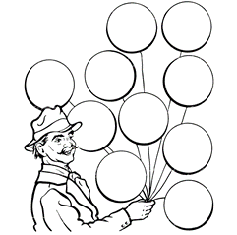
989
988
990
995
991

999

1.4.1 Arrange the numbers in the balloons from the smallest to
the largest. (1)
________________________________________
1.4.2. Arrange the numbers in the balloons from the largest to
the smallest. (1)
________________________________________
1.5. Fill in more than or less than between the following numbers.(2)

1.7.1 999 is___________ 989 (1)
1.7.1. 818 is___________ 881 (1)

1.6. Break the following numbers up in hundreds, tens and units. (4)

1.6.1. 649 = _______ + 40 + ________ (2)
1.6.2. 880 = 800 + ________ + ________ (2)

1.7. Solve the following problems. You have to show your calculations
and write a number sentence. (8
1.7.1. Ben would like to go to Gold Reeff City with his friends.
It costs R125 to enter. His father tells him to wash
people's cars for R25. How many cars will Ben have to
wash before he has enough money? (4)

Number sentence: __________________________________
1.7.2. There are 598 passengers on a train. 17 passengers
Climbs off the train. How many passengers are left on
the train? (4)

Number sentence: _________________________________

1.8. A man is selling pancakes. A lady asked if her 12 pancakes can
be divided equally into 3 bags. Help the man to divide the
pancakes equally into 3 bags below and then answer the
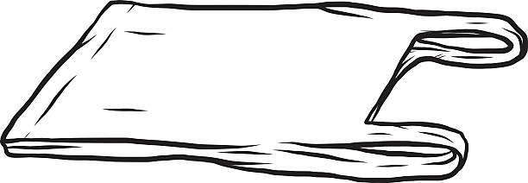
questions. (5)

    - How many groups do you count? _____ (1)
    - How many pancakes are in each group? _____ (1)
    - How many pancakes are there altogether? _____ (1)
    - Write a number sentence: _____ + _____ + _____ = _____ (1)

  - Mental maths - Complete. (10)

a. 25 + 25 + 25 = ___
f. 200 + 200 = ___
g. 900 + 4 = ___
- 800 - 5 = ___
i. 880 + 100 = ___
j. 6 + 6 + 6 = ___

b 25 more than 250 = ___
- 5 more than 85 = ___
- 1 less than 81 = ___
- 1 more than 79 = ___

  - Choose which fraction is shaded. Color the correct answer. (2)
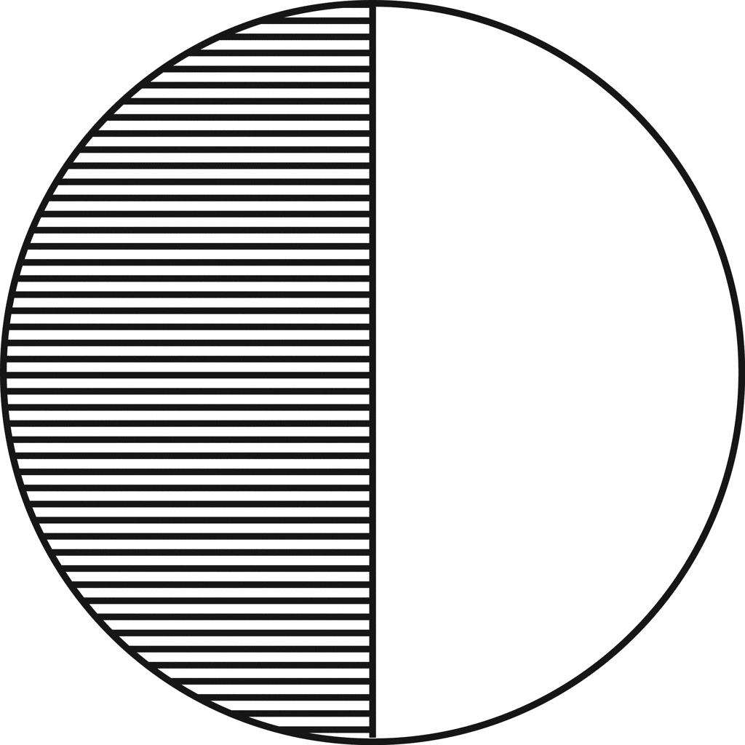
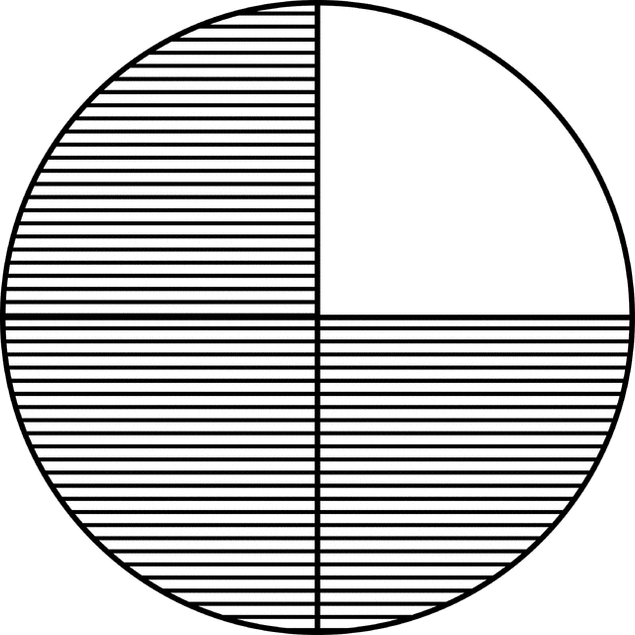

1 third
1 quarter
half

half
quarter
three quarter

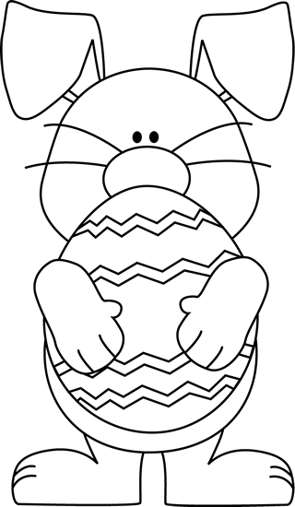
  - Help the Easter Bunny to color the Easter eggs in the following ways. (2)
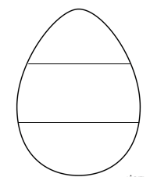
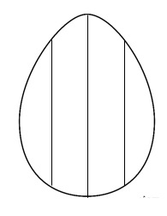

1 quarter
two thirds

1.12. Divide the 7 chocolate bars between 3 friends so that
everyone gets the same amount of chocolate. Draw a
picture to show your answer. (2)

  - Add up the money in every row and write the total in the
box. (5)
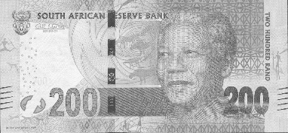  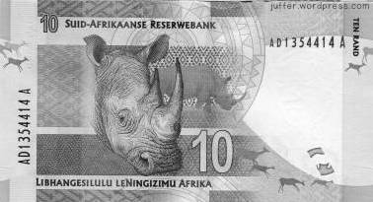  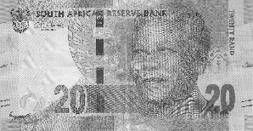 | =
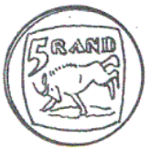  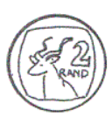   | =
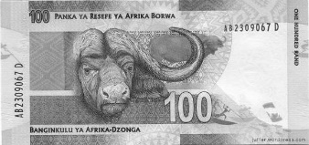  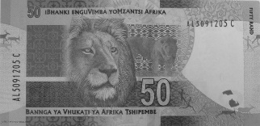 | =
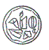 | =
 | =

  - Addition and subtraction (10)
Do the following sums. Show all calculations.

- 525 + 72 = (5) B. 889-137 = (5)

C. 39 ¸ 3 = (4 x ƒ = 2)

Total Section 1: __ / 65
Section 2: Patterns, functions and algebra

2.1. Expand the following patterns only once. (2)

2.2. Complete the patterns in the table. (6)

2.3. Look at the pattern of the floor tiles and extend it two
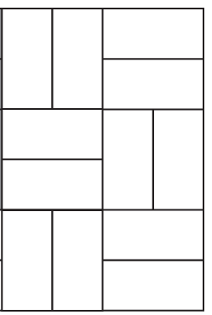
times to the right. (1)

2.4. Describe in words what you see in the following patterns. (2)
- 550, 600, 650, 700.
Rule: ________________________________________ (1)
- 275, 250, 225, 200.
Rule: ________________________________________ (1)

Total section 2: ___ / 10
_________________________________________________

Total Section 2: ___/10
___________________________________________________
Section 3: Space and Shape
3.1. Write down the names of the following shapes in the blocks. (2)
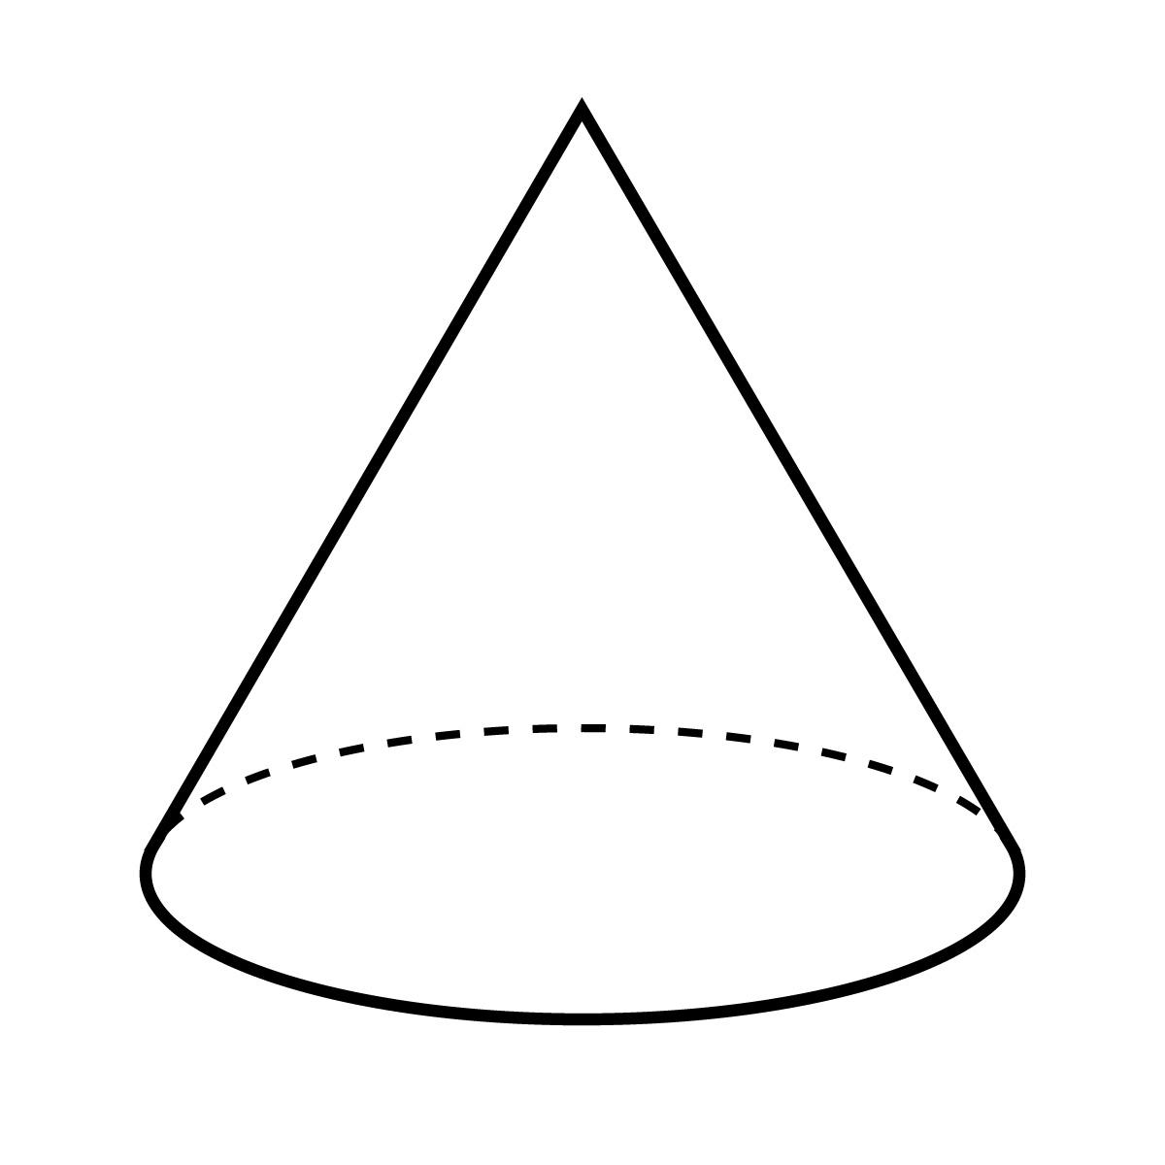

  - Does the following shapes have curved or flat sides? Color the right answer. (2)
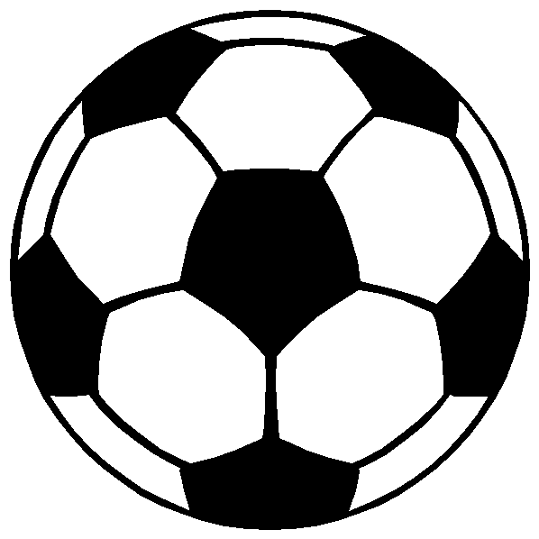

curved
flat

curved
flat

  - Make a √ on all the shape with the correct symmetry lines. (2)

3.4. Look at the following pictures in the box. (4)
- Color all sphere pictures with blue. (2)
- Circle all the objects that are prisms. (2)

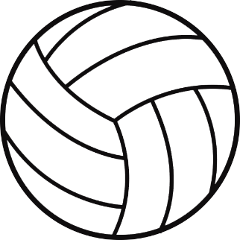
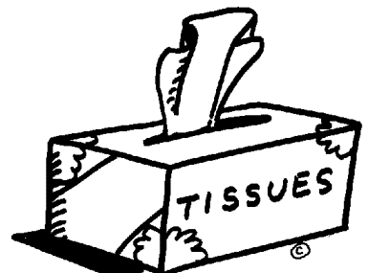

  - What do we call the shape in the picture? Write your answer below. (1)
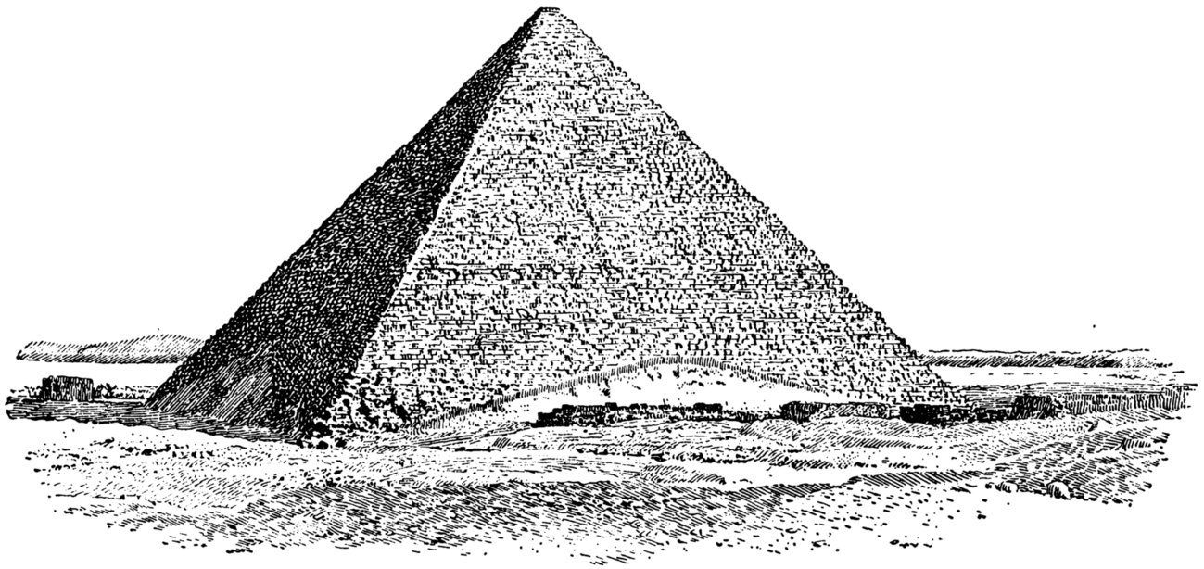

Total Section 3: ___ / 11
Section 4: Measurement

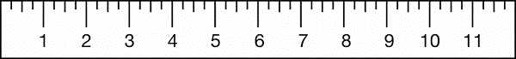
4.1. Measure how long the pencil is and write down the length. (1)
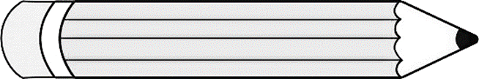
=

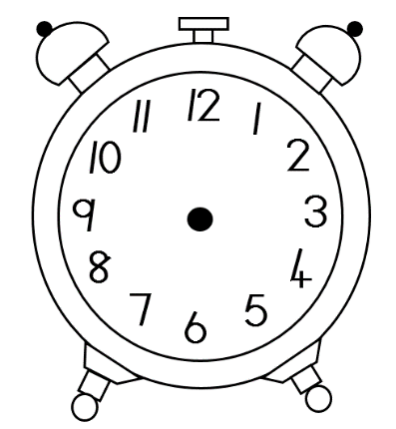
4.2. Look at the times and draw the hands of the watches. (2)

twelve o’clock
quarter past three

4.3. Write the time of the clock. (1)

4.4. Arrange the items weight from the smallest to the largest
in the table by writing down the item's weight and name.
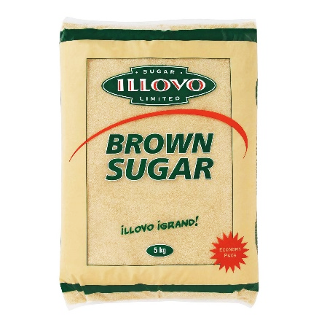
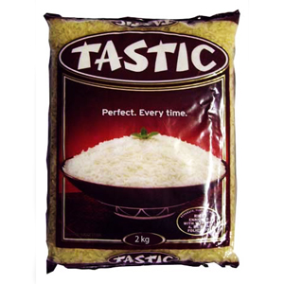
(4 x ƒ = 2)
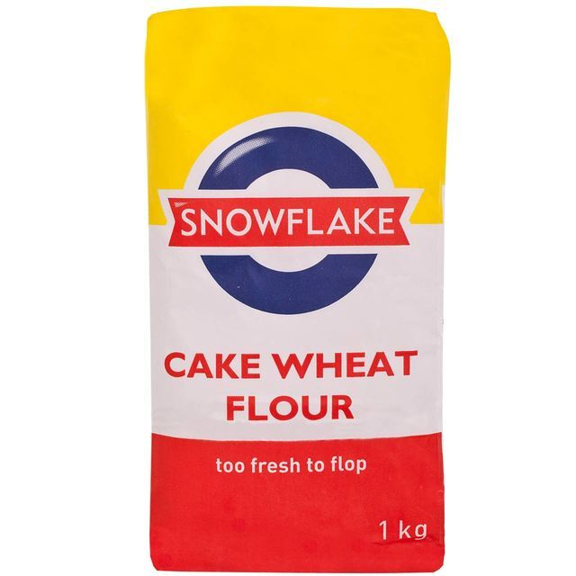
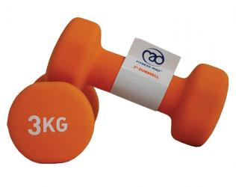

rice
flour
weights
sugar

Item | Weight

4.5. Circle the mass which is the biggest. (1)
750g 3kg 3,5kg 900g 2,5kg

4.6. Circle the mass which is the smallest. (1)
750g 3kg 3,5kg 900g 2,5kg

4.7. In what unit is volume measured? Circle right answer. (2)
kilogram milliliter kilometers liter
Total Section 4: ___ / 9
Section 5: Data Handling
8
7
6
5
4
3
2
1
0
Coke Fanta Grape Cream Soda Pepsi Sparberry

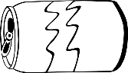

Answer the questions:
- Which cool drink does the children like the most?
________________________________________________(1)
- Which cool drink does the children like the least?
________________________________________________(1)
- Which cool drink does the children like equally?
________________________________________________(2)
- There is ___ more children who like Coke than Fanta Grape. (1)
- Write a title for the pictograph. ______________________(1)

Total Section 5 = ___ / 5

