**Life Skills**

**Assessment – Term 3**

**Grade 3**

**Name and Surname: ____________________________**

**Date: _________________________________**

|  |  |  |
| --- | --- | --- |
| **Marks Assessment** |  | **Mark** |
| 1. Beginning knowledge | **10** |  |
| 1. Personal and Social Wellbeing | **35** |  |
| 1. Creative Arts | **35** |  |
| 1. Physical Education | **20** |  |
| **Total** | **100** |  |

**Activity 1**

**Beginning Knowledge**

**Marks: 10**

**How people lived long ago**

* 1. Is the following statements true or false?

|  |  |
| --- | --- |
| Statement | True or false |
| 1. People in the past paid with coins and notes. |  |
| 1. People in the past made use of the exchange of goods. |  |
| 1. Today we use coins, notes and credit cards to pay for products. |  |
| 1. People in the past used bulbs as a source of light. |  |
| 1. People in the past didn’t have cars, cellphones and televisions. |  |

**Total: ______ / 5**

* 1. 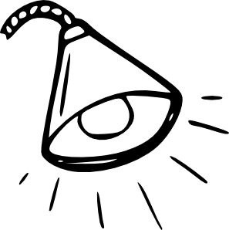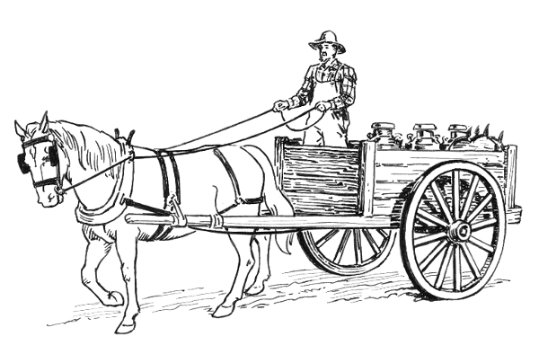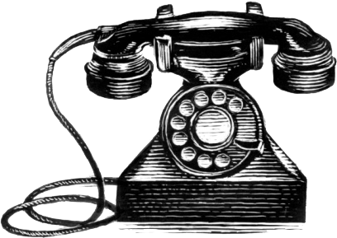Write underneath each picture if it is in the past or the present.

**Total: ______ / 10**

**Total: ______ / 5**

**Activity 2**

**Personal and Social Wellbeing**

**Marks: 20**

2.1. a) Public safety

Color in the if the picture is safe or color in the if you think the picture is unsafe.

|  |  |
| --- | --- |
| Related imageImage result for playing with fire clipart black and white  Image result for wrong mark clipart black and white | Image result for wrong mark clipart black and whiteRelated imageImage result for grownup walking with child over road clipart |
| Related imageRelated image  Image result for wrong mark clipart black and white | Image result for wrong mark clipart black and whiteRelated imageImage result for playing with fire clipart black and white |
| Image result for safety plug for kids clipartImage result for wrong mark clipart black and whiteRelated image |  |

**Total: ______ / 5**

**Totaal: ______ / 5**

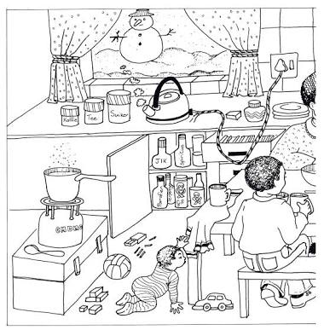

b) Draw a cross on the parts of the picture you think is dangerous.

**Total: ____ / 5**

2.2. Pollution

Look at the pictures and write down which type of pollution

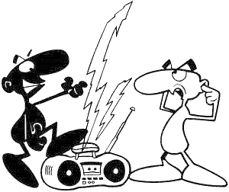 it is.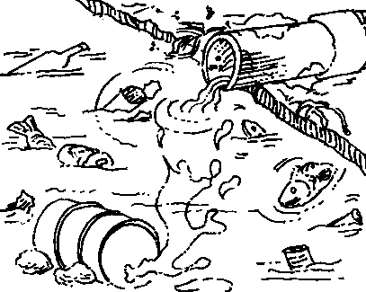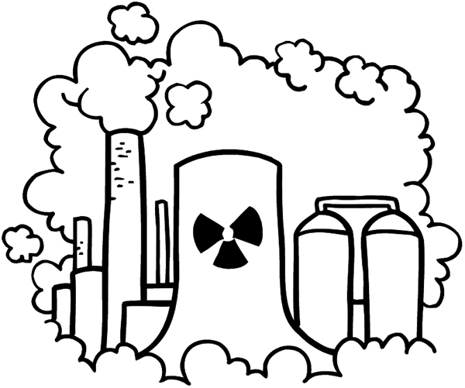

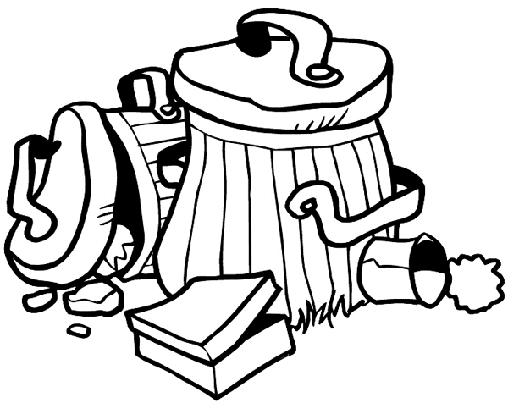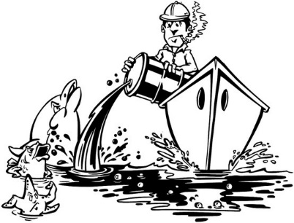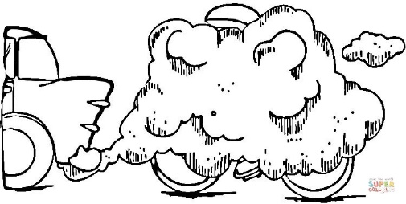

**Total: ____ / 6**

2.3. Road safety

a) What does the following road signs stand for?

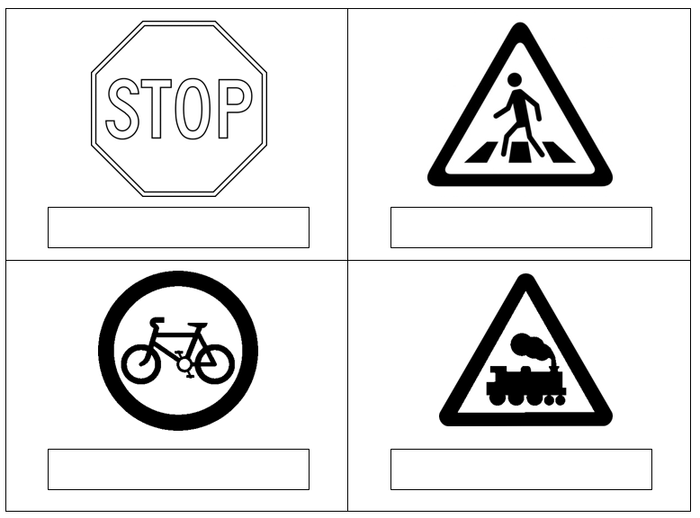

**Total: ___/ 4**

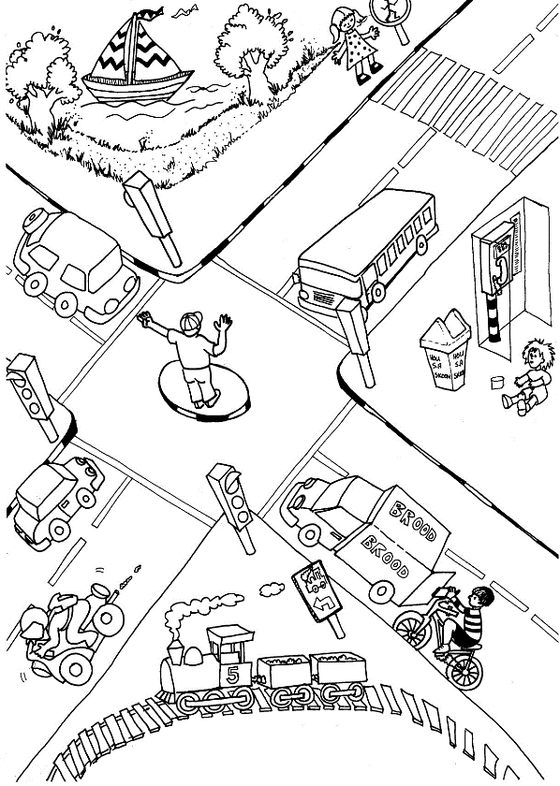2.3. Write down 4 traffic rules you see in the picture.

1. __________________________________________________________________
2. __________________________________________________________________
3. __________________________________________________________________
4. __________________________________________________________________

**Total: ___/ 4**

2.4. Space

2.4.1. Is the following statements true or false?

1. There is 10 planets in space. ___________
2. Die sun is a star. _____________
3. There is many planets where animals and people can live in space. ____________
4. Die moon is cold, dead sphere of rock and dust that revolves around the earth. __________
5. Stars are intense warm gas ball. ____________
6. Scientists use telescope to look at things which are near. ____________

**total: ___/ 6**

2.4.2. Match the words in the block with the pictures.

|  |  |  |  |  |
| --- | --- | --- | --- | --- |
| Earth | Sun | Shooting star | Satellite | Meteor |

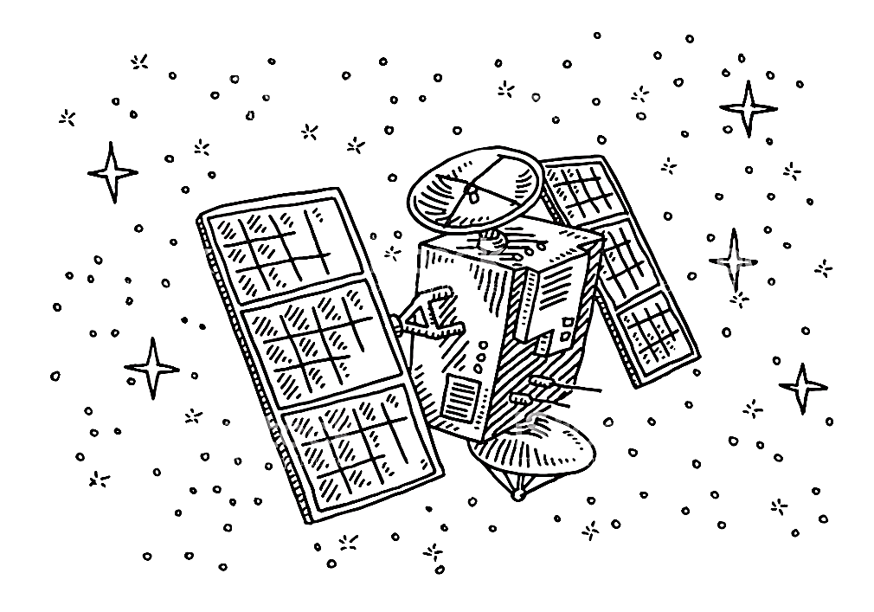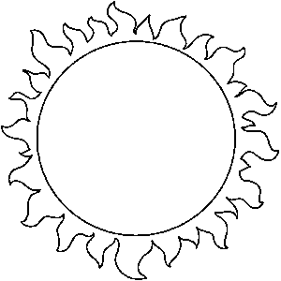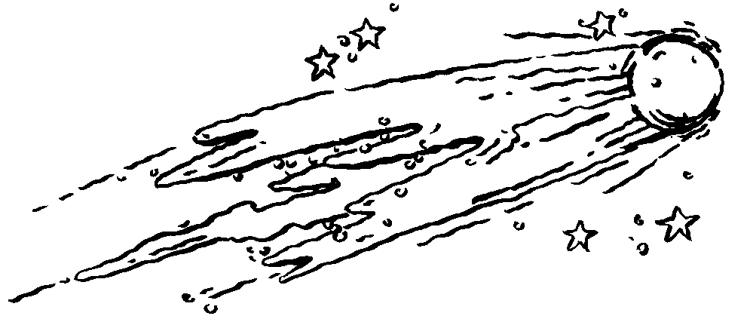

**total: ___ / 5**

|  |  |  |
| --- | --- | --- |
| **Rubric – Personal and Social Wellbeing** |  |  |
| 1. Public safety | **10** |  |
| 1. Pollution | **6** |  |
| 1. Road safety | **8** |  |
| 1. Space | **11** |  |
| **total** | **35** |  |

**Activity 3**

**Creative Arts**

**Marks: Performing Arts + Visual Arts = 35**

**3.1. Performing Arts – Improvise and Interpret**

Roleplay

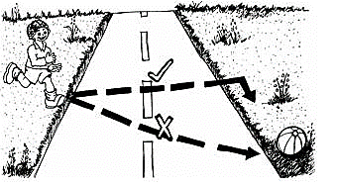Work in groups of 5 and create a roleplay about one of the following topics:

* Road rules for cars.
* Road rules for pedestrians
* Road rules for cyclists.

Tour group will be assessed according to the following rubric:

|  |  |  |  |  |  |
| --- | --- | --- | --- | --- | --- |
| **Rubric – Performing arts** | **5** | **4** | **3** | **2** | **1** |
| 1. Participation: Learner actively participates and makes a contribution to the planning of the roleplay. | 5 | 4 | 3 | 2 | 1 |
| 1. Enjoyment: The learner enjoys participating in the creative activity and gives his cooperation. | 5 | 4 | 3 | 2 | 1 |
| 1. Content: The roleplay is applicable to one of the given topics. | 5 | 4 | 3 | 2 | 1 |
| 1. Creative: Was the learners creative with their roleplay. | 5 | 4 | 3 | 2 | 1 |
| **Total** | **___/20** | | | | |

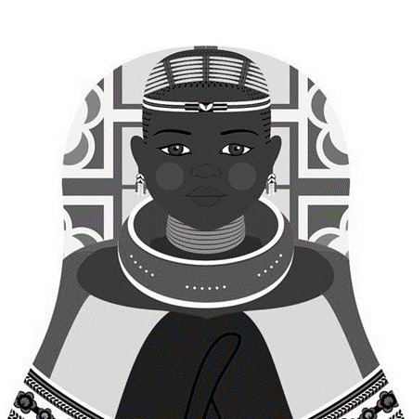**3.2. Visual Arts**

Create your own Ndebele artwork by using their African patterns and prints. Use paint or crayons as medium.

Keep the following in mind when you make your artwork:

* It must be colorful.
* It must consist of patterns.
* You will be marked according to a rubric. Read the rubric before making your artwork.

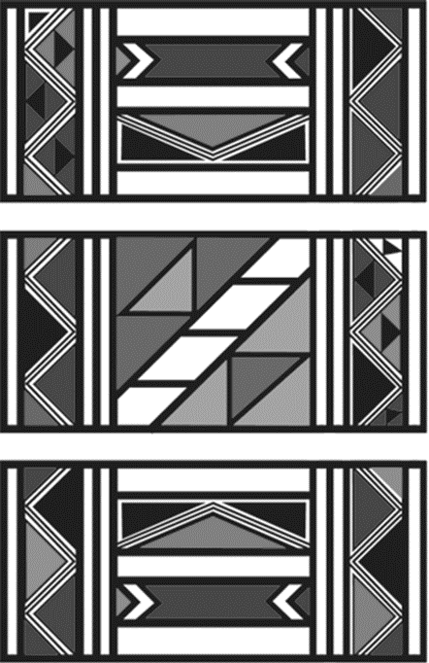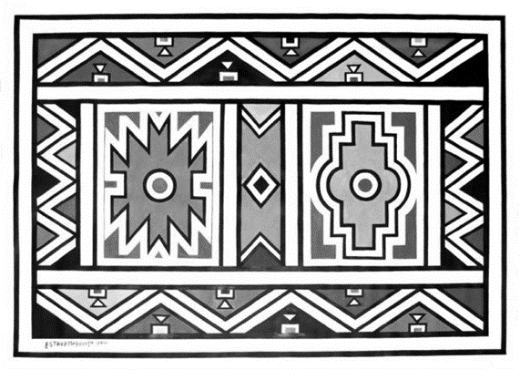**Here is a few examples of Ndebele art:**

|  |  |  |
| --- | --- | --- |
| **Rubric – Visual Arts** |  |  |
| 1. The learners artwork is colorful. | **5** |  |
| 1. The learner made use of Ndebele patterns and prints. | **5** |  |
| 1. Was the learner creative? | **5** |  |
| **total** | **15** |  |

**Activity 4**

**Physical Education**

**Marks: 20**

**Purpose of activity – Coordination and Perceptual Motor**

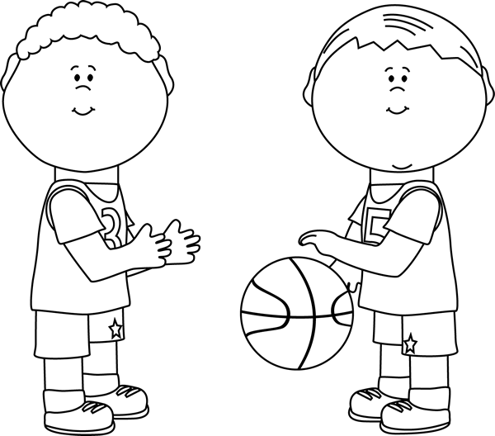

**Resources needed:**

* Empty container or trash can.
* A tennis ball
* A bean bag
* A rugby ball
* A netball ball

**Instructions**

* Divide into teams. Each team is in a row.
* Place a trash can or empty container about five steps away from the team.
* The first assignment is that the learners should try to throw the different balls with ONE HAND.
* The learner in front of the line throws the item into the container, runs to get the ball and hands it to the next learner in the line.
* If you miss, try again and try again. Each learner must throw the tennis ball, bean bag, rugby ball and netball ball.
* The second assignment is: The learners must now throw the items with TWO HANDS in the container. Each learner must throw tennis ball, bean bag, rugby ball and netball ball with two hands.
* Everybody in the team gets a turn. The first team who finish is the winning team.

|  |  |  |
| --- | --- | --- |
| **Rubric – Physical Education** |  |  |
| 1. The learner was capable to throw the tennis ball in the container with ONE HAND. | **2** |  |
| 1. The learner was capable to throw the netball ball in the container with ONE HAND. | **2** |  |
| 1. The learner was capable to throw the rugby ball in the container with ONE HAND. | **2** |  |
| 1. The learner was capable to throw the bean bag in the container with ONE HAND. | **2** |  |
| 1. The learner was capable to throw the tennis ball in the container with TWO HAND. | **2** |  |
| 1. The learner was capable to throw the netball ball in the container with TWO HAND. | **2** |  |
| 1. The learner was capable to throw the rugby ball in the container with TWO HAND. | **2** |  |
| 1. The learner was capable to throw the bean bag in the container with TWO HAND. | **2** |  |
| 1. The learner waited his turn and followed the instructions. | **2** |  |
| 1. The learner was enthusiastic about the activity and gave his best. | **2** |  |
| **Total** | **20** |  |