**Mathematics**

**Assessment Task Term 4**

**Grade 2**

**Name and surname: ____________________________**

**Date: _________________________________**

|  |  |  |
| --- | --- | --- |
| **Section** |  | **Mark obtained** |
| 1. Numbers, operations and relationships | **65** |  |
| 1. Patterns, functions and algebra. | **10** |  |
| 1. Space and Shape | **11** |  |
| 1. Measurement | **9** |  |
| 1. Data Handling | **5** |  |
| **Total** | **100** |  |

**Section 1: Numbers, operations and relationships**

* 1. Count how many balloons the man is holding. Count in groups to help you. Write your answer in the box. (1)

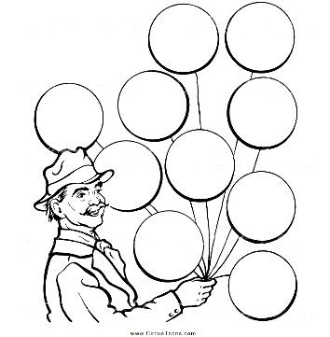



= 120

* 1. Complete- Count backwards and forwards. (5)

130 140 150 170

* + 1. 110, 120, ___, ___, ___, 160, ___. (1)

190 185 180

* + 1. 200, 195, ___, ___, ___, 175, 170. (1)
    2. 122, 124, ___, ___, ___, 132, ___. (1)

83 86 89

126 128 130 134

* + 1. 77, 80, ___, ___, ___, 92. (1)

133 122 111

* + 1. 155, 144, ___, ___, ___, 101. (1)
  1. Complete the table by filling in the number names and symbols. (5)

|  |  |
| --- | --- |
| **Number name** | **number symbol** |
| ninety-nine | **99** |
| **seventy-eight** | 87 |
| fifty-three | **53** |
| hundred | **100** |
| **sixty-five** | 65 |

* 1. Look at the following numbers and answer the questions: (2)

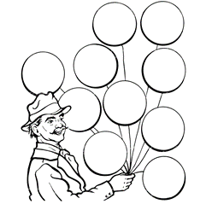

63

99

53

60

90

40

* + 1. Arrange the numbers in the balloons from the smallest to the largest. (1)

40, 53, 60, 63, 90, 99.

________________________________________

* + 1. Arrange the numbers in the balloons from the largest to the smallest. (1)

99, 90, 63, 60, 53, 40.

________________________________________

* 1. Break the following numbers up into tens and ones. (4)

90 9

* + 1. 99 = _______ + ________ (2)

60 0

* + 1. 60 = _______ + ________ (2)
  1. Use the number line to solve the following problem. You have to show your answer on the number line. You must also write a number sentence for the sum. (4)

David has 23 marbles. He won 13 marbles in the first round against his friend, but he lost 14 marbles the second time. How many marbles does he have left?

√

√



23 + 13 = 36 marbles after the first round. √

36 - 14 = 22 marbles after second round. √

* 1. Solve the following problems. You have to draw a picture. You have to show your calculations and write a number sentence. (8)
     1. 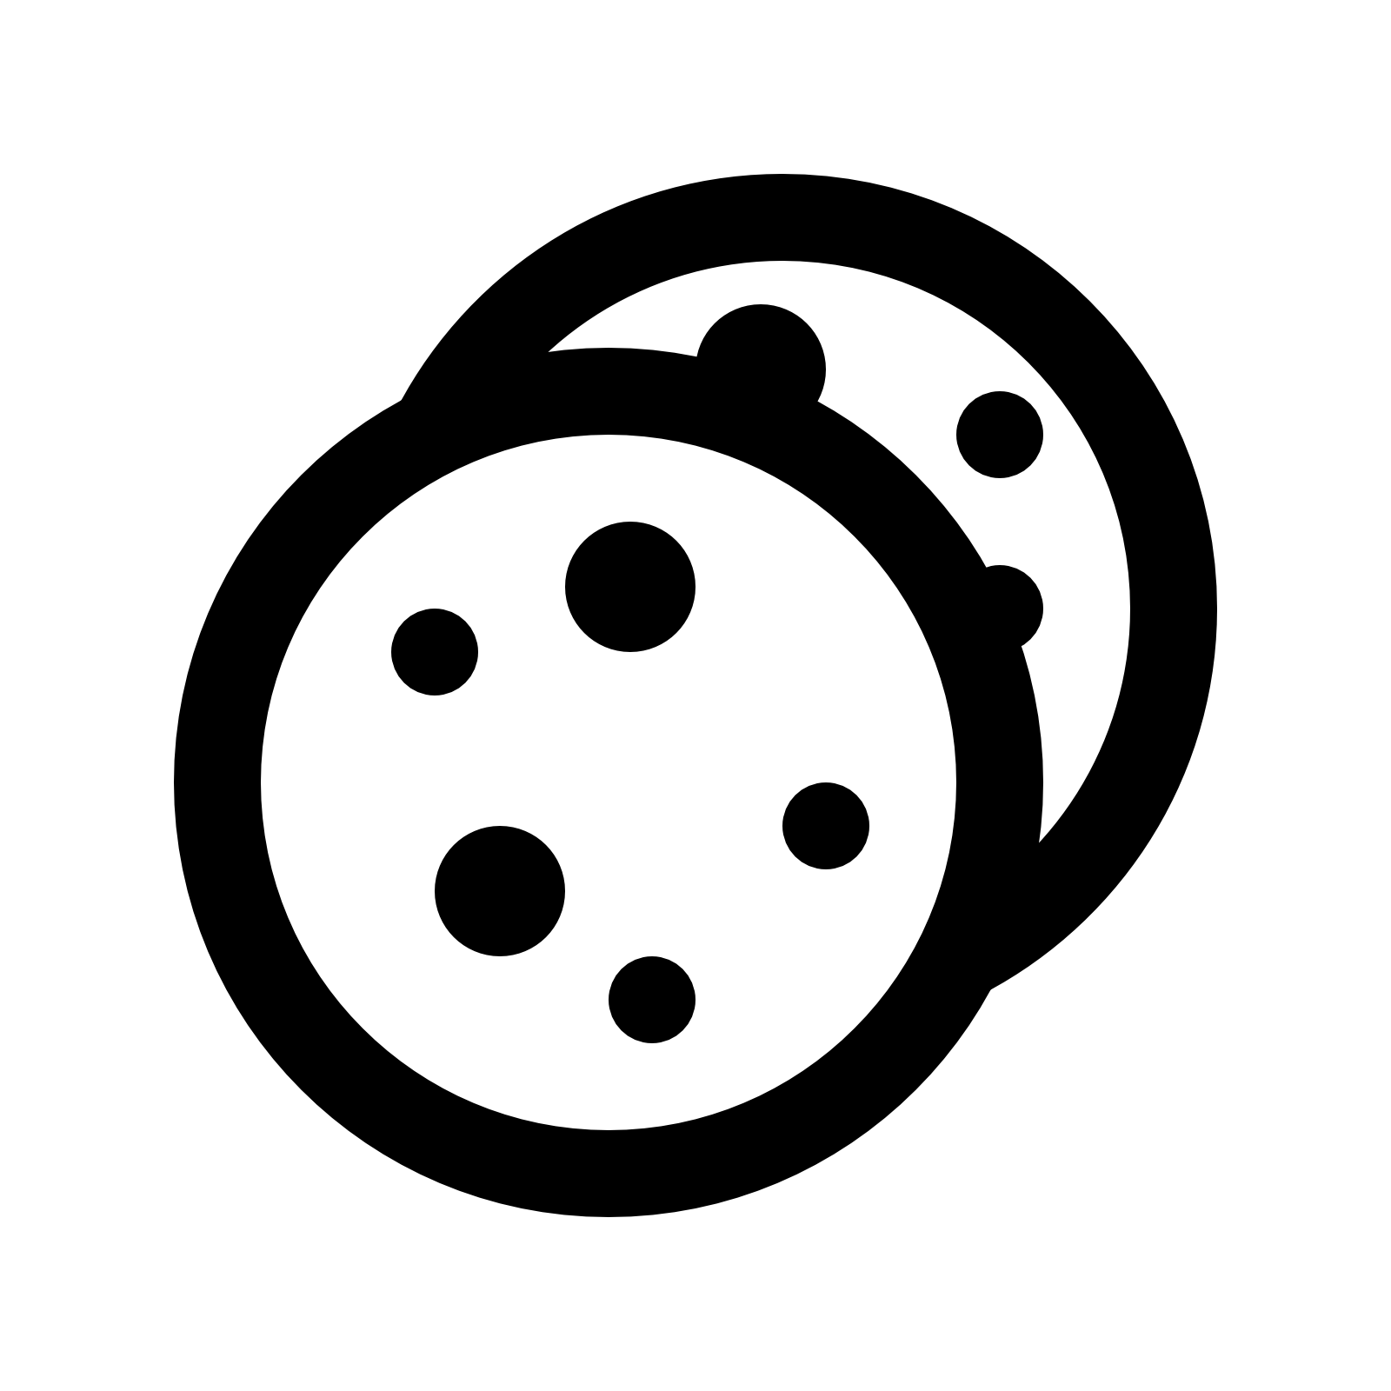John eats two cookies every day. How many cookies has he eaten at the end of the week? (4)

√

√

√

√

2 + 2 + 2 + 2 + 2 + 2 + 2 = 14 cookies

Number sentence: __________________________________

* + 1. My mother has 44 sweets. She must divide them between four children. How much does each child receive? (4)

Learner's own drawing. For example 4 children's faces with 44 sweets over them and then take a sweet to each child until all 44 sweets are divided.

√

√

√

√

√

11 + 11 + 11 + 11 = 44 sweets OR

44 ¸ 4 = 11 sweets

Number sentence: _________________________________

√

* 1. Match the money with its name by drawing a line with a ruler. (5)

Two rand

|  |  |  |
| --- | --- | --- |
| money |  | name |
|  |  | Twenty rand |
| Related image |  |
|  | Five rand  Five cent |
|  |  |
| Image result for geld graad 1 | Fifty rand |

* 1. Louisa sells ice creams at R5 each. Help her to complete the table so that she can easily get the amount for large orders. (10)

|  |  |  |  |  |  |  |  |  |  |  |
| --- | --- | --- | --- | --- | --- | --- | --- | --- | --- | --- |
| Number of ice creams | **1** | **2** | **3** | **4** | **5** | **6** | **7** | **8** | **9** | **10** |
| Cost | 5 | 10 | **15** | **20** | **25** | **30** | **35** | **40** | **45** | **50** |

R100 (20 x 5 = R100)

R75 (15 x 5 = R75)

97 - 65 = (90 + 7) - (60 + 5)√

= (90-60) + (7-5)√

= 30 + 2√

= 32√

43 + 46 = (40 + 3) + (40 +6)√

= (40 + 40) + (3 + 6)√

= 80 + 9√

= 89 √

1. If Louisa sells 15 ice creams. What is the amount? (1)

_____________________________________________

1. If Louisa sells 20 ice creams. What is the amount? (1)

_____________________________________________

1:10. Addition and subtraction (8)

Do the following sums. Show all calculations.

1. 43 + 46 = (4) B. 97-65 = (4)
   1. Mental Math’s- Complete. (9)

18

1. 6 + 6 + 6 = ___

87

1. 87 + 0 = ___

50

1. 10 x 5 = ___

14

1. 7 +7 = ___

12

1. 18 - 6 = ___

99

1. 10 plus 89 = ___

90

1. 5 more than 85 = ___

80

1. 1 less than 81 = ___

80

1. 1 more than 79 = ___
   1. Say what fraction is shaded. Color the correct answer. (2)

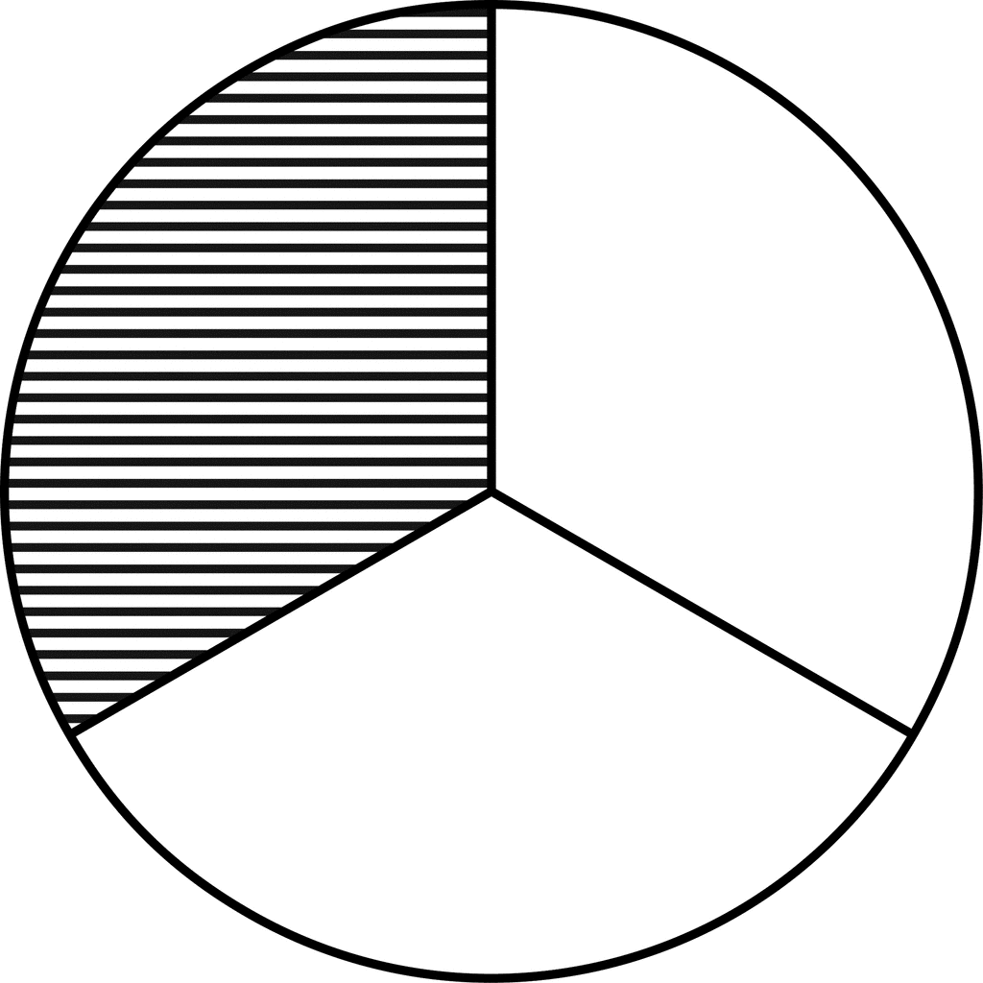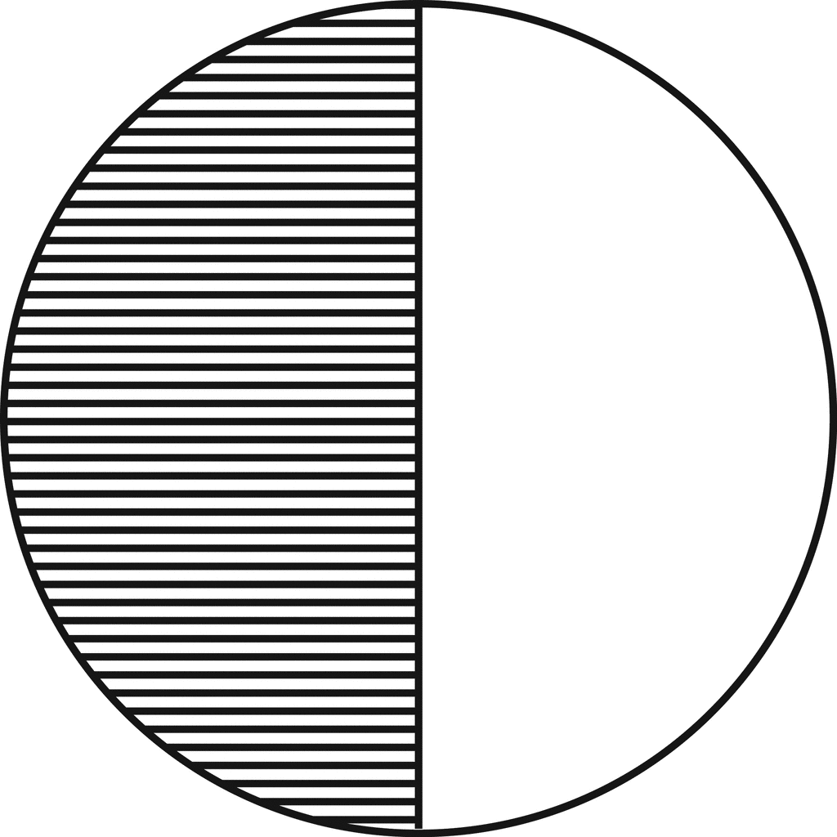

|  |
| --- |
| 1 third |
| 1 quarter |
| half |

|  |
| --- |
| 1 third |
| 1 quarter |
| half |

* 1. 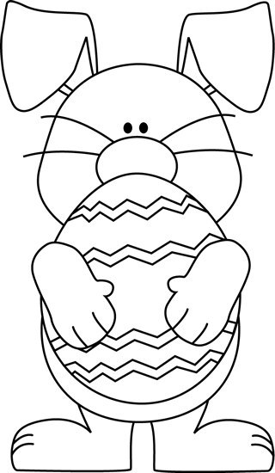Help the Easter Bunny to color the Easter eggs in the following ways. (2)

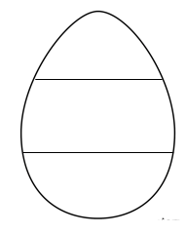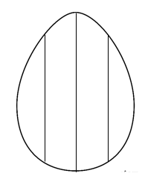

two thirds

1 quarter

**Total Section 1: __ / 65**

**___________________________________________________ `**

**Section 2: Patterns, Functions and Algebra**

2.1. Expand the following patterns only once. (2)

1. 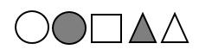

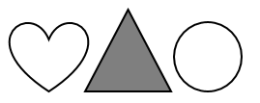



2.2. Complete the patterns in the table. (6)

|  |  |  |  |  |
| --- | --- | --- | --- | --- |
|  |  |  |  |  |
|  |  |  |  |  |
|  |  |  |  |  |

2.3. Look at the pattern on the floor tiles and extend it two

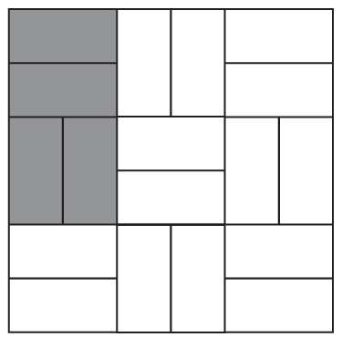 times to the right.  (1)

2.4. Describe in words what you see in the following patterns. (2)

1. 188, 177, 166, 155, 144.

Rule: ________________________________________ (1)

1. 55, 60, 65, 70, 75.

Rule: ________________________________________ (1)

**Total section 2: ___ / 10**

**_________________________________________________**

Counting in 10s back.

Counting in 5's forward.

**Section 3: Space and Shape**

3.1. Draw the following shapes in the blocks. (2)

triangle

square

* 1. Does the following shapes have curved or straight sides? Color the right answer. (2)

|  |
| --- |
| curved |
| straight |

|  |
| --- |
| curved |
| straight |

* 1. Make a √ on all the shapes with symmetry. (2)

√

√

3. 3.4. Look at the following items in the box. (4)

* Color all spheres with blue. (2)
* Circle all the prisms. (2)

blue



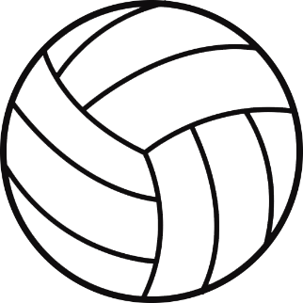

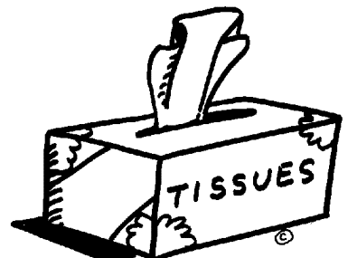

blue

3.5. Put a cross (X) on all objects that can slide. (2 x $\frac{1}{2}$ = 1)

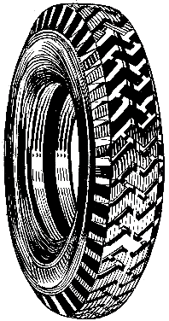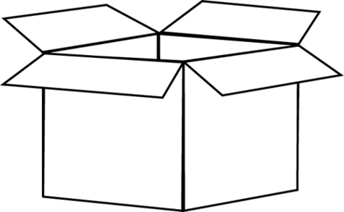

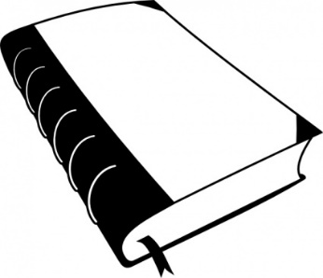

X

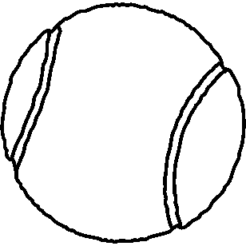

X

**Total Section 3: ___ / 11**

**Section 4: Measurement**

4.1. Write the days of the week in the correct order on the line.(1)

Sunday, Wednesday, Monday, Friday, Tuesday, Saturday,

Thursday

Monday, Tuesday, Wednesday, Thursday, Friday, Saturday, Sunday.

______________________________________________________________________________________________________

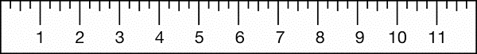4.2. Measure the length of the ruler and write down the length.(1)

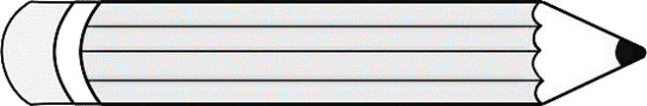

= 8 cm

4.2. Draw the minute and the hour hands on the watches of the

following times: (2)

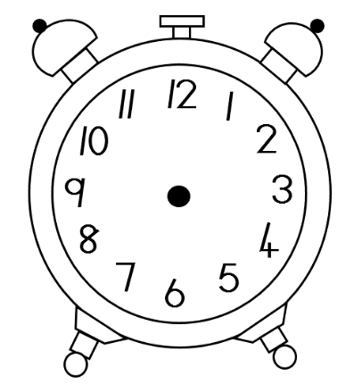

quarter past three

twelve o’clock

4.3. Write the time of the clock. (1)

half past five

4.4. Arrange the items' weight from the smallest to the largest

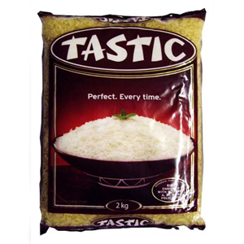 in the table by writing down the item's weight and name. (4)

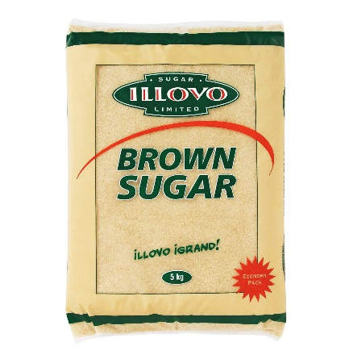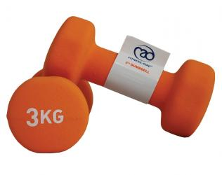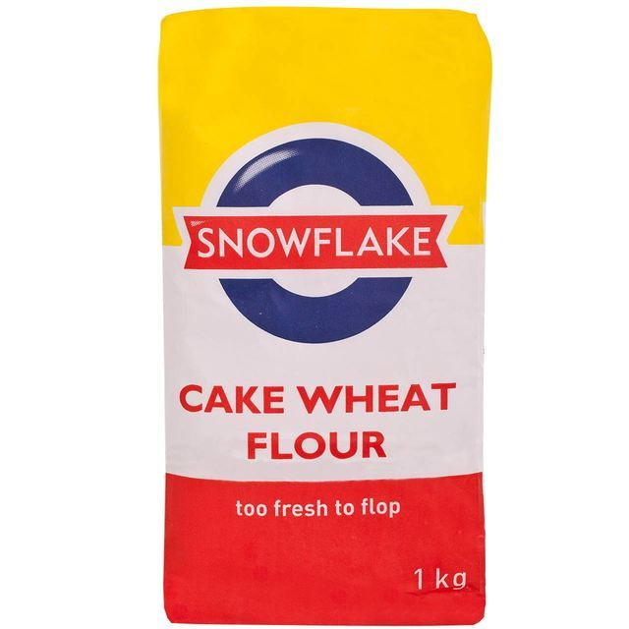

sugar

weights

flour

rice

|  |  |
| --- | --- |
| **Item** | **Weight** |
| flour | 1 kg |
| rice | 2 kg |
| weights | 3 kg |
| sugar | 5 kg |

**Total Section 4: ___ / 9**

**Section 4: Data handling**

Ben would like to invite 8 of his friends to his party. He wants to know what soda is their favourite. Look at his friends' answers in the table. (5)

|  |  |
| --- | --- |
| Type soda | Amount |
| 1. Coke | 4 |
| 1. Cream soda | 2 |
| 1. Fanta grape | 1 |
| 1. Sparberry | 1 |

Assignment: Complete the pictograph by using the above information. Write a title on the line for the chart.

|  |  |  |  |
| --- | --- | --- | --- |
|  |  |  |  |
|  |  |  |  |
|  |  |  |  |
|  |  |  |  |
|  |  |  |  |
|  |  |  |  |
|  |  |  |  |
|  |  |  |  |

Coke Cream soda Fanta Grape Sparberry

8

7

6

5

4

3

2

1

0

Learner receives 1 point for each table which is correct. Total: 4 points.

Learner receives 1 point for his heading.

**Total Section 5: ___ / 5**