Life Skills
Assessment Task Term 4
Grade 2

Name and surname: ____________________________
Date: _________________________________

Sections |  | Mark obtained
- Beginning Knowledge | 20
- Personal and Social Well-being | 30
- Creative Arts | 20
- Physical education | 30
Total | 100

Section 1
Beginning Knowledge
Marks: 20

Our country
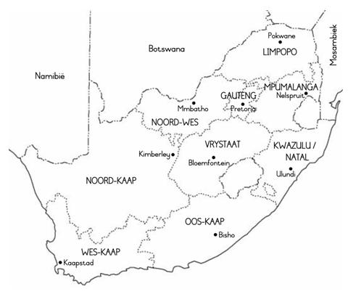
  - Look at the map of South Africa and answer the following questions: (3)

    - In which province you live? _________________ (1)
    - Which province is next to your province?
__________________ (1)
    - How many provinces does South Africa have? ____________ (1)
  - There are 11 official languages ​​in South Africa. Write down 4 of the languages which you know. (4)
_________________________
_________________________
_________________________
_________________________

  - Draw the South African flag in the block and color it in with the correct colors. (6)

  - At which events do we see the South African flag? Name 2. (2)
___________________ _______________________
  - What is the name of our national anthem'? ______________________ (1)
  - There is ________ languages ​​in our national anthem. (1)
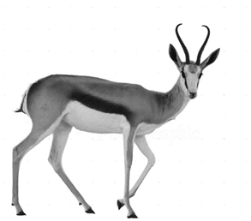
  - Look at the pictures and write the names of the national symbols. (6 x ƒ = 3)

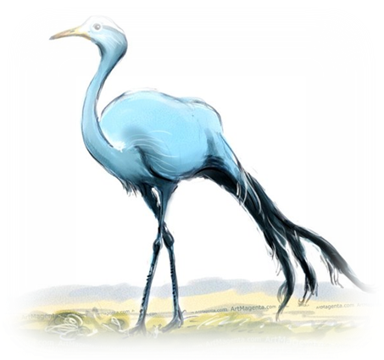

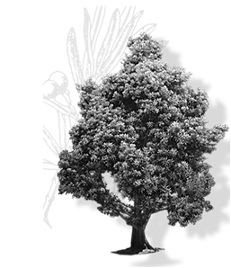
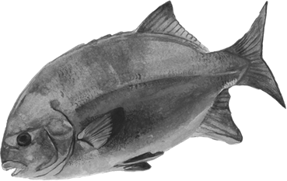

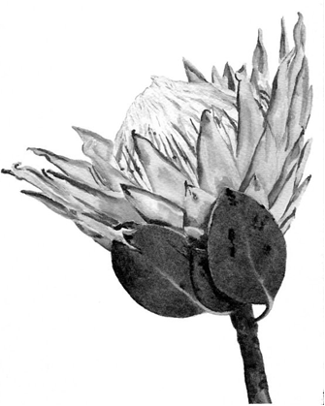
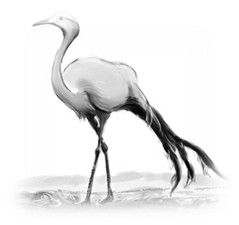

Total Section 1: ___ / 20

Section 2
Personal and Social Well-being
Marks: 30

Question 1: Ways we communicate
1.1. Are the following statements true or false? (5)
Statement | True or False
- We use writing and our voices to communicate.
- Sign language is not a form of communication.
- People who are blind and cannot see, use the Braille alphabet when they read and write.
- People who use sign language, use hand or finger signs to communicate with others.
- Newspapers are a form of communication.

1.2. Give one word for the following statements. (2)
- Uses dots that you can feel on the paper with your fingers._____________________ (1)
- A man named ______________, invented the Braille alphabet. (1)

1.3. Look at the picture below and write down 4 examples of
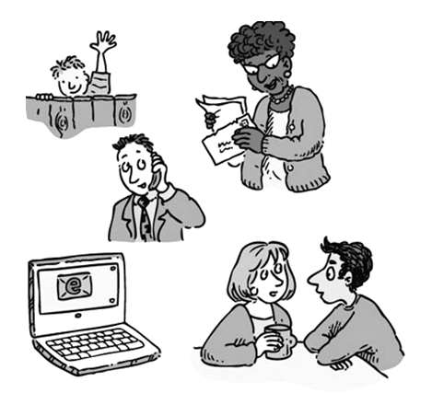
communication. (4)

__________________________________________________________________________________________________________________________________________________________________________________________________________________________________________________________________________________________________________________
Total Question 1: ___ / 11

Question 2: Life at night

2.1. Look at the pictures below and write if the people work
during the "day" or "night "and give a reason for your answer.

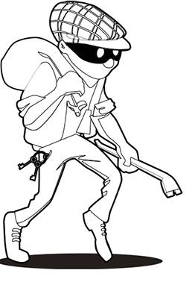
(4)
____________________________________________________________________________________________________________________________________________________________________________________________________________________________
(2)

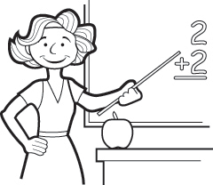
____________________________________________________________________________________________________________________________________________________________________________________________________________________________
(2)

2.2. Write down 4 ways in which we communicate by writing. (4)
________________________________________________________________________________________________________________________________________________________________________________

2.2. What is a nocturnal animal? (2)
______________________________________________________________________________________________________

2.3. Which senses of nocturnal animals are highly developed? Name
3 examples. (3)
__________________
__________________
__________________

2.4. Name 2 nocturnal animals you have learned about in class. (2)
__________________
__________________

2.5. Are the following statements true or false? (4) )
Total Question 2: ___ / 19
Total Section 2: ___ / 30

Statement | True or False
Owls sleep during the night but comes out in the day to hunt.
Porcupines sleep during the day. At night they look for food.
Some nocturnal animals hide from other animals during the day who hunt them.
Nocturnal animals have poorly developed senses.
Section 3
Creative Arts – Performing Arts + Visual Arts
Marks: 10 + 10 = 20

Question 1: Performing Arts - Improvise and interpret

Assignment:
Design a puppet show with your partner to portray the different ways of communicating.

Keep the following in mind:
- You must use puppets.
- There has to be dialogue.
- You should have a stage where you can hide behind
so that the audience do not see you.
- You should vary your tone.
- You will be marked according to a rubric.
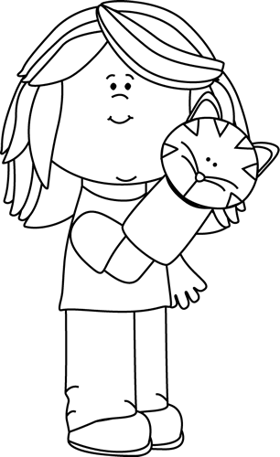
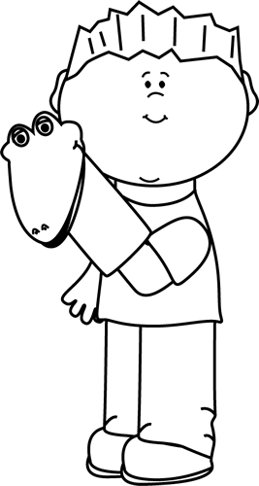

 | Rubric - Puppet Show | Mark
 |  | 5 | 4 | 3 | 2 | 1
1. | Uses appropriate intonation and volume. Words are pronounced clearly and correctly, | 5 | 4 | 3 | 2 | 1
2. | Students had a stage where they could hide behind so that the audience couldn’t see them. | 5 | 4 | 3 | 2 | 1
3. | Students made use of puppets and there was dialogue between the characters. | 5 | 4 | 3 | 2 | 1
4. | Content: The puppet show portrayed different way of communicating. | 5 | 4 | 3 | 2 | 1
Total |  | / 20

Processed mark (20 x ƒ = 10): __ / 10

Question 2: Visual Arts - 2D designs

Assignment:
Create a 2D image depicting the life of nocturnal animals by painting or drawing. Your image should be colorful and creative. Recall what you learned in class about nocturnal animals to use in your artwork.

You will be assessed according to the following rubric:
Rubric - Visual Arts
- The student's artwork is colorful. Was the learner creative? | 5
- The learner has depicted a scene of nocturnal in his / her picture and the picture shows the learner's knowledge and understanding of nocturnal animals. | 5
Total | 10
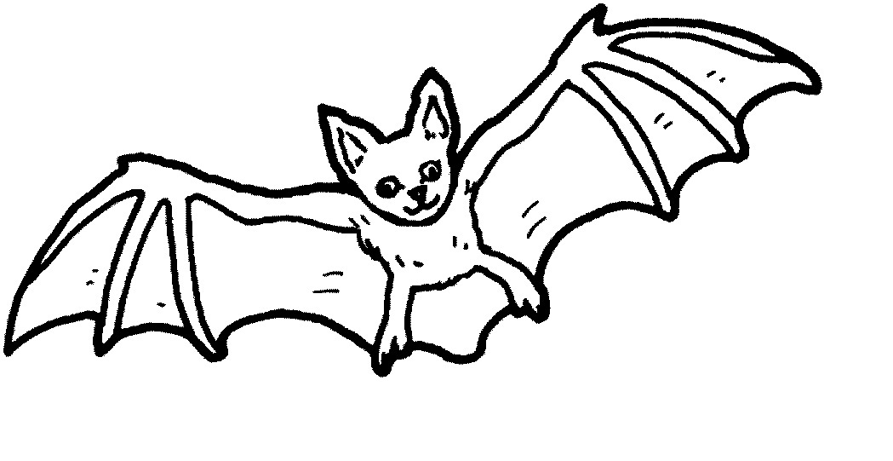
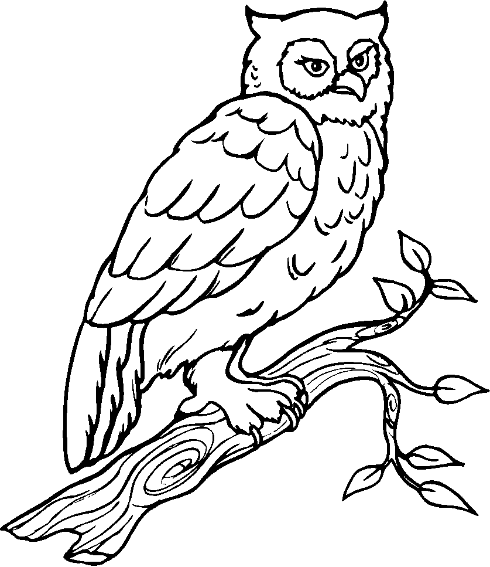

Section 4
Physical Education
Marks: 20

Purpose of activity – Coordination and Perceptual Motor
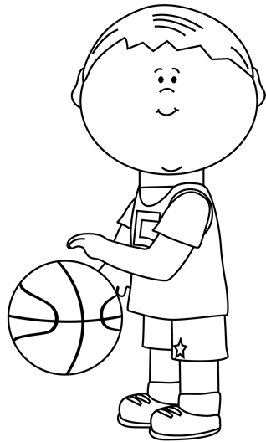
Resources needed:
Empty container or trash can.
A tennis ball
A bean bag
A rugby ball
A netball ball

Instructions
Divide into teams. Each team is in a row.
Place a trash can or empty container about five steps away from the team.
The first assignment is that the learners should try to throw the different balls with ONE HAND.
The learner in front of the line throws the item into the container, runs to get the ball and hands it to the next learner in the line.
If you miss, try again and try again. Each learner must throw the tennis ball, bean bag, rugby ball and netball ball.
The second assignment is: The learners must now throw the items with TWO HANDS in the container. Each learner must throw tennis ball, bean bag, rugby ball and netball ball with two hands.
Everybody in the team gets a turn. The first team who finish is the winning team.

Rubric – Physical Education
- The learner was capable to throw the tennis ball in the container with ONE HAND. | 2
- The learner was capable to throw the netball ball in the container with ONE HAND. | 2
- The learner was capable to throw the rugby ball in the container with ONE HAND. | 2
- The learner was capable to throw the bean bag in the container with ONE HAND. | 2
- The learner was capable to throw the tennis ball in the container with TWO HAND. | 2
- The learner was capable to throw the netball ball in the container with TWO HAND. | 2
- The learner was capable to throw the rugby ball in the container with TWO HAND. | 2
- The learner was capable to throw the bean bag in the container with TWO HAND. | 2
- The learner waited his turn and followed the instructions. | 2
- The learner was enthusiastic about the activity and gave his best. | 2
Total | 20

