English First Additional Language
Assessment Term 4
Grade 2

Name and Surname: ____________________________
Date: _________________________________

MEMORANDUM

Content |  | Mark
- Listening and speaking | 30
- Reading | 25
- Phonics | 25
- Writing and handwriting | 20
Total | 100

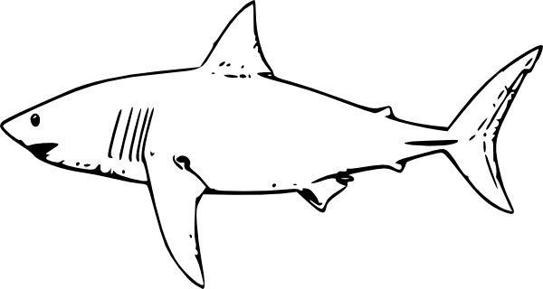
Activity 1
Listening and speaking
Marks: 20

  - Listening Comprehension
Listen to the story while the teacher is reading and answer comprehension questions orally. You will be marked according to a rubric.
Sharks
What has fins, sharp teeth, and swims in the ocean? A shark!

Sharks have been around for a very long time. Sharks have lived in the oceans even before dinosaurs roamed the earth! Sharks are fish, and there are over 400 types of sharks. When they have babies, the babies are called pups.

Sharks lose their teeth, like humans, but they don’t just lose their baby teeth. They lose teeth throughout their lives. When a shark loses a tooth, a tooth from another row of teeth will move into its place. New teeth are always growing. Most sharks are carnivores, so they feed on other animals, like fish or seals.

Sharks might look scary, but they are not usually dangerous to people. People are more dangerous to sharks, since people hunt sharks. To be safe, though, it is a good idea to leave sharks alone if you see them!

Answer the following questions orally:
- About what animal is the story?
The story is about a shark.
- Name three things which they tell us at the beginning of the story by which a shark is known for.
Sharks has fins, sharp teeth, and swims in the ocean.
- How many types of sharks are there?
There are 400 types of sharks.
- What is the babies of sharks called?
Baby sharks are called pups.
- What do sharks eat? Name two things.
Sharks eat fish and seals.
- What happens when a shark loses its teeth?
When a shark loses a tooth, a tooth from another row of teeth will move into its place.
- Why do you think people hunt sharks?
Learners own answer.

Listening and Speaking Rubric
 | 1 | 2 | 3 | 4
Vocabulary and language use | Struggles to communicate effectively, limited vocabulary. Cannot print himself / herself. | Uses a limited vocabulary. Makes many grammatical errors. | Uses appropriate vocabulary. Talks in full sentences and speaks in the correct time, eg. Past, future or present. | Uses a comprehensive vocabulary. Talks in full sentences and uses correct and good language. Use descriptive words.
Appropriate volume and intonation | Talks too soft or mumbles. Difficult to understand and hear. | Talks too fast. Sometimes difficult to understand. | Talk slowly and clearly. Easy to understand. Most of the time can be clearly heard. | Talk slowly and clearly. Can be easily heard and understood at all times.
Content | Learner doesn’t participate. Doesn’t want to try to answer questions. | Limited content. Teacher must ask questions to get clarity. | Spontaneous. Provides adequate content which is expected of the learner. | Spontaneous and elaborative. Content provides more information than expected.
Comprehension skills | Most of the answers to the questions are incorrect. | Some of the answers are correct. | Most of the answers are correct. | All of the answers were correct. The learner was able to answer in full sentences.
Ask questions for clarity | The learner has to ask questions the whole time for clarity because he seldom gives attention when given instructions. | The learner has to ask questions some times for clarity because he seldom gives attention when given instructions. | The learner has to ask questions seldom for clarity because he gives attention when instructions are given. | The learner never has to ask questions for clarity because he gives attention when instructions are given.
 |  |  | Total /20

Listening activity

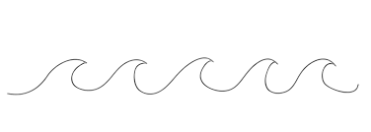
Listen to the instructions of the teacher and concentrate. Do exactly as she instructs you to do. Remember to draw neatly.
blue
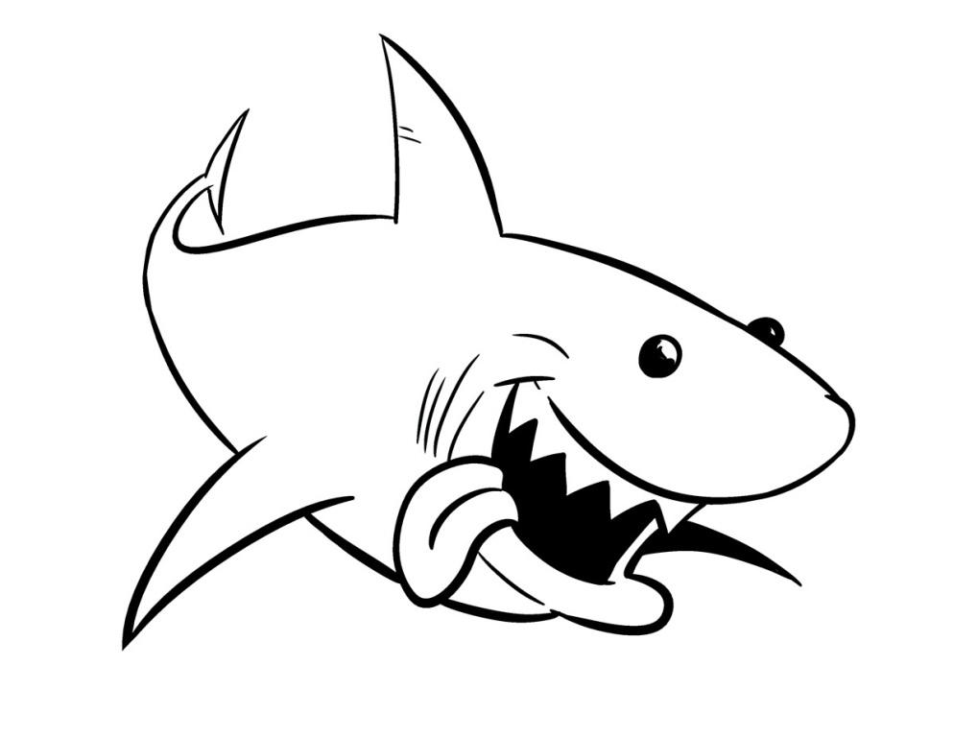
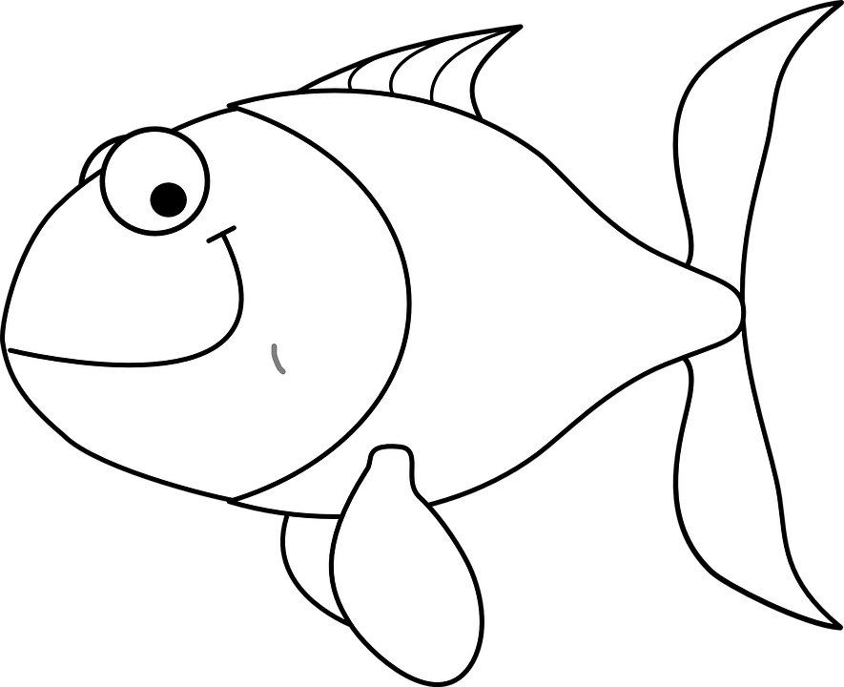
grey

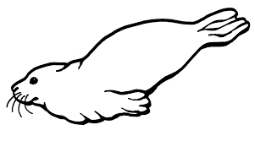

Instructions:
- Draw a shark√ with teeth√ in the middle√ of the block. (3)
- Color the shark grey. (1)
- Draw two fish√√ at the mouth of your shark. (2)
- Draw a seal√ beneath√ your shark. (2)
- Draw waves√ above your shark with blue√. (2)

Total: ______ / 10
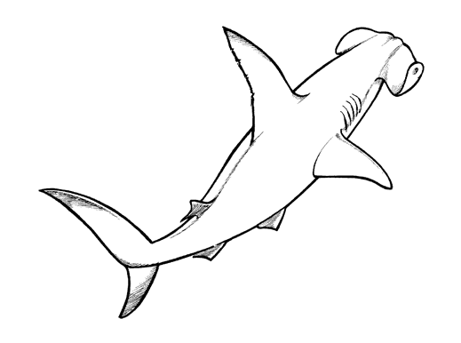
Activity 2
Reading
Marks: 25

2.1. Shared reading

Instructions:
Retell the story about the shark which your teacher has read to you in 3 sentences.

You will be assessed according to the following rubric:

Rubric : Retelling of story |  | Mark obtained
- Was the learner able to shortly retell wat happened in the story? | 2
- Learner speaks clearly and pronounces words correct. | 1
- The learner speaks with confidence and makes eye contact and uses facial expressions. | 2
Total | 5
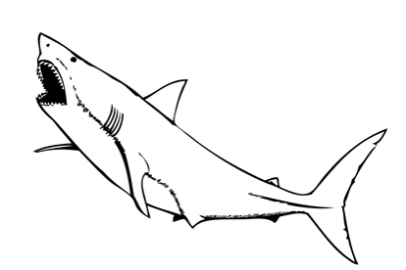

2.2. Group Guided Reading

Read aloud from your own book in a guided reading group with the teacher. This means the whole group reads the same story or non-fiction text with the teacher. You will be marked according to this rubric:

Rubric – Group Guided Reading
- Words a pronounced correctly. | 2
- Learner makes use of the reading strategies taught in the Home Language to make sense and monitor self when reading (phonics, context clues, structural analysis, sight words) | 2
- Learner reads with increasing fluency and expression. | 2
- Shows an understanding of punctuation when reading aloud. | 2
- Reads with feeling and intonation. | 2
Total | 10

2.3. Independent reading – Read the poem below aloud
to your Teacher. Remember to read with feeling.

A Shark is a pet

A shark is a pet
that you do not want to get.
There is nothing less fun than a shark.
He does not have fur.
He will not cuddle or purr,
and he never takes walks in the park.

Instead he just stares
and prepares,
as he circles and waits in the dark,
to nibble your nose
and your fingers and toes,
for his bite is much worse than his bark.

Rubric – Independent reading
- Words a pronounced correctly. | 2
- Learner makes use of the reading strategies taught in the Home Language to make sense and monitor self when reading (phonics, context clues, structural analysis, sight words) | 2
- Learner reads with increasing fluency and expression. | 2
- Shows an understanding of punctuation when reading aloud. | 2
- Reads with feeling and intonation. | 2
Total | 10
Activity 3
Phonics
Marks: 25

  - Look at the words in the box and group the according to word family in the table. (10)
rug lip bag mug tip
wag hip jug wip bug

-ug | -ip | -ag
rug | hip | bag
mug | tip | wag
jug | lip
bug | wip

3.2. Complete the words in the sentences by using: oo
and ee. (4)

a. My mother sweep the floor with a broom.
b. I go to sleep at eight o’clock.

3.3. Choose the correct consonant blend and complete
the word. Colour the correct block. (8)

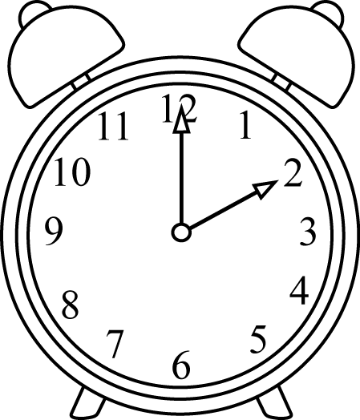  trblclfl | 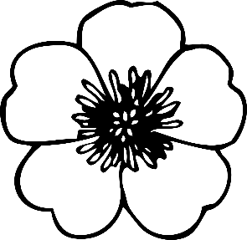  trblclfl  fl ower  cl ock
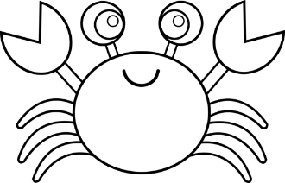  cr ab  grcrclth | 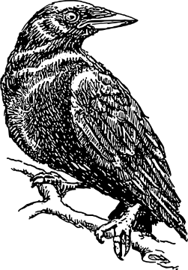  crgrcltr  cr ow
br ead
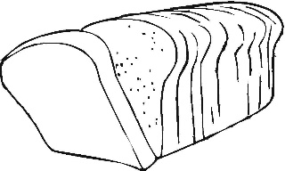
brcrtrcr

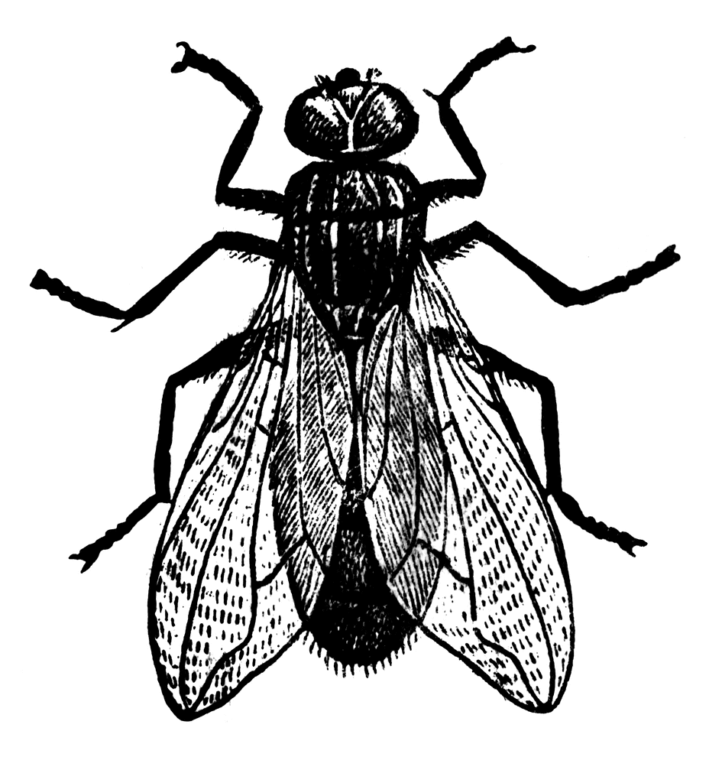
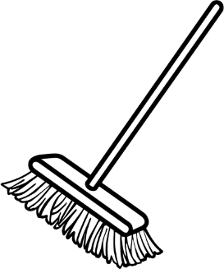
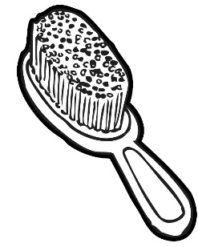
brflclbl
brflclbl
fl y
br oom
br ush
3.4. Write your own words with oo and ee in the table.
( 6 x ƒ = 3)

oo | ee
roof | feet
book | greet
moon | deep

Any other applicable word is correct.
Activity 3: Phonics total: ___/25
Activity 4
Writing and Handwriting
Marks: 20
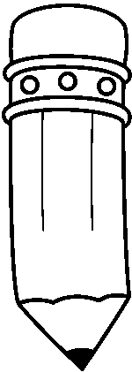
Write the following paragraph over on the lines.

Sharks have been around for a very long time. Sharks have lived in the oceans even before dinosaurs roamed the earth! Sharks are fish, and there are over 400 types of sharks. When they have babies, the babies are called pups.

________________________________________________________________________________________________________________________________________________________________________________________________________________________________________________________________________________________________________________________________________________________________________________________________________________________________________________________________________________________________________________________________________________________________________________________________________________________________________________________________________________________________________________________________
Rubric – Writing and Handwriting: Cursive | 1 | 2 | 3 | 4 | 5
- Line usage – How well did the learner use his writing lines? | Many errors in line usage. | Some errors in line usage. | Few errors using lines correctly. | Uses lines correctly most of the time. | Always uses lines correctly.
- Spacing - How well did the learner space their letters and/or words? | Many errors in spacing. | Some errors in spacing. | Few errors using spacing correctly. | Uses proper spacing most of the time. | Always uses proper spacing.
- Letter formation-  Did the learner form his letters correctly? | Many errors in letter formation. Incorrect letter formations. | Some errors in letter formation. Letters formed incorrectly. | Few errors in letter formation. Few letters are formed incorrectly. | Most letters are formed correctly. | Consistently forms all letters correctly.
- Readability – How easy is it to read the learners handwriting? | Many errors in readability. | Some errors in readability. | Few errors in readability. | Very easy to read. | Always easy to read.
- Neatness - How neat is the learners handwriting? | Difficult to read. | Not neatly done. | Not as neatly done. | Writes neatly. | Always writes neatly.
Total: ___/20

blflclbr

