**Mathematics**

**Assessment Task Term 4**

**Grade 1**

**Name and surname: ____________________________**

**Date: _________________________________**

|  |  |  |
| --- | --- | --- |
| **Section** |  | **Mark obtained** |
| 1. Numbers, operations and relationships | **58** |  |
| 1. Patterns, functions and algebra | **10** |  |
| 1. Space and Shape | **13** |  |
| 1. Measurement | **14** |  |
| 1. Data Handling | **5** |  |
| **Total** | **100** |  |

**Section 1: Numbers, operations and relationships**

* 1. Add up the following items and write the answer in the block. (1)

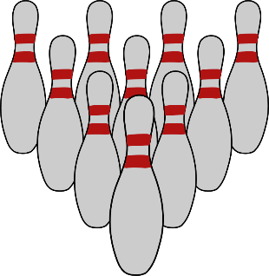





=

* 1. Complete the following by counting forwards and backwards:

1.2.1. 55, 60, 65, ____, ____, ____, 85, 90. (1)

1.2.2. 43, 53, 63, ____, ____, ____. (1)

1.2.3. 86, 84, 82, ____, ____, ____, 74. (1)

* 1. Number names and symbols - Complete the table. (4)

|  |  |
| --- | --- |
| Number symbol | Number name |
| 10 |  |
|  | sixteen |
| 6 |  |
|  | nineteen |

* 1. 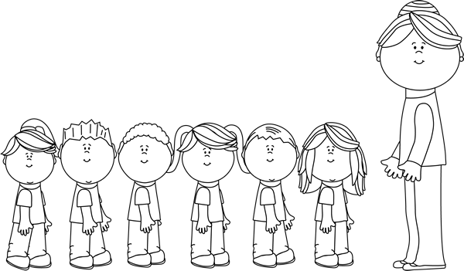Answer the following questions about the students standing in the queue. Start with the teacher as the starting point. (6)

Ben Charles Lucy Dave Anne

Lisa

1.4.1. Who is first in line? ____________ (1)

1.4.2. Who is second in line? ____________ (1)

1.4.3. Where is Charles in the queue? _________ (1)

1.4.4. Who is last in the row? _____________ (1)

1.4.5. How many children are there in the queue? ________ (1)

1.4.6. Color the fifth student in the queue yellow. (1)

* 1. Organize
     1. Arrange the following numbers from smallest to largest. (1)

12, 2, 15, 17, 9, 8

__________________________________________

* + 1. Arrange the following numbers from the largest to the smallest. (1)

12, 2, 15, 17, 9, 8

__________________________________________

* 1. Fill in more or less.
     1. 28 is ________ than 30 (1)
     2. 32 is ________ than 22 (1)
  2. Double and divide in half by completing the table. (4)

|  |  |
| --- | --- |
| Question | Answer |
| 1. 10 doubled is |  |
| 1. 10 divide in half |  |
| 1. 8 doubled is |  |
| 1. 4 divided in half is |  |

* 1. Solve the following problems by writing a number sentence. You can draw a picture to help you. Your picture will count a point.
     1. There are 16 bottles of red and green soda. If 7 bottles are green, how many bottles are red? (4)

* + 1. Tom has 4 marbles. If Ben has 4 times more than Tom. How many marbles does Ben have? (4)
  1. Connect the coins with their names by drawing a line. (5)

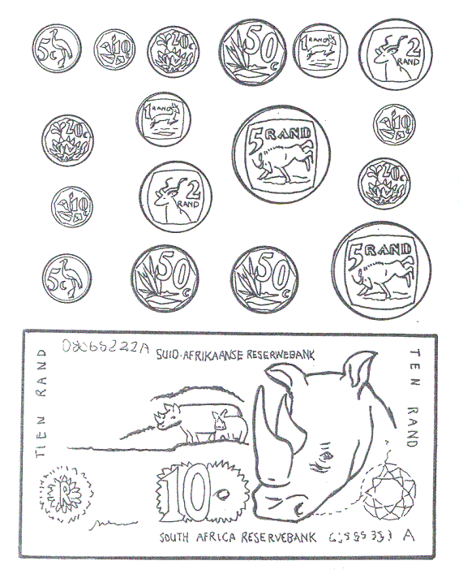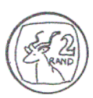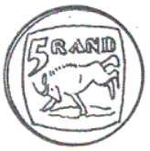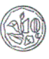

|  |  |  |  |  |
| --- | --- | --- | --- | --- |
| two rand | fifty cent | five cent | five rand | ten cent |

* 1. Complete the table by adding and subtracting the following money. Show your steps. (6)

|  |  |
| --- | --- |
| Image result for geld graad 1  +  + |  |
| Image result for geld graad 1  - |  |
| +  + |  |

* 1. Here are 15 stars. Divide the stars into 3 groups in the circles. (4)
     1. How many groups do you count? _____ (1)
     2. How many stars are in each group? _____ (1)
     3. How many stars are there? _____ (1)
     4. Write a number sentence: _____ + _____ + _____ = _____ (1)
  2. Mental maths - Complete. (8)

e. 2 less than 18 = ___

f. 2 more than 14 = ___

g. 1 less than 10 = ___

h. 1 more than 19 = ___

1. 3 + 3 + 3 = ___
2. 10-5 = ___
3. 6 + 4 = ___
4. 8 divided in half = ___
   1. Addition and subtraction. (4)

Complete the following sums by looking at the pictures. Write a number sentence.

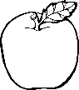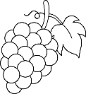



+



**Total Section 1: ___ / 58**

___________________________________________________

**Section 2: Patterns, Functions and Algebra**

2.1. Expand the following patterns by one set. (2)

2.2. Create your own pattern in the block by using the objects

below. Your pattern should repeat 3 times. (2)

2.3. Complete the pattern. (1)

|  |  |  |  |  |  |  |  |  |
| --- | --- | --- | --- | --- | --- | --- | --- | --- |
|  |  |  |  |  |  |  |  |  |

2.4. Consider the following number patterns. Write down the rule

for each pattern. (5)

2.4.1. 40, 50, 60, 70, 80. (1)

Rule: ____________________________________

2.4.2. 22, 24, 26, 28, 30. (1)

Rule: ____________________________________

2.4.3. 55, 50, 45, 40, 45. (1)

Rule: ____________________________________

2.4.4. 55, 44, 33, 22, 11. (1)

Rule: ____________________________________

2.4.5. 48, 46, 44, 42, 40. (1)

Rule: ____________________________________

**Total Section 2: ___ / 10**

**___________________________________________________**

**Section 3: Space and Shape**

3.1. Where is the sun? Color the right answer. (2)



|  |
| --- |
| in front |
| behind |
| next to |

|  |
| --- |
| in front |
| behind |
| next to |

3.2. Name the following 3-D shapes. (2)

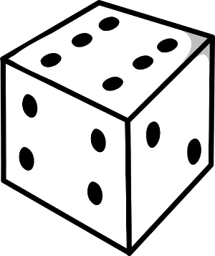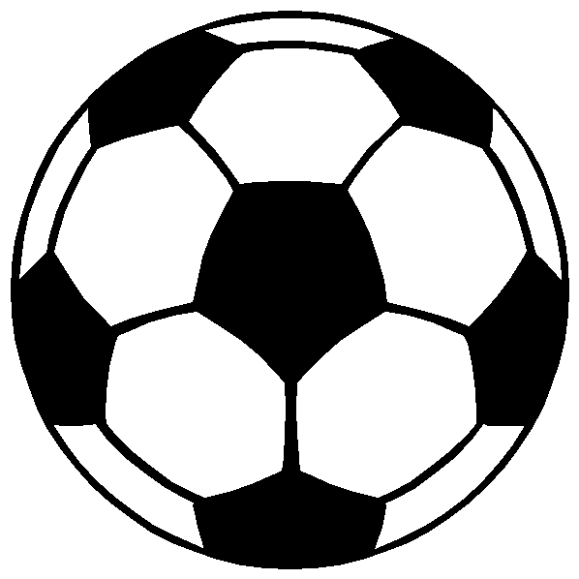

3.3. Consider the following items in the box. (4)

* Color all the objects that roll with blue. (2)
* Circle all the objects that slide. (2)



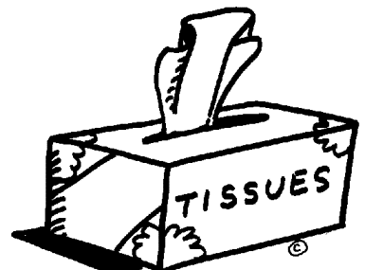

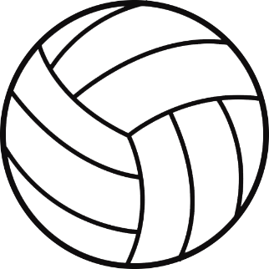

* 1. Draw the following shapes in the blocks. (2)

triangle

square

* 1. Does the following shapes have curved or straight sides? Color the right answer. (2)

|  |
| --- |
| curved |
| straight |

|  |
| --- |
| curved |
| straight |

* 1. Draw the lines of symmetry for the next shape. (1)

**Total Section 3: ___ / 13**

___________________________________________________

**Section 4: Measurement**

* 1. 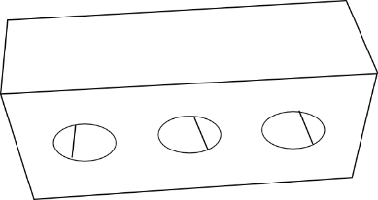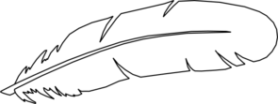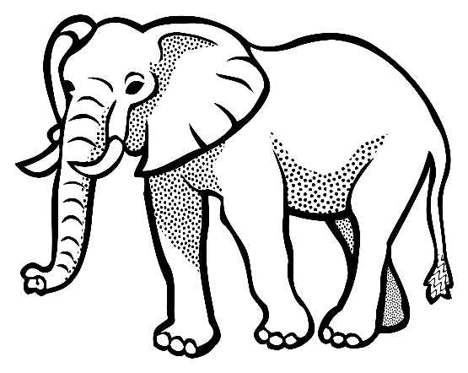Look at the pictures and arrange them from the heaviest to the lightest by writing their names on the lines.

feather

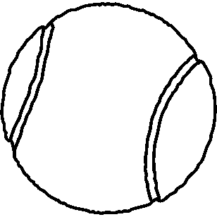

tennis ball

brick

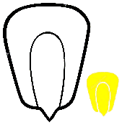

kernel

elephant

1. ______________ (1)
2. ______________ (1)
3. ______________ (1)
4. ______________ (1)
5. ______________ (1)
   1. Look at the following pictures. Decide which of the two images may contain more liquid and tick it with a correct mark (√). (4)

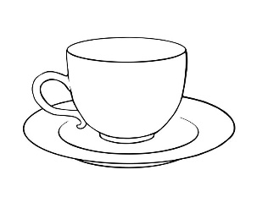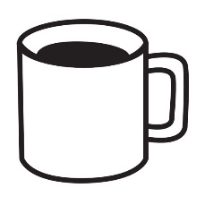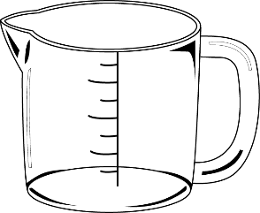

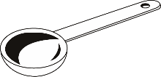

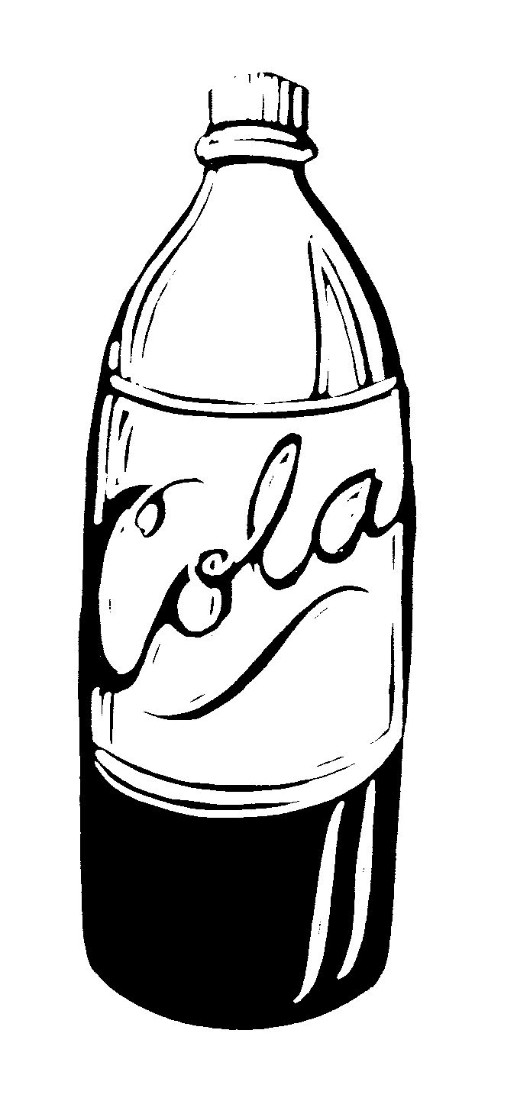

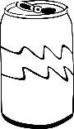

* 1. Consider the following glasses and color whether it is full or empty. (2)

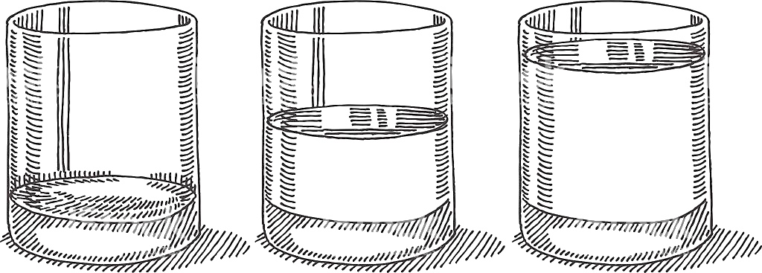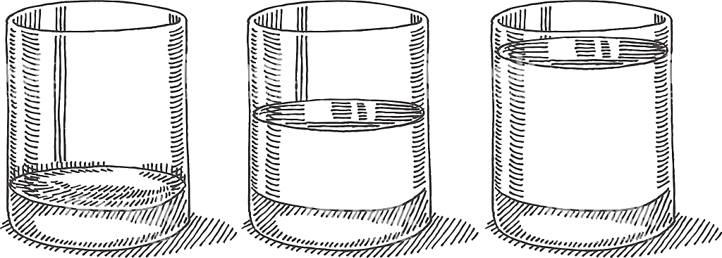

|  |
| --- |
| full |
| empty |

|  |
| --- |
| full |
| empty |

* 1. Fill in: More than or less than.(2)

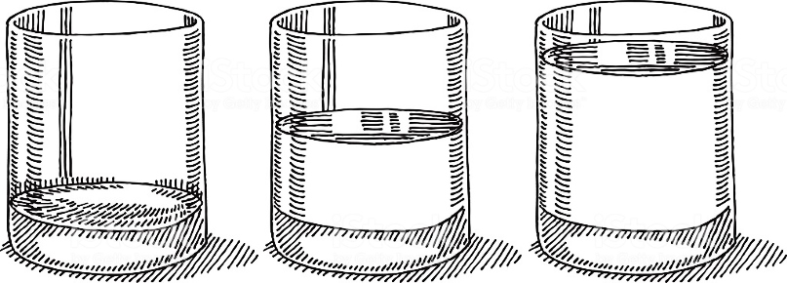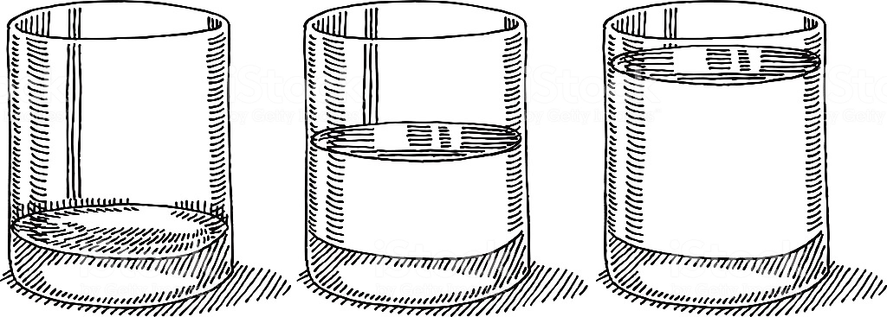

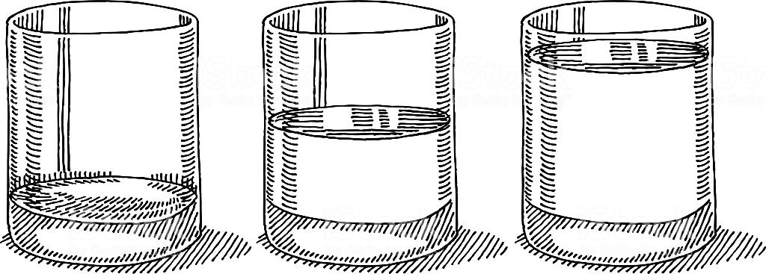

* 1. 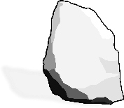If we have a stone and a ball placed on a balance scale. To which side will it tip? Color the right answer. (1)

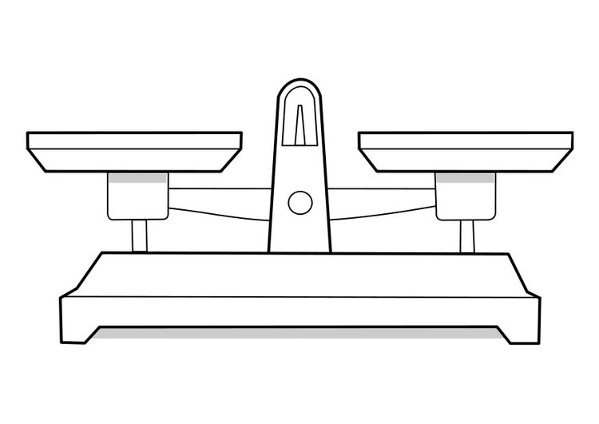

|  |
| --- |
| right |
| left |

**Total Section 4: ___ / 14**

**Section 5: Data Handling**

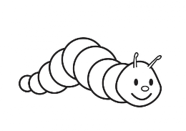Add up all the different types of insects in the block and complete the pictogram. (5)

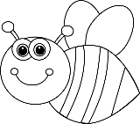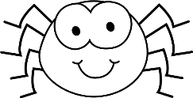

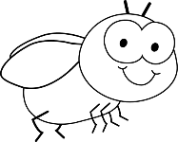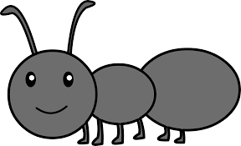





|  |  |  |  |  |
| --- | --- | --- | --- | --- |
|  |  |  |  |  |
|  |  |  |  |  |
|  |  |  |  |  |
|  |  |  |  |  |
|  |  |  |  |  |
|  |  |  |  |  |
|  |  |  |  |  |
|  |  |  |  |  |

bee ant worm fly spider

8

7

6

5

4

3

2

1

0

**Total Section 5: ___ / 5**