Mathematics
Assessment Task Term 1
Grade 1

Name and surname: ____________________________
Date: _________________________________

Task 1

Section |  | Mark obtained
- Numbers, operations and relationships | 30
- Patterns, functions and algebra | 5
- Space and Shape | 6
- Measurement | 6
- Data Handling | 3
Total | 50

Section 1: Numbers, operations and relationships

  - Count how many apples are on each dice and write the number symbol and the number name. (8)
 | Number symbol | Number Name
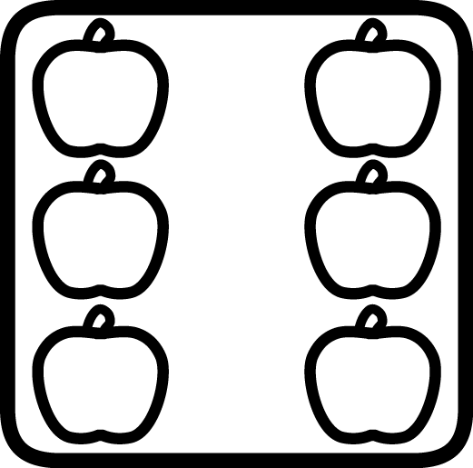

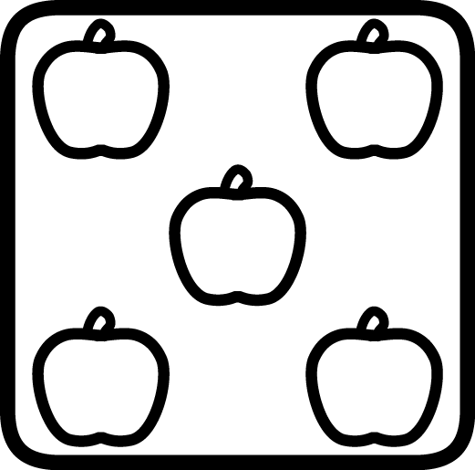

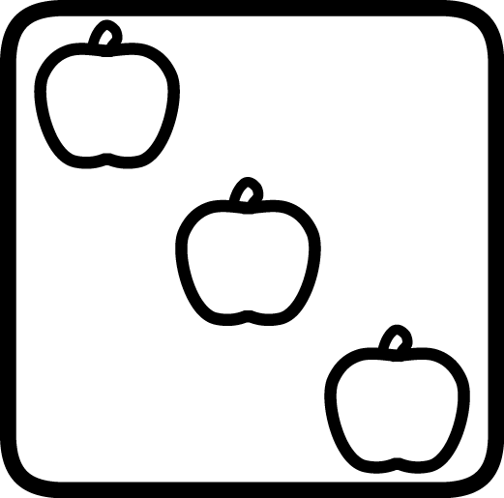

Total: ___ / 8
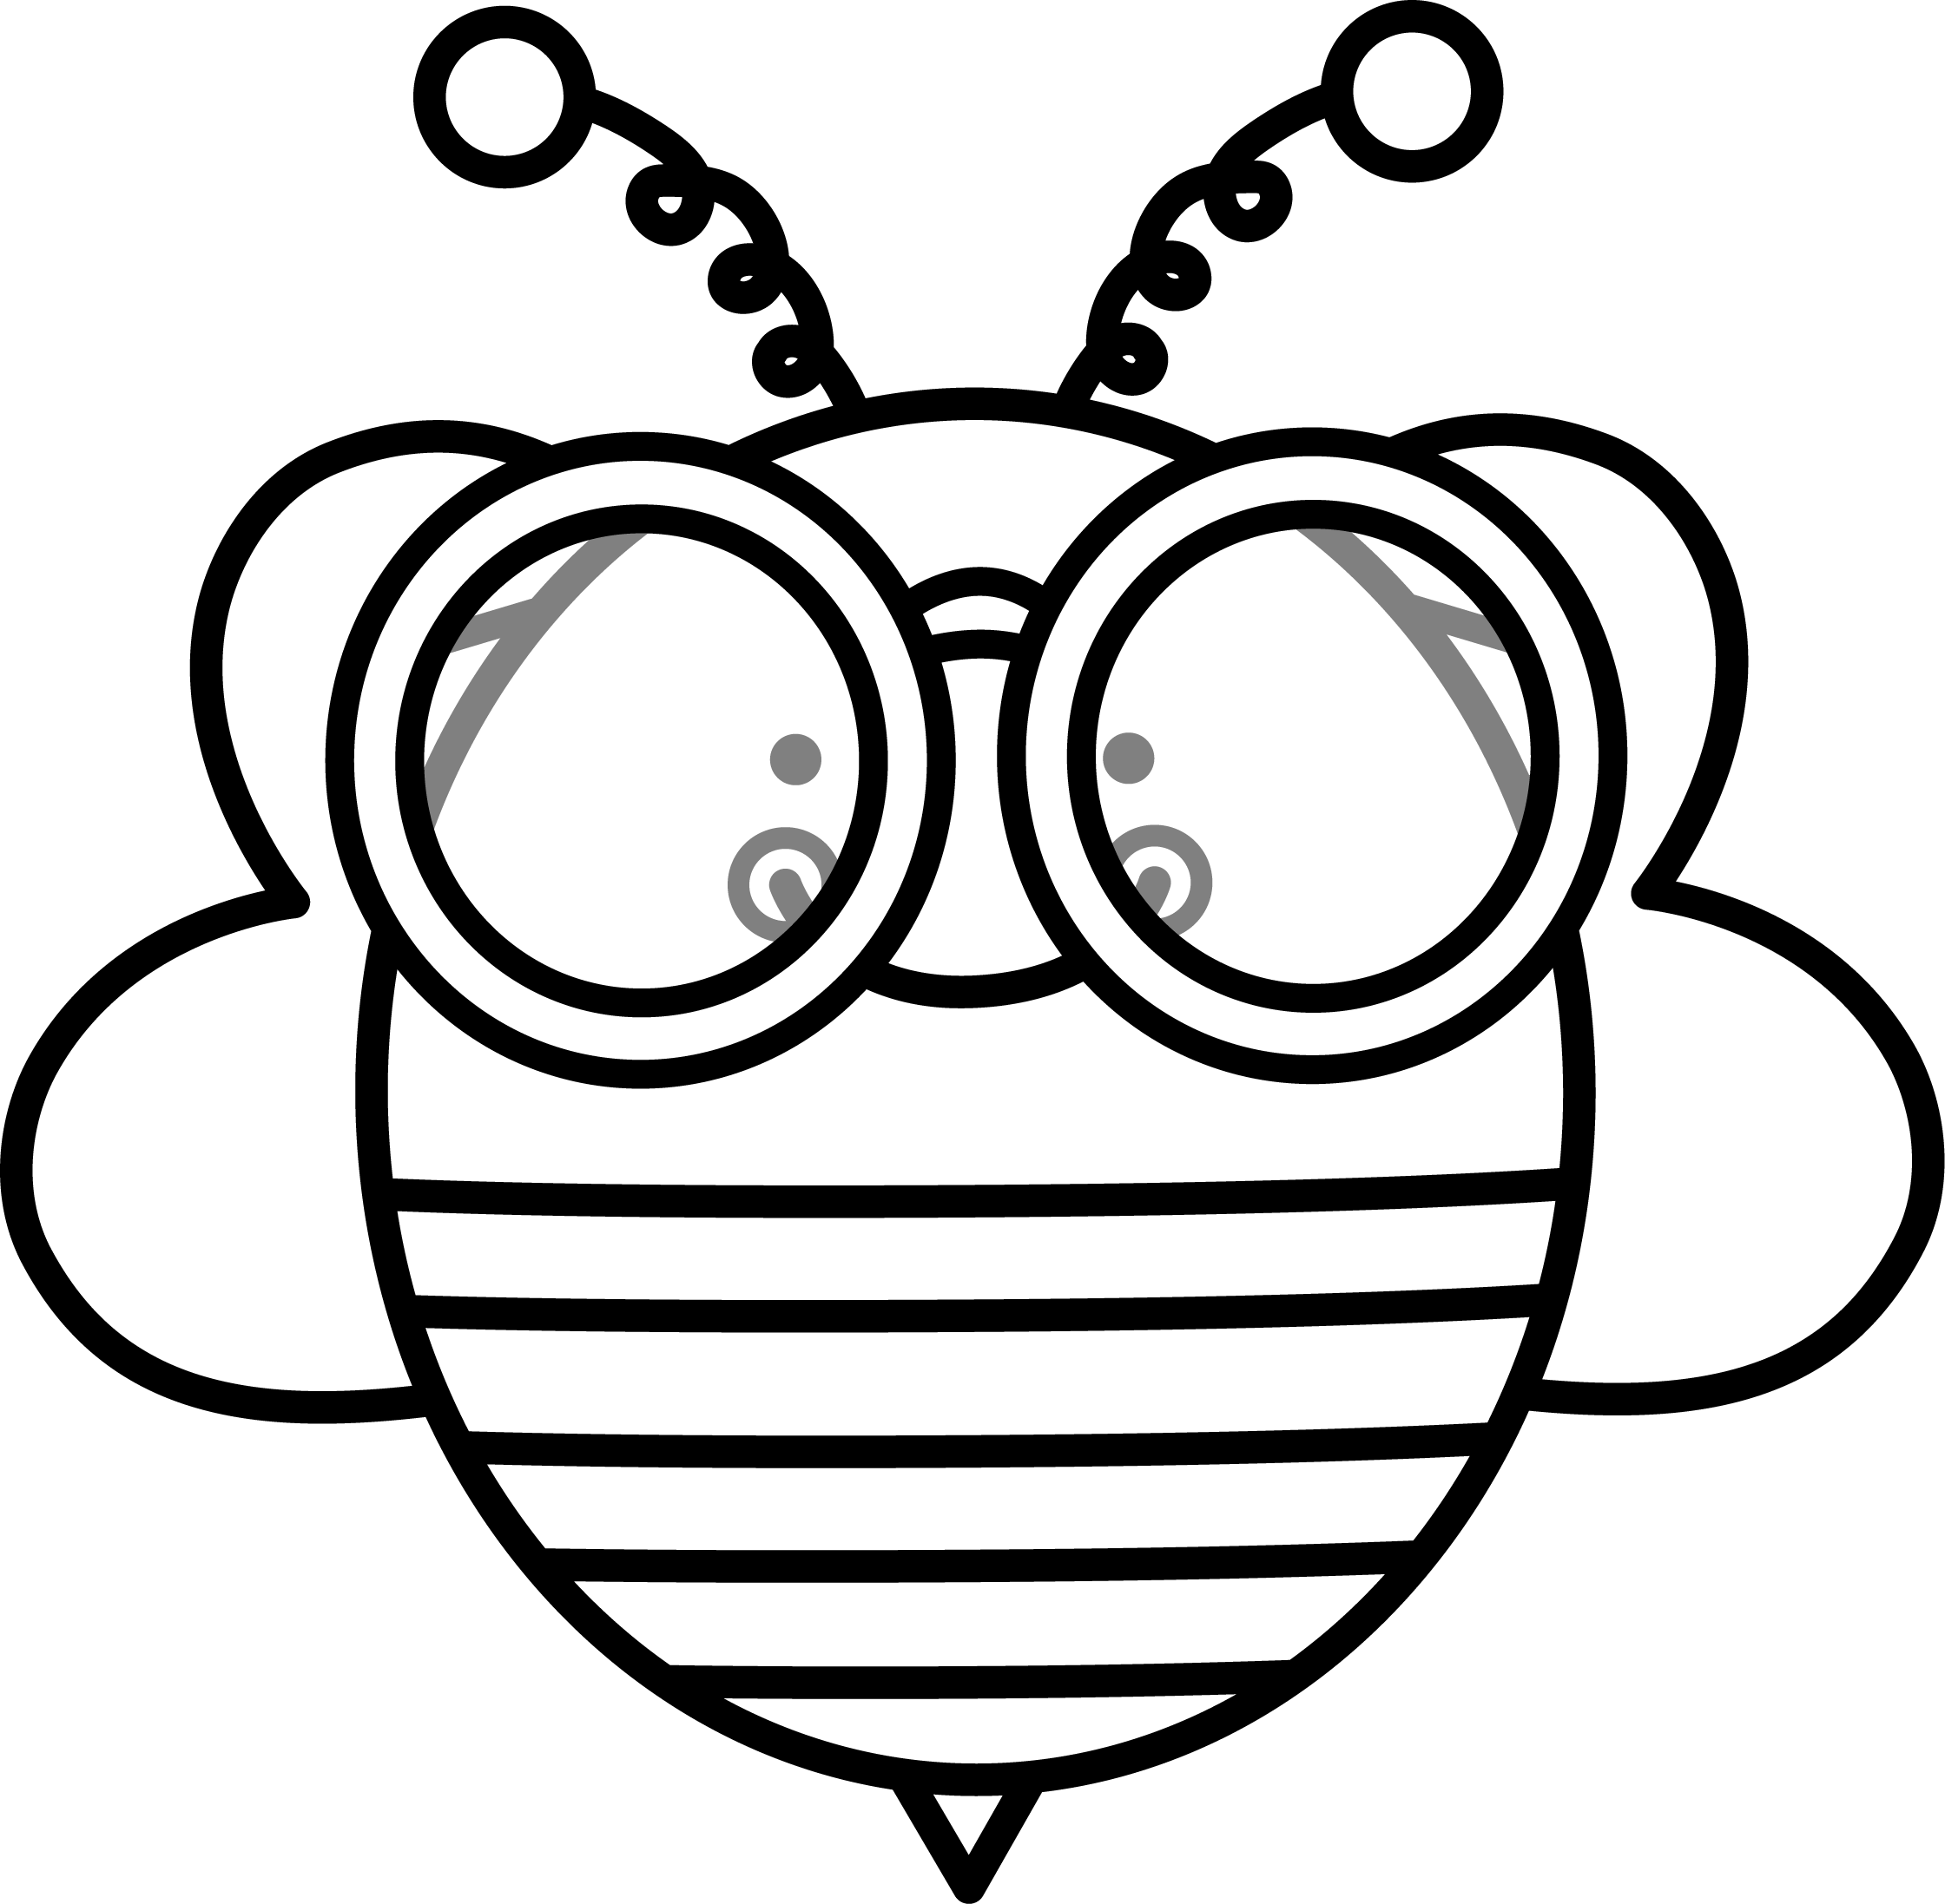
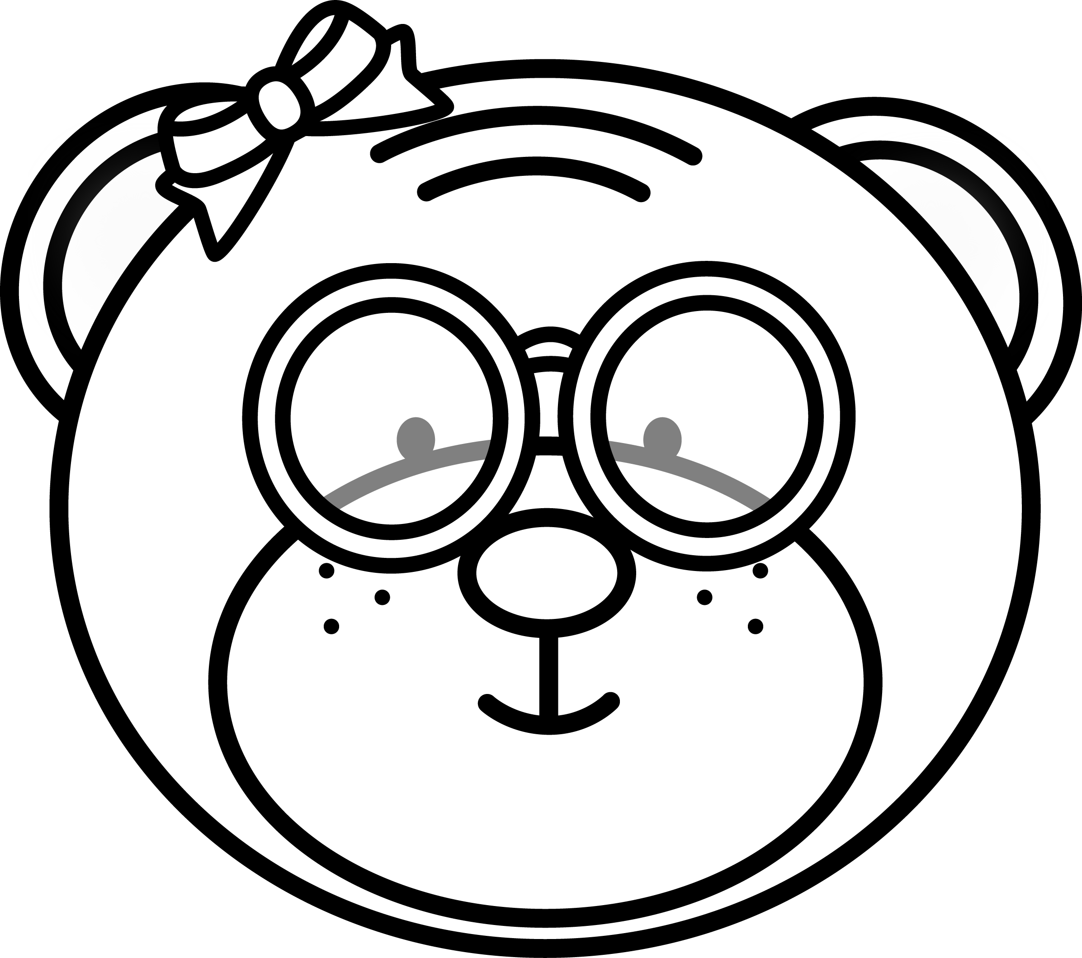
Make a √ ​​in the box with most bees.
Make a √ ​​in the box with the least bears.
Total: ___ / 2


  - Lisa's mother buys her 5 pencils for school. She lost three of the pencils. How many pencils does she have left? (1)

  - Jaco's mother bakes 3 cupcakes for his birthday. His grandmother bakes another 2. How many cupcakes did they bake altogether? (1)



  - Order the numbers in the heart from the smallest to largest by writing it on the line. (1)
5
3
1

9
6
  - Order the numbers in the heart from the largest to smallest by writing it on the line. (1)
5
3
1
9
6

  - There are 4 sweets. David and Gary want to divide the sweets equally so that everyone gets the same amount of sweets. Help them to divide it. (1)
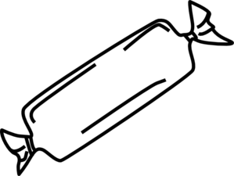

  - Complete the table. (8)
- Which number is less, 3 or 5?
- Which number is more, 4 or 5?
- What number comes before 2?
- What number comes after 3?
- The number between 1 and 3
- Which number is 2 more than 3?
- What number is 1 less than 5?
- Which number is 2 more than 2?

Total Section 1: ___ / 23
___________________________________________________
Section 2: Patterns, Functions and Algebra

2.1. Expand the following patterns by drawing one more set. (2)

2.2. Complete the missing numbers on the number line. (3)
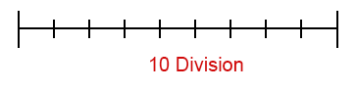

1 2 3 6 9 10
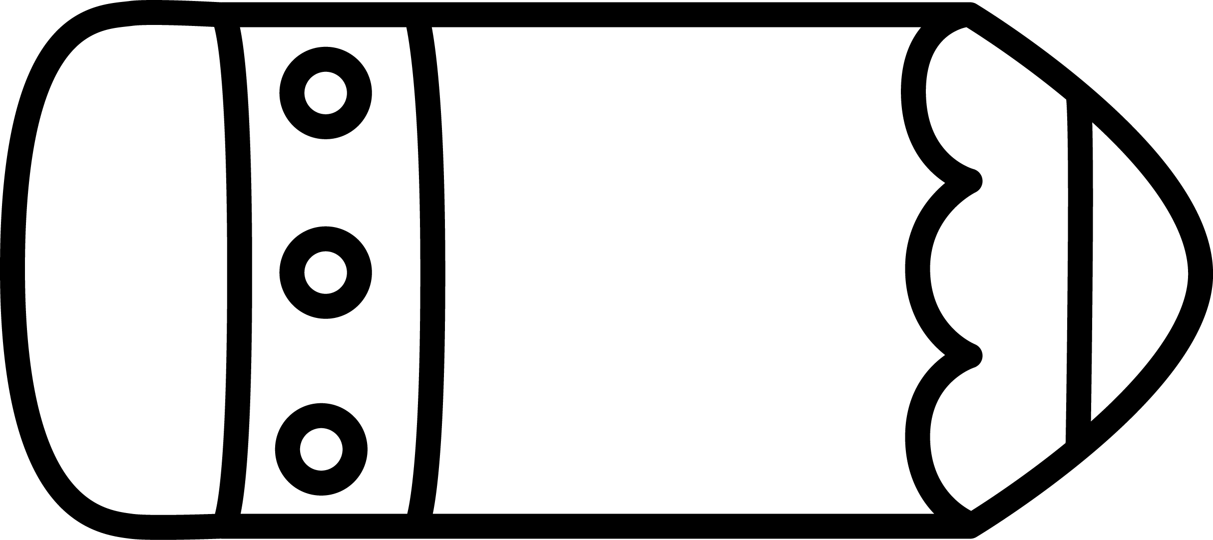
5 6 8 10

10 9 7 4 3

Total Section 2: ___ / 5

Section 3: Space and Shape

3.1 Draw a ball under the table and then draw a bowl of fruit
on top of the table. (2)
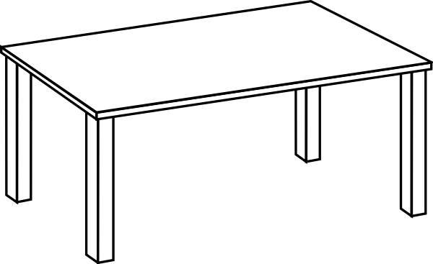


  - The following items shaped like a ball or a box? (ƒ × 2 = 1)
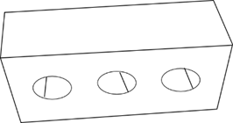

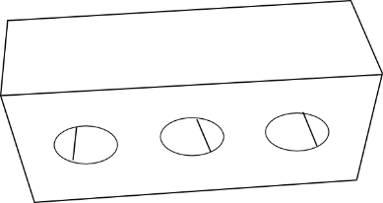

box
ball

box
ball

full
empty

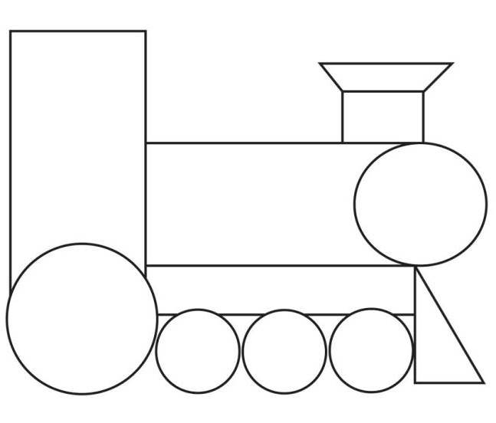
  - Count the shapes and write the amount in the blocks. (3)

Shape | Amount
rectangle

triangle

circle

Total Section 3: ___ / 6

Section 4: Measurement

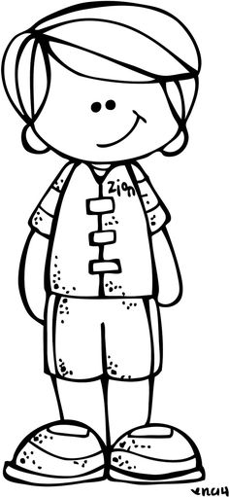
4.1. Answer the questions about the picture. (3)
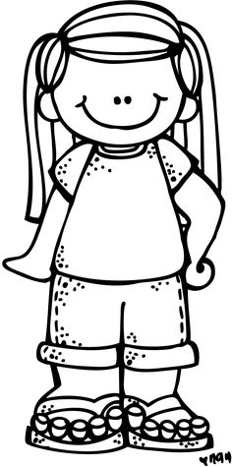
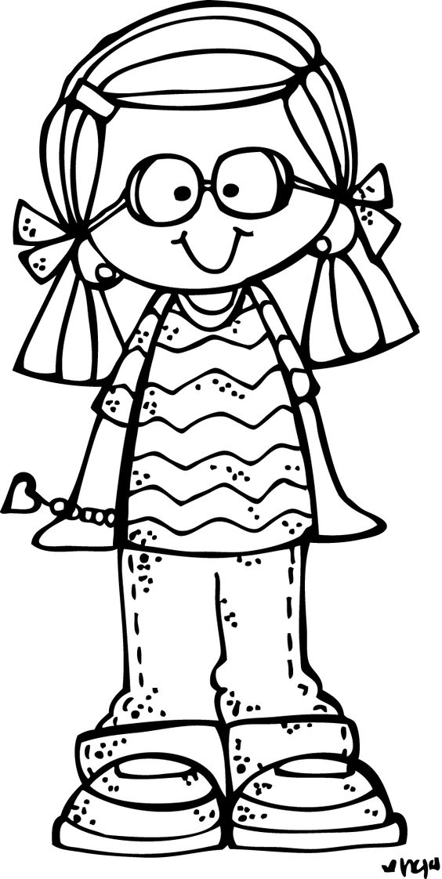
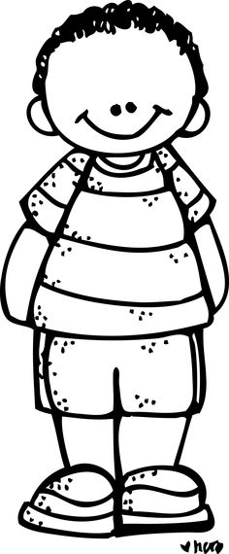

Ben Lisa Jana Jaco

  - Who is the tallest? _______________ (1)
  - Who is the shortest? ______________ (1)
  - _______ and ______ are the same length. (1)

4.2. Complete the months of the year. (3)
January, __________, March, April, __________,
June, July, ____________, September.

4.3. Look at the picture and decide when it is happening:
morning, afternoon or evening. (2)
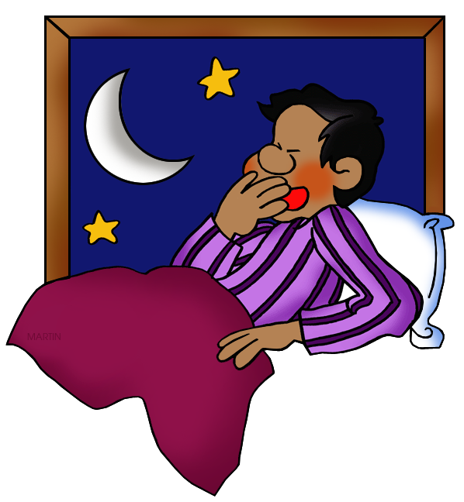
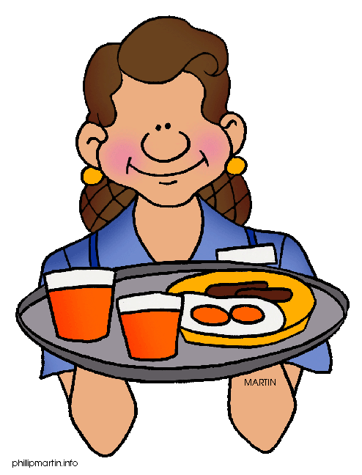

bedtime
morning
afternoon
evening

breakfast
morning
afternoon
evening

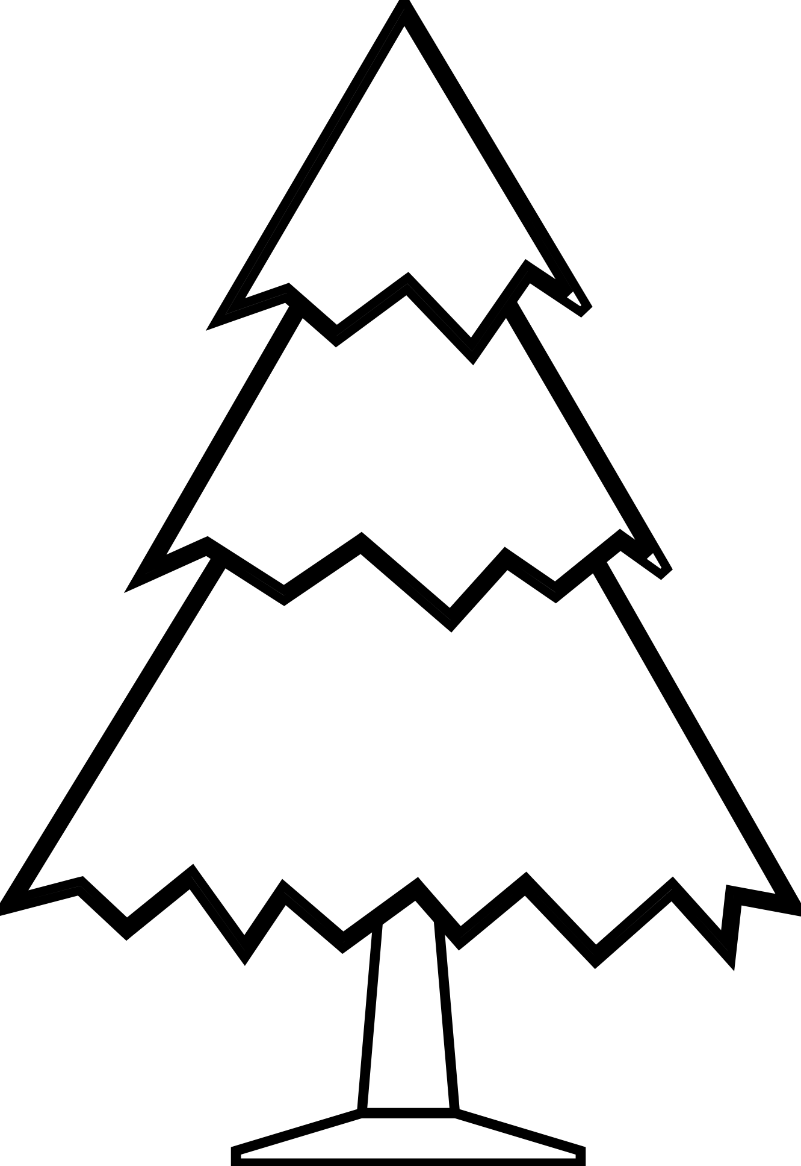
  - Fill in: longer, shorter or wider. (2)

is than



is than

4.5. Look at the pictures and write which one you think is heavier.
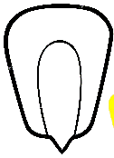
(2)
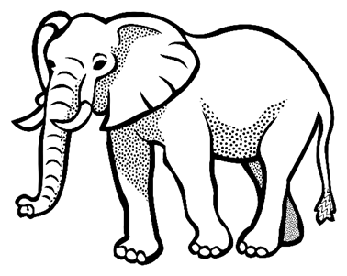
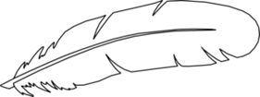
kernel
brick
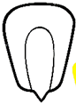

feather
elephant

kernel
kernel
Total Section 4: __ / 12
Processed mark Section 4 - (12 x ƒ = 6): __ / 6

Section 5: Data Handling
Sort the pictures by drawing them in the correct column in the table and answer the questions. (3)
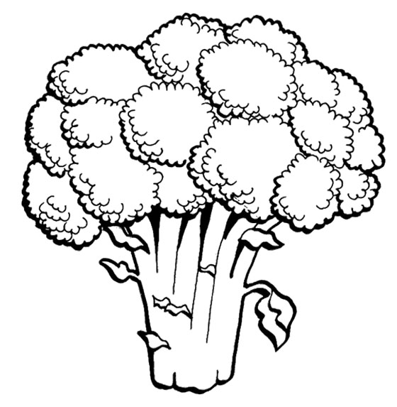
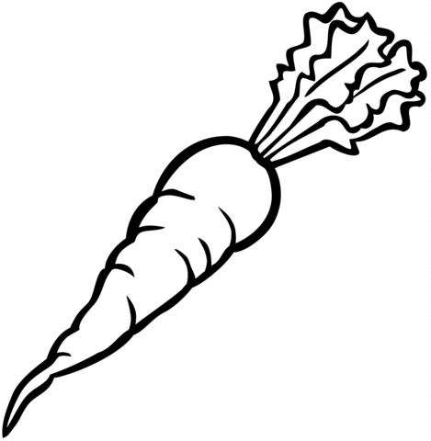
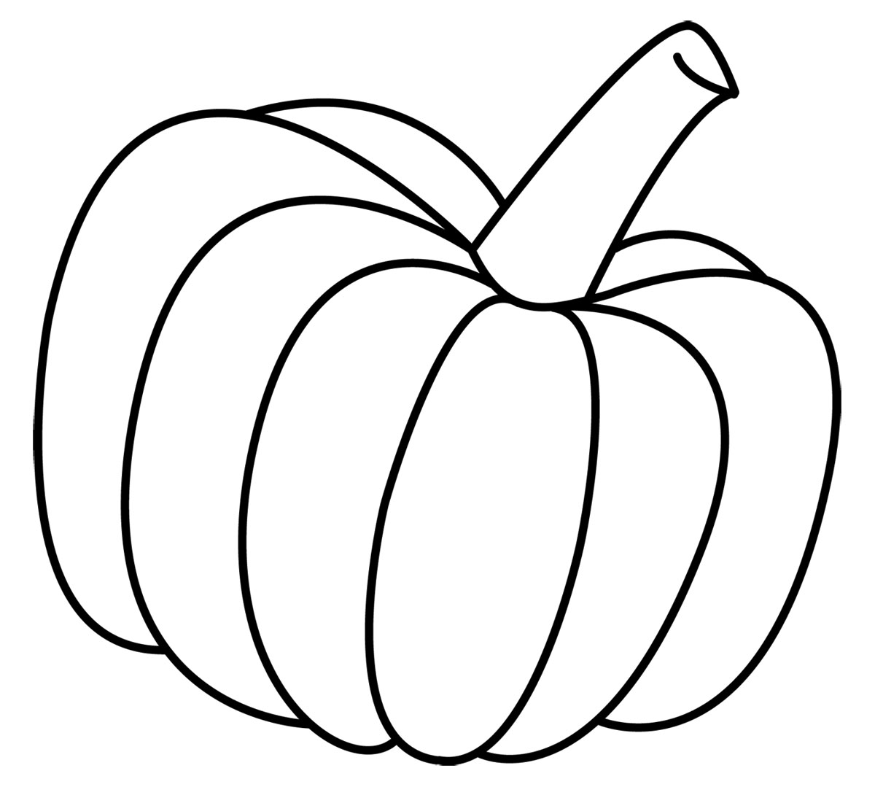
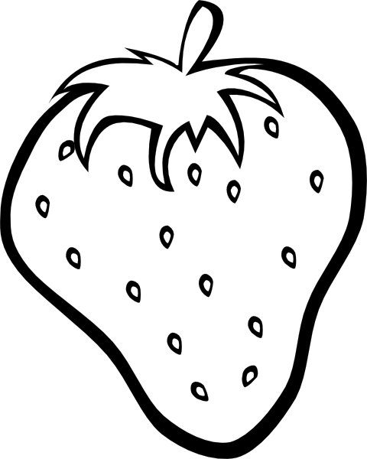

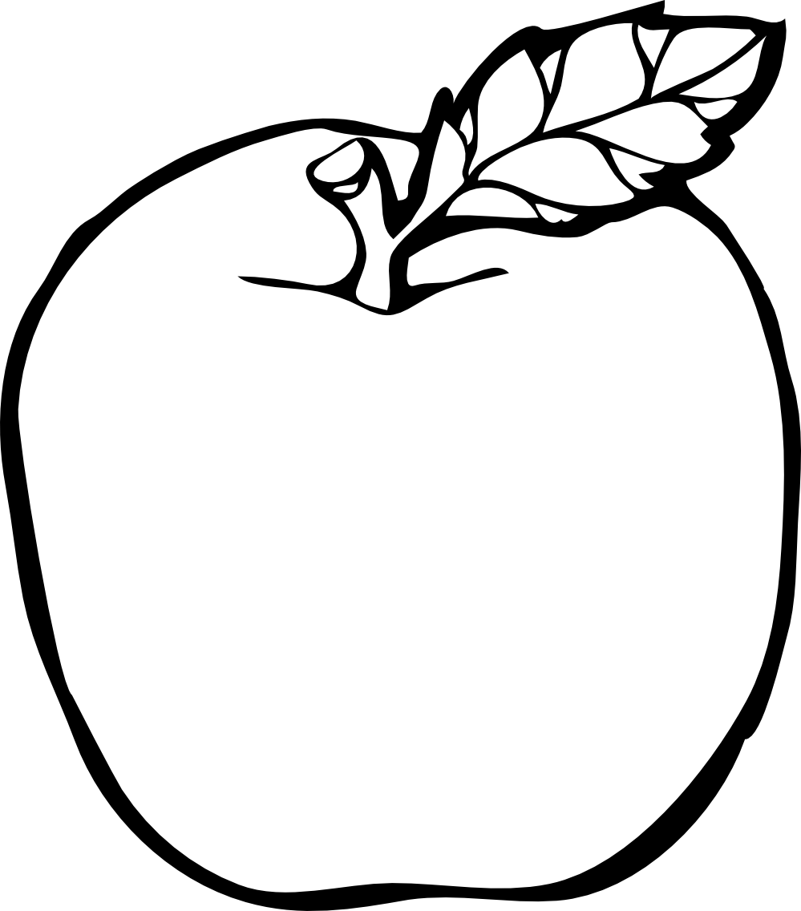
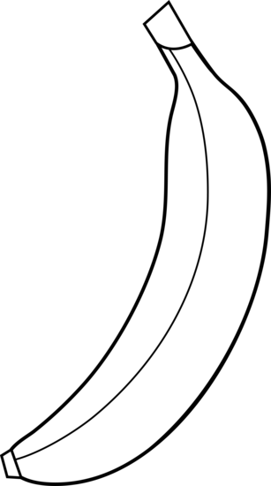

Vegetables | Fruits
ƒ | ƒ
(ƒ+ ƒ = 1)
- How many fruits are there? _____________________ (1)
- How many vegetables are there? ________________________ (1)
Total Section 5: __ / 3

