Mathematics
Assessment Task Term 1
Grade 1

Name and surname: ____________________________
Date: _________________________________

Task 1
MEMO

Section |  | Mark obtained
- Numbers, operations and relationships | 30
- Patterns, functions and algebra | 5
- Space and Shape | 6
- Measurement | 6
- Data Handling | 3
Total | 50

Section 1: Numbers, operations and relationships

  - Count how many apples are on each dice and write the number symbol and the number name. (8)
 | Number symbol | Number Name
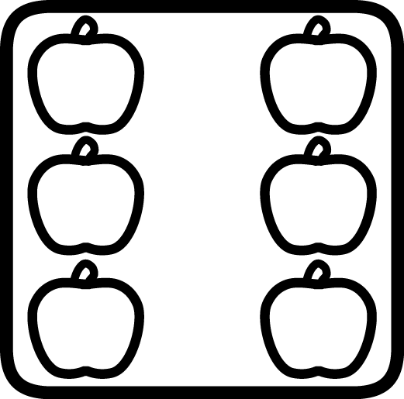 | 6 | six
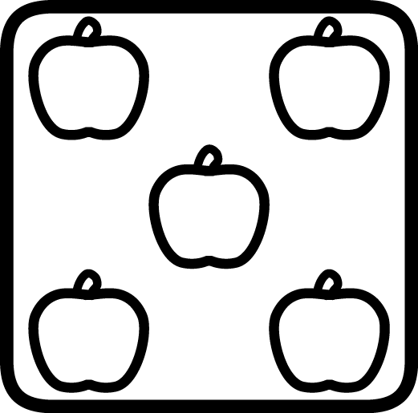 | 10 | ten
 | 5 | five
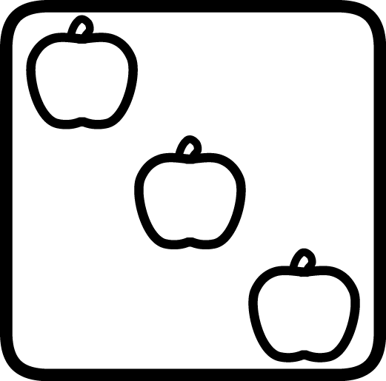 | 3 | three

Total: ___ / 8
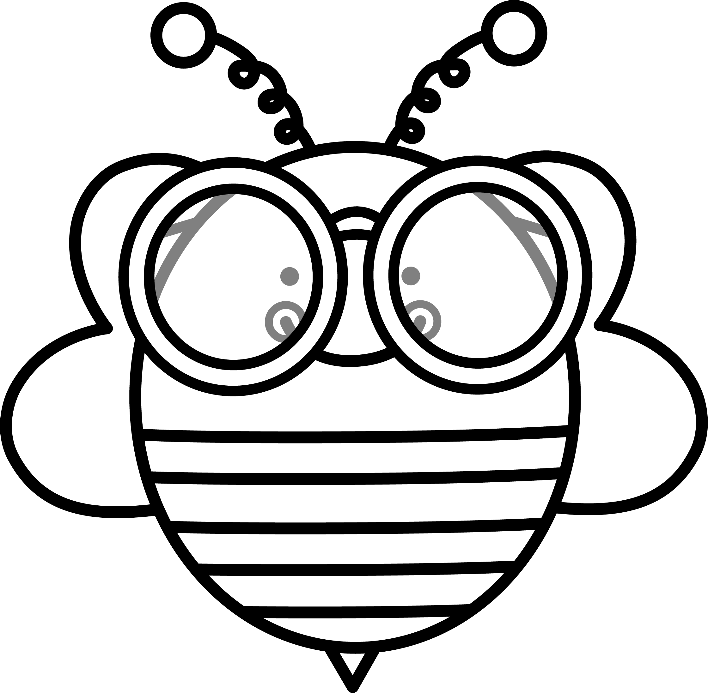
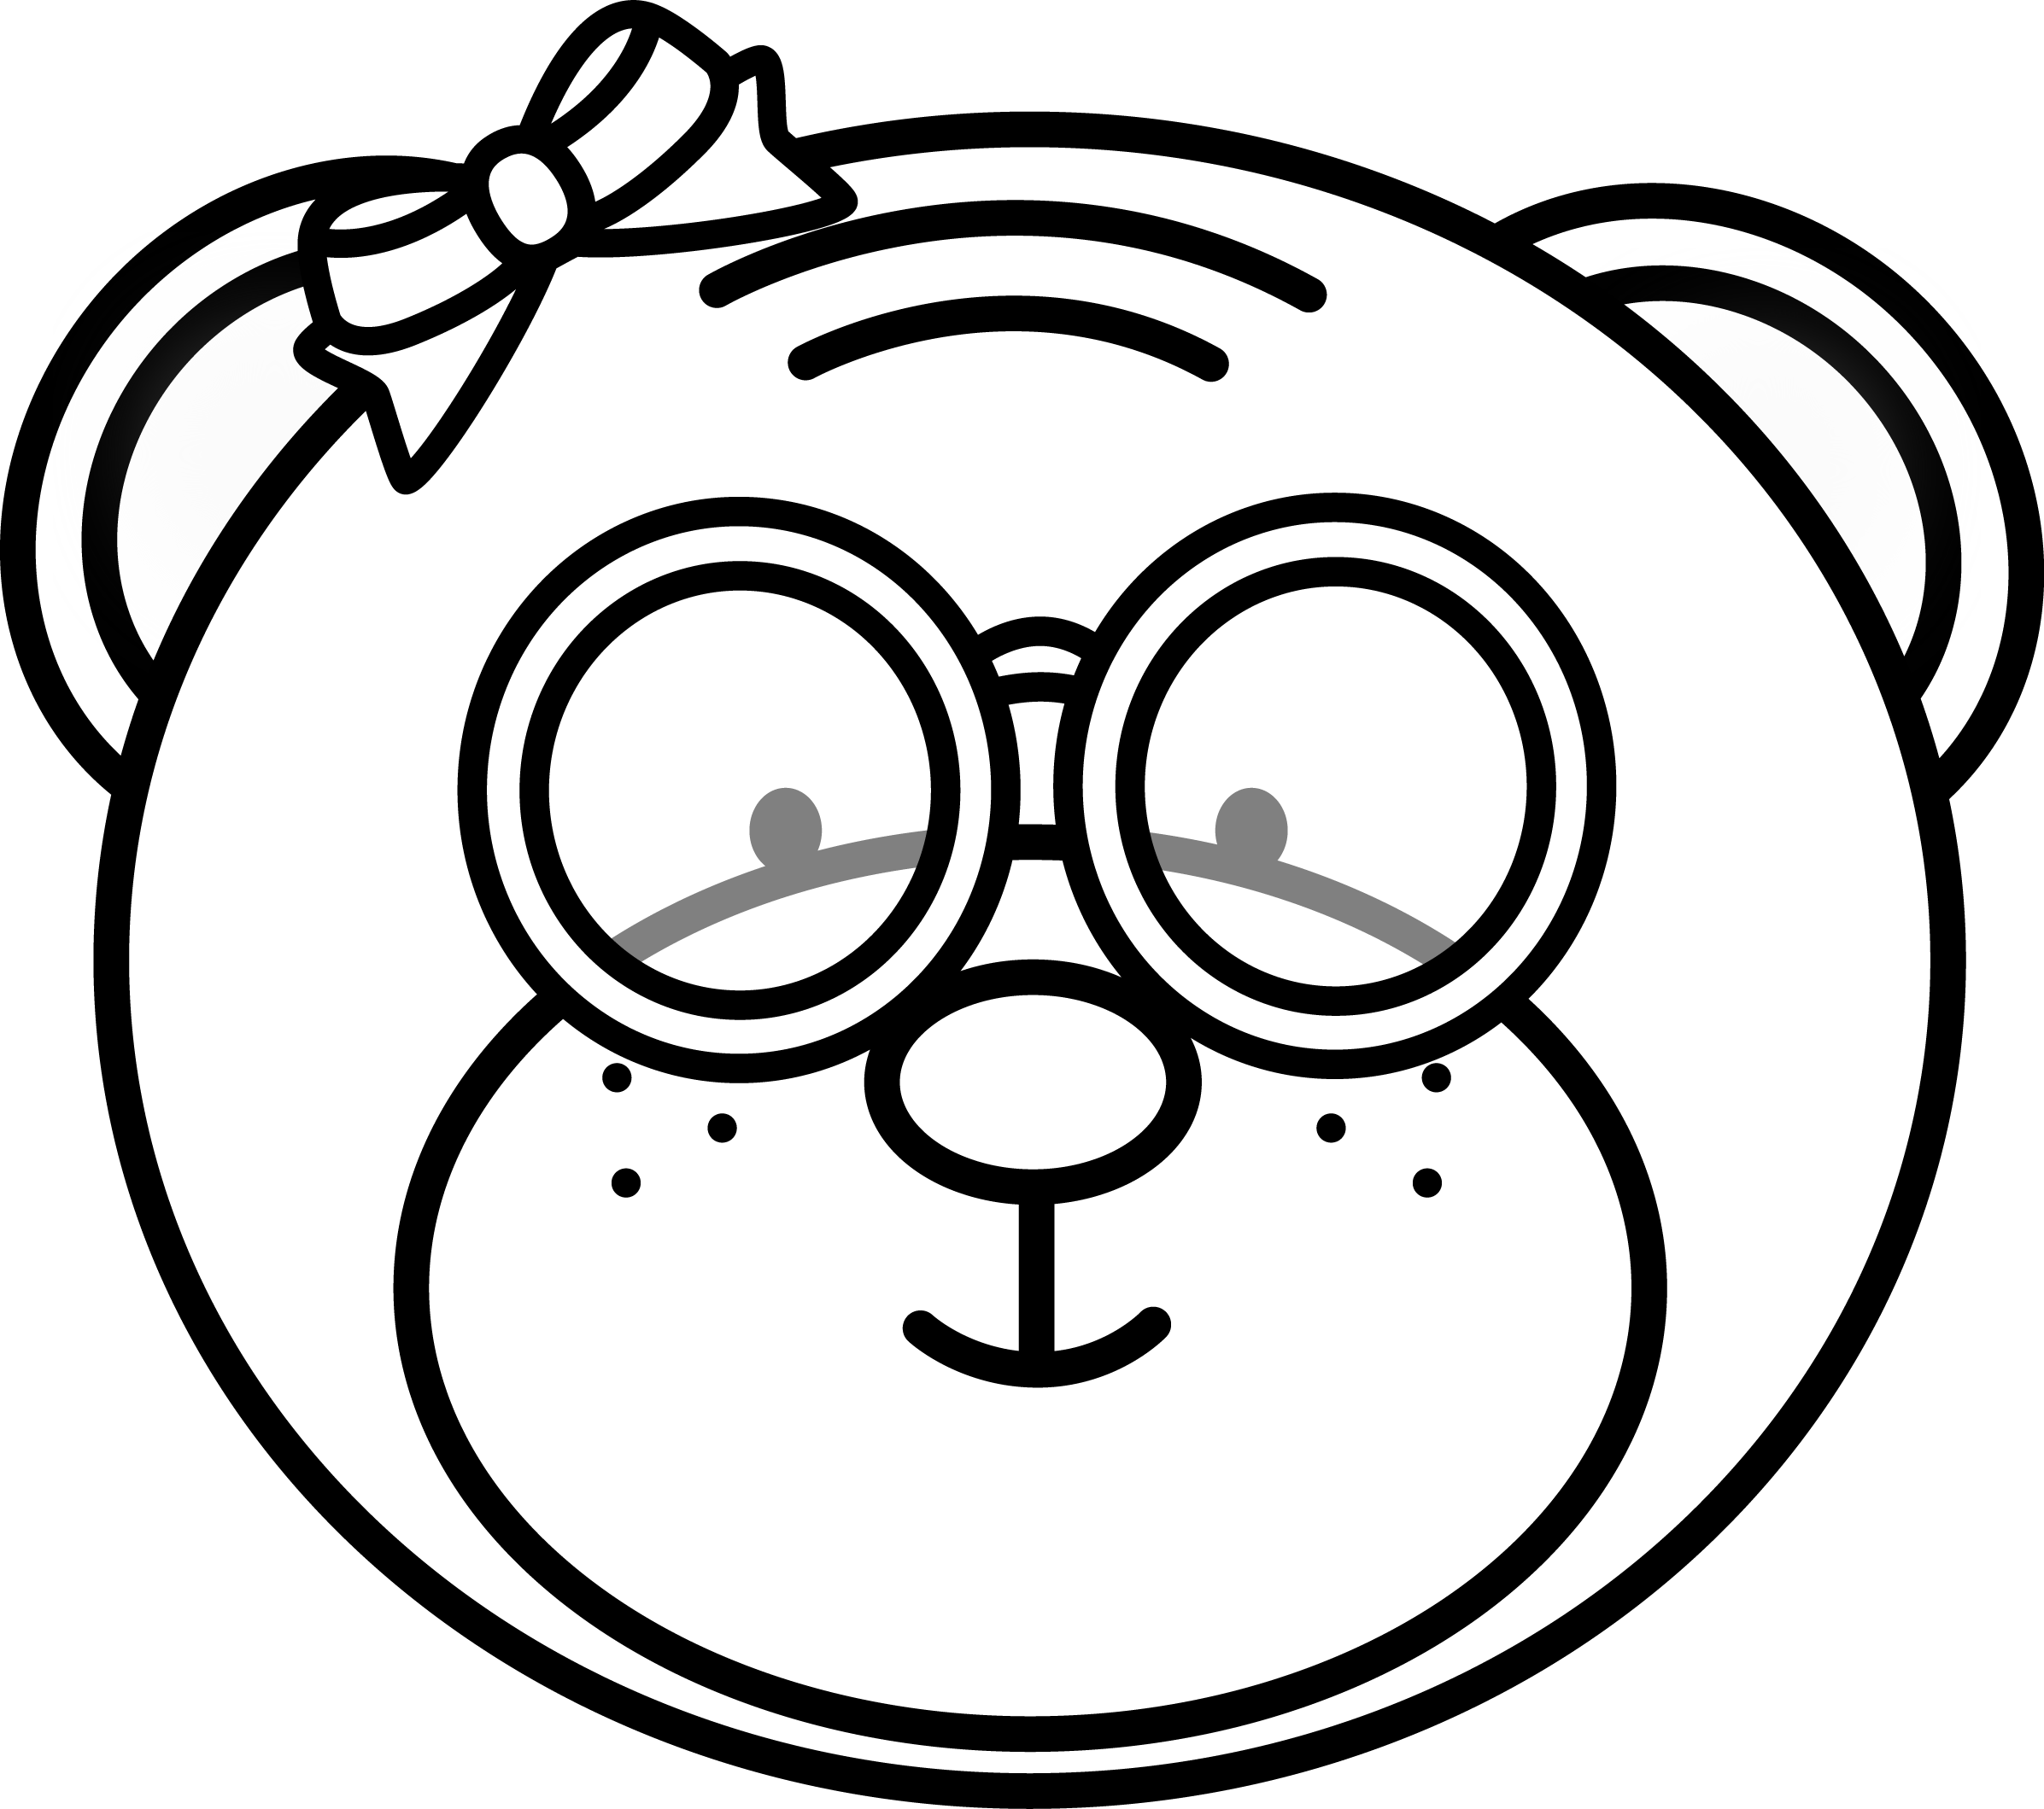
Make a √ ​​in the box with most bees.
Make a √ ​​in the box with the least bears.
√
√
Total: ___ / 2

  - Lisa's mother buys her 5 pencils for school. She lost three of the pencils. How many pencils does she have left? (1)

Lisa has 2 pencils left.

  - Jaco’s mother bakes 3 cupcakes for his birthday. His grandmother bakes another 2. How many cupcakes did they bake altogether? (1)
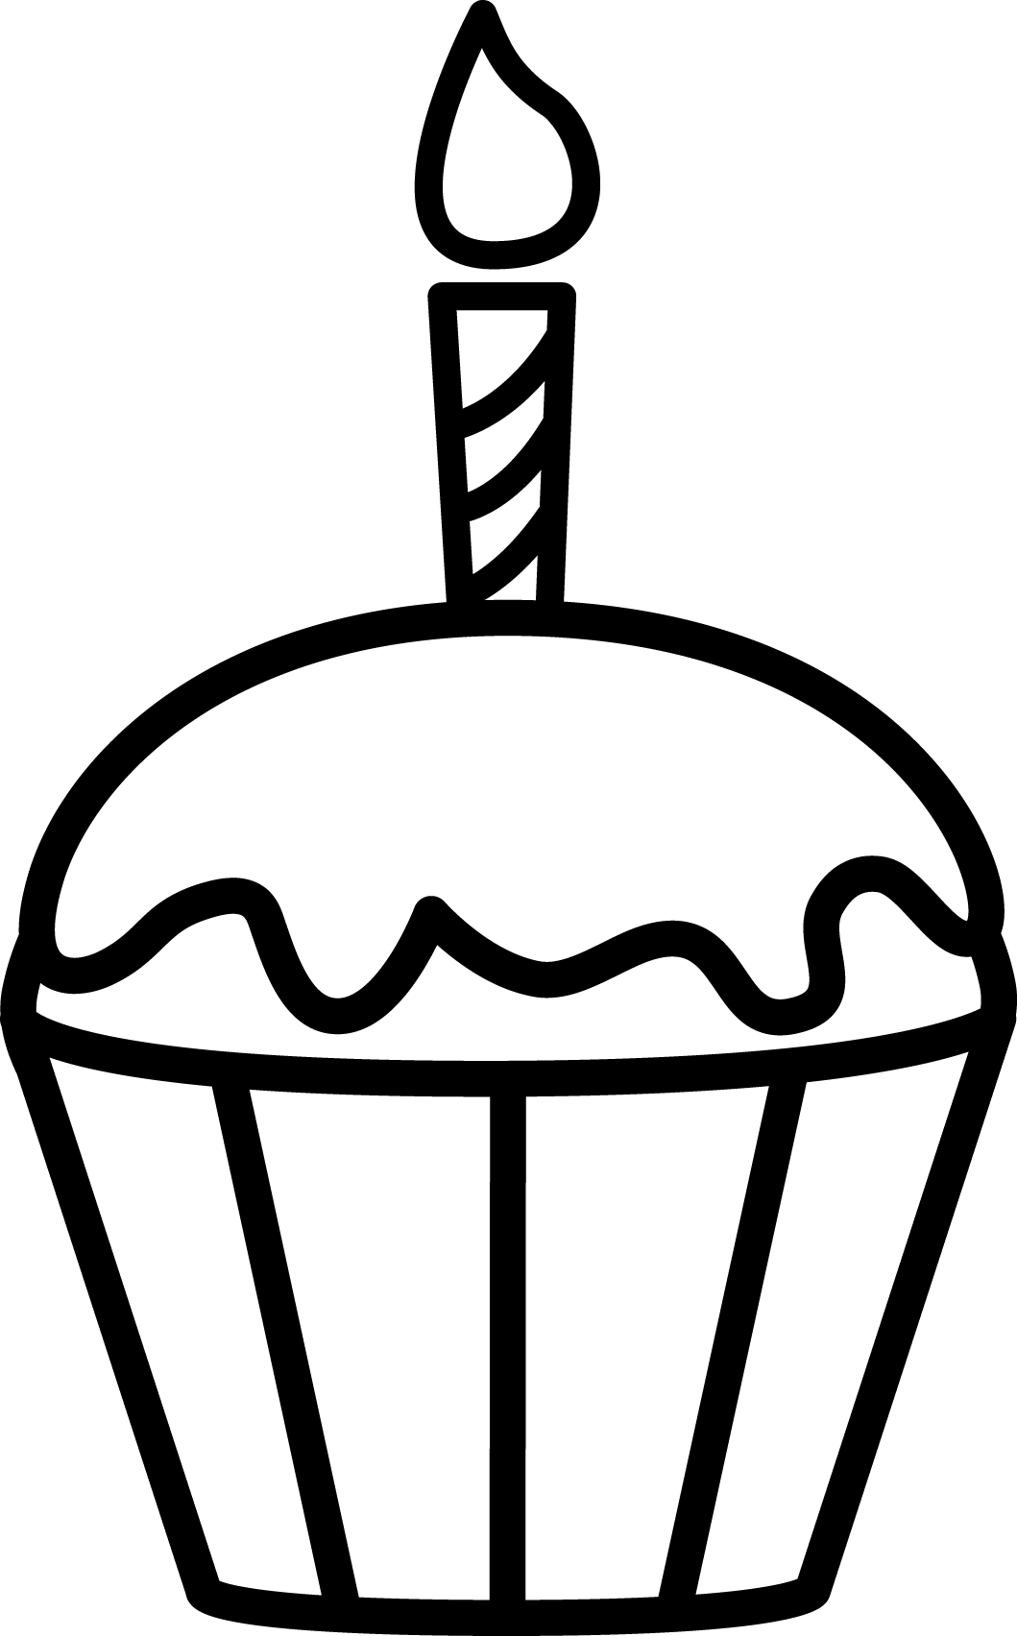

3 + 2 = 5 cupcakes.


  - Order the numbers in the heart from the smallest to largest by writing it on the line. (1)
5
3
1

1, 3, 5, 6, 9.
9
6
  - Order the numbers in the heart from the largest to smallest by writing it on the line. (1)
5
3
1
9
9, 6, 5, 3, 1.
6

  - There are 4 sweets. David and Gary want to divide the sweets equally so that everyone gets the same amount of sweets. Help them to divide it. (1)
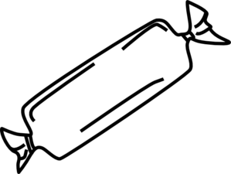

David and Gary each gets 2 sweets.

  - Complete the table. (8)
- Which number is less, 3 or 5? | 3
- Which number is more, 4 or 5? | 5
- What number comes before 2? | 1
- What number comes after 3? | 4
- The number between 1 and 3 | 2
- Which number is 2 more than 3? | 5
- What number is 1 less than 5? | 4
- Which number is 2 more than 2? | 4

Total Section 1: ___ / 23
___________________________________________________
Section 2: Patterns, Functions and Algebra

2.1. Expand the following patterns by drawing one more set. (2)

2.2. Complete the missing numbers on the number line. (3)

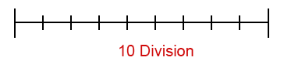
4
5

7

8

1 2 3 6 9 10
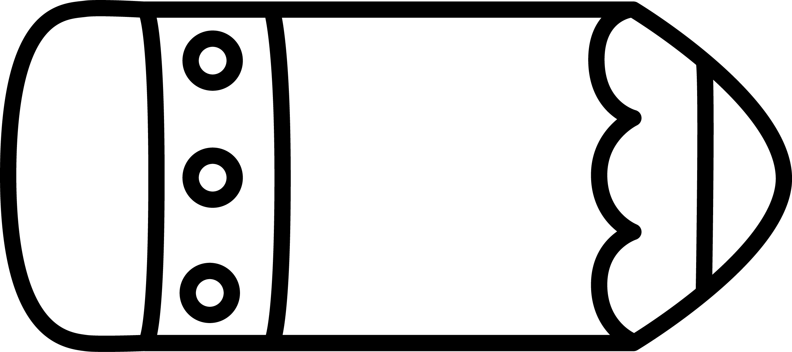
5 6 8 10
7
9

10 9 7 4 3
8

6

5

2

1

Total Section 2: ___ / 5
Section 3: Space and Shape

3.1 Draw a ball under the table and then draw a bowl of fruit
on top of the table. (2)
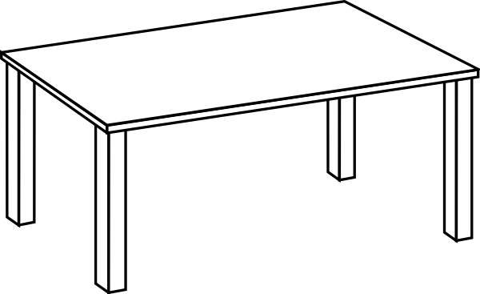
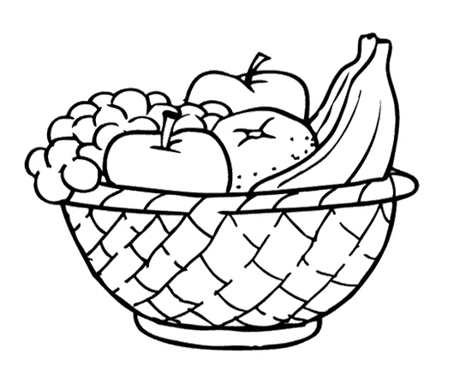

Total: ___ / 2



  - The following items shaped like a ball or a box? (ƒ × 2 = 1)
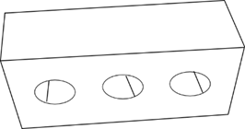

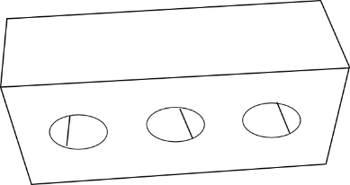

box
ball

box
ball

full
empty

  - Count the shapes and write the amount in the blocks. (3)
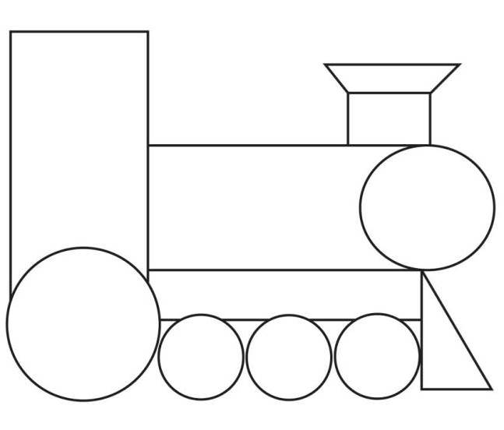

Shape | Amount
rectangle | 5
triangle | 2
circle | 5

Total Section 3: ___ / 6
Section 4: Measurement

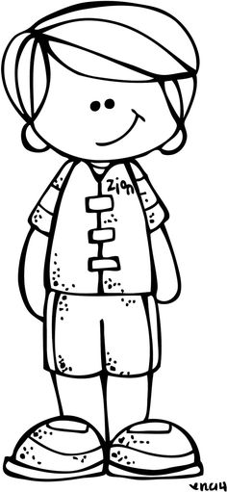
4.1. Answer the questions about the picture. (3)
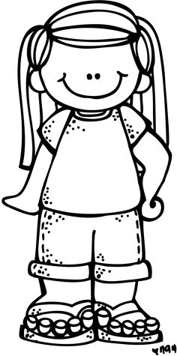
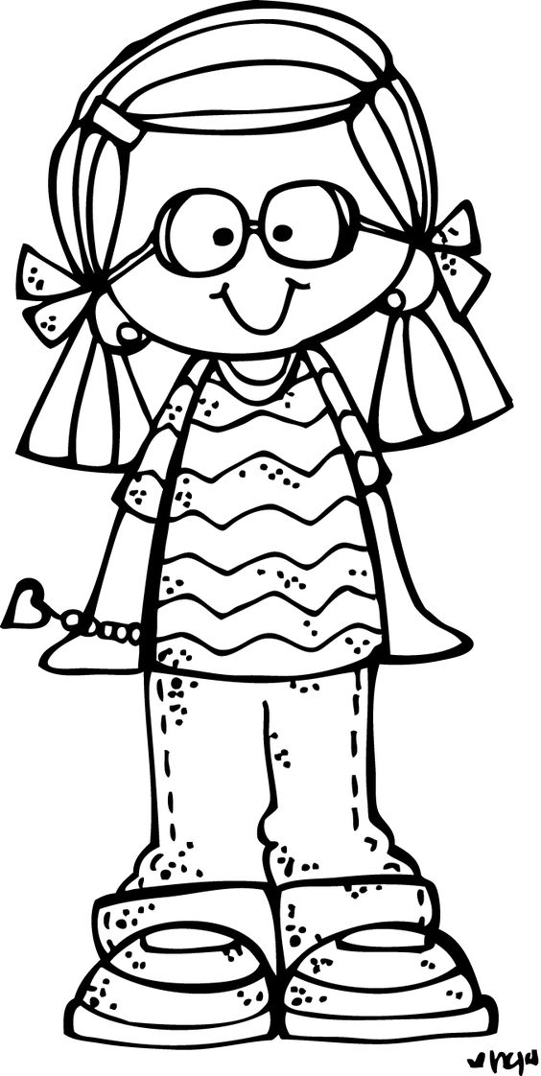
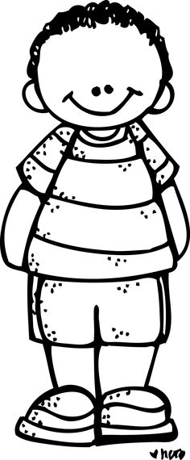

Ben Lisa Jana Jaco

  - Who is the tallest? Jaco (1)
  - Who is the shortest? Ben (1)
  - Lisa and Jana are the same length. (1)

4.2. Complete the months of the year. (3)
January, February, March, April, May, June, July, August,
September.

4.3. Look at the picture and decide when it is happening:
morning, afternoon or evening. (2)
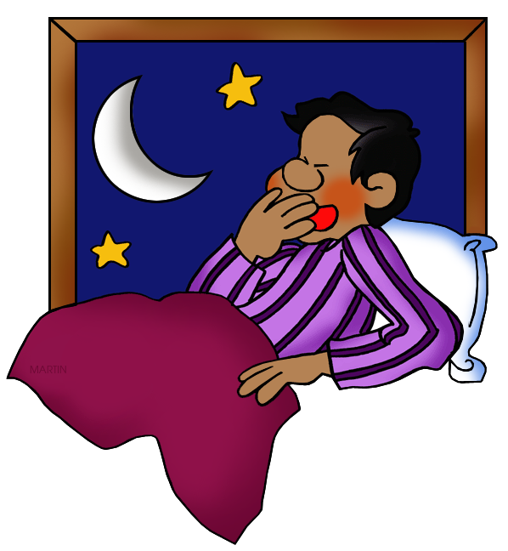
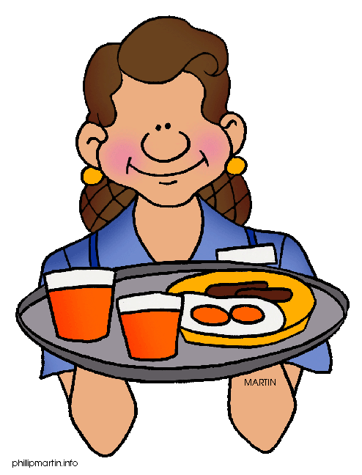

bedtime
morning
afternoon
evening

breakfast
morning
afternoon
evening

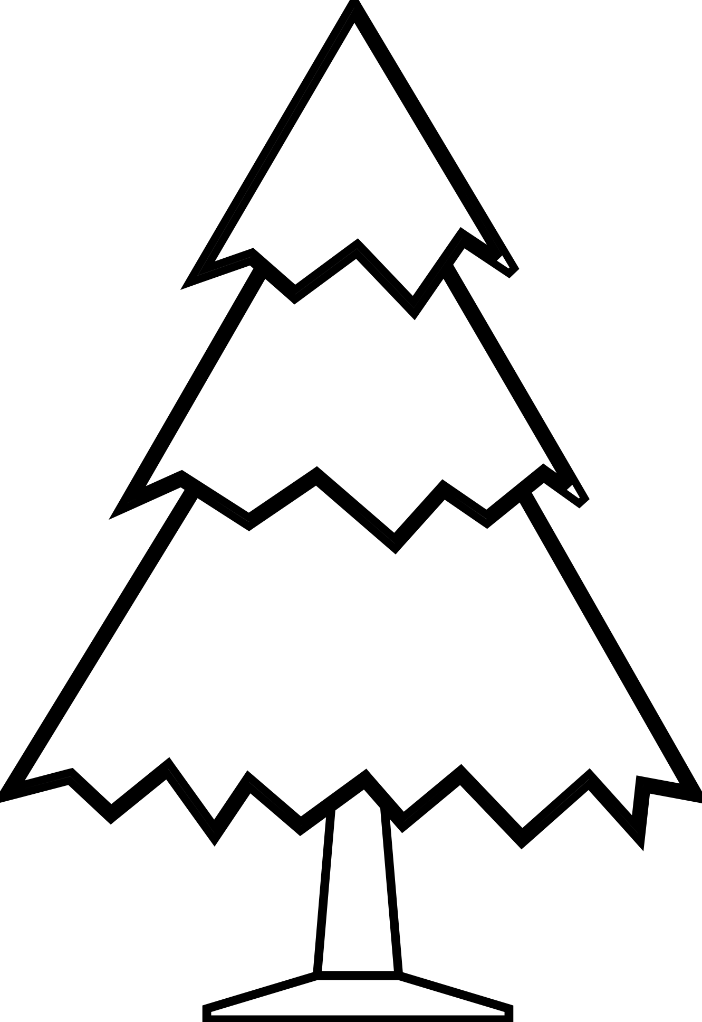
  - Fill in: longer, shorter or wider. (2)
wider
is than


taller
is than

4.5. Look at the pictures and write which one you think is heavier.
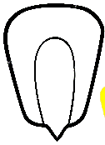
(2)
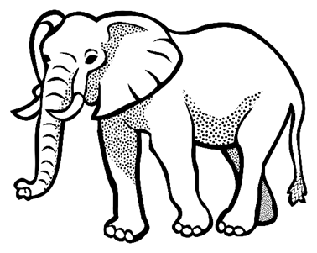
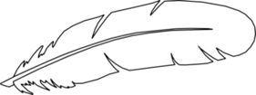
kernel
brick
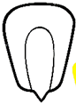

feather
elephant
elephant
kernel

kernel
kernel
Total Section 4: __ / 12
Processed mark Section 4 - (12 x ƒ = 6): __ / 6

Section 5: Data Handling
Sort the pictures by drawing them in the correct column in the table and answer the questions. (3)
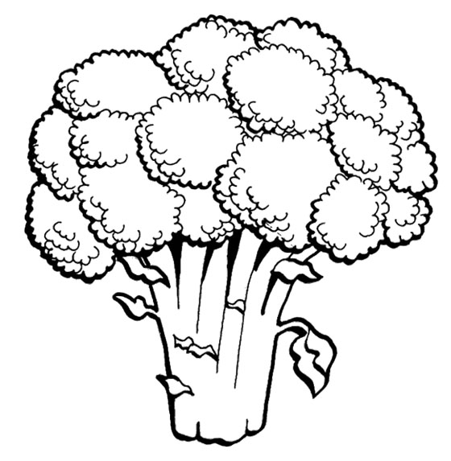
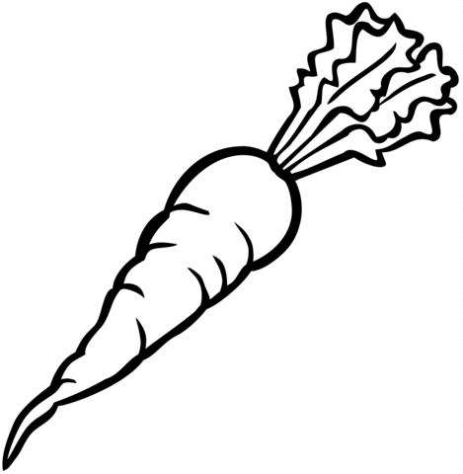
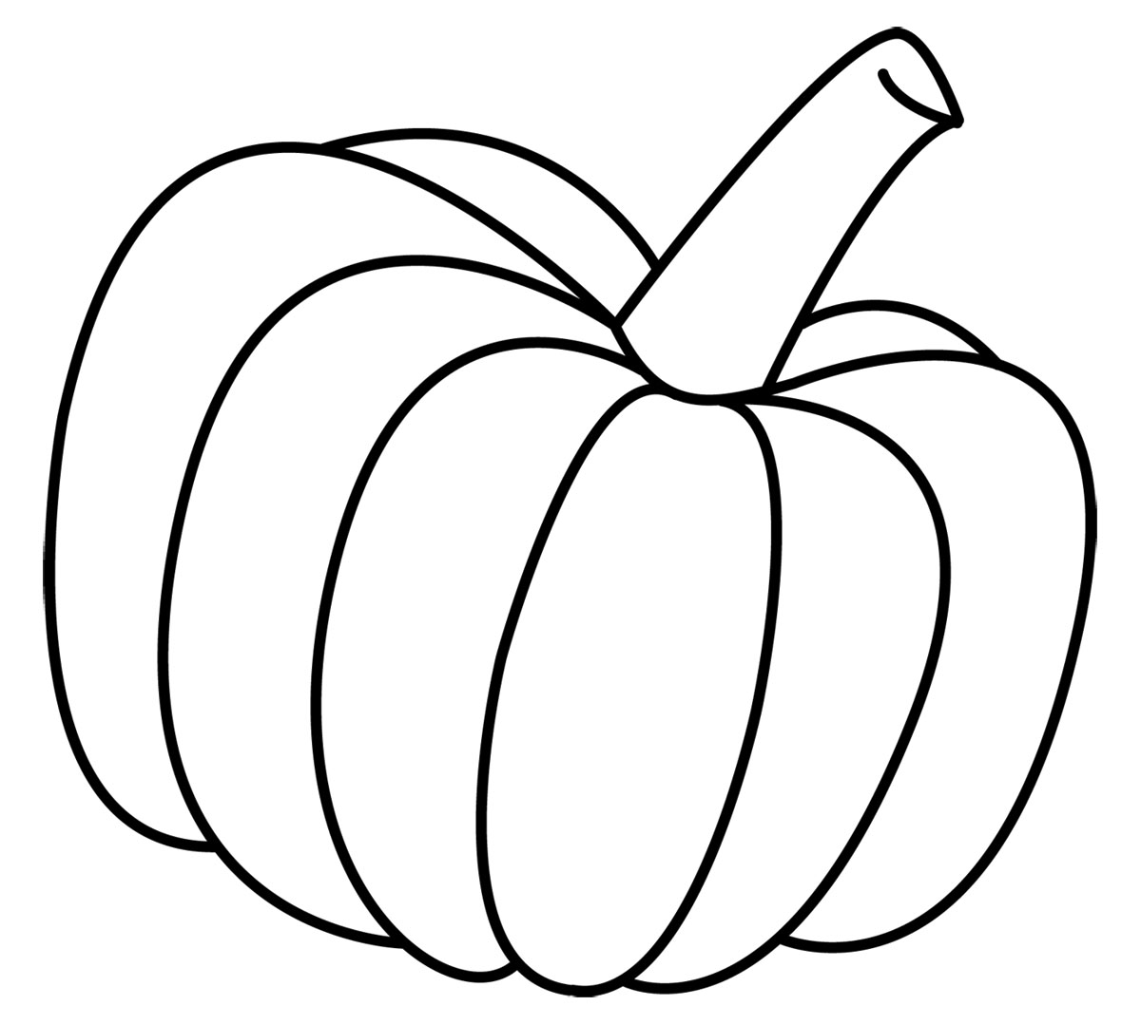
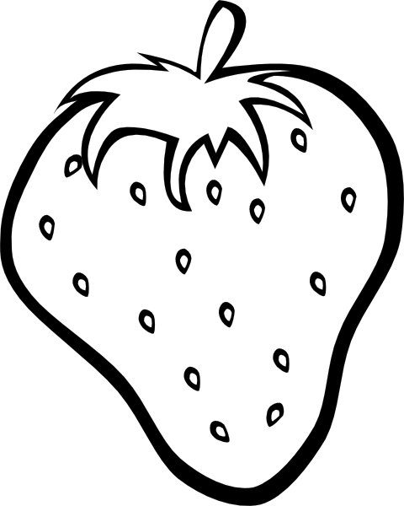

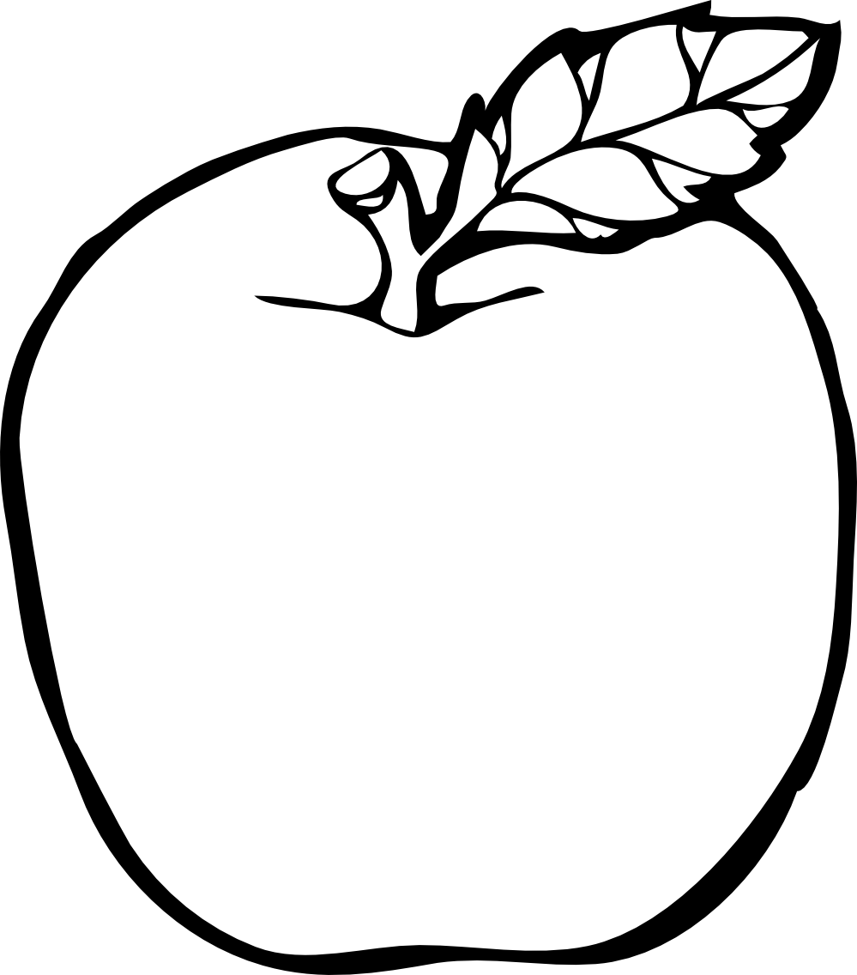
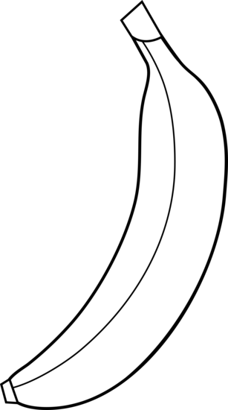

Vegetables | Fruits
ƒ | ƒ
(ƒ+ ƒ = 1)
- How many fruits are there? There are 3 fruits. (1)
- How many vegetables are there? There are 3 vegetables. (1)
Total Section 5: __ / 3

