**Life Skills**

**Assessment Task Term 4**

**Grade 1**

**Name and surname: ____________________________**

**Date: _________________________________**

|  |  |  |
| --- | --- | --- |
| **Sections** |  | Mark obtained |
| 1. Beginning Knowledge and Personal and Social Welfare | **45** |  |
| 1. Creative Arts | **35** |  |
| 1. Physical education | **20** |  |
| **Total** | **100** |  |

**Section 1**

**Beginning Knowledge and Personal and Social Well-being**

**Points: 45**

**Question 1: Houses**

* 1. 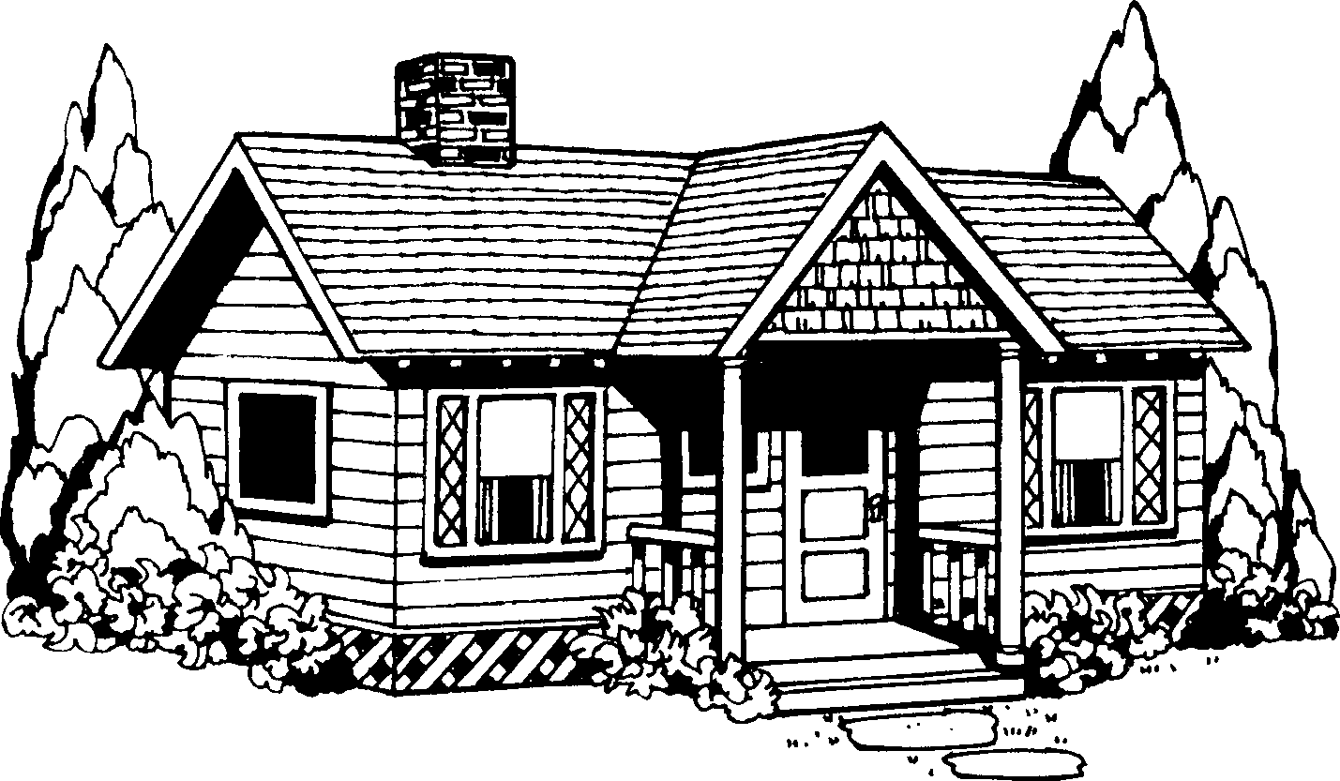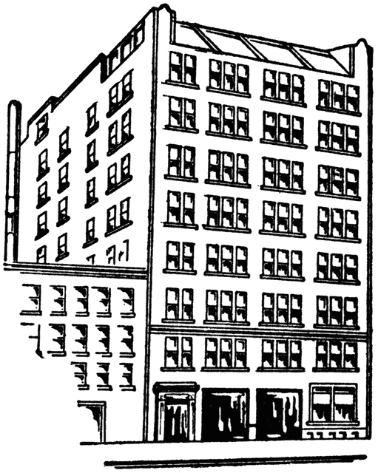Look at the different houses and name them. (4)

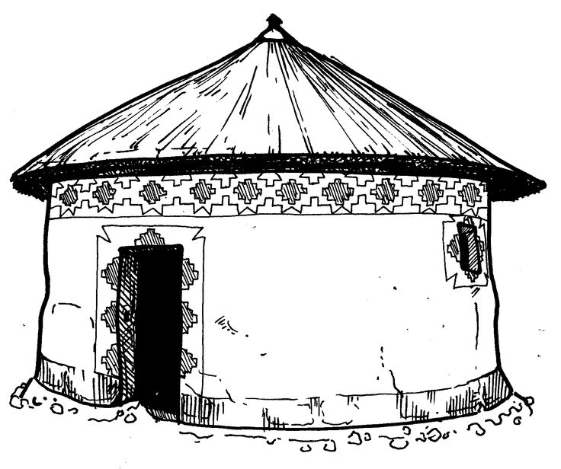

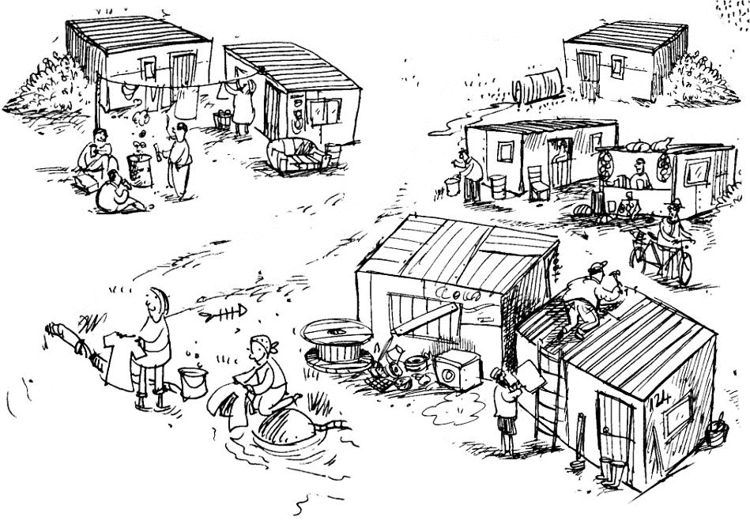

* 1. 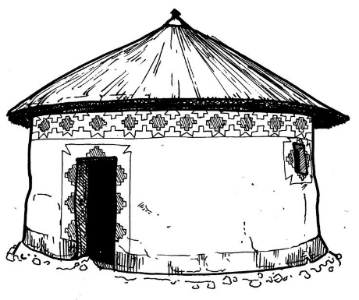Connect every home with the type of materials with which it is built in the block. Draw a line with a ruler. (4)

|  |
| --- |
| iron plates |

|  |  |
| --- | --- |
| bricks | glass |
| cement | iron |

|  |  |
| --- | --- |
| tiles | bricks |
| iron | cement |

|  |  |
| --- | --- |
| clay or mud | straw |



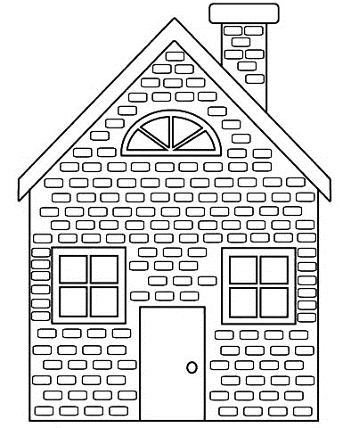



* 1. Are the following statements true or false? Complete the table. (3)

|  |  |
| --- | --- |
| Statement | True or false |
| 1. Houses protect us from weather conditions such as heat, cold, hail, rain and wind. |  |
| 1. The weaker a house is built,   the more protection it offers. |  |
| 1. Strong winds and rainstorms can damage houses. |  |

Question 2: Picture maps

Answer the following questions:

* 1. With what does street maps help us?

____________________________________________ (1)

* 1. Name three things farmers look for on picture maps. (3)

__________________

__________________

__________________

* 1. Look at the picture map of the town and answer the questions.

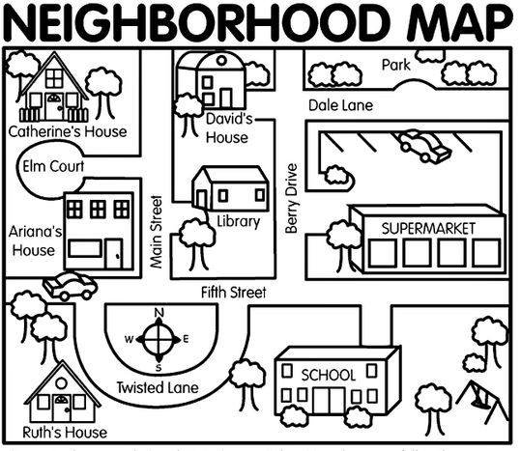

School

park

Image result for pedestrian crossing clipart black and white

Wilger Street

Mary’s home

Ben’s home

Boekenhout

crescent

Gumtree Street

Jacaranda Street

Library

Teacher Gouws’s home

SUPERMARKET

Vlamboom Street

park

Sering avenue

David’s house

* + 1. Where will you find books to read? _______________ (1)
    2. Where can you buy food? _______________ (1)
    3. Whose house is left from the library?______________(1)
    4. Where is it save to play for children? (1)

___________________

* + 1. Out of which road do you turn right to the school? (1)

___________________

* + 1. Where can Mary cross the rod safely and why?

_______________________________________________________________________________________(2)

Question 3: Water

* 1. We use water every day. Write 5 uses of water. (5)

1. _______________________________________
2. _______________________________________
3. _______________________________________
4. _______________________________________
5. _______________________________________

3.2. Look at the pictures. Tick ​​(√) For each operation that helps

to save water and a cross (X) in the box when someone is

wasting water. (6 x = 3)

|  |  |
| --- | --- |
|  |  |
|  |  |
|  |  |

* 1. Name three ways we can clean our water so that it is save to drink. (3)

1. ______________________________________________________________________________________
2. ______________________________________________________________________________________
3. ______________________________________________________________________________________

Question 4: The sky at night

* 1. Are the following statements true or false? Complete the table. (5)

|  |  |
| --- | --- |
| Statement | True or false |
| 1. The sun provides light and cold. |  |
| 1. The moon is out of rock and radiates heat. |  |
| 1. We can see the moon in the day sometimes. |  |
| 1. The planet Saturn has rings around him. |  |
| 1. The nights are warmer than the days. |  |

* 1. What is the sun?

___________________________________________________________________________________________(2)

* 1. Give one word for the following descriptions. Choose a word from the box. (4)

|  |  |  |  |  |  |
| --- | --- | --- | --- | --- | --- |
| solar system | Mercury | sun | astronaut | Neptune | star |

1. Glowing ball gases. _________________ (1)
2. The nearest star to Earth. ________________ (1)
3. The people traveling with special spacecraft into space to find out more about the stars. _________________ (1)
4. The sun and all the planets are called the _______________ (1)
5. The planet the farthest from the sun. ____________ (1)
6. The planet closest to the sun. ________ (1)

**Total Section 1: ___ / 45**

**___________________________________________________**

**Section 2**

**Creative Arts- Entertainment + Visual Arts**

**Points: 35**

**Question 1:**

Performing Arts - Improvise and interpret

Assignment:

Practice the poem and come dramatize the poem to the class.

Keep the following in mind:

Build, build your brand new house!

Bring bricks, measure that wall,

Hit that nail, turn that screw –

Give shelter from the sun.

Build, build your brand new house!

Bring sand and doors and tiles,

Bring water, mix cement –

Give shelter from the rain.

* You must use movements.
* You must use facial expressions.
* You should vary your tone.
* Present your poem with self-confidence and enjoy!
* 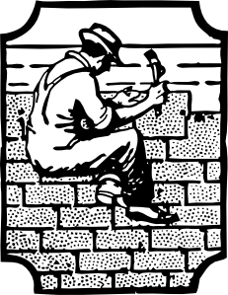You will be marked according to a rubric.

|  |  |  |  |  |  |  |
| --- | --- | --- | --- | --- | --- | --- |
|  | **Rubric - Presentation of poem** | **Mark** | | | | |
|  |  | **5** | **4** | **3** | **2** | **1** |
| 1. | Uses appropriate intonation and volume. | 5 | 4 | 3 | 2 | 1 |
| 2. | Pronunciation: Words are pronounced clearly and correctly, | 5 | 4 | 3 | 2 | 1 |
| 3. | Facial expression and eye contact are used to enliven the poem. | 5 | 4 | 3 | 2 | 1 |
| 4. | Body language and movements -Learner carry the poem with self-confidence and make use of movements. | 5 | 4 | 3 | 2 | 1 |
| **Total** | | **/ 20** | | | | |

**Question 2:** visual Arts - 2D designs

Assignment:

Create a 2D artwork by painting or drawing a picture of space. Your image should be colorful and creative. Recall what you learned in class about space to assist you with your artwork.

You will be assessed according to the following rubric:

|  |  |  |
| --- | --- | --- |
| **Rubric - Visual Arts** |  |  |
| 1. The student's artwork is colorful. | **5** |  |
| 1. The learner has portrayed space in his / her picture and the picture shows the learner's knowledge and understanding of space. | **5** |  |
| 1. Was the learner creative? | **5** |  |
| **Total** | **15** |  |

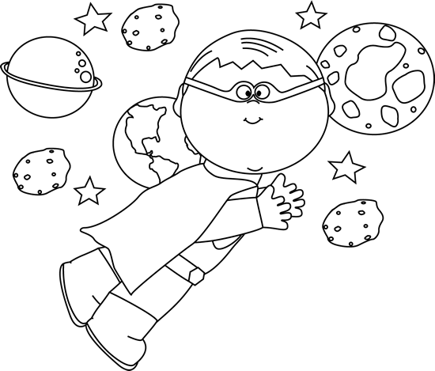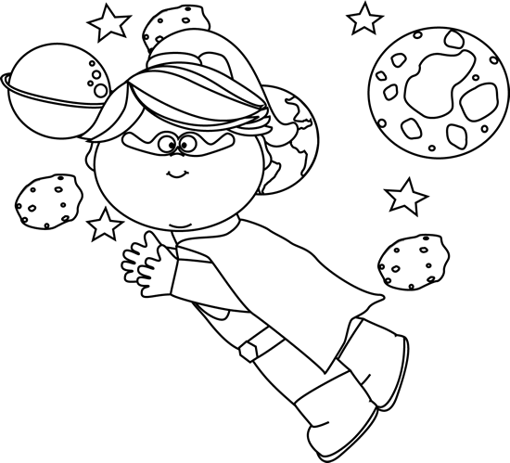

**Section 3**

**Physical education**

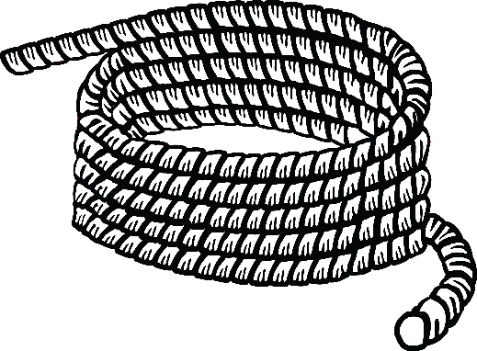**Points: 20**

Purpose of activity: Balance

Resources:

* Rope - Each child needs his own rope.

Teacher takes students out, each has its own rope. The teachers give the students the following instructions:

1. Find yourself a big enough space, a distance from your partner.
2. 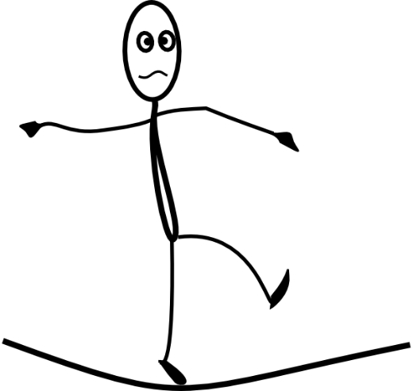Place a long rope in the form of a shape on the floor, such as a circle, square, triangle, and so on.
3. Walk on your toes forward on the rope.
4. Walk on your heels backwards on the rope.
5. Walk forward on the rope with your hands on your head.
6. Walk backwards onto the rope with your hands behind your back.
7. Walk sideways on the rope with your hands on your hips.

|  |  |  |
| --- | --- | --- |
| **Rubric - Physical education** |  |  |
| 1. Learner is able to walk forward on their toes on the rope. | **4** |  |
| 1. Learner is able to walk backwards on his heels on the rope. | **4** |  |
| 1. Learner is able to walk forward on the rope with their hands on their head. | **4** |  |
| 1. Learner is able to walk backward on the rope with their hands behind their backs. | **4** |  |
| 1. The learner is able to walk sideways on the rope with their hands on their hips. | **4** |  |
| **Total** | **20** |  |