Life Skills
Assessment Task Term 1
Grade 1

Name and surname: ____________________________
Date: _________________________________

Task 1
MEMO

Section
- Beginning Knowledge | 7
- Personal and Social Well-being | 23
- Creative Arts | 6
- Physical education | 10
Total | 46

Section 1
Beginning Knowledge
Points: 7

  - Me - Personal information

My name is: __________________________
My surname is: ____________________________
I am _____________ years old.
There are ________ people in my family.
girl | boy

I am a

I know my address
yes | no

yes | no

I know my telephone number

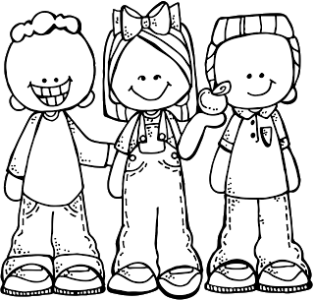
Total Section 1.1. : ___ / 7

This question is the learners
own answer.
answers.

  - We are all different
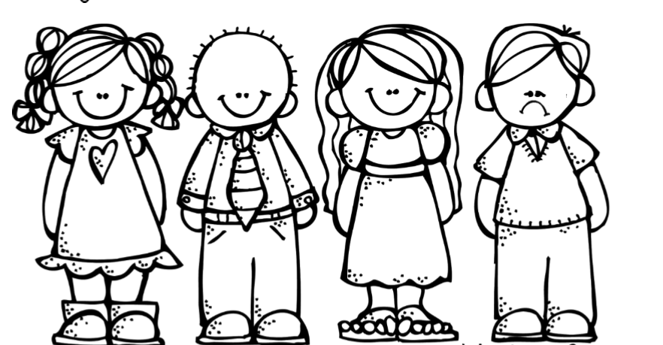
  - Look at the picture and say whether the statement is true or false by coloring in the block.

Statement | True | False
- All the children in the picture are boys. | true | false
- Everyone has two arms. | true | false
- Everyone has two eyes. | true | false
- Both boys have a tie on. | true | false
- Both girls have a dress on. | true | false
- All the children are happy. | true | false
- The girls hair looks the same. | true | false

Total 1.2. : ___ / 7
Total Section 1 (1.1. + 1.2.): ____ / 14
Processed mark Section 1 (14 x ƒ = 7): ___ / 7
Section 2
Personal and Social Well-being
Points: 23

2.1. At school

Look at the words in the boxes and write it under the
correct picture.
classroom
playground
office

toilet
secretary

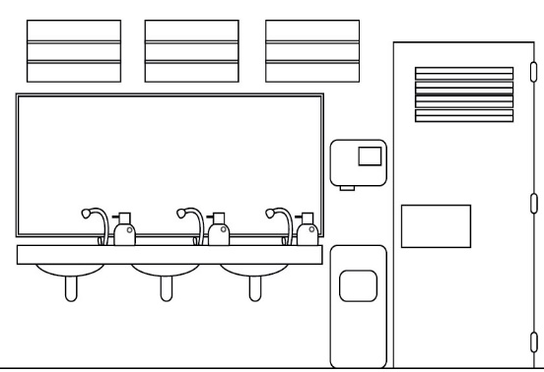
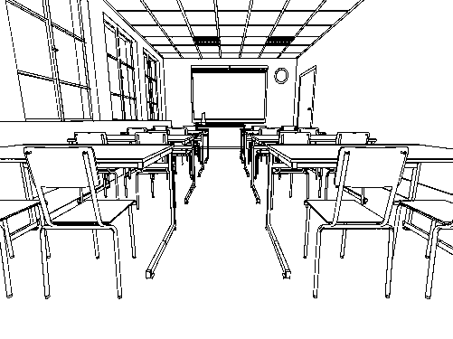
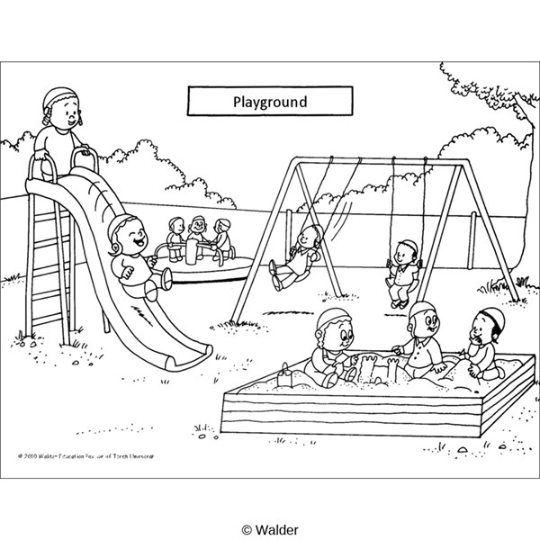

classroom
toilet
playground

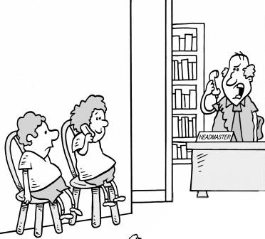
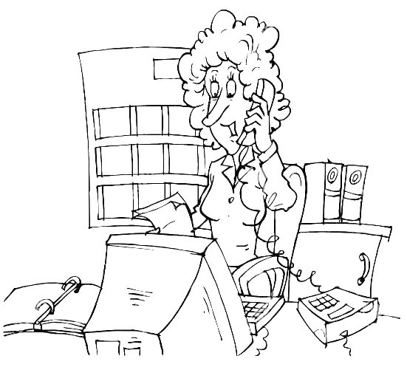

Total: ______ / 7
secretary
office
2.2. Healthy habits


- Color in the for healthy food and the for unhealthy food. (7)
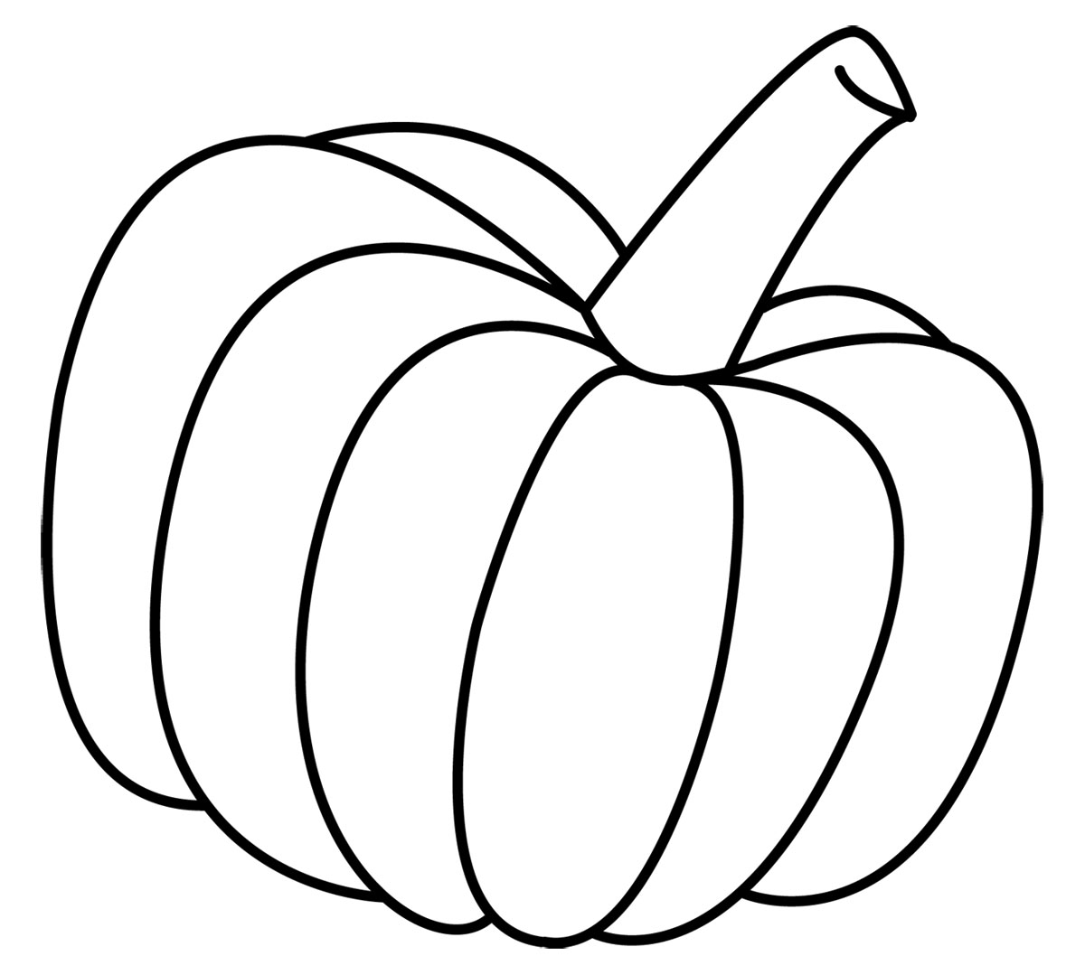

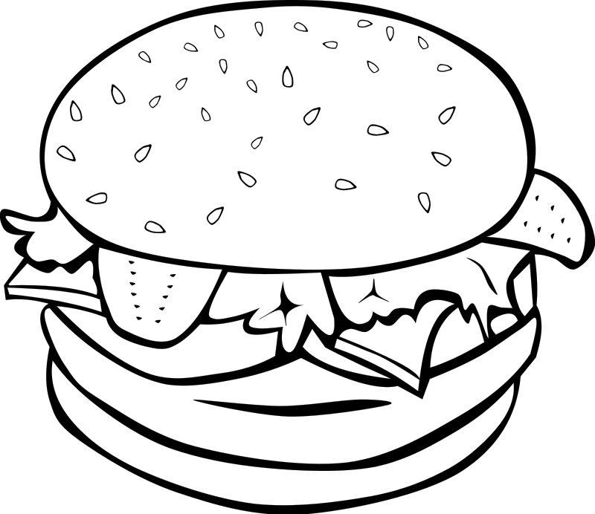

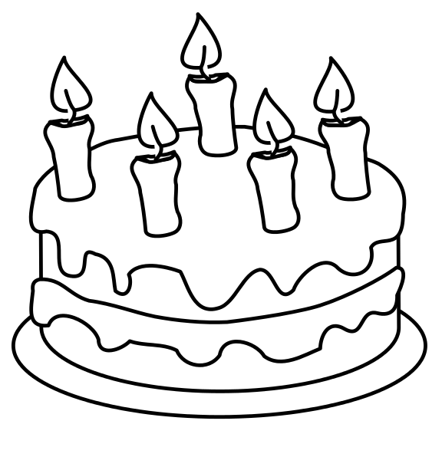

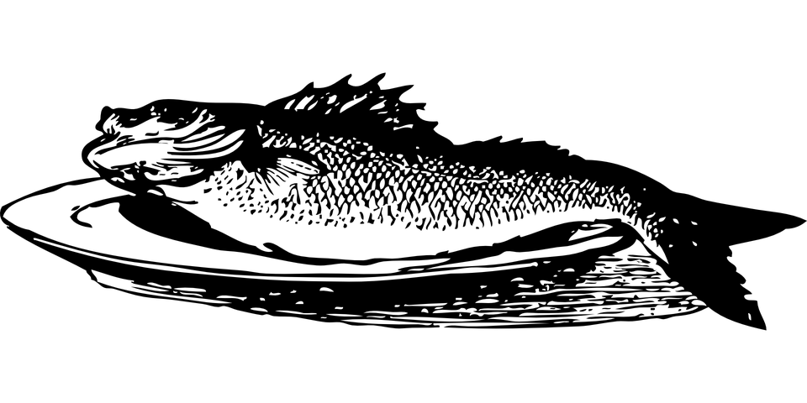

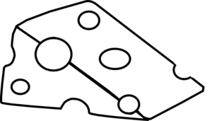

Total: __ / 7

- Look at the pictures in the block and color in all the pictures we use to keep ourselves clean.
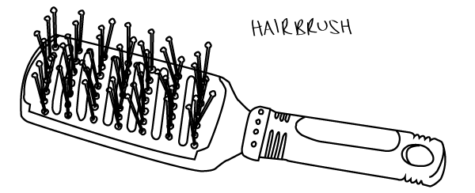


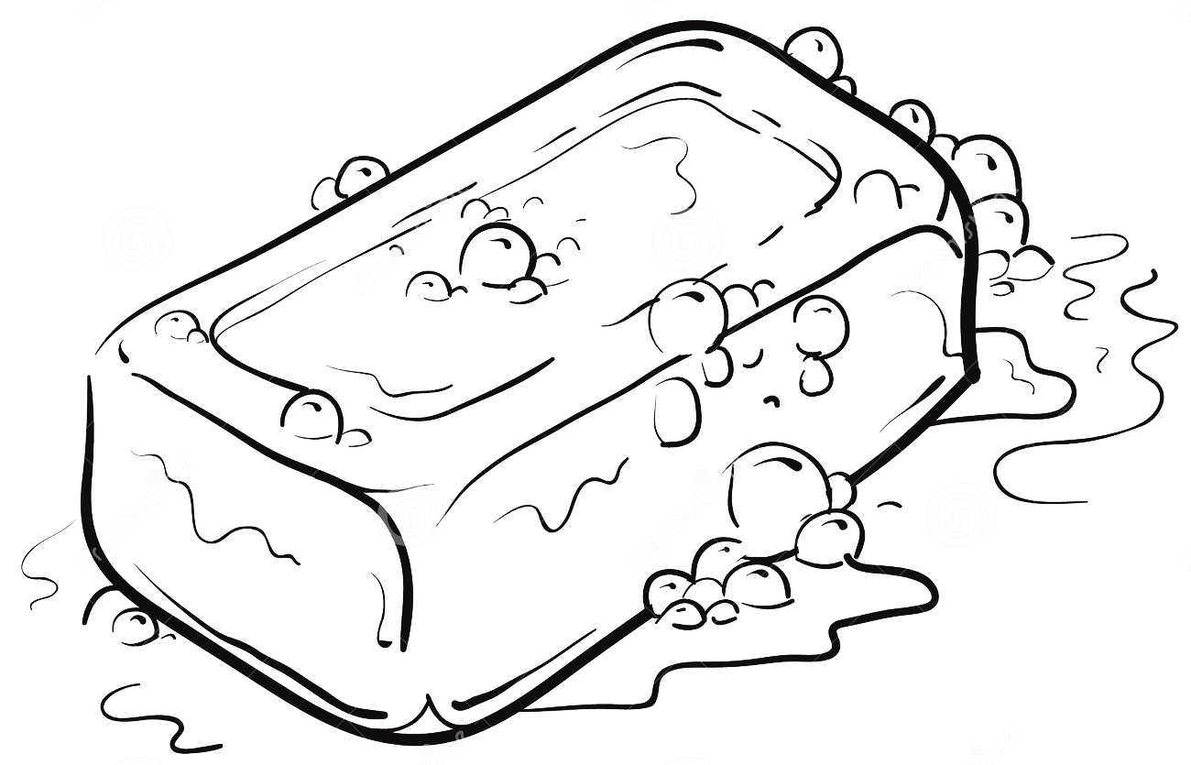

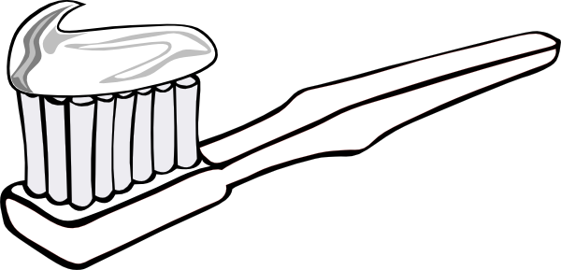
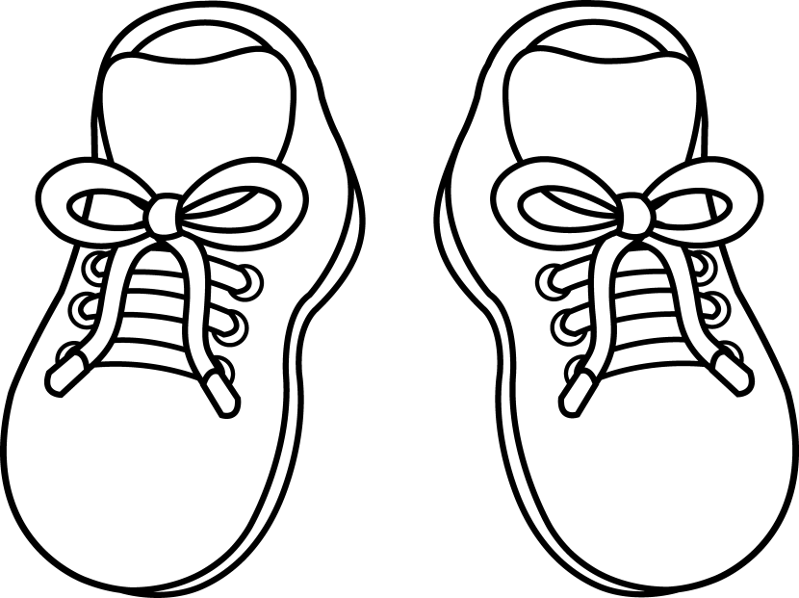

Total: __ / 3

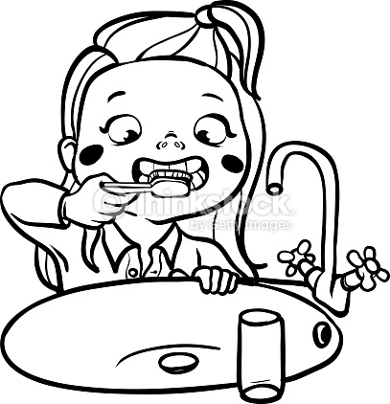
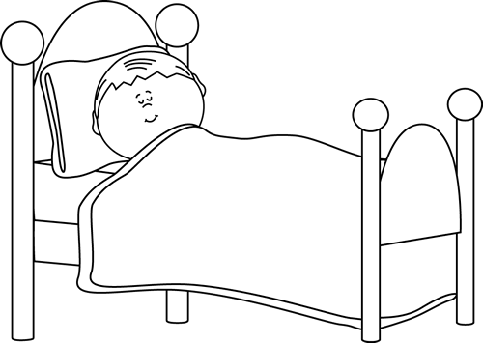
- Look at the pictures and make a √ in all the blocks which is a good habit and make a X in the block which is a bad habit.

√
√
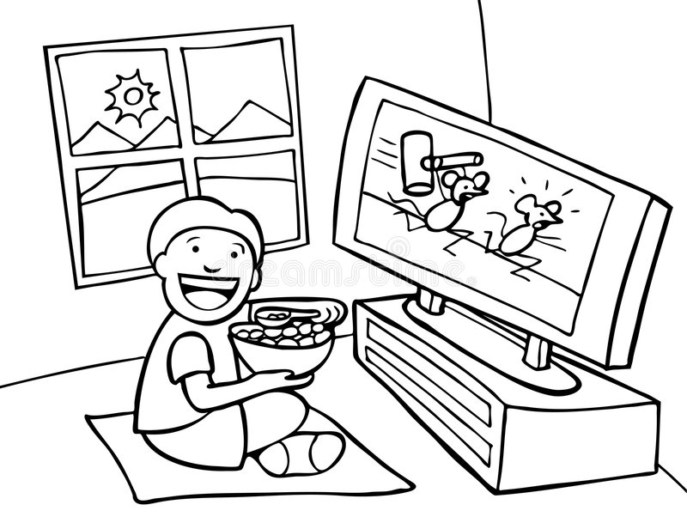
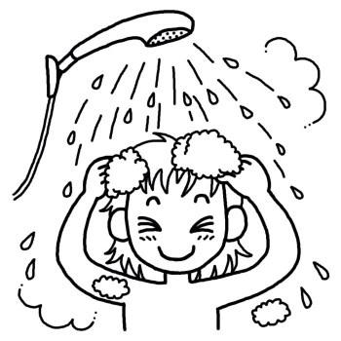

Total (4 x ƒ): __ / 2
X
√
- Look at the symbols of the different weather conditions. Write down the name of each symbol.



sunny
cloudy
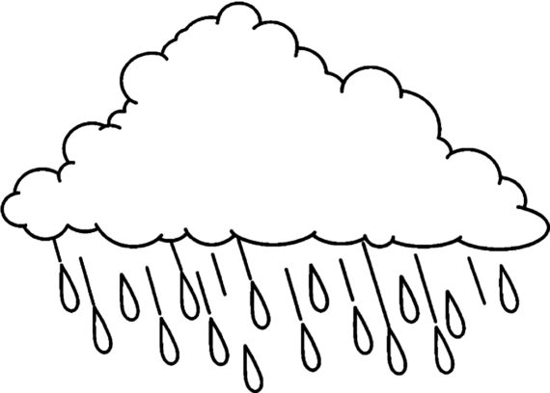

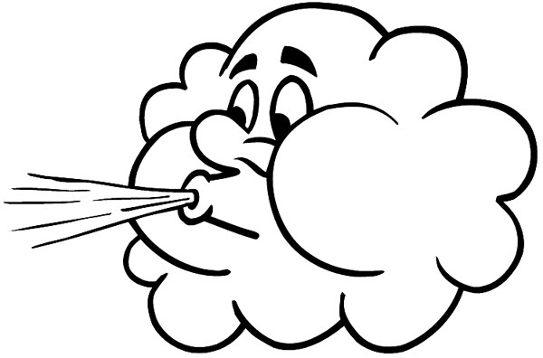

rain
windy

Total: __ / 4
Marks - Personal and Social Well-being |  | Mark
2.1 | 7
2.2 a | 7
b | 3
c | 2
d | 4
Total | 23

Section 3

Creative Arts
Marks: Performing Arts + Visual Arts = 6

3.1. Performing Arts: Improvise and interpret
Dramatisation
The learner must create a short story about an interesting article that has been drawn from a box. Learner receives a few minutes to think about how he is going to demonstrate his story about the object.
Rubric – Performing Arts | 5 | 4 | 3 | 2 | 1
- Creativity: The learner was creative with his dramatization. | 5 | 4 | 3 | 2 | 1
- Pleasure and confidence: The learner portrayed the dramatisation with confidence and enjoyed it. | 5 | 4 | 3 | 2 | 1
- Contents: The learner’s dramatisation was about the object which he/she has drawn. | 5 | 4 | 3 | 2 | 1
Total | ___/6

Processed mark (6 x ƒ = 3): __ /3

  - Visual Arts - 2D Design

Assignment:
Paint a portrait of yourself and add features such as eyes, ears, nose and mouth.
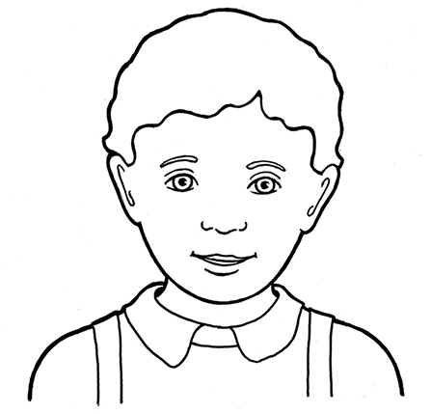
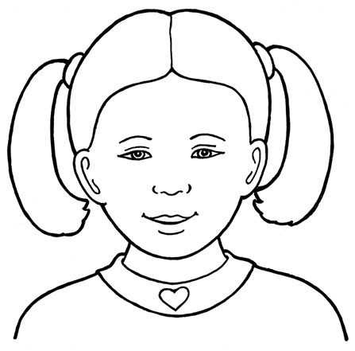

You will be assessed according to the following rubric:
Rubric - visual Arts
- The student's artwork is colorful. | 2
- The learner painted a portrait of himself with features such as: eyes, ears, nose and mouth. | 2
- Was the learner creative? | 2
Total | 6
Processed mark (6 x ƒ = 3): __ / 3
Section 4
Physical education
Points: 10

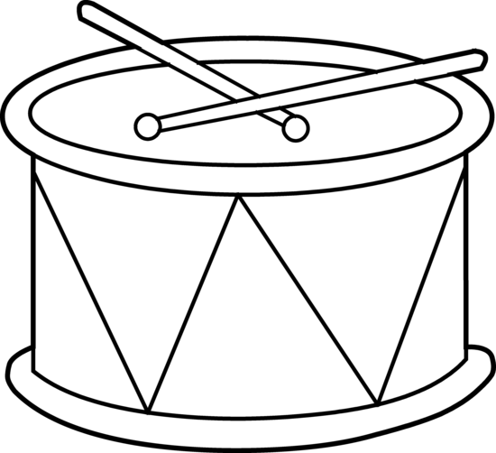
Purpose of activity - Movement, perceptual motor and rhythm.
Resources
- Drum / tambourine
- Beanbags

Instructions
The teacher beats on a drum / tambourine.
- Hit the drum once. Learners clap their hands once. Start hitting the drum faster. The learners must clap their hands each time the drum is hit, which means they will start to clap faster and faster on the beat of the drum.
- Hit the drum once. Learners jump on one leg and then the other leg to the rhythm that the drum is beaten.
- Hit the drum again. Learners now jump up and down to the rhythm being beaten on the drum.
- Learners now divided into groups of two and gets one bean bag. If the teacher hits the drum they must throw and catch the beanbag. The teacher starts to beat faster on the drum each time which means they will throw faster and faster on the beat of the drum.

Rubric - Physical education
- Learner is able to clap to the rhythm of the drum. | 2
- Learner is able to jump on one leg and then the other leg to the beat of the drum. | 2
- Learner is able to jump up and down to the beat of the drum. | 2
- The two students were able to throw the beanbag to each other and to catch the beanbag to the rhythm of the drum. | 2
- Demonstrates cooperation and listen to the instructions of the teacher. Learner also works well with partner during the group activity. | 2
Total | 10

