English Home Language
Assessment Term 4
Grade 1

Name and Surname: ____________________________
Date: _________________________________

Content |  | Mark
- Listening and speaking | 30
- Reading | 30
- Phonics | 30
- Writing and handwriting | 20
Total | 110

Activity 1
Listening and speaking: Part 1
Marks: 20

  - Listening Comprehension
Listen to the story while the teacher is reading and answer comprehension questions orally. You will be marked according to a rubric.

Ben goes fishing

Ben and his dad went fishing. Ben took
the pole. His dad took some worms.

They got on a boat. The boat was in
The Vaal river. Ben's dad drove the boat. He
knows where to find the fish. Ben liked the
boat ride.

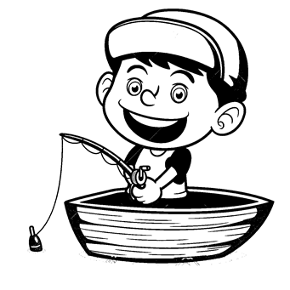
Ben put a worm on the hook. He put his
line in the water. He felt the pole pull. Was
it a fish? He reeled it in. He did not get a
fish. Ben got an old can.

Questions about story:

- What is the boy in the stories name?
- What did Ben and his dad do?
- What did Ben and his dad take with them?
- Where was the boat?
- Who drove the boat?
- What did Ben put on his hook?
- What did Ben catch?
- Who was the two characters in the story?

Listening and Speaking Rubric
 | 1 | 2 | 3 | 4
Vocabulary and language use | Struggles to communicate effectively, limited vocabulary. Cannot print himself / herself. | Uses a limited vocabulary. Makes many grammatical errors. | Uses appropriate vocabulary. Talks in full sentences and speaks in the correct time, eg. Past, future or present. | Uses a comprehensive vocabulary. Talks in full sentences and uses correct and good language. Use descriptive words.
Appropriate volume and intonation | Talks too soft or mumbles. Difficult to understand and hear. | Talks too fast. Sometimes difficult to understand. | Talk slowly and clearly. Easy to understand. Most of the time can be clearly heard. | Talk slowly and clearly. Can be easily heard and understood at all times.
Content | Learner doesn’t participate. Doesn’t want to try to answer questions. | Limited content. Teacher must ask questions to get clarity. | Spontaneous. Provides adequate content which is expected of the learner. | Spontaneous and elaborative. Content provides more information than expected.
Comprehension skills | Most of the answers to the questions are incorrect. | Some of the answers are correct. | Most of the answers are correct. | All of the answers were correct. The learner was able to answer in full sentences.
Ask questions for clarity | The learner has to ask questions the whole time for clarity because he seldom gives attention when given instructions. | The learner has to ask questions some times for clarity because he seldom gives attention when given instructions. | The learner has to ask questions seldom for clarity because he gives attention when instructions are given. | The learner never has to ask questions for clarity because he gives attention when instructions are given.
 |  |  | Total /20

Listening and speaking: Part 2
Marks: 10

Draw a beginning, a middle and an end about the story. Write a short sentence about each picture.
beginning
middle
________________________________________________________________________________
________________________________________________________________________________
________________________________________________________________________________
end
Activity 2
Reading
Marks: 30

2.1. Shared reading – Comprehension test.
Read the story and answer the questions.
Remember to answer in full sentences and with the
correct punctuation.
Clothing
By: Sue Peterson

First, my top.
My top is white.
Second, my pants.
My pants are brown.
Third, my shoes.
My shoes are white and brown.
I put them on.
First, second, third.
I put them on myself.
All by myself.

- The boy in the story dresses in a certain order. Complete the order:
  - first: ____________ (1)
  - second: ______________ (1)
  - third: ______________ (1)

- What color is the boy’s shoes?
_____________________________________________(2)

- Match the number with the correct word. (3)

- second
- third
- first

- Does the boy dress by himself? Give a reason for your answer.
__________________________________________________________________________________________(2)
Total: ____/10

2.2. Group Guided Reading

Read aloud from your own book in a guided reading group with the teacher. This means the whole group reads the same story or non-fiction text with the teacher. You will be marked according to this rubric:

Rubric – Group Guided Reading
- Words a pronounced correctly. | 2
- Learner makes use of the reading strategies taught in the Home Language to make sense and monitor self when reading (phonics, context clues, structural analysis, sight words) | 2
- Learner reads with increasing fluency and expression. | 2
- Shows an understanding of punctuation when reading aloud. | 2
- Reads with feeling and intonation. | 2
Total | 10

2.3. Independent reading – Read the poem below aloud
to your Teacher. Remember to read with feeling.
The Weather
By: Sue Peterson

The sky is blue and sunny.
Do you like the sunny sky?
The sky is black and rainy.
Do you like the rainy sky?
The temperature is cold. It is winter.
Do you like the winter cold?
The temperature is hot. It is summer.
Do you like the summer hot?
I like them all!

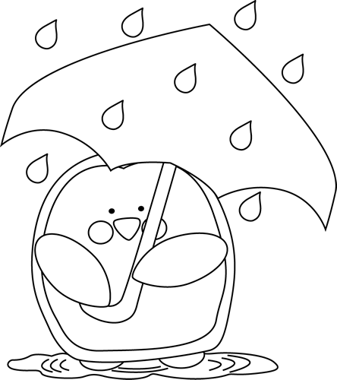

Rubric – Independent reading
- Words a pronounced correctly. | 2
- Learner makes use of the reading strategies taught in the Home Language to make sense and monitor self when reading (phonics, context clues, structural analysis, sight words) | 2
- Learner reads with increasing fluency and expression. | 2
- Shows an understanding of punctuation when reading aloud. | 2
- Reads with feeling and intonation. | 2
Total | 10
Activity 3
Phonics
Marks: 30

  - Look at the pictures and decide if there is one or more than one. Color in the correct answer. (4)
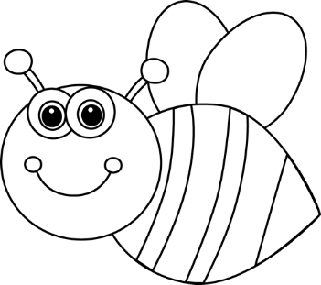
bees | bee

peach | peaches

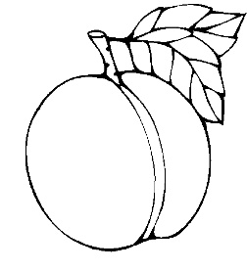

dogs | dog

buses | bus

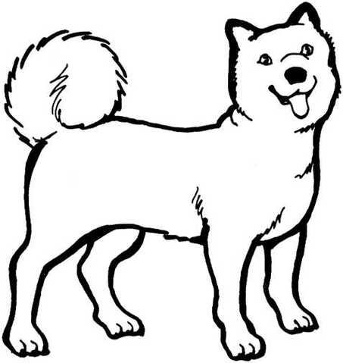
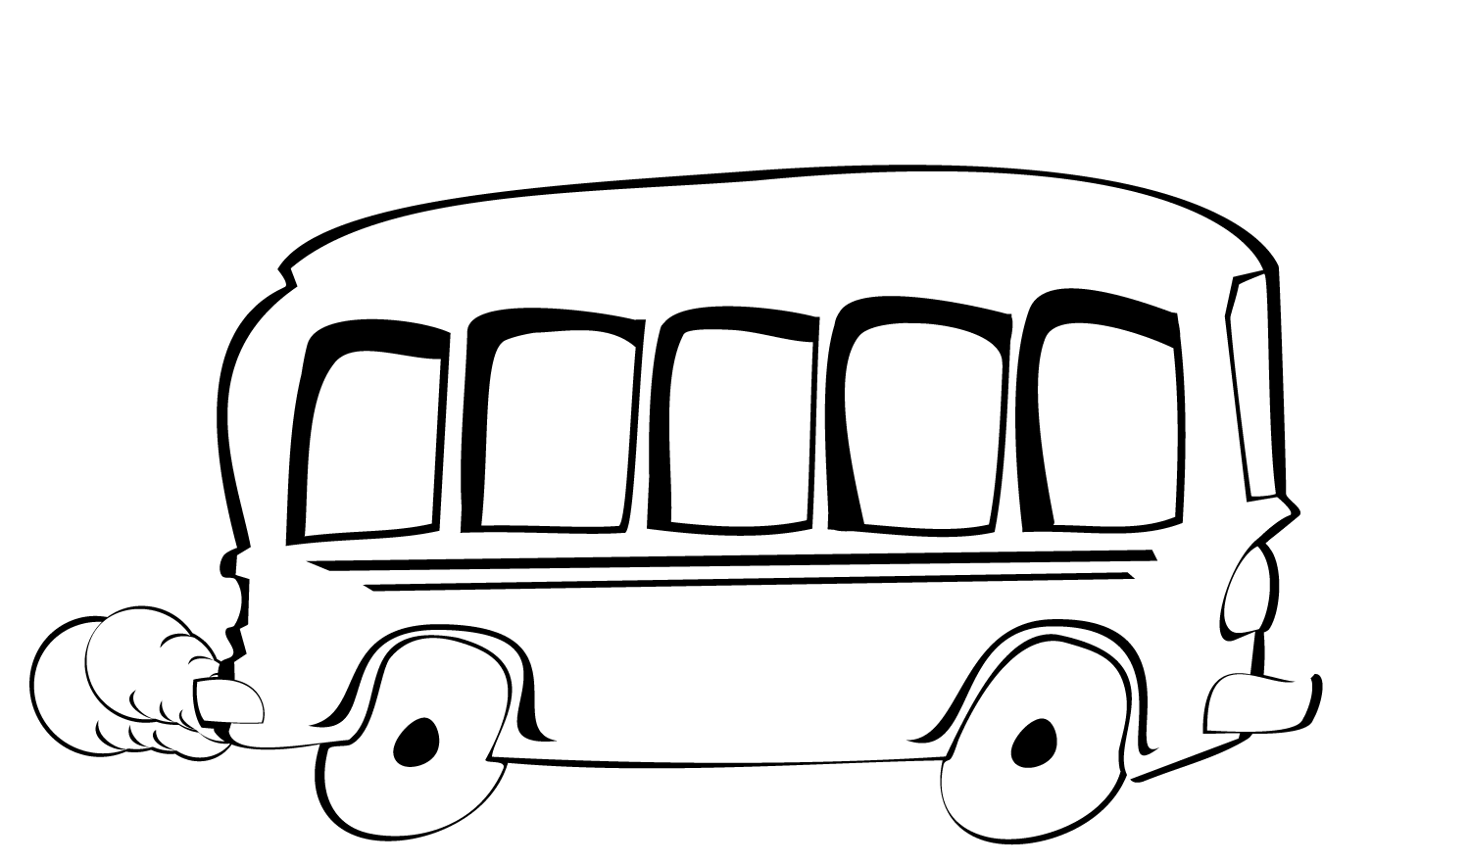

  - Choose the correct consonant digraph in die block and complete the words. Color in the block. (16 x ƒ = 8)

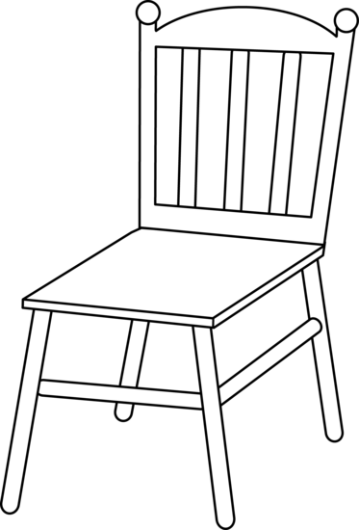  _ _ air  shchphth | 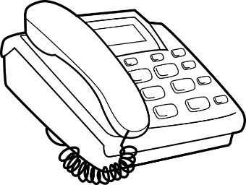  _ _ one  shchthph
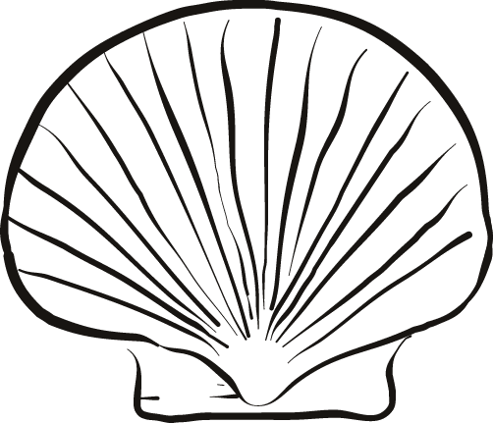  _ _ ell  shchphth |   _ _ umb
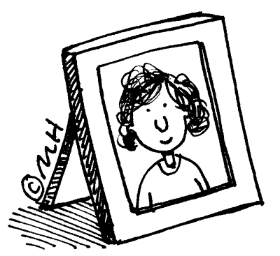  _ _ oto  chshphth | 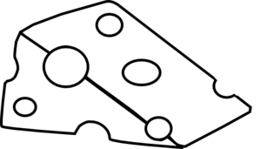    shchthph  thphchsh  _ _ ree  _ _ eese  shchphth
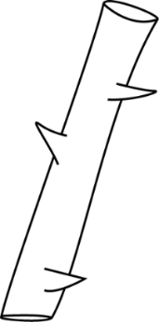
shchphth
_ _ orn
  - Circle the word in each box which is not a word family of the other words. (6)

hen ten pen men man net
vet wet jet pet pan hen
hug bag bug plug mug
nut cut shut hut cat
rib cub rub tub club

3.4. Look at the words in the box and group them with the
correct word family in the table. (10 x ƒ = 5)
rub pet tub hug shut
nut club hen men wet mug

pen | cub | vet | bug | cut

  - Look at the pictures and fill in the correct sound at the end of the word. (4)
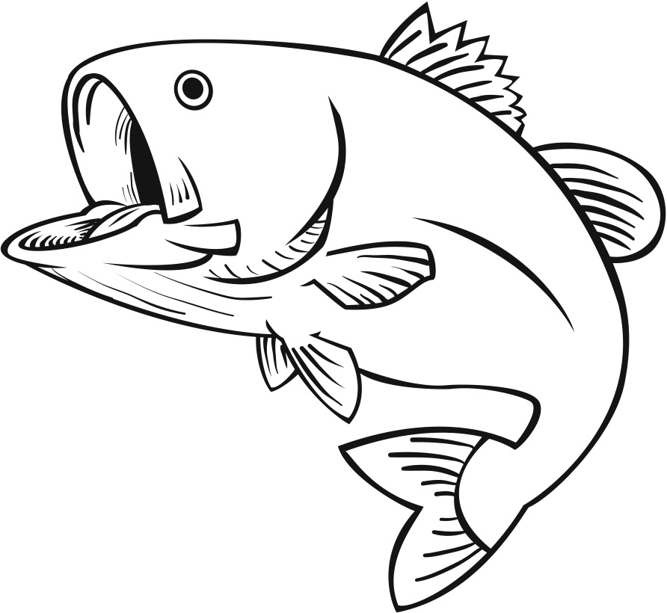  fi _ _ | 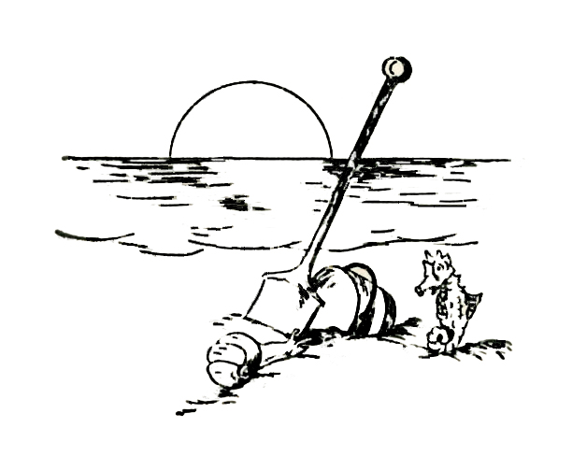  bea _ _
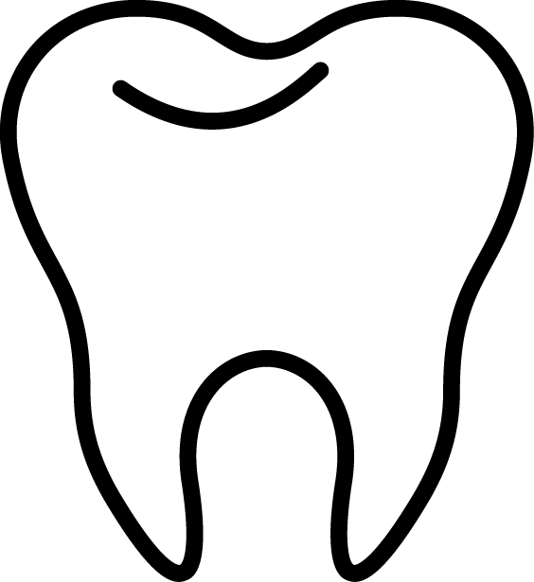  too _ _ | pea _ _

  - Build your own words using the following sounds and write your word on the lines. Make 3 words. (3)

fr
dr
o
g
nk
i
st
ck

________________________
________________________
________________________

Phonics total: ___/30
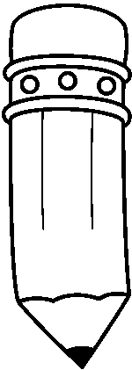
Activity 4
Writing and Handwriting
Marks: 20

Write the following letters. Repeat letter 3 times.

_ _ _ _ _ _ _ _ _ _ _ _ _ _ _ _ _ _ _ _ _ _ _ _ _ _ _ _ _ _ _ _ _ _ _ _ _ _ _ _ _ _ _ _ _ _ _ _ _ _ _ _ _ _ _ _ _ _ _ _ _ _ _ _ _ _ _ _ _ _ _ _ _ _ _ _

_________________________________________________________________________________________________________________________________________________

___________________________________________________________
f

_ _ _ _ _ _ _ _ _ _ _ _ _ _ _ _ _ _ _ _ _ _ _ _ _ _ _ _ _ _ _ _ _ _ _ _ _ _ _ _ _ _ _ _ _ _ _ _ _ _ _ _ _ _ _ _ _ _ _ _ _ _ _ _ _ _ _ _ _ _ _ _ _ _ _ _

_________________________________________________________________________________________________________________________________________________

___________________________________________________________
m

_ _ _ _ _ _ _ _ _ _ _ _ _ _ _ _ _ _ _ _ _ _ _ _ _ _ _ _ _ _ _ _ _ _ _ _ _ _ _ _ _ _ _ _ _ _ _ _ _ _ _ _ _ _ _ _ _ _ _ _ _ _ _ _ _ _ _ _ _ _ _ _ _ _ _ _

_________________________________________________________________________________________________________________________________________________

___________________________________________________________
w

_ _ _ _ _ _ _ _ _ _ _ _ _ _ _ _ _ _ _ _ _ _ _ _ _ _ _ _ _ _ _ _ _ _ _ _ _ _ _ _ _ _ _ _ _ _ _ _ _ _ _ _ _ _ _ _ _ _ _ _ _ _ _ _ _ _ _ _ _ _ _ _ _ _ _ _

_________________________________________________________________________________________________________________________________________________

___________________________________________________________
A

_ _ _ _ _ _ _ _ _ _ _ _ _ _ _ _ _ _ _ _ _ _ _ _ _ _ _ _ _ _ _ _ _ _ _ _ _ _ _ _ _ _ _ _ _ _ _ _ _ _ _ _ _ _ _ _ _ _ _ _ _ _ _ _ _ _ _ _ _ _ _ _ _ _ _ _

_________________________________________________________________________________________________________________________________________________

___________________________________________________________
E

Rubric – Writing and Handwriting | 1 | 2 | 3 | 4 | 5
- Line usage – How well did the learner use his writing lines? | Many errors in line usage. | Some errors in line usage. | Few errors using lines correctly. | Uses lines correctly most of the time. | Always uses lines correctly.
- Spacing - How well did the learner space their letters and/or words? | Many errors in spacing. | Some errors in spacing. | Few errors using spacing correctly. | Uses proper spacing most of the time. | Always uses proper spacing.
- Letter formation-  Did the learner form his letters correctly? | Many errors in letter formation. Incorrect letter formations. | Some errors in letter formation. Letters formed incorrectly. | Few errors in letter formation. Few letters are formed incorrectly. | Most letters are formed correctly. | Consistently forms all letters correctly.
- Readability – How easy is it to read the learners handwriting? | Many errors in readability. | Some errors in readability. | Few errors in readability. | Very easy to read. | Always easy to read.
- Neatness - How neat is the learner’s handwriting? | Difficult to read. | Not neatly done. | Not as neatly done. | Writes neatly. | Always writes neatly.
Total: ___/20

