English First Additional Language
Assessment Term 1
Grade 1

Name and Surname: ____________________________
Date: _________________________________

FAT 1

Content |  | Mark
- Listening and speaking | 90
- Emergent reading | 5
- Phonemic awareness | 5
Total | 100

Activity 1
Listening and speaking
Marks: Mark out of 45 x 2 = 90

  - Listening Comprehension
Listen to the story while the teacher is reading and answer the comprehension questions.

The new bicycle
Emma has a new bicycle. It is bright pink and shiny.
It was a gift from her uncle Fred who came to visit from Cape Town. He hid it behind a bush to surprise her.

When Emma looked behind the bush and saw the bicycle, she jumped from joy. It is just what she wanted. She gave her uncle a big hug.

She loves her new bicycle, and she loves her uncle.

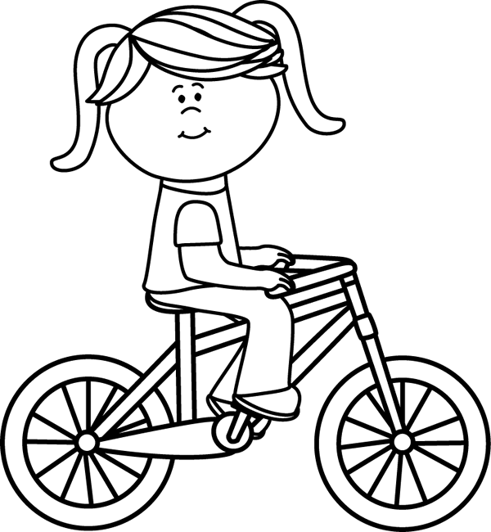

Teacher reads the statements below out loud. The learners color in the block with the correct answer.
Emma

Emmie

Jenna

- The girl in the stories name is:
doll

bicycle

- She got a new:
Pink and bright

Purple and shiny

Pink and shiny

- The bicycle is:
Her father

Her uncle

- Who bought Emma the bicycle?
Cape Town

Bloemfontein

- Where does her uncle live?
In her room

In the garage

Behind a bush

- Where was the bicycle hid?

happy

sad

- When Emma saw the bicycle she was:

Total: __/7
1.2. Go to your teachers table when she calls you. Listen to the
story while the teacher is reading and answer the questions
orally.
The thunderstorm

The kids were outside playing catch. They heard loud noises in the sky.

They didn’t want to stop playing, but they knew it was not save to be out in the storm. Also, they did not want to get wet. They decided to go inside and play a board game. They loved listening to the thunder while playing their game.

The kids went outside when the storm had passed. They saw a rainbow!

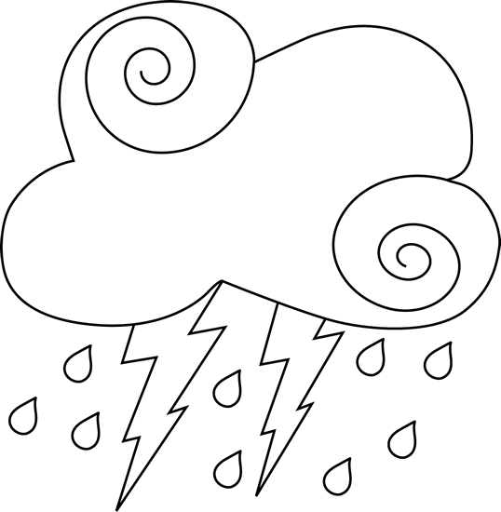

- Where were the kids playing?
- What did they hear in the sky?
- What are the loud noises in the sky called?
- Why did they decide to go play inside? Give two reasons.
- What did they play inside?
- When the storm had passed what did they see outside?
- Have you seen a rainbow and what colors are a rainbow?
Listening and Speaking Rubric - The thunderstorm
 | 1 | 2 | 3 | 4
Vocabulary and language use | Struggles to communicate effectively, limited vocabulary. Cannot print himself / herself. | Uses a limited vocabulary. Makes many grammatical errors. | Uses appropriate vocabulary. Talks in full sentences and speaks in the correct time, eg. Past, future or present. | Uses a comprehensive vocabulary. Talks in full sentences and uses correct and good language. Use descriptive words.
Appropriate volume and intonation | Talks too soft or mumbles. Difficult to understand and hear. | Talks too fast. Sometimes difficult to understand. | Talk slowly and clearly. Easy to understand. Most of the time can be clearly heard. | Talk slowly and clearly. Can be easily heard and understood at all times.
Content | Learner doesn’t participate. Doesn’t want to try to answer questions. | Limited content. Teacher must ask questions to get clarity. | Spontaneous. Provides adequate content which is expected of the learner. | Spontaneous and elaborative. Content provides more information than expected.
Comprehension skills | Most of the answers to the questions are incorrect. | Some of the answers are correct. | Most of the answers are correct. | All of the answers were correct. The learner was able to answer in full sentences.
Ask questions for clarity | The learner has to ask questions the whole time for clarity because he seldom gives attention when given instructions. | The learner has to ask questions some times for clarity because he seldom gives attention when given instructions. | The learner has to ask questions seldom for clarity because he gives attention when instructions are given. | The learner never has to ask questions for clarity because he gives attention when instructions are given.
 |  |  |  | Total: ___/20

1.3. Listening activity
Respond to simple oral instructions. (6 x 2 = 12)
- Draw a yellow sun. (2) | - Draw a table and chair. (2)
- Draw a green tree with red apples. (2) | - Draw a girl with a pink dress. (2)
- Draw a boy with a blue hat. (2) | - Draw a green car. (2)

Total: ___/12
1.4. Look at the pictures and tell your teacher about what you
see in each picture. (6)

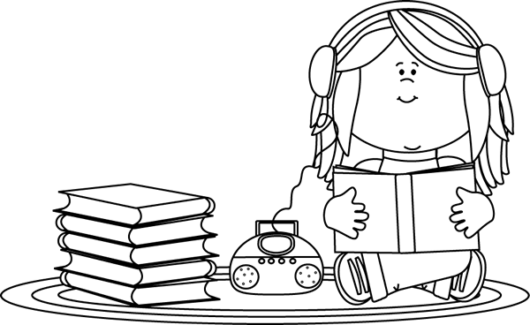 | 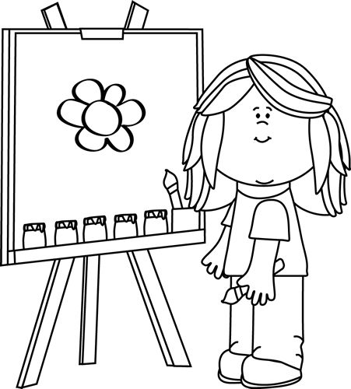
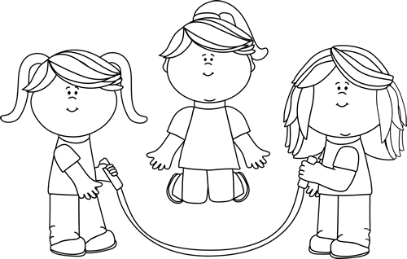 | 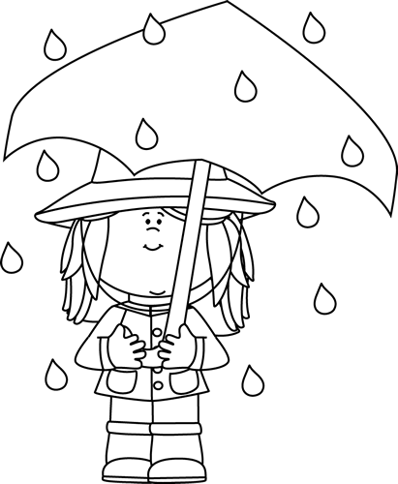
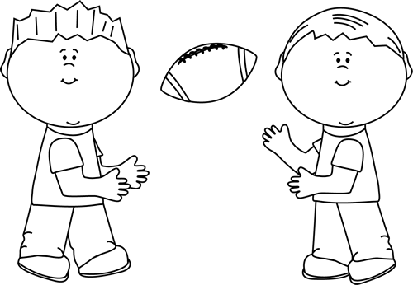 | 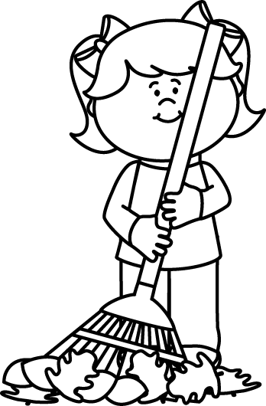

Total: __/6
Total mark activity 1 (1.1. + 1.2. + 1.3. + 1.4.) = ___/45
Activity 2
Emergent reading
Marks: 5

Shared reading
Listen to the story your teacher is going to read. Then
follow her instructions.

Ken's Messy Room

Ken's room was a mess! There were shoes and toy
trucks on the floor. There were books by the
door. There were pants on the bed.
Ken's dad said, “This room is a pig pen!
Clean it now!” He was not happy. Ken started to clean his room.
He made his bed. He put his trucks in the toy
Box and shoes in the closet. He put his books away. He folded the pants and put them away.
Ken's Dad came back. “You did a great job,” he said. Ken and his dad were both happy.

2.1. Draw a picture about what you have heard in the story and
color it in. (5)

Rubric picture
 | Mark | Mark obtained
1. Does the picture of the learner show the main idea about the story? | 4
2. Is the picture colored in and neat? | 1
Total 2.1. | 5

2.2. Look at the picture. Answer the questions your teachers
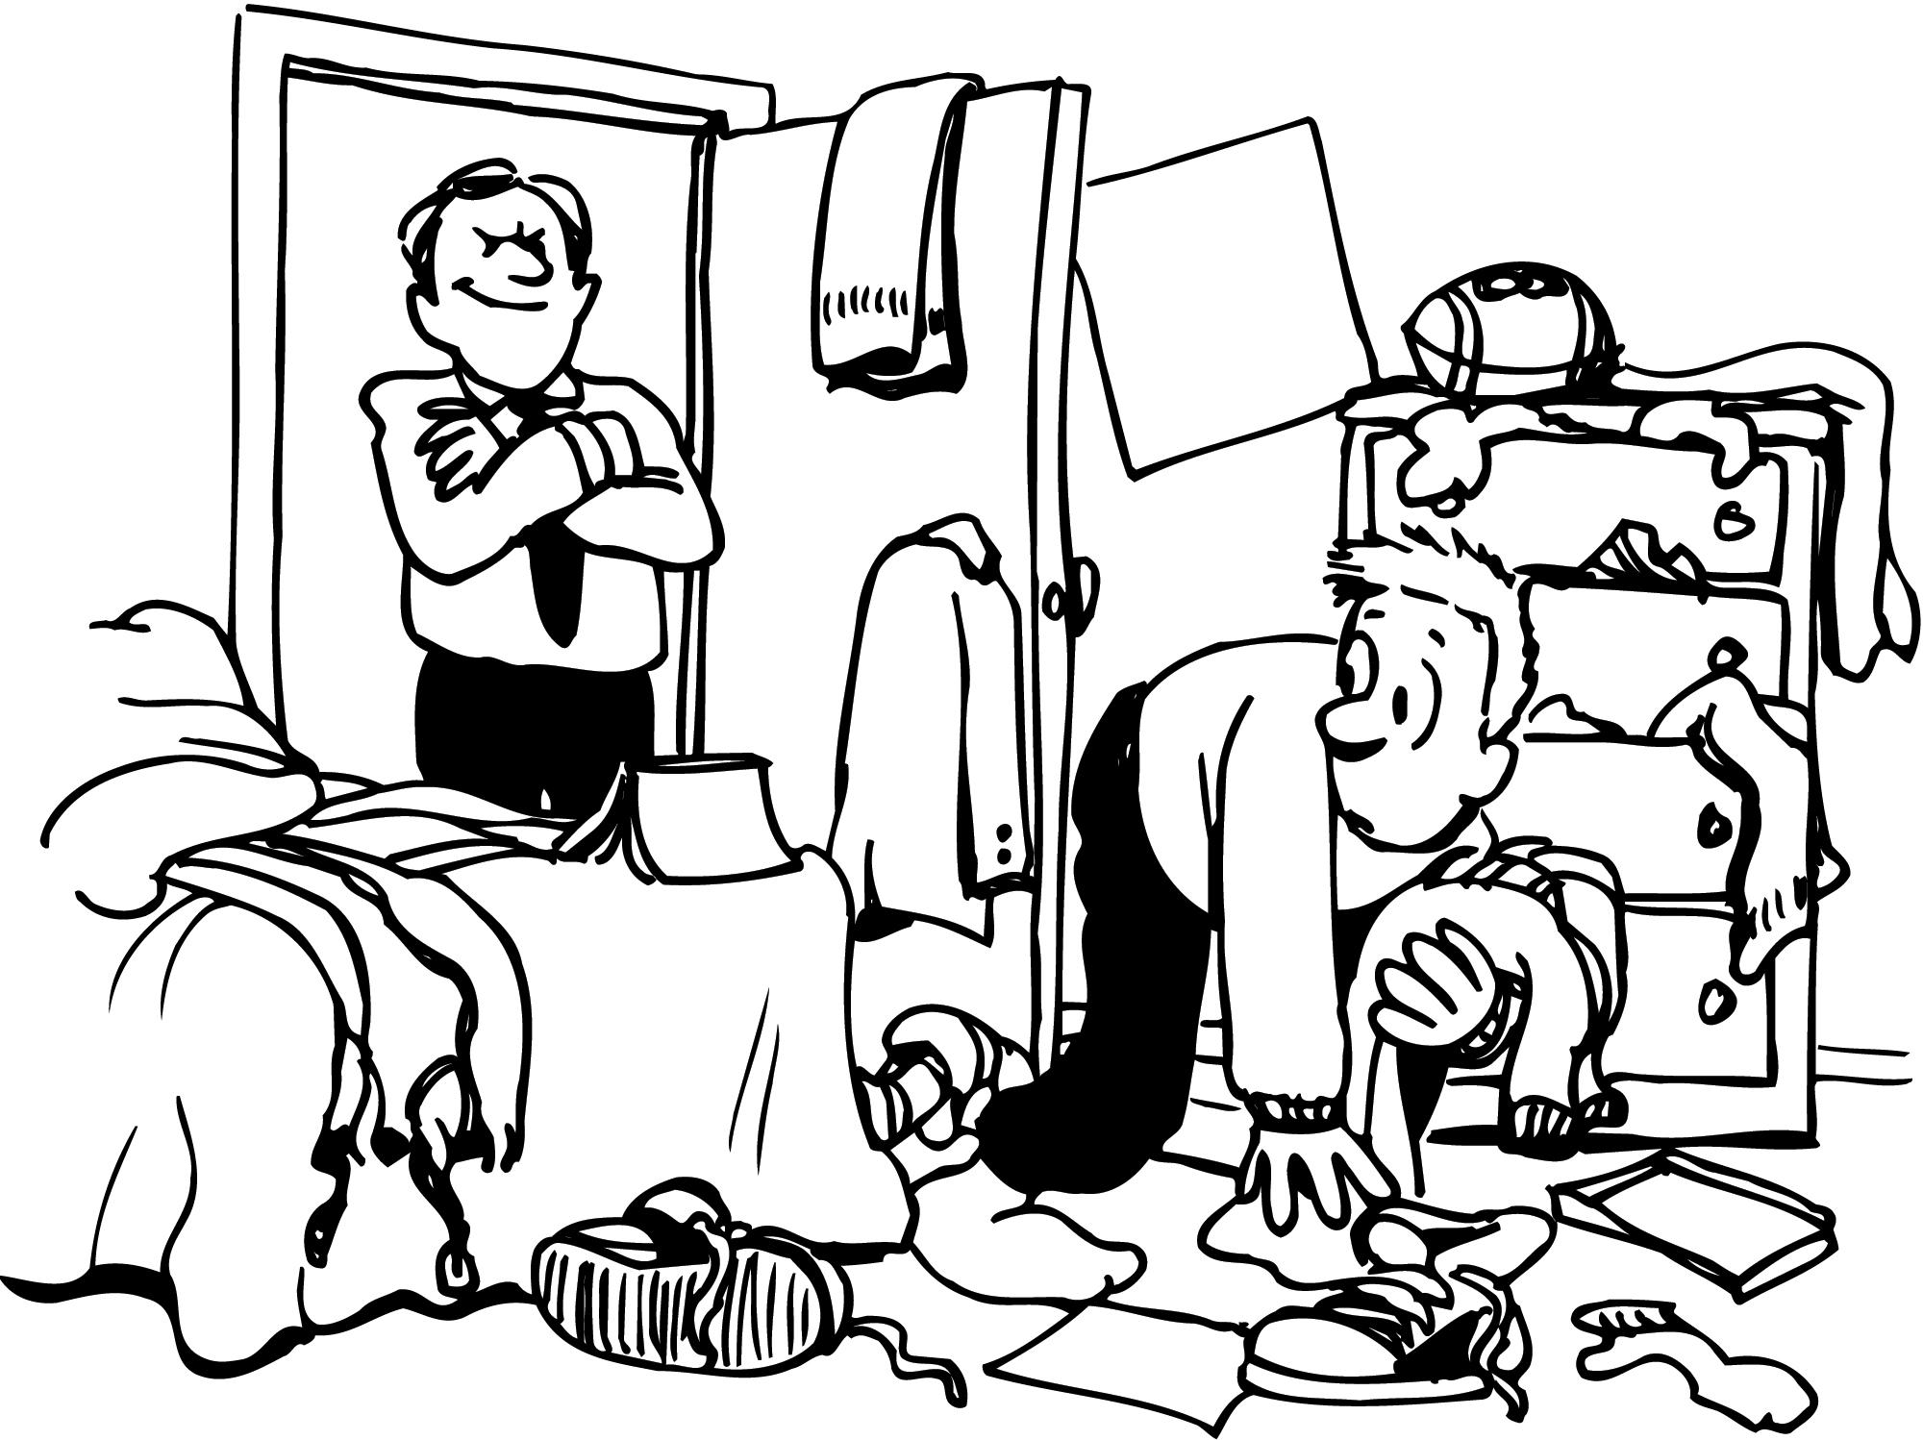
asks you about the picture.

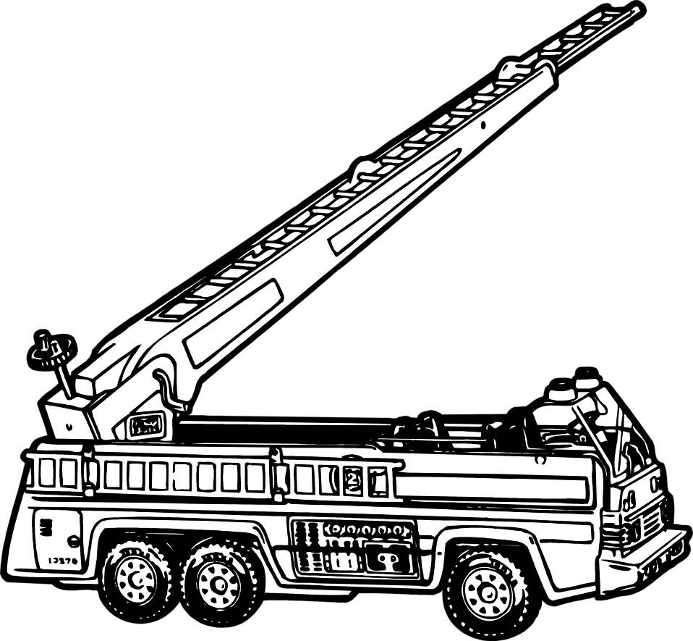
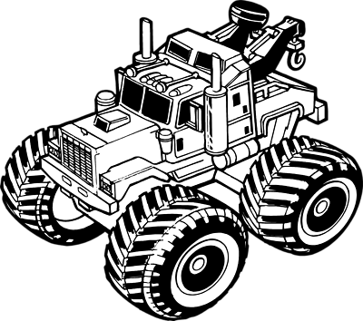

Questions:
- Show me where the toy trucks are. (1)
- Where is the shoes? (1)
- Where is Ken’s dad? (1)
- Where is the ball? (1)
- Show me where the jacket is. (1)
Total 2.2.: __/5
Processed mark Question 2.1. + 2.2. (10 ¸ 2 = 5) = __/5
Activity 3
Phonemic awareness
Marks: 5

The Teacher says the word of the picture out loud.
Learners then circle the first sound of the word which they hear. (5)

  m  n  h |   i  k  l |   b  p  q
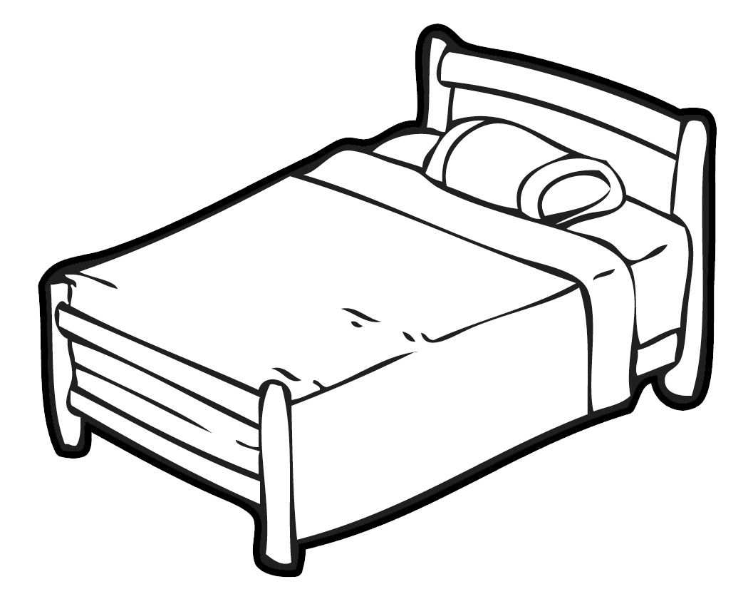  d  b  h |   s  c  z

Total: __/5

