**English First Additional Language**

**Assessment Term 1**

**Grade 1**

**Name and Surname: ____________________________**

**Date: _________________________________**

**FAT 1**

|  |  |  |
| --- | --- | --- |
| **Content** |  | **Mark** |
| 1. Listening and speaking | **90** |  |
| 1. Emergent reading | **5** |  |
| 1. Phonemic awareness | **5** |  |
| **Total** | **100** |  |

**Activity 1**

**Listening and speaking**

**Marks: Mark out of 45 x 2 = 90**

* 1. Listening Comprehension

Listen to the story while the teacher is reading and answer the comprehension questions.

The new bicycle

Emma has a new bicycle. It is bright pink and shiny.

It was a gift from her uncle Fred who came to visit from Cape Town. He hid it behind a bush to surprise her.

When Emma looked behind the bush and saw the bicycle, she jumped from joy. It is just what she wanted. She gave her uncle a big hug.

She loves her new bicycle, and she loves her uncle.

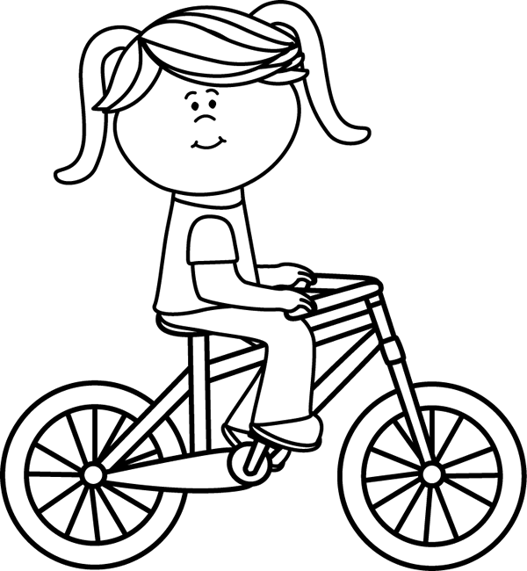

Teacher reads the statements below out loud. The learners color in the block with the correct answer.

|  |
| --- |
| Jenna |

|  |
| --- |
| Emma |

|  |
| --- |
| Emmie |

1. The girl in the stories name is:

|  |
| --- |
| bicycle |

|  |
| --- |
| doll |

1. She got a new:

|  |
| --- |
| Pink and shiny |

|  |
| --- |
| Purple and shiny |

|  |
| --- |
| Pink and bright |

1. The bicycle is:

|  |
| --- |
| Her uncle |

|  |
| --- |
| Her father |

1. Who bought Emma the bicycle?

|  |
| --- |
| Bloemfontein |

|  |
| --- |
| Cape Town |

1. Where does her uncle live?

|  |
| --- |
| Behind a bush |

|  |
| --- |
| In the garage |

|  |
| --- |
| In her room |

1. Where was the bicycle hid?

|  |
| --- |
| sad |

|  |
| --- |
| happy |

1. When Emma saw the bicycle she was:

Total: __/7

1.2. Go to your teachers table when she calls you. Listen to the

story while the teacher is reading and answer the questions

orally.

The thunderstorm

The kids were outside playing catch. They heard loud noises in the sky.

They didn’t want to stop playing, but they knew it was not save to be out in the storm. Also, they did not want to get wet. They decided to go inside and play a board game. They loved listening to the thunder while playing their game.

The kids went outside when the storm had passed. They saw a rainbow!

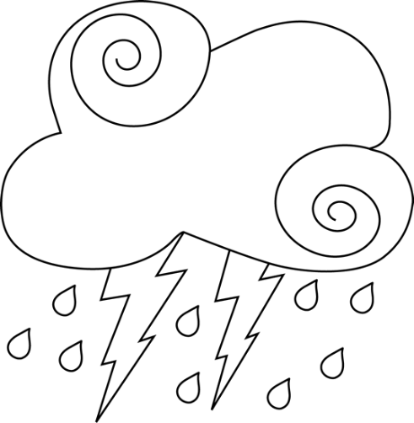

1. Where were the kids playing?
2. What did they hear in the sky?
3. What are the loud noises in the sky called?
4. Why did they decide to go play inside? Give two reasons.
5. What did they play inside?
6. When the storm had passed what did they see outside?
7. Have you seen a rainbow and what colors are a rainbow?

Answers to questions:

1. Where were the kids playing?

The kids are playing outside.

1. What did they hear in the sky?

They heard loud noises.

1. What are the loud noises in the sky called?

The loud noises are called thunder.

1. Why did they decide to go play inside? Give two reasons.

* It is not safe to play outside in the storm.
* They did not want to get wet.

1. What did they play inside?

They played a board game.

1. When the storm had passed what did they see outside?

They saw a rainbow.

1. Have you seen a rainbow and what colors are a rainbow?

Learners own answer. The learners must say a few different colors.

|  |  |  |  |  |
| --- | --- | --- | --- | --- |
| **Listening and Speaking Rubric - The thunderstorm** | | | | |
|  | **1** | **2** | **3** | **4** |
| **Vocabulary and language use** | Struggles to communicate effectively, limited vocabulary. Cannot print himself / herself. | Uses a limited vocabulary. Makes many grammatical errors. | Uses appropriate vocabulary. Talks in full sentences and speaks in the correct time, eg. Past, future or present. | Uses a comprehensive vocabulary. Talks in full sentences and uses correct and good language. Use descriptive words. |
| **Appropriate volume and intonation** | Talks too soft or mumbles. Difficult to understand and hear. | Talks too fast. Sometimes difficult to understand. | Talk slowly and clearly. Easy to understand. Most of the time can be clearly heard. | Talk slowly and clearly. Can be easily heard and understood at all times. |
| **Content** | Learner doesn’t participate. Doesn’t want to try to answer questions. | Limited content. Teacher must ask questions to get clarity. | Spontaneous. Provides adequate content which is expected of the learner. | Spontaneous and elaborative. Content provides more information than expected. |
| **Comprehension skills** | Most of the answers to the questions are incorrect. | Some of the answers are correct. | Most of the answers are correct. | All of the answers were correct. The learner was able to answer in full sentences. |
| **Ask questions for clarity** | The learner has to ask questions the **whole time** for clarity because he seldom gives attention when given instructions. | The learner has to ask questions **some times** for clarity because he seldom gives attention when given instructions. | The learner has to ask questions **seldom** for clarity because he gives attention when instructions are given. | The learner **never** has to ask questions for clarity because he gives attention when instructions are given. |
|  | | |  | Total: ___/20 |

1.3. Listening activity

Respond to simple oral instructions. (6 x 2 = 12)

Hat - blue√

Boy √

|  |  |
| --- | --- |
| 1. Draw a yellow sun. (2)   yellow √  Sun√ | 1. Image result for chair clipart black and whiteDraw a table and chair. (2)   Chair√  Table√ |
| 1. Draw a green tree with red apples. (2)   Related image  Apples – red√  Tree - green√ | 1. Image result for girl with dress clipart black and whiteDraw a girl with a pink dress. (2) |
| 1. Image result for boy with hat clipart black and whiteDraw a boy with a blue hat. (2) | 1. Related imageDraw a green car. (2)   Car √ - green√  Dress - pink√  Girl √ |

Total: ___/12

1.4. Look at the pictures and tell your teacher about what you

see in each picture. (6)

|  |  |
| --- | --- |
| * The girl is reading a book. * The girl is listening to music with her headphones. * She is sitting on a mat. | * The girl is painting. * She is painting a flower. * She is painting on an esel. |
| * The girls are jumping rope. * There are 3 girls. * One girl is jumping, the other two are holding the rope. | * It is raining. * The girl is holding an umbrella. * The girls is standing under an umbrella. |
| * There are two boys. * The boys are throwing a ball. | * It is a girl. * She is raking the leaves. * She has two ponytails. |

Total: __/6

Total mark activity 1 (1.1. + 1.2. + 1.3. + 1.4.) = ___/45

**Activity 2**

**Emergent reading**

**Marks: 5**

Shared reading

Listen to the story your teacher is going to read. Then

follow her instructions.

Ken's Messy Room

Ken's room was a mess! There were shoes and toy

trucks on the floor. There were books by the

door. There were pants on the bed.

Ken's dad said, “This room is a pig pen!

Clean it now!” He was not happy. Ken started to clean his room.

He made his bed. He put his trucks in the toy

Box and shoes in the closet. He put his books away. He folded the pants and put them away.

Ken's Dad came back. “You did a great job,” he said. Ken and his dad were both happy.

2.1. Draw a picture about what you have heard in the story and

color it in. (5)

Learners own drawing and creativity.

|  |  |  |
| --- | --- | --- |
| **Rubric picture** | | |
|  | Mark | Mark obtained |
| 1. Does the picture of the learner show the main idea about the story? | 4 |  |
| 2. Is the picture colored in and neat? | 1 |  |
| **Total 2.1.** | 5 |  |

2.2. Look at the picture. Answer the questions your teachers

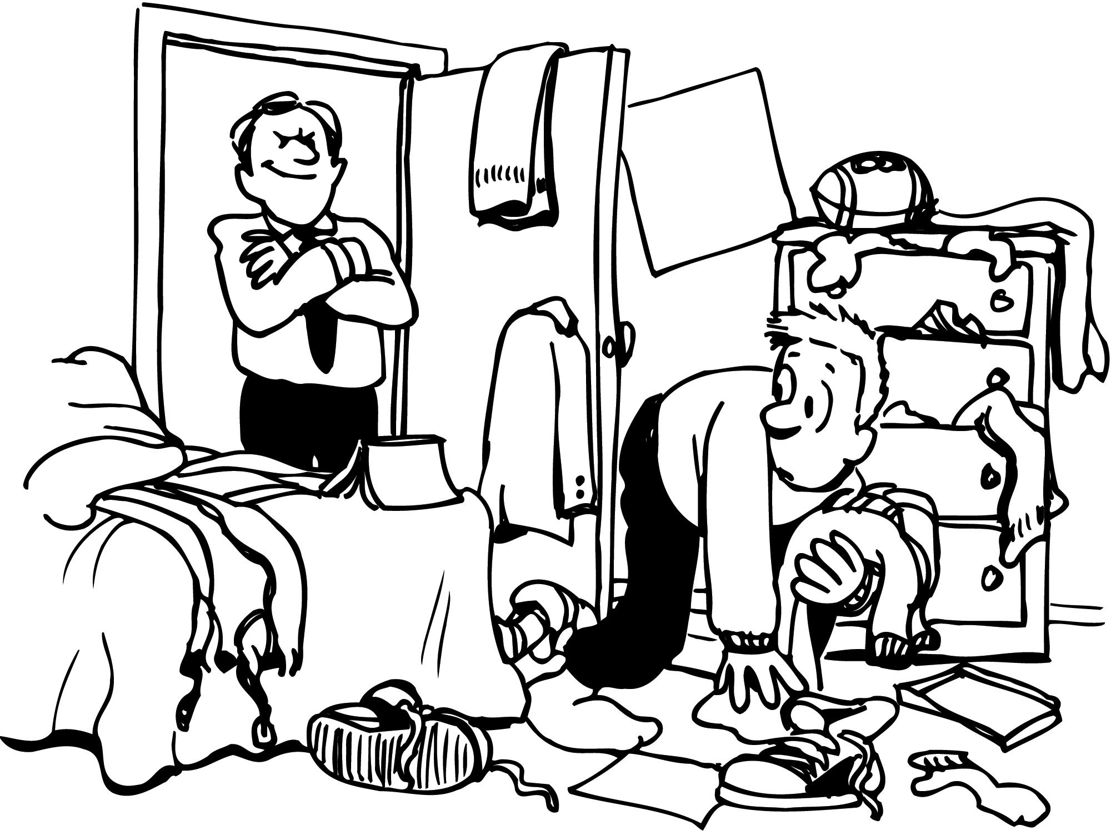 asks you about the picture.

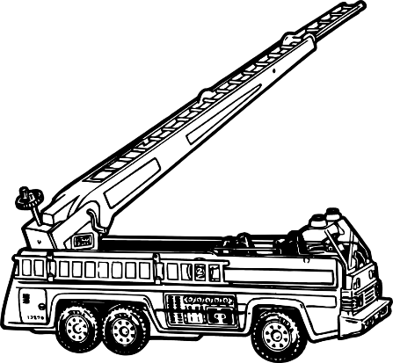

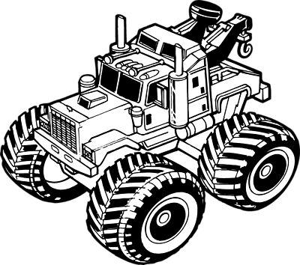

Questions:

1. Show me where the toy trucks are. (1)
2. Where is the shoes? (1)
3. Where is Ken’s dad? (1)
4. Where is the ball? (1)
5. Show me where the jacket is. (1)

Total 2.2.: __/5

Processed mark Question 2.1. + 2.2. (10 ¸ 2 = 5) = __/5

**Activity 3**

**Phonemic awareness**

**Marks: 5**

The Teacher says the word of the picture out loud.

Learners then circle the first sound of the word which they hear. (5)

|  |  |  |
| --- | --- | --- |
| Image result for mouse clipart black and white | Image result for lip clipart black and white | Image result for pan clipart black and white |
| Image result for bed clipart black and white | Image result for sun clipart black and white | |

Total: __/5