Life Skills

Assessment Task Term 2

Grade 3

Name and Surname: ____________________________

Date: _________________________________

MEMO

|  |  |  |
| --- | --- | --- |
| Content Areas |  | Marks |
| 1. Beginning Knowledge and Personal and Social Wellbeing | 40 |  |
| 1. Creative Arts | 20 |  |
| 1. Physical Education | 30 |  |
| Total | 90 |  |



Beginning Knowledge

Total: ___/20

QUESTION 1: Healthy eating habits

* 1. Write the names of the correct food in the blocks of the different groups. (8)

milk

bananas

pasta

cheese

bread

grapes

yogurt

chicken

|  |  |  |  |
| --- | --- | --- | --- |
| Carbohydrates | Proteins | Vitamins and minerals | Fats |
| bread | chicken | grapes | cheese |
| pasta |  | bananas | yogurt |
|  |  |  | milk |

* 1. Complete the sentences by writing the correct word in the correct sentence.

energy

infection

Protein

heat

1. 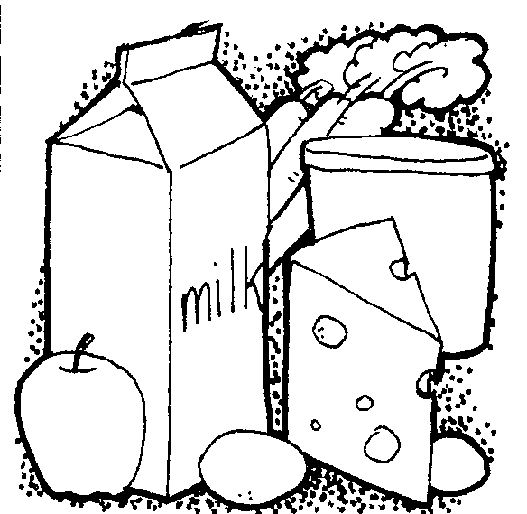**Protein** build new cells to

help our bodies grow.

1. Vitamins and minerals help our bodies to fight **infection** and to stay healthy.
2. Carbohydrates give us **energy**.
3. We need fats for **heat** and energy.
   1. 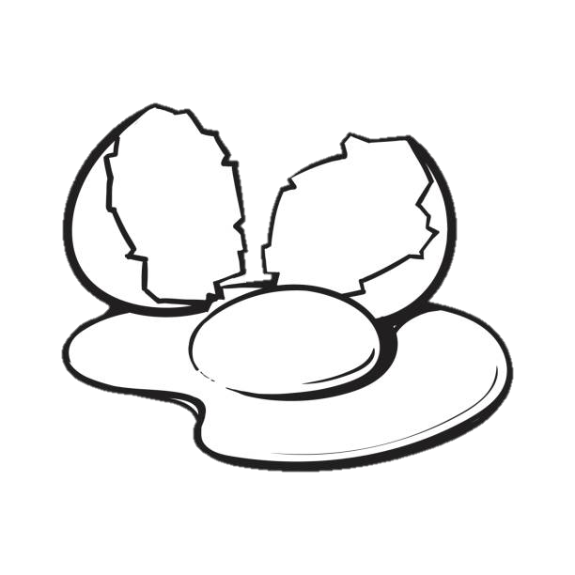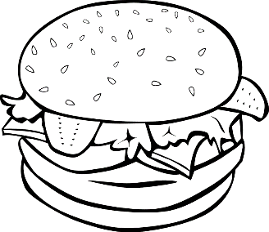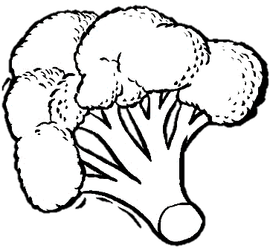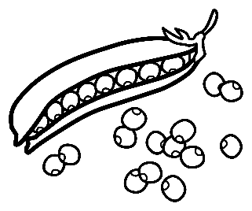Colour the pictures showing healthy food. (5)

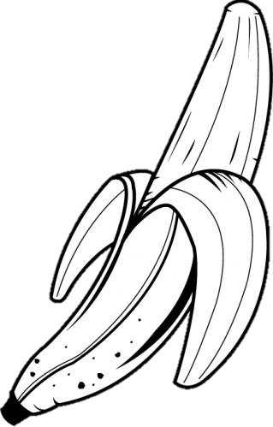



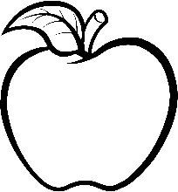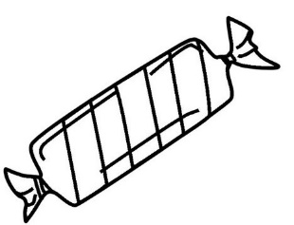

* 1. 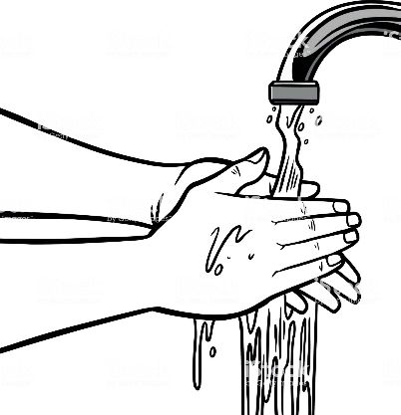Look at the three pictures. Write down the rules for healthy eating. (3)

Always wash your hands before you touch food.

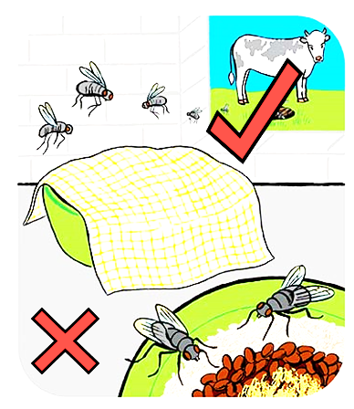

Don’t leave food uncovered.

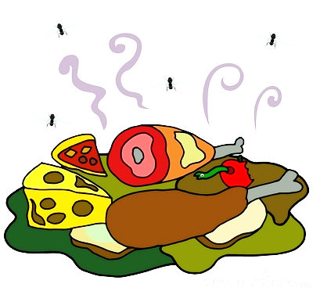

Don’t eat old food.



Personal and Social Well - being

Total: 20

Question 1 - Insects

* 1. Name the body parts of the ant by using the words in the blocks. (6¸2=3)

leg

eye

head

antenna

lower body

upper body

head

eye

antenna

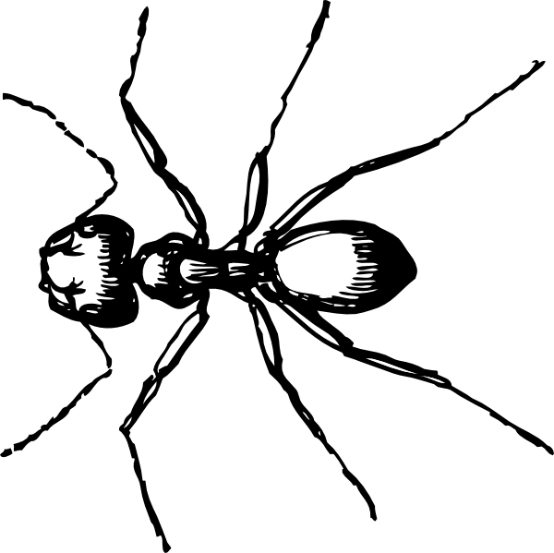

upper body

leg

lower body

* 1. 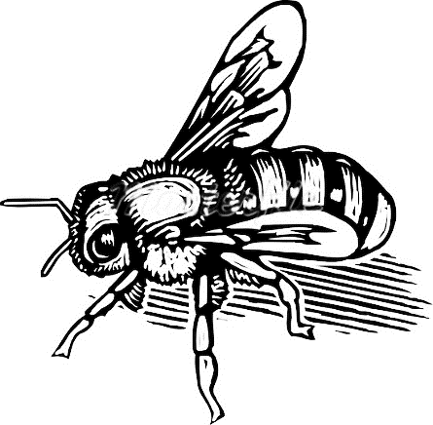 Name the insects. (6¸2=3)

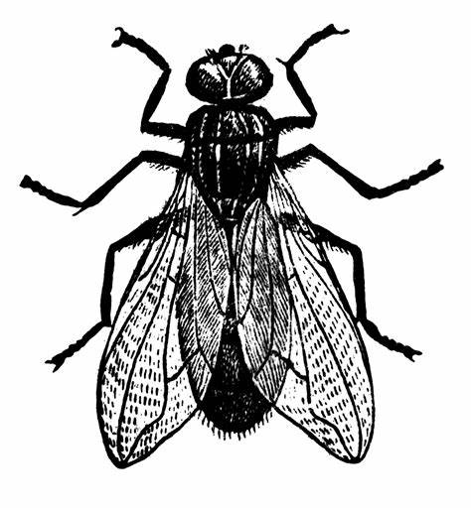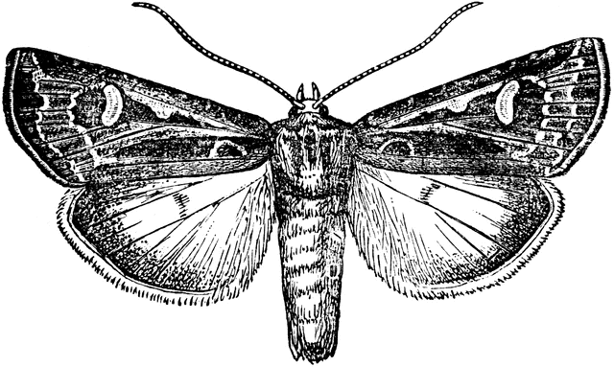

fly

moth

bee

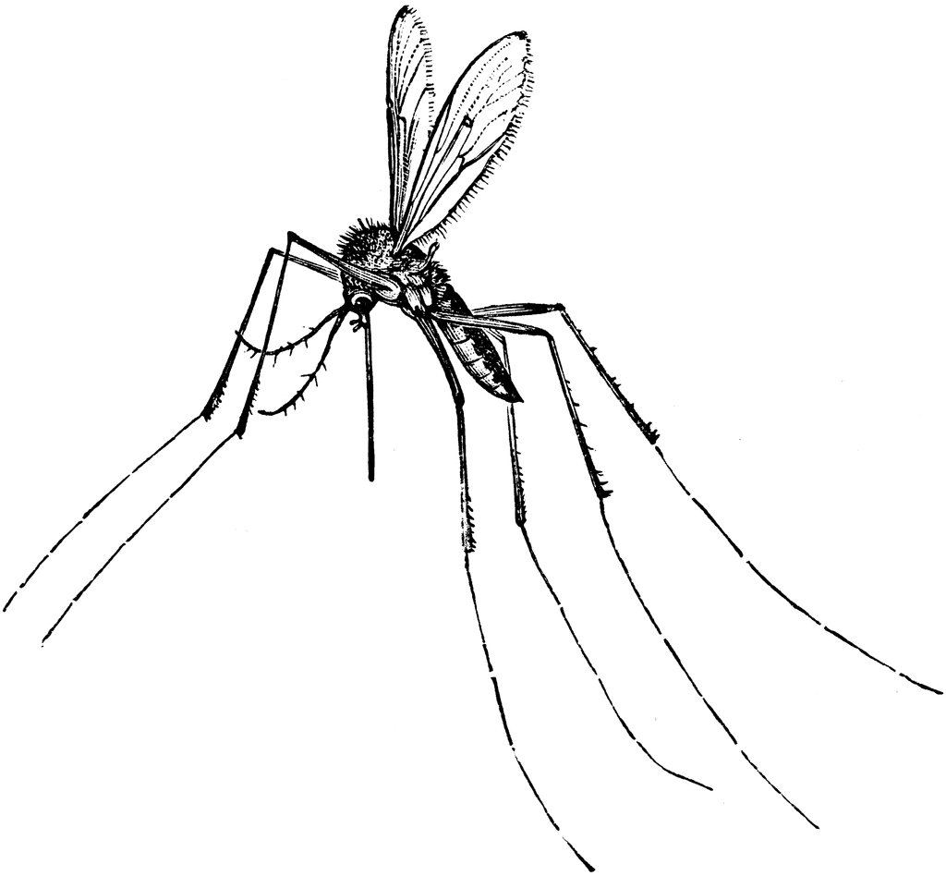

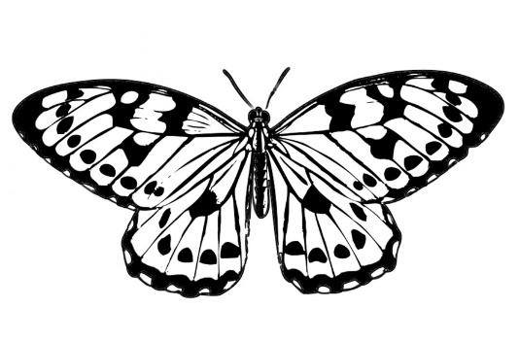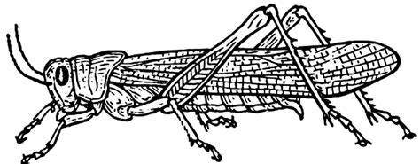

mosquito

butterfly

locust

* 1. Answer the questions: (4¸2=2)

1. Which insect makes honey? bee
2. Which insect pollinates flowers? butterfly
3. Which insect spreads malaria? mosquito
4. Which insect eats the crops of farmers? locust

Question 2 : Life cycle

2.1. Complete the life cycle of a chicken. (5)

Hen lays egg

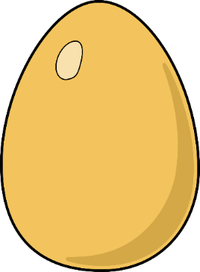



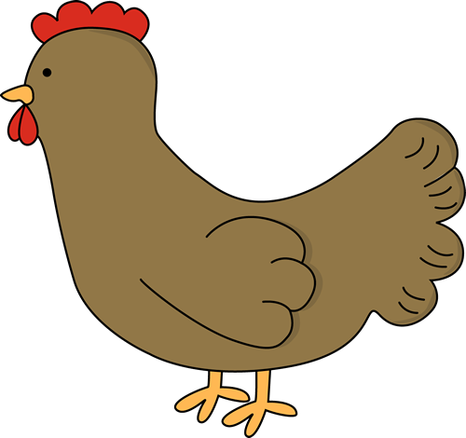

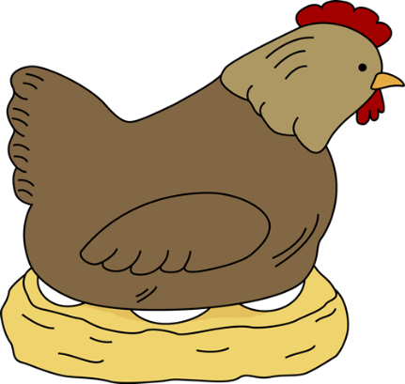

Mature chicken



Hen sits on egg



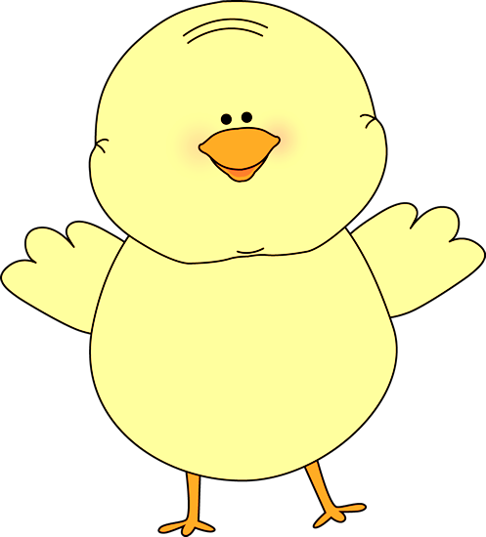

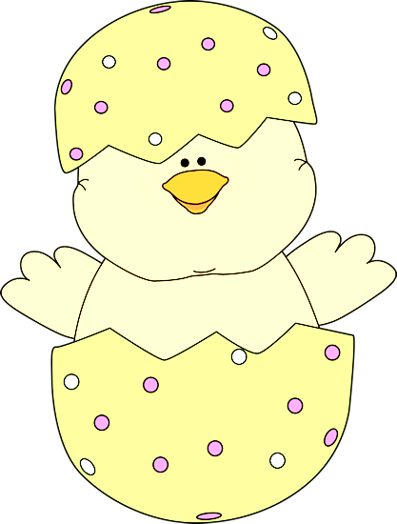



Chick grows bigger

Chick hatches

Question 3 - Recycling

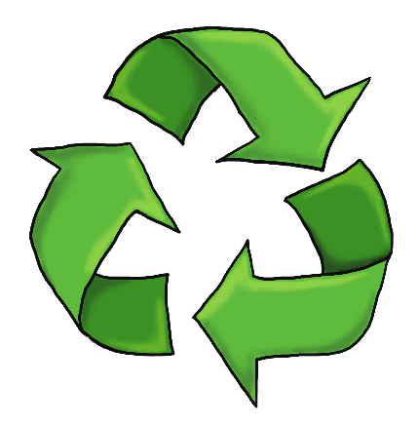3.1. What does the emblem in the picture represent? (ƒ)

Recycling / recycling logo

3.2. Write the words to the sentence that describes it correctly. Use a ruler to draw the lines. (3 x ƒ = 1ƒ)

|  |  |  |
| --- | --- | --- |
| Re-use |  | We need to find ways of using paper, bottles and tins. |
| Reduce | We must re-use as many things as possible before we throw it away. |
| Recycle | We should reduce our littering. |

3.3. Name 4 materials that we can recycle. (4¸2=2)

1. Plastic

2. Metal

3. Paper

4. Glass

3.4. Colour the pictures of the things that can rot. (4¸2=2)

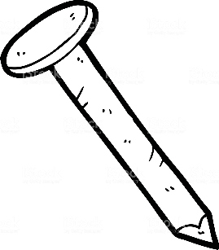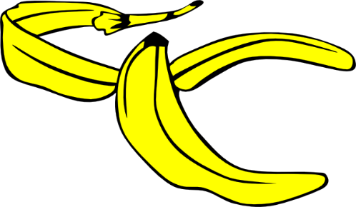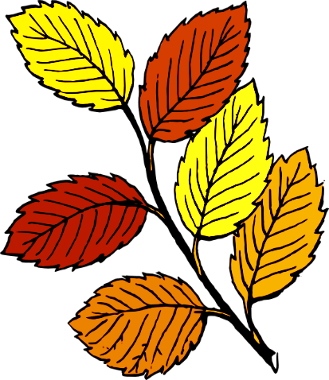

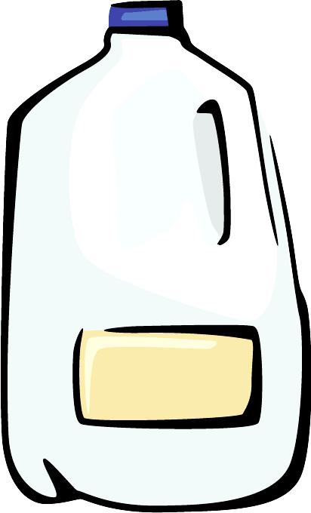

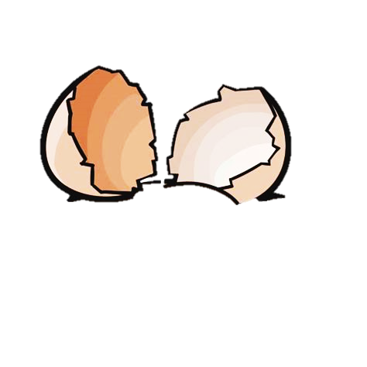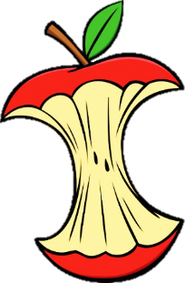

|  |  |  |
| --- | --- | --- |
| Rubric: Personal and Social Well-being |  | Marks |
| Question 1.1. Insects - Name the body parts of an ant. | 3 |  |
| Question 1.2. Name the insects. | 3 |  |
| Question 1.3. Answer the questions about insects. | 2 |  |
| Question 2.1. Complete the lifecycle of a chicken. | 5 |  |
| Question 3.1. Recycling: What does the emblem mean? | ƒ |  |
| Question 3.2. Write the words to the sentence describing it. | 1ƒ |  |
| Question 3.3. Name 4 materials that can be recycle. | 2 |  |
| Question 3.4. Colour the pictures of things that can rot. | 2 |  |
| Total | ____/20 | |