Life Skills

Assessment Task Term 2

Grade 3

Name and Surname: ____________________________

Date: _________________________________

|  |  |  |
| --- | --- | --- |
| Content Areas |  | Marks |
| 1. Beginning Knowledge and Personal and Social Wellbeing | 40 |  |
| 1. Creative Arts | 20 |  |
| 1. Physical Education | 30 |  |
| Total | 90 |  |



Beginning Knowledge

Total: ___/20

QUESTION 1: Healthy eating habits

* 1. Write the names of the correct food in the blocks of the different groups. (8)

milk

bananas

pasta

cheese

bread

grapes

yogurt

chicken

|  |  |  |  |
| --- | --- | --- | --- |
| Carbohydrates | Proteins | Vitamins and minerals | Fats |
|  |  |  |  |
|  |  |  |  |
|  |  |  |  |

* 1. Complete the sentences by writing the correct word in the correct sentence.

Protein

energy

infection

heat

1. 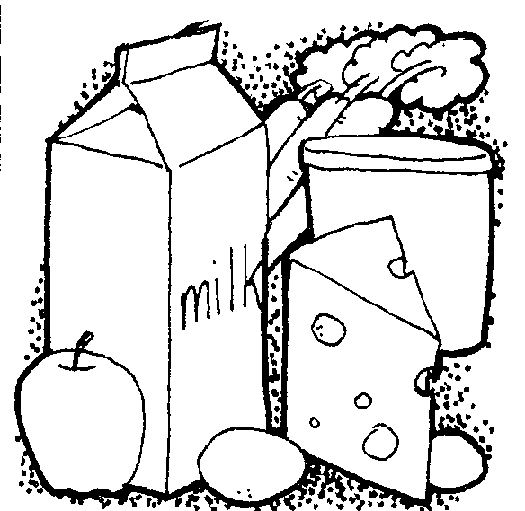___________ build new cells to

help our bodies grow.

1. Vitamins and minerals help our bodies to fight ___________ and to stay healthy.
2. Carbohydrates give us __________.
3. We need fats for ______ and energy.
   1. 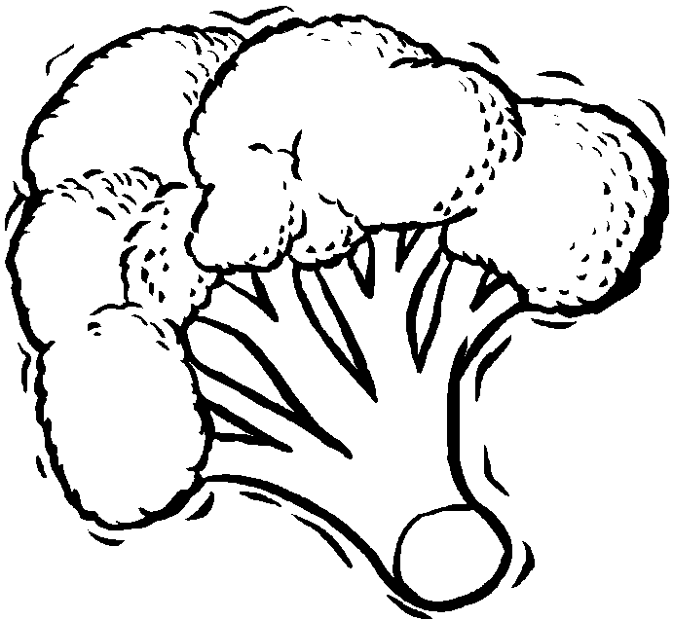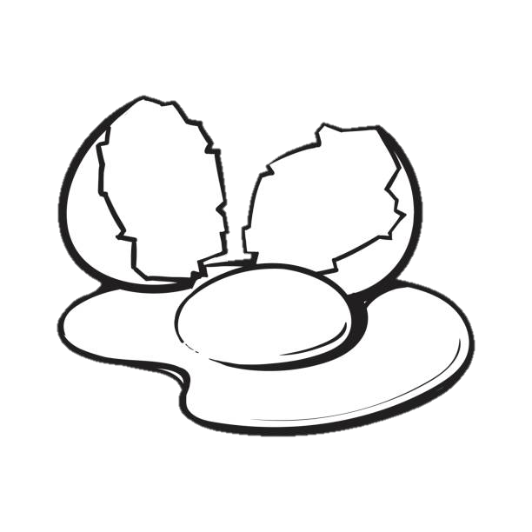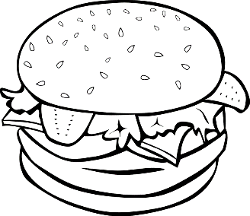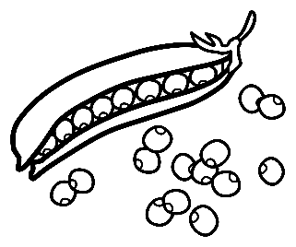Colour the pictures showing healthy food.(5)

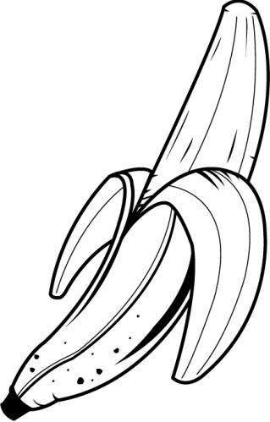



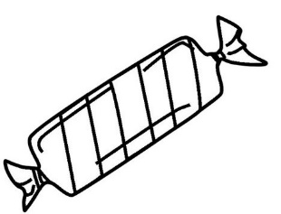

* 1. 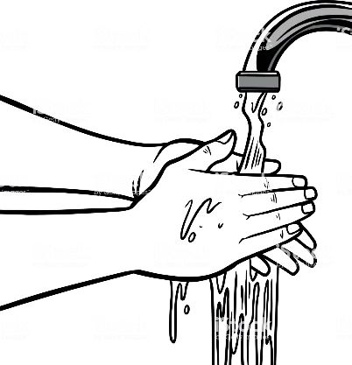Look at the three pictures. Write down the rules for healthy eating. (3)

___________________________________________________________________________

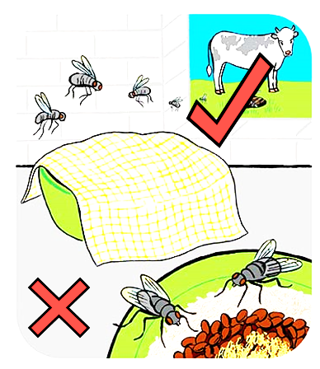

___________________________________________________________________________

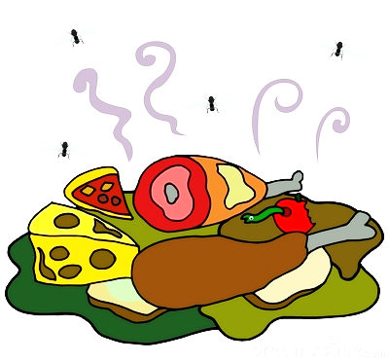

___________________________________________________________________________



Personal and Social Well - being

Total: 20

Question 1 - Insects

* 1. Name the body parts of the ant by using the words in the blocks. (6¸2=3)

leg

eye

head

antenna

lower body

upper body

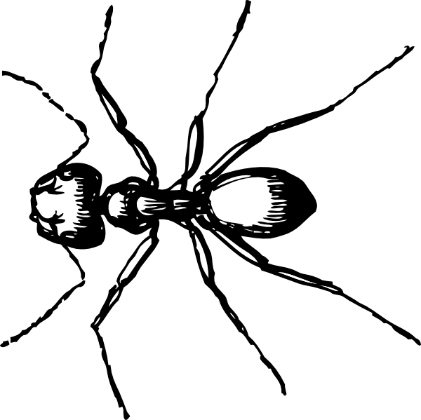

* 1. 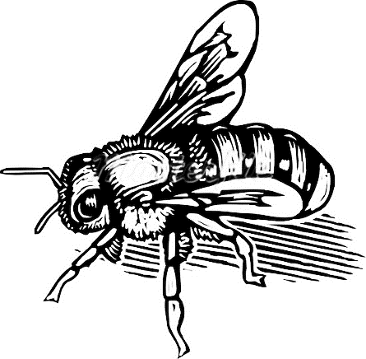 Name the insects. (6¸2=3)

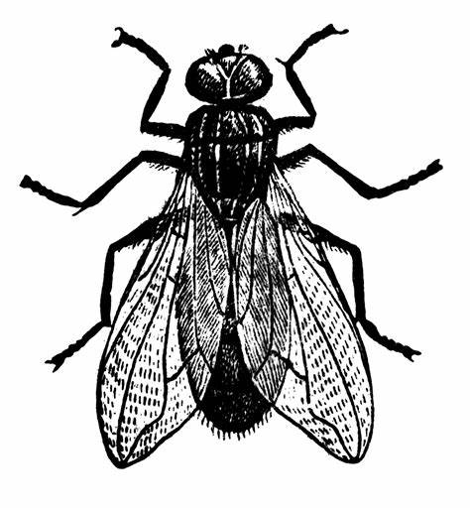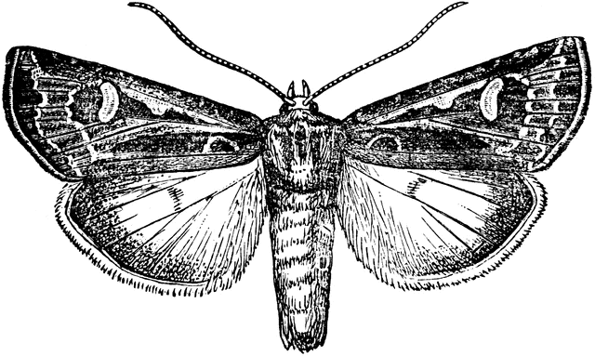

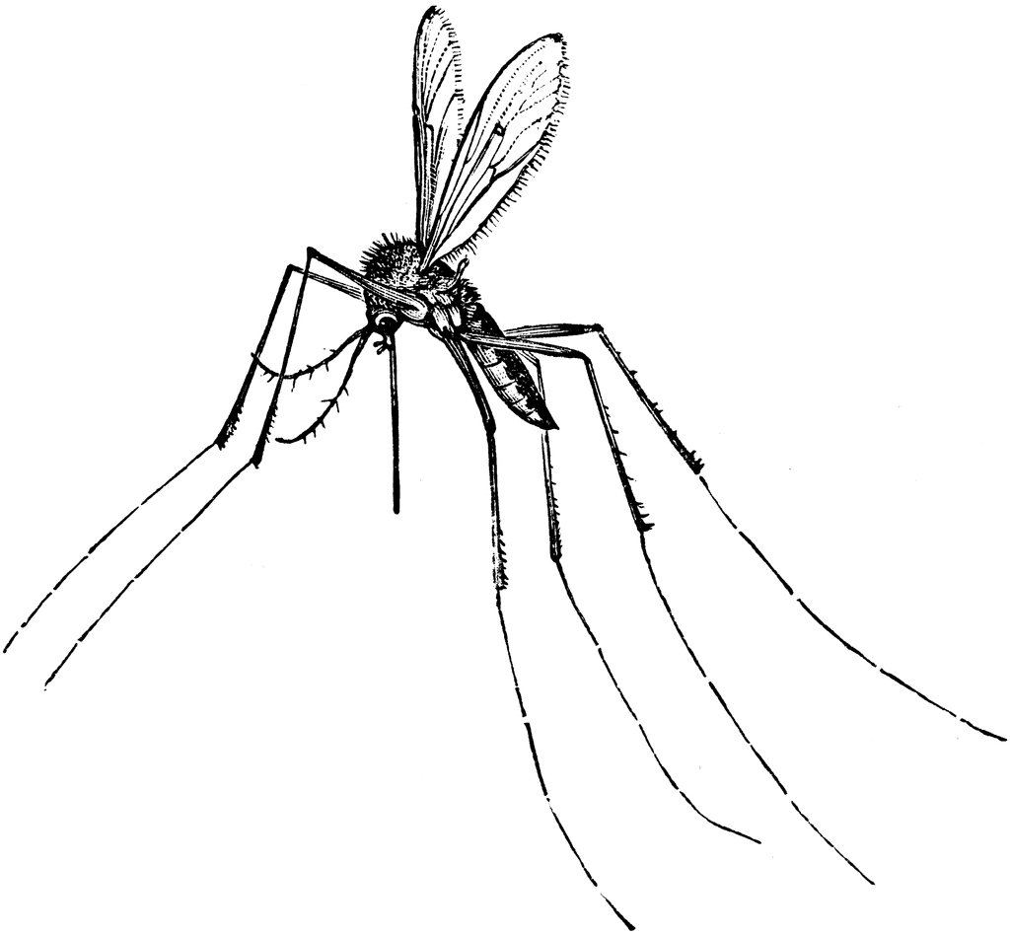

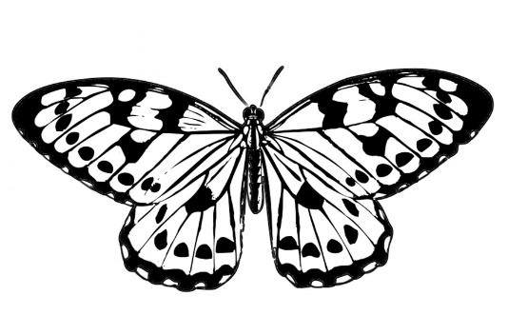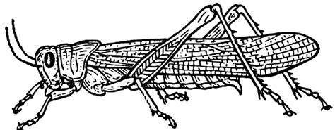

* 1. Answer the questions: (4¸2=2)

1. Which insect makes honey? ____________
2. Which insect pollinates flowers? ____________
3. Which insect spreads malaria? ____________
4. Which insect eats the crops of farmers? ____________

Question 2: Life cycle

2.1. Complete the life cycle of a chicken. (5)

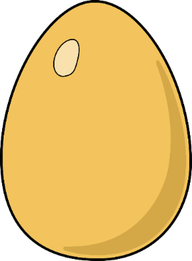



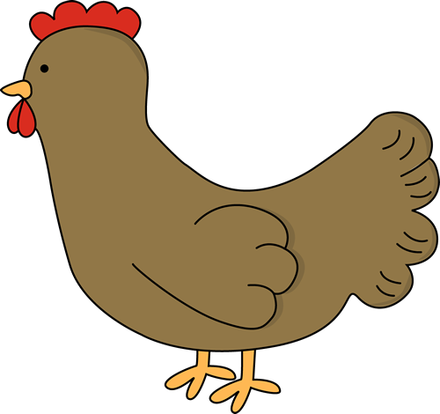

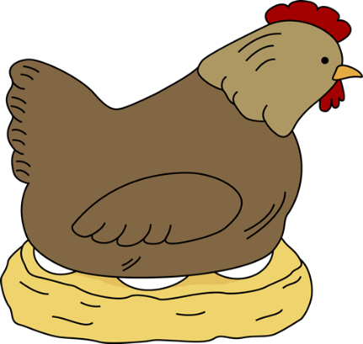





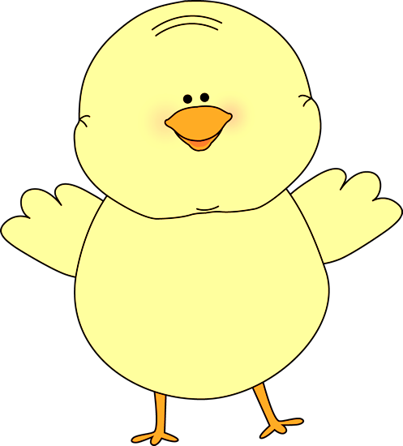

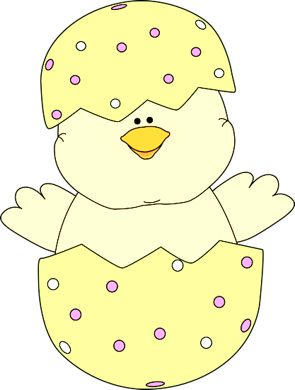



Question 3 - Recycling

3.1. What does the emblem in the picture represent? (ƒ)

_____________________

3.2. Write the words to the sentence that describes it correctly. Use a ruler to draw the lines. (3 x ƒ = 1ƒ)

|  |  |  |
| --- | --- | --- |
| Re-use |  | We need to find ways of using paper, bottles and tins. |
| Reduce | We must re-use as many things as possible before we throw it away. |
| Recycle | We should reduce our littering. |

3.3. Name 4 materials that we can recycle. (4¸2=2)

1. ______________________
2. ______________________
3. ______________________
4. ______________________

3.4. Colour the pictures of the things that can rot. (4¸2=2)

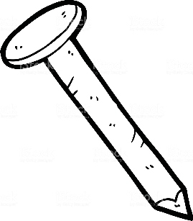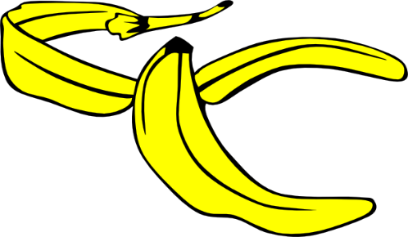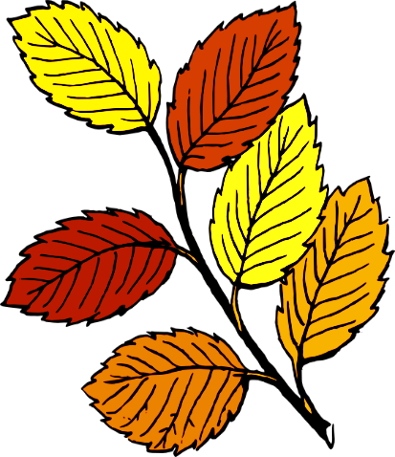



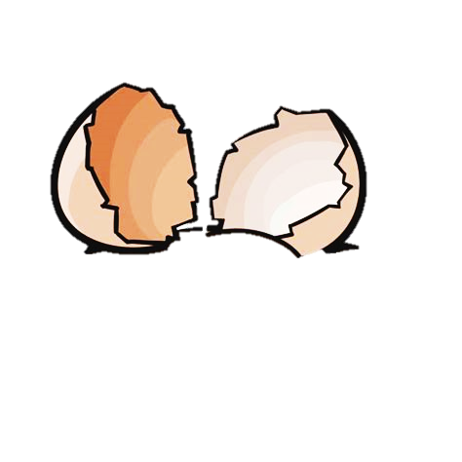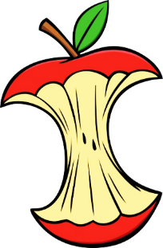

|  |  |  |
| --- | --- | --- |
| Rubric: Personal and Social Well-being |  | Marks |
| Question 1.1. Insects - Name the body parts of an ant. | 3 |  |
| Question 1.2. Name the insects. | 3 |  |
| Question 1.3. Answer the questions about insects. | 2 |  |
| Question 2.1. Complete the lifecycle of a chicken. | 5 |  |
| Question 3.1. Recycling: What does the emblem mean? | ƒ |  |
| Question 3.2. Write the words to the sentence describing it. | 1ƒ |  |
| Question 3.3. Name 4 materials that can be recycle. | 2 |  |
| Question 3.4. Colour the pictures of things that can rot. | 2 |  |
| Total | ____/20 | |

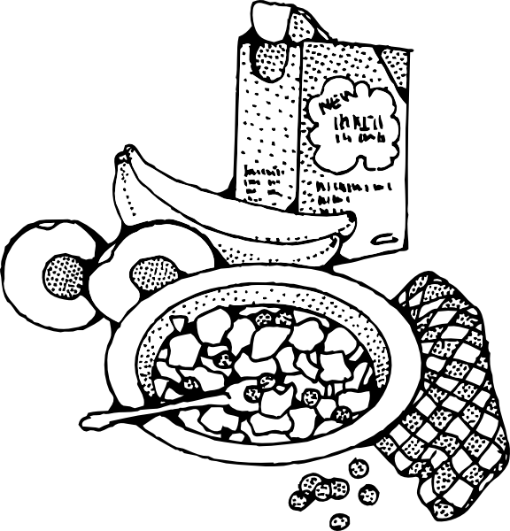

Creative Arts

* Visual art -

2D-shapes: Healthy eating habits

Task:

Make a colourful poster to explain the five food groups. Use pictures or drawings. Remember your headings for every food group.

You will be marked according to the following rubric.

|  |  |  |  |  |  |
| --- | --- | --- | --- | --- | --- |
| Rubric: Visual Arts - Healthy eating habits : Poster | | | | | |
| 1 | 2 | | 3 | 4 | 5 |
| Poster image of food groups, but it is very unclear. The poster is rushed, unclear and information is limited. | The poster image of food groups, but the groups were not properly defined. Headings not clear. Layout is unclear and difficult to read information. | | Poster image of food groups, but the groups were not properly defined. Headings unclear. Poster seems to be a little chased and unfinished. | Poster shows 5 food groups and are clearly named. Food groups defined in one /two sentences. Pictures/drawings are neat, clear and are applicable to relevant food groups. Good work. | Poster depicts all elements of food groups as well as additional information .Each food group is clearly described with the correct heading. Good pictures/ drawings. Creative, neat and rounded off. |
| Marks: _____ / 5 | | Marks out of 10 (5 x 2) = _____/10 | | | |

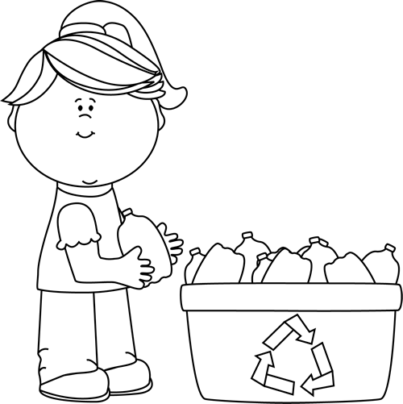

Creative Arts

* Performing Arts -

Improvise and interpret- Recycling

Task: Perform a classroom drama in groups.

The theme of the drama is” Recycling”.

Each group must portray their own story.

You will be marked according to the following rubric:

|  |  |  |  |  |  |
| --- | --- | --- | --- | --- | --- |
| Criteria | 1 | 2 | 3 | 4 | 5 |
| 1. Participation: Learner actively participates by making a contribution towards the planning of the play. |  |  |  |  |  |
| 1. Enjoyment: Learner enjoys participating in creative activities and collaborating in the group. |  |  |  |  |  |
| 1. Contents: Applicable to the given theme. |  |  |  |  |  |
| 1. The learner speaks loud and clear. |  |  |  |  |  |
| Total : 20 | ____/20 | | | | |
| Marks out of 10 | 20 ¸ 2 = ___/10 | | | | |

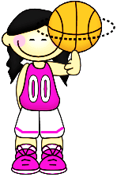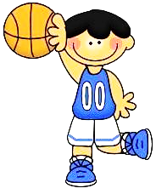

Physical Education

Activity 1

Activity 1: Co-ordination

Rotate between the 5 stations set up by teacher. When the whistle blows, move to the next station.

* Station 1:

Basketball: Bounce the ball on the ground while running in a zigzag pattern.

* Station 2:

Hockey: Use the hockey stick to move the ball towards the goal line.

* Station 3:

Netball: Bounce the ball between you and a friend while running.

* Station 4:

Rugby: Run with the ball and pass it on.

* 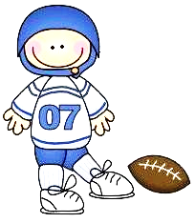Station 5:

Soccer: Dribble the ball to the goal line.

You will be marked to the following rubric:

|  |  |  |  |  |
| --- | --- | --- | --- | --- |
| Rubric: Physical Education - Activity 1 | 1 | 2 | 3 | 4 |
|  | Need help | Partially | Good | Outstanding |
| 1. Station 1:   Basketball: Bounce the ball while running in a zigzag pattern. |  |  |  |  |
| 1. Station 2:   Hockey: Use the hockey stick to move the ball towards the goal line. |  |  |  |  |
| 1. Station 3:   Netball: Bounce the ball between you and a friend while running. |  |  |  |  |
| 1. Station 4:   Rugby: Run with the ball and pass it on. |  |  |  |  |
| 1. Station 5:   Soccer: Dribble the ball to the goal line. |  |  |  |  |
| Total | ___/20 | | | |

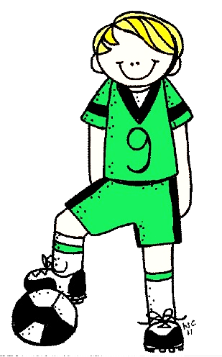

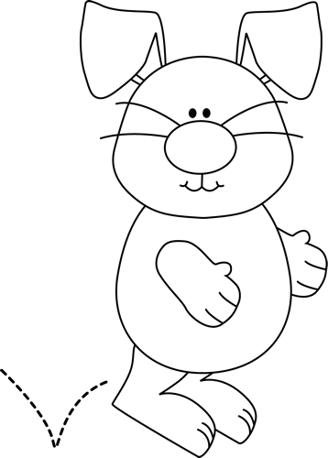

Physical Education

Activity 2

Activity 2 - Movement

Task: Imitate the movements.

* Jump like a frog.
* Gallop like a horse.
* Hop like a bunny.
* Waggle like a duck.
* Fly like a bee.
* Hop like a kangaroo.
* Fly like a bird.
* Run like a cheetah.
* Swim like a seal.
* Walk like a crab.

|  |  |  |
| --- | --- | --- |
| Rubric: Physical Education - Activity 2  The learner was able to do the following. |  | Marks |
| 1. Jump like a frog. | 1 |  |
| 1. Gallop like a horse. | 1 |  |
| 1. Hop like a bunny. | 1 |  |
| 1. Waggle like a duck. | 1 |  |
| 1. Fly like a bee. | 1 |  |
| 1. Hop like a kangaroo. | 1 |  |
| 1. Fly like a bird. | 1 |  |
| 1. Run like a cheetah. | 1 |  |
| 1. Swim like a seal. | 1 |  |
| 1. Walk like a crab. | 1 |  |
| Total | ____/10 | |