**GRADE 5 Life Skills – TERM 4 - MEMO**

**Name and surname: _______________________ Total: 30**

**Date: ____________________ Time: 45 minutes**

**INSTRUCTIONS**

1. Read the questions carefully.
2. Answer all the questions.
3. Write neatly.

**___________________________________________________________________**

**QUESTION 1**

Match column B with column A. Write only the letter. (5)

|  |  |  |
| --- | --- | --- |
| **Column A** | **Answer** | **Column B** |
| 1. Cholera | **C** | 1. A disease that is caused by a virus   called Rubella. |
| 1. Stigma | **D** | 1. Substance abuse is the use of a substance (drug) in ways that are harmful to the person using the substance or other people. |
| 1. Cocaine | **E** | 1. An infection of the small intestine that is caused by the bacteria. This disease are found in water. |
| 1. Measles | **A** | 1. Means that something or somebody has a bad reputation or a   negative label. For example, if a person has been to jail, people might say things like: That man, he is bad and violent. |
| 1. Substance abuse | **B** | 1. A very addictive drug made from the leaves of the coca plant. Can be inhaled through the nose. |

___________________________________________________________________

**QUESTION 2**

Is the following statements true or false? If false correct the statement. (5)

2.1. People who abuse drugs do so because it gives them a temporary feeling of

wellbeing or happiness . (1)

**True**

2.2. The abbreviation AIDS stand for: Attention Immune Deficiency Syndrome. (1)

**False. AIDS stands for Acquired Immune Deficiency Syndrome**

2.3. HIV can be spread by hugging someone. (1)

**False. HIV cannot be spread by hugging someone.**

2.4. Malaria is commonly known as TB. It is caused by bacteria. (1)

**False. Malaria is commonly known as TB. It is caused by a bacteria.**

2.5. People who has HIV need all the support and understanding they can get.

Well informed people don’t judge people with HIV/AIDS or create stigmas. (1)

**True**

**QUESTION 3**

Read the story and answer the questions below. (6)

Jana’s grandmother is coughing a lot lately. She is also tired but she says she is tired because she is old. She is not eating her food. She says she is not eating because her teeth are sore. Jana can see she has lost weight. She says it is because she is not eating. Jana tells her to go to the doctor or the clinic to be tested for TB. She says Jana is talking nonsense and doesn’t have to worry.

1. Explain why you think Jana’s grandmother has TB. (4)

* She is coughing a lot.
* She is very tired.
* She is not eating her food, because her teeth is sore.
* She has lost a lot of weight.

All of the above is signs of TB and therefore Jana’s grandmother has a very good chance of having TB.

1. How is malaria caused? (1)

Malaria is caused by a parasite called Plasmodium.

1. What is diarrhoea? (1)

Diarrhoea is characterized by loose, watery stools or a frequent need to have a bowel movement (To go to the bathroom). It usually lasts a few days and often disappears without any treatment.

___________________________________________________________________

**QUESTION 4**

Answer the following questions:

4.1. What does it mean to be addicted to something? (1)

Physically and mentally dependent on a particular substance for example drugs,

bad habits or an activity.

4.2. Name two type of drugs. (2)

1. Cocaine

2. Marijuana

Any other correct answer.

4.3. Name 3 negative impacts of drugs on your health. (3)

* Drugs can cause your death
* Cause seizures, stroke and widespread brain damage
* Paranoia
* Aggressiveness
* Hallucinations
* Addiction
* Impaired judgment, impulsiveness, loss of self-control which can lead to your death.
* Amnesia, confusion.
* Vomiting, headaches and sweating.

4.4. Drugs can be legal and illegal. Look at the pictures and sort them in the table

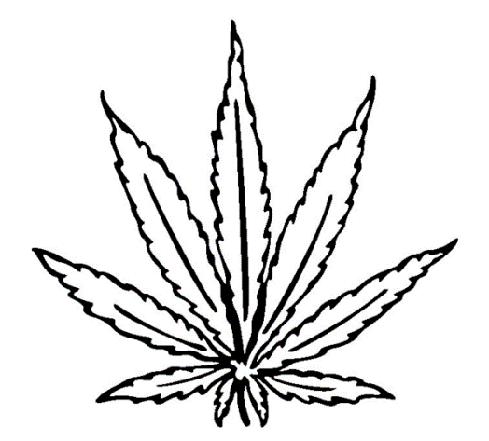 according to legal and illegal by wring down the name of the picture. (7)

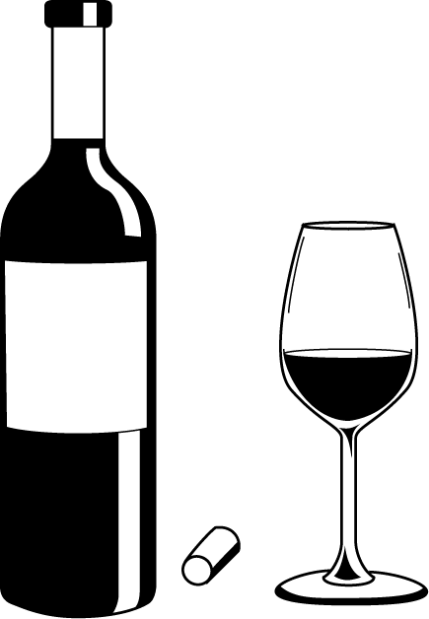

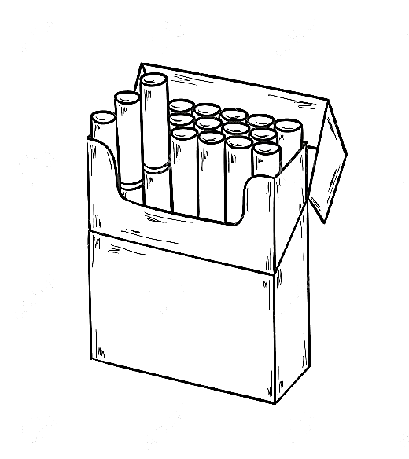

tobacco

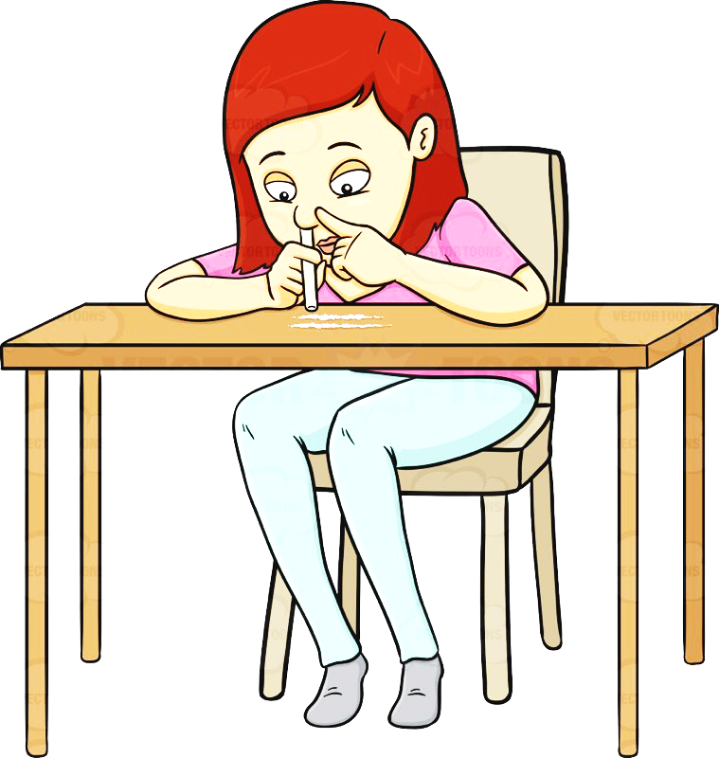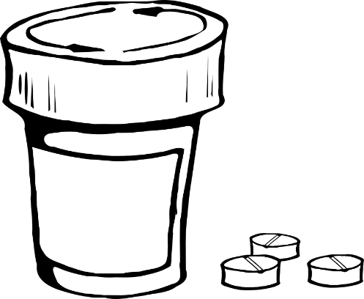

cocaine

headache pills

alcohol

marijuana

caffeine



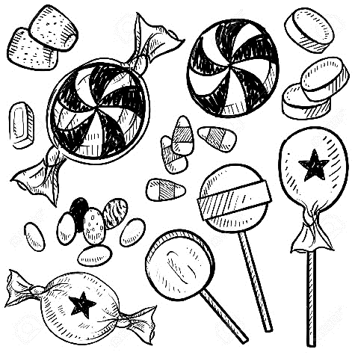

sweets

|  |  |
| --- | --- |
| Legal drugs | illegal drugs |
| **caffeine** | **cocaine** |
| **sweets** | **marijuana** |
| **alcohol** |  |
| **tobacco** |  |
| **alcohol** |  |

________________________________________________________

**QUESTION 5**

* 1. What does the abbreviation HIV stand for? (1)

Human Immuno-deficiency Virus

* 1. Write down 3 ways how HIV cannot be spread. (3)

HIV cannot be passed on by hugging somebody.

HIV cannot be passed on by touching somebody.

HIV cannot be passed on by sharing eating utensils, cups or plates.

HIV cannot be passed on by sitting close to somebody.

HIV cannot be passed on by using the same toilet as somebody

* 1. There is a lot of stigmas surrounding HIV and AIDS. Explain how you think we can change these people’s attitudes about HIV and AIDS. (3)

Well informed people don’t judge people with HIV/AIDS or create stigmas.

The best way to change attitudes and prejudice about HIV/AIDS is by making sure that people are well informed about the virus. Children can be informed at schools through education of HIV. Society can be informed by die government, pamphlets, presentations ext.

**Total: ___/30**