GRADE 5 ENGLISH HOME LANGUAGE – TERM 4

Name and surname: _______________________ Total: 40
Date: ____________________ Time: 1 hour

INSTRUCTIONS
- Read the questions carefully.
- Answer all the questions in full sentences.
- Write neatly.
___________________________________________________________________________
SECTION A
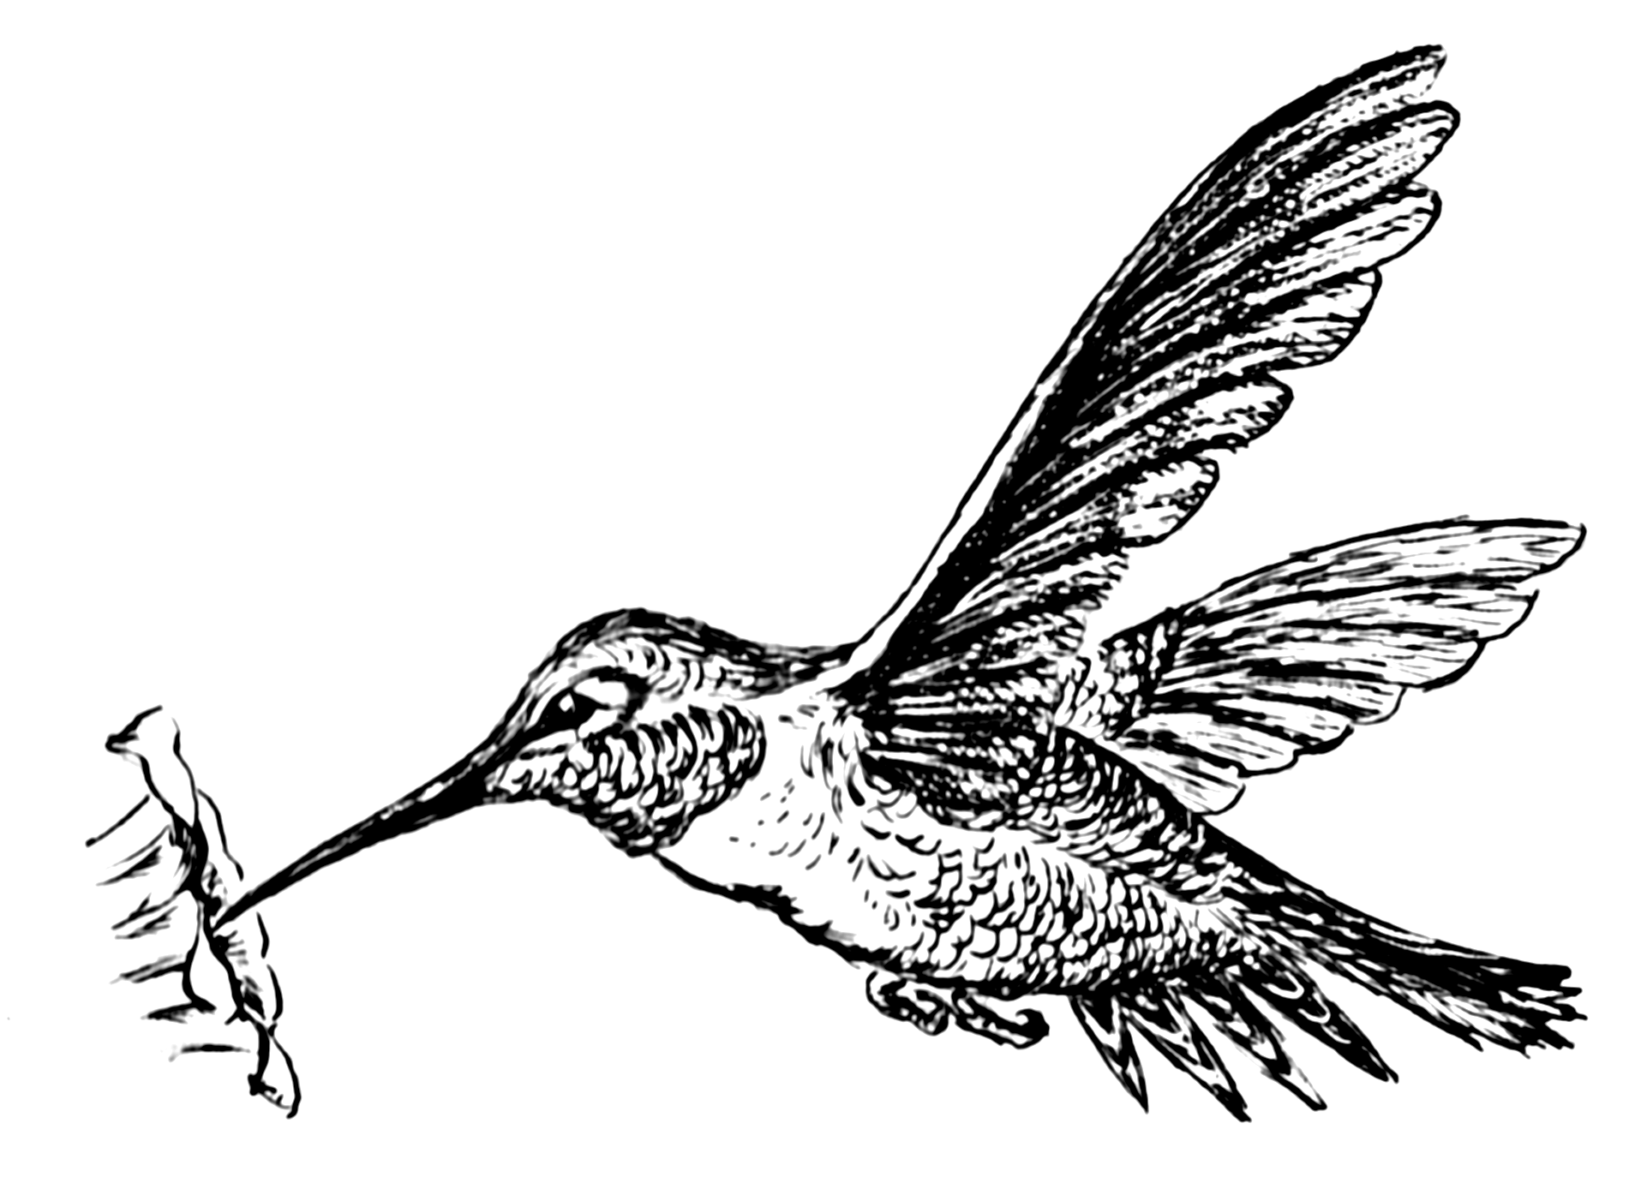
QUESTION 1: Comprehension Test
Read the text about humming birds and answer the questions.
Humming birds

The most beautiful humming birds are found in the West Indies and South America. The crest of the tiny head of one of these shines like a sparkling crown of colored light. The shades of color that adorn its breast are equally brilliant. As the bird flits from one object to another, it looks more like a bright flash of sunlight than it does like a living being.

But, you ask, why are they called humming birds? It is because they make a soft, humming noise by the rapid motion of their wings—a motion so rapid, that as they fly, you can hardly see that they have wings.

One day when walking in the woods, I found the nest of one of the smallest humming birds. It was about half the size of a very small hen's egg, and it was attached to a twig no thicker than a steel knitting needle. It seemed to have been made of cotton fibers and was covered with the softest bits of leaf and bark. It had two eggs in it, and each was about as large as a small sugarplum.

When you approach the spot where one of these birds has built its nest, it is necessary to be careful. The mother bird will dart at you and try to peck your eyes. Its sharp beak may hurt your eyes most severely, and even destroy your sight. The poor little thing knows no other way of defending its young, and instinct teaches it that you might carry off its nest if you find it.

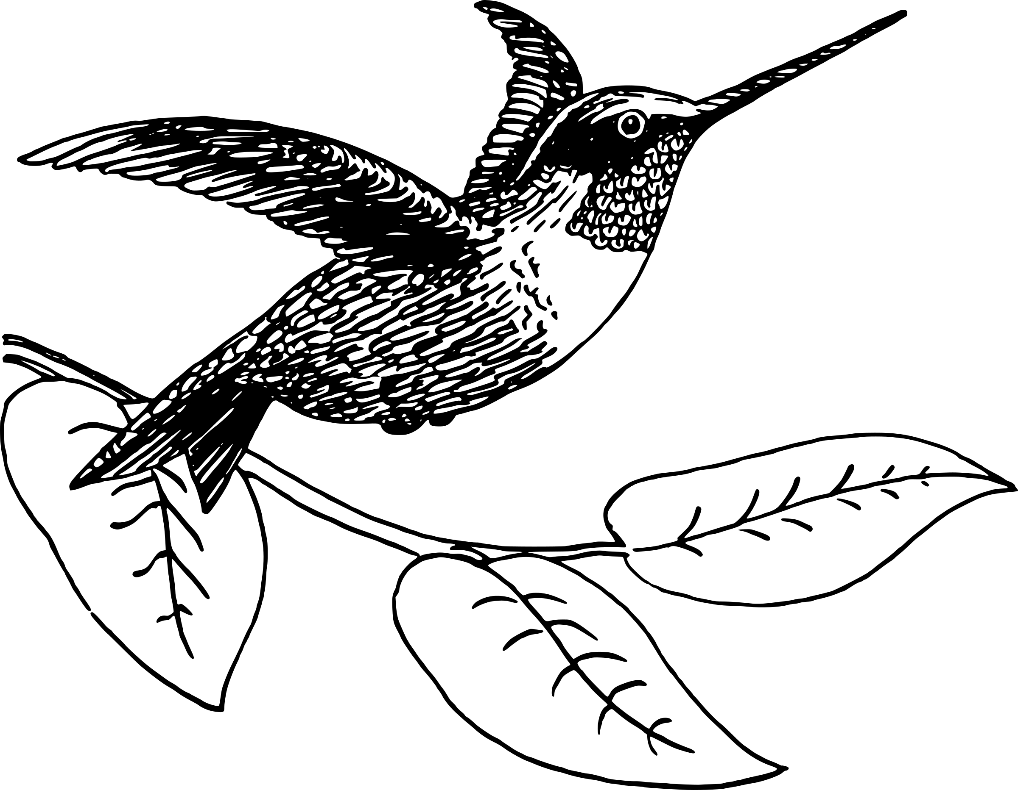

- Where can you find the most beautiful humming birds?
The most beautiful humming birds are found in the West Indies√ and South America√. (2)

- To what does the author compare the crest on their tiny head?
The author compares the crest of the tiny head of one of these shines like a sparkling crown of colored light. (1)

- Why are these birds called humming birds?
They are called humming birds because they make a soft, humming noise√ by the rapid motion of their wings√. (2)

- Why do you think it can be difficult to find a humming bird’s nest?
It can be difficult because the nest was about half the size of a very small hen's egg. (1)

- What is a humming bird’s nest made of?
The nest is made of cotton fibers√ and was covered with the softest bits of leaf√ and bark√. (3)

- Why is it necessary to be careful when approaching a humming bird’s nest?
The mother bird will dart at you and try to peck your eyes√. Its sharp beak may hurt your eyes most severely√, and even destroy your sight√. (3)

- Underline the correct answer:
  - As the bird flits from one object to another. What does the word flits mean in this sentence? (1)
- Sitting quietly in one place.
- Move swiftly and lightly.
- Eating different objects.

  - “….a soft, humming noise by the rapid motion of their wings”. The word rapid in the sentence means: (1)
- Slowly
- Silently
- Very fast
- Very loud

  - Is the following statement TRUE or FALSE? (1)
A humming bird is only defending its young when they try to hurt you when you come near their nest.
- True
- False
(Total Question 1: __/15)
___________________________________________________________________________

QUESTION 2: Poem

Read the poem about the humming bird and answer the questions.
The Humming bird
Robert James Parfett

Yes, I am small, but can you move like me?
Can you fly backwards and hum like a bee?
Now you can see me! I've stopped for a while.
How you admire me. See how you smile.

Pay close attention! Don't even blink!
Look at my colors. What do you think?
I hover just briefly to suck up sweet nectar.
I guess you could say I'm a nectar collector.

You may have learned a few things
From watching me fly, and my light perfect wings.
You may think I'm cocky, crazy or too confident
But sit and observe. It will be time well spent.

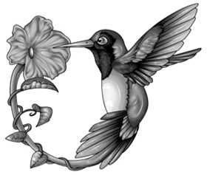

- Write down two examples of rhyme from the first paragraph of the poem. (2)
Me√ and bee√ OR while√ and smile√.

- Read the paragraph. Underline the words which rhyme. (2)

You may have learned a few things
From watching me fly, and my light perfect wings.

- Write down your own word which rhymes with “smile”. (1)
Any correct word which rhymes with smile will be marked as correct.

- Which one of the following words does not rhyme with “blink”? Underline the correct answer. (1)
- think
- drank
- sink
- wink

- Look at the last paragraph. Search for an example of alliteration and write it down. (1)
You may think I'm cocky, crazy or too confident

- Write an example of a simile from the first paragraph. (1)
Hum like a bee.

- Give an antonym for backwards.
Forwards (1)
- Write down a verb from the second paragraph. Pay, blink, look, think, hover, suck up, guess OR say. (1)

(Total Question 2: __/10)
Total SECTION A: ___/25
___________________________________________________________________________
SECTION B: Language

- Find the adverb and verb in the following sentence. Underline the adverb with blue and the verb with green. (2)
green
Can you fly backwards and hum like a bee?
blue

- Write the sentences with the correct capital letters and punctuation marks. (5)
  - can you find humming birds in west indies and south America (4)
Can√ you find humming birds in West Indies√ and South America√?√
  - watch out (1)
Watch out!√

- Underline the adjectives in the following sentences: (2)
  - The dog found a large stick.
  - Everest is the highest mountain.

- Write the following sentence in the indirect speech. (1)
Jenny says: “I love humming birds, they are so beautiful.”
Jenny said the she loves humming birds, because they are so beautiful.

- Join the following sentences using the word in brackets. (1)
Humming birds needs flowers. They suck up the nectar. (because)
Humming birds needs flowers, because the suck up the nectar.

- Read the sentence and answer the questions.
The most beautiful humming birds are found in the West Indies and South America. They enjoy and love drinking nectar.

    - Write down an example of a proper noun from the paragraph.
West Indies or South America (1)
    - Write down an example of a common noun from the paragraph.
birds (1)
    - Write down an example of an abstract noun from the paragraph.
love (1)

- Read the sentence. Underline the predicate of the sentence and draw a circle around the subject. (2 x ƒ = 1)
Humming birds like to drink sweet nectar.

Total SECTION B = __/15
___________________________________________________________________________

Total (SECTION A + SECTION B): ____/40

